Dispense Method Prediction Process Report
Generated: 2026-03-06 10:00

1. Prediction Process Steps

Step 1: Base Data Extraction
Export fill-level data from OLC (order_lifecycle_nrt) via 01_base_data.sql. Includes dispense_method (target), product attributes, wh_name, order_qty. Date range: prior 6 months (dynamic).

Step 2: Feature Selection
Run feature_selection.py to identify predictive features. Uses chi-square and mutual information to rank features by association with dispense_method. Output: selected_features.txt.

Step 3: Data Preparation
Load base_data.csv; encode categorical features (LabelEncoder); prepare train/test split (80/20 stratified by dispense_method).

Step 4: Model Training
Train Random Forest classifier (n_estimators=100, max_depth=15) on training set. Uses selected features; optionally weights by order_qty.

Step 5: Model Evaluation
Predict on held-out test set. Compute accuracy, macro F1, weighted F1, confusion matrix, per-class precision/recall.

Step 6: Outputs
Save metrics (metrics.json), classification report, confusion matrix (CSV + PNG), feature importance (CSV + PNG).

2. Model Fit Evaluation

Summary Metrics
Accuracy: 96.61%
Macro F1: 0.9739 (average F1 across classes, handles imbalance)
Weighted F1: 0.9658 (F1 weighted by class frequency)
Training samples: 623,801
Test samples: 155,951
Features used: wh_name, is_compound, unit_of_measure, level_3, is_rx, product_type, level_2
Target classes: automated, manual, other

Classification Report (Per-Class)
Unnamed: 0 | precision | recall | f1-score | support
automated | 0.9395493093148084 | 0.999963458305927 | 0.968815459507302 | 82098.0
manual | 0.999943814963948 | 0.909977161945666 | 0.9528415529718298 | 58674.0
other | 1.0 | 1.0 | 1.0 | 15179.0
accuracy | 0.9661111502972088 | 0.9661111502972088 | 0.9661111502972088 | 0.9661111502972088
macro avg | 0.979831041426252 | 0.969980206750531 | 0.9738856708263772 | 155951.0
weighted avg | 0.9681555270265776 | 0.9661111502972088 | 0.9658407889253652 | 155951.0

Confusion Matrix
Rows = actual dispense_method; Columns = predicted. Diagonal = correct predictions.
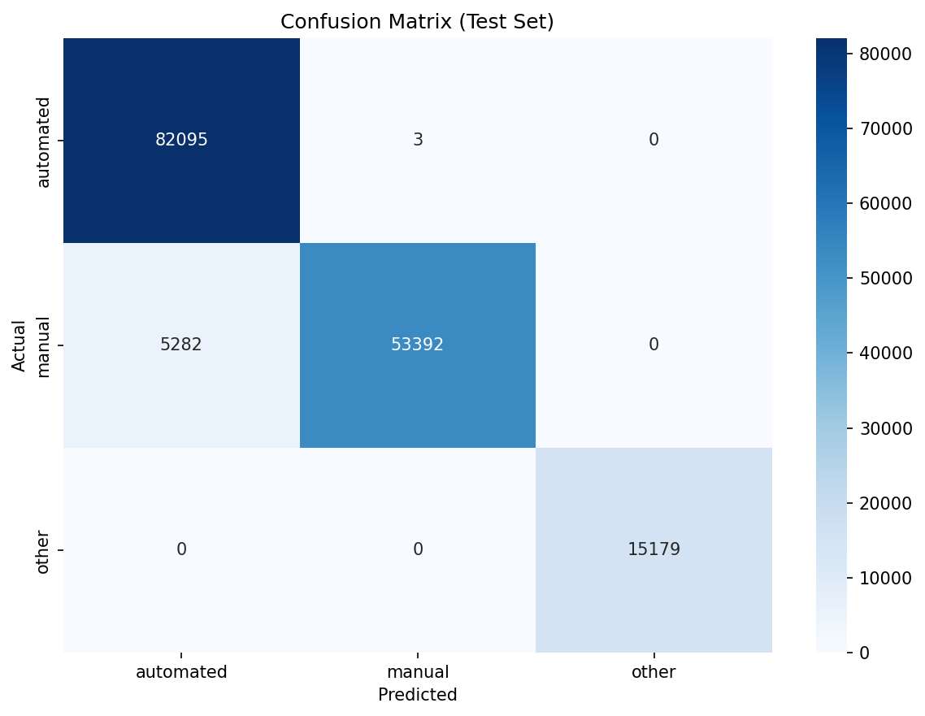
Confusion matrix (test set)

Unnamed: 0 | automated | manual | other
automated | 82095 | 3 | 0
manual | 5282 | 53392 | 0
other | 0 | 0 | 15179

Feature Importance
Random Forest feature importances (Gini importance). Higher = more predictive of dispense_method.
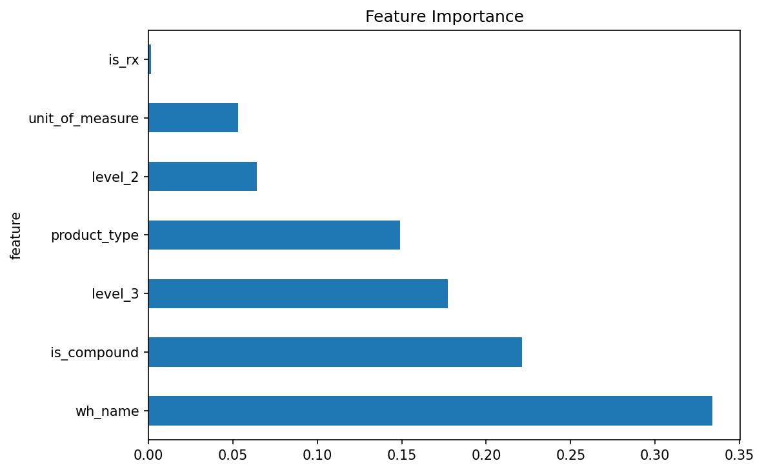
Feature importance

feature | importance
wh_name | 0.3338302525374544
is_compound | 0.221122885775553
level_3 | 0.1773822010753435
product_type | 0.149085335535632
level_2 | 0.0641636712046123
unit_of_measure | 0.0530553936748143
is_rx | 0.0013602601965902

3. Next Steps
• Deploy model for pre-dispense prediction (product_id + wh_name → predicted dispense_method)
• For new products not in training data: use product_type + wh_name rules from Part 1 distributions
• Consider temporal validation: train on first 5 months, test on 6th month
• Monitor accuracy over time; retrain as dispense patterns evolve

