Task Productivity: Verify Tasks — Duration Distribution
Histogram analysis of logic_adjusted_new_step_duration_minutes, broken out by task, wh_name, and task × wh_name.

Summary Statistics by Cut
n = count of observations; mean_min, median_min, p25, p75, p90 in minutes.
cut | dimension | value | n | mean_min | median_min | p25 | p75 | p90
Overall | — | — | 5000 | 8.45 | 7.84 | 5.79 | 10.65 | 13.41
task | task | Verify Batch | 1693 | 8.47 | 7.88 | 5.76 | 10.73 | 13.48
task | task | Verify Fill | 1641 | 8.35 | 7.79 | 5.79 | 10.6 | 13.07
task | task | Verify Order | 1666 | 8.52 | 7.87 | 5.79 | 10.64 | 13.63
wh_name | wh_name | BEYONDRX_OH | 1712 | 8.31 | 7.68 | 5.72 | 10.6 | 13.18
wh_name | wh_name | OHIO | 1642 | 8.6 | 7.99 | 5.88 | 10.78 | 13.71
wh_name | wh_name | BEYONDRX_AZ | 1646 | 8.43 | 7.86 | 5.76 | 10.61 | 13.4
task × wh_name | task_wh | Verify Batch | OHIO | 581 | 8.46 | 7.73 | 5.68 | 10.55 | 13.74
task × wh_name | task_wh | Verify Batch | BEYONDRX_OH | 580 | 8.21 | 7.66 | 5.58 | 10.55 | 12.82
task × wh_name | task_wh | Verify Order | BEYONDRX_OH | 568 | 8.54 | 7.88 | 5.84 | 10.73 | 13.52
task × wh_name | task_wh | Verify Order | BEYONDRX_AZ | 567 | 8.33 | 7.69 | 5.58 | 10.42 | 13.25
task × wh_name | task_wh | Verify Fill | BEYONDRX_OH | 564 | 8.2 | 7.59 | 5.78 | 10.49 | 13.11
task × wh_name | task_wh | Verify Fill | BEYONDRX_AZ | 547 | 8.2 | 7.79 | 5.58 | 10.33 | 12.74

Visualizations

Histogram Overview
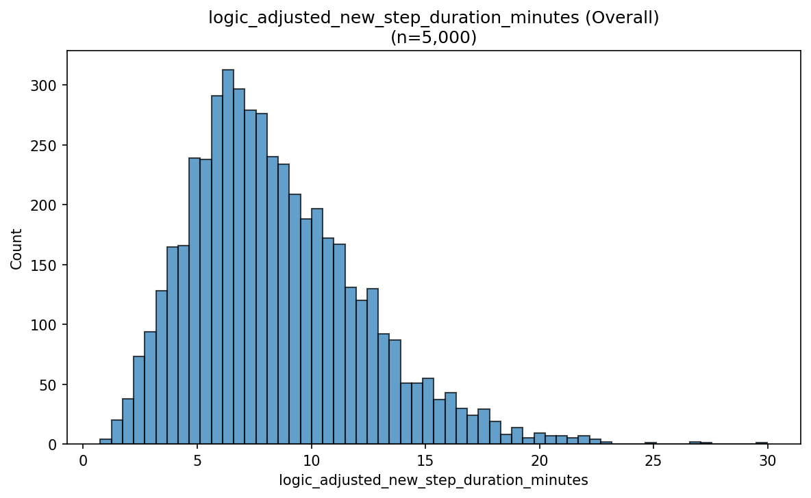

Histogram By Task
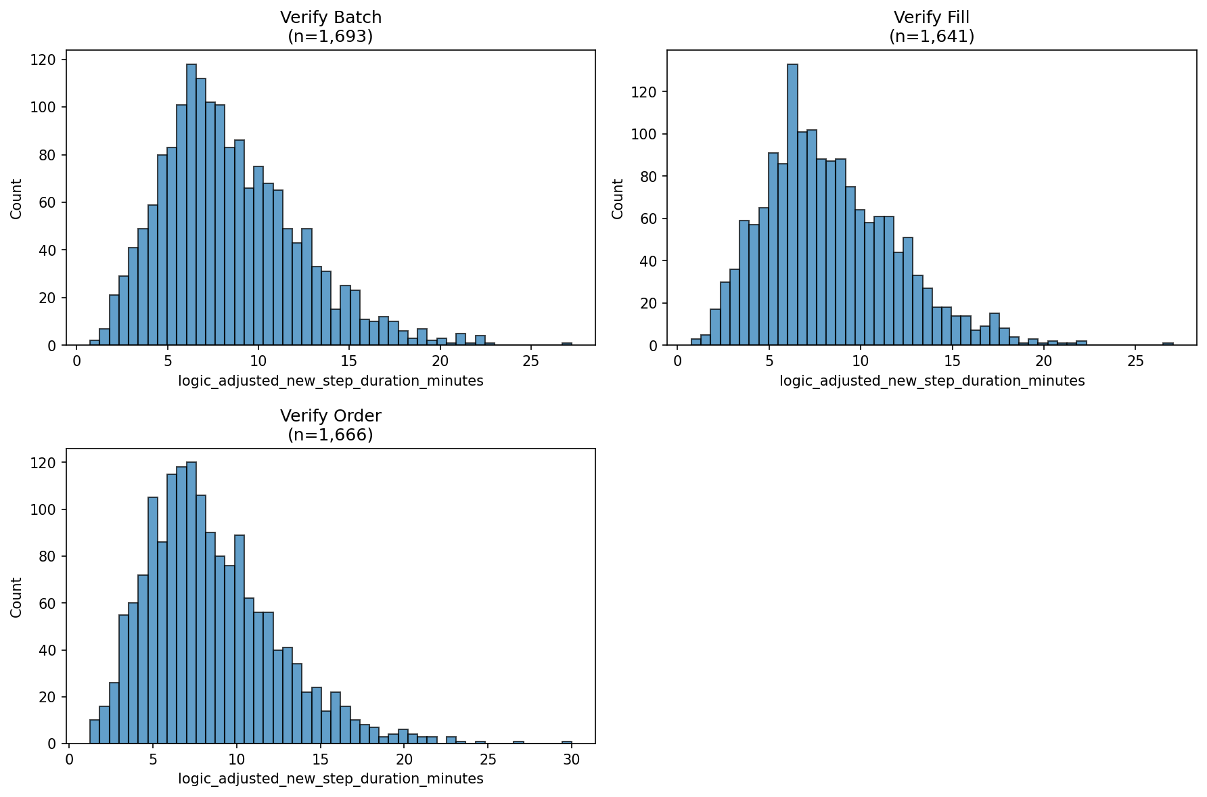

Histogram By Wh Name
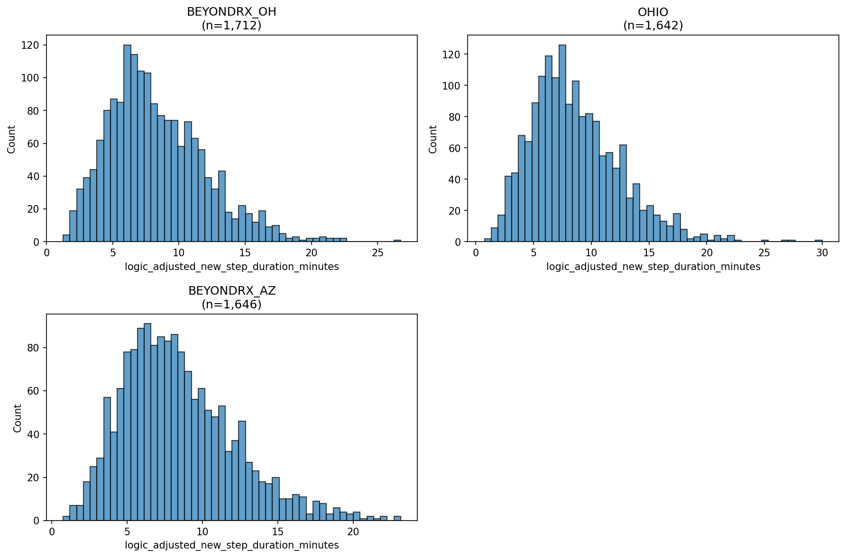

Histogram By Task Wh
