Reproducible Research: Peer Assessment 1

## Loading and preprocessing the data

#loading data  
data<-read.csv("activity.csv")  
#converting date column from factor to date type  
data$date<-as.Date(data$date)

## What is mean total number of steps taken per day?

#getting steps mean and median by date  
steps_per_day_mean<-aggregate(data$steps, list(data$date), FUN = mean)  
steps_per_day_median<-aggregate(data$steps, list(data$date), FUN = median)  
steps_per_day_total<-aggregate(data$steps, list(data$date), FUN=sum)  
#naming columns  
names(steps_per_day_mean)<-c("date","stepsMean")  
names(steps_per_day_median)<-c("date","stepsMedian")  
names(steps_per_day_total)<-c("date","stepsTotal")  
#merging dataframes  
steps_per_day<-merge(steps_per_day_mean,steps_per_day_median)  
steps_per_day<-merge(merge(steps_per_day_mean,steps_per_day_median),steps_per_day_total)

#### **Histogram of total steps per day**

library(ggplot2)  
hist<-ggplot(steps_per_day,aes(x=steps_per_day$stepsTotal))  
hist+geom_histogram(breaks=seq(0,25000,5000), aes(fill=..count..))+xlab("Total Steps")+ggtitle("Total Steps per day")

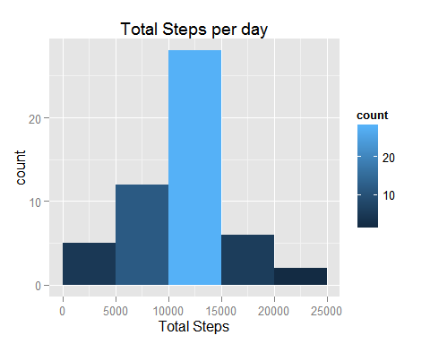

#### **Mean and median total number of steps taken per day**

steps_per_day[,c(1:3)]

## date stepsMean stepsMedian  
## 1 2012-10-01 NA NA  
## 2 2012-10-02 0.4375000 0  
## 3 2012-10-03 39.4166667 0  
## 4 2012-10-04 42.0694444 0  
## 5 2012-10-05 46.1597222 0  
## 6 2012-10-06 53.5416667 0  
## 7 2012-10-07 38.2465278 0  
## 8 2012-10-08 NA NA  
## 9 2012-10-09 44.4826389 0  
## 10 2012-10-10 34.3750000 0  
## 11 2012-10-11 35.7777778 0  
## 12 2012-10-12 60.3541667 0  
## 13 2012-10-13 43.1458333 0  
## 14 2012-10-14 52.4236111 0  
## 15 2012-10-15 35.2048611 0  
## 16 2012-10-16 52.3750000 0  
## 17 2012-10-17 46.7083333 0  
## 18 2012-10-18 34.9166667 0  
## 19 2012-10-19 41.0729167 0  
## 20 2012-10-20 36.0937500 0  
## 21 2012-10-21 30.6284722 0  
## 22 2012-10-22 46.7361111 0  
## 23 2012-10-23 30.9652778 0  
## 24 2012-10-24 29.0104167 0  
## 25 2012-10-25 8.6527778 0  
## 26 2012-10-26 23.5347222 0  
## 27 2012-10-27 35.1354167 0  
## 28 2012-10-28 39.7847222 0  
## 29 2012-10-29 17.4236111 0  
## 30 2012-10-30 34.0937500 0  
## 31 2012-10-31 53.5208333 0  
## 32 2012-11-01 NA NA  
## 33 2012-11-02 36.8055556 0  
## 34 2012-11-03 36.7048611 0  
## 35 2012-11-04 NA NA  
## 36 2012-11-05 36.2465278 0  
## 37 2012-11-06 28.9375000 0  
## 38 2012-11-07 44.7326389 0  
## 39 2012-11-08 11.1770833 0  
## 40 2012-11-09 NA NA  
## 41 2012-11-10 NA NA  
## 42 2012-11-11 43.7777778 0  
## 43 2012-11-12 37.3784722 0  
## 44 2012-11-13 25.4722222 0  
## 45 2012-11-14 NA NA  
## 46 2012-11-15 0.1423611 0  
## 47 2012-11-16 18.8923611 0  
## 48 2012-11-17 49.7881944 0  
## 49 2012-11-18 52.4652778 0  
## 50 2012-11-19 30.6979167 0  
## 51 2012-11-20 15.5277778 0  
## 52 2012-11-21 44.3993056 0  
## 53 2012-11-22 70.9270833 0  
## 54 2012-11-23 73.5902778 0  
## 55 2012-11-24 50.2708333 0  
## 56 2012-11-25 41.0902778 0  
## 57 2012-11-26 38.7569444 0  
## 58 2012-11-27 47.3819444 0  
## 59 2012-11-28 35.3576389 0  
## 60 2012-11-29 24.4687500 0  
## 61 2012-11-30 NA NA

## What is the average daily activity pattern?

#### **Time series plot of the 5-minute interval and the average number of steps taken, averaged across all days**

steps_per_int_mean=aggregate(data$steps, list(data$interval), FUN=mean, na.rm=TRUE)  
names(steps_per_int_mean)<-c("interval","stepsMean")

plot(steps_per_int_mean, type="l",col="blue")  
title("Steps Average per interval")

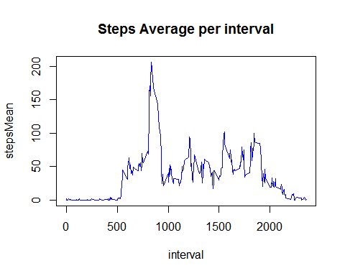

#### **5-minute interval containing the maximum number of steps**

steps_per_int_mean[which(steps_per_int_mean$stepsMean==max(steps_per_int_mean$stepsMean)),1]

## [1] 835

## **Imputing missing values**

#### **Number of missing values in the dataset**

nrow(data[ is.na(data$steps),])

## [1] 2304

#### **Filling the missing values**

Missing values were filled using the median of the steps on all other days

dataFilled<- data  
steps_per_int_median=aggregate(data$steps, list(data$interval), FUN=median, na.rm=TRUE)  
names(steps_per_int_median)<-c("interval","stepsMedian")  
  
#Filling na values in steps field with steps median per interval  
  
for (i in seq(1,nrow(dataFilled))){  
 int <- dataFilled$interval[i]  
 if (is.na(dataFilled$steps[i])){  
 dataFilled[1][i,] <- steps_per_int_median[steps_per_int_median$interval == int,]["stepsMedian"]  
 }  
}

They were then calculated the total, average and median steps using the new dataset

steps_per_day_mean_DF<-aggregate(dataFilled$steps, list(dataFilled$date), FUN=mean)  
steps_per_day_median_DF<-aggregate(dataFilled$steps, list(dataFilled$date), FUN=median)  
steps_per_day_total_DF<-aggregate(dataFilled$steps, list(dataFilled$date), FUN=sum)  
names(steps_per_day_mean_DF)<-c("date","stepsMean")  
names(steps_per_day_median_DF)<-c("date","stepsMedian")  
names(steps_per_day_total_DF)<-c("date","stepsTotal")  
steps_per_day_DF<-merge(merge(steps_per_day_mean_DF,steps_per_day_median_DF),steps_per_day_total_DF)

The following histogram was made to present the results:

library(ggplot2)  
hist<-ggplot(steps_per_day_DF,aes(x=steps_per_day_DF$stepsTotal))  
hist<-hist+geom_histogram(breaks=seq(0,25000,5000), aes(fill=..count..))+xlab("Total Steps")+ggtitle("Total Steps per day")  
hist<-hist +scale_fill_gradient("Count", low = "#093B0D", high = "#98D69D")  
hist

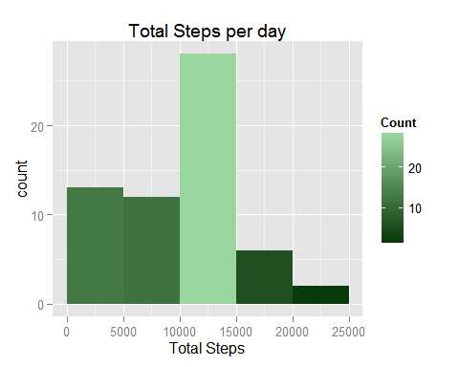

As you can see the values differ from the first histogram for the first five thousand steps.

## Are there differences in activity patterns between weekdays and weekends?

#### **Creating a new factor variable in the dataset with two levels - "weekday" and "weekend" indicating whether a given date is a weekday or weekend day.**

library(plyr)  
Sys.setlocale("LC_TIME", "C") # setting LOCAL TIME -> English

## [1] "C"

dataFilled<-mutate(dataFilled, dayType = ifelse(weekdays(date) %in% c("Saturday","Sunday","sábado","domingo"),"weekend","weekday"))

#### **Making a panel plot containing a time series plot (i.e. type = "l") of the 5-minute interval (x-axis) and the average number of steps taken, averaged across all weekday days or weekend days (y-axis)**

DFSummary<-aggregate(dataFilled$steps, by=list(dataFilled$dayType,dataFilled$interval),FUN=mean)  
names(DFSummary)<-c("DayType","Interval","Steps")  
g<-ggplot(DFSummary,aes(Interval,Steps))  
g+geom_line(color="#017292") +facet_wrap(~DayType, nrow=2, ncol=1)+labs(x="Interval")+labs(y="Number of steps")+labs(title="Steps by day type")

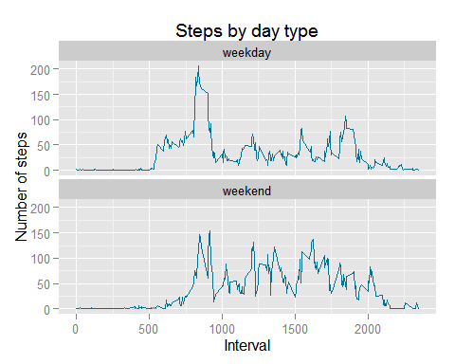

As you can see, there are some differences between the patterns of weekday and weekend day