BAB II - METODOLOGI DAN SOLUSI YANG DITAWARKAN

2.1 Metodologi Pengembangan Sistem

2.1.1 Pendekatan Metodologi

Pengembangan Sistem Validasi Kegiatan ASN berbasis AI menggunakan **metodologi hybrid** yang menggabungkan **Design Thinking**, **Agile Development**, dan **AI-First Approach** untuk memastikan solusi yang user-centric, iteratif, dan berbasis kecerdasan buatan.

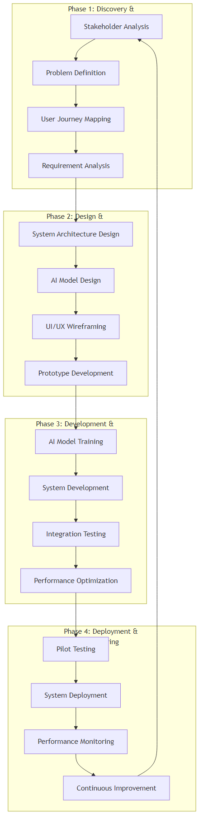

Fig. Diagram 1

2.1.2 Framework Pengembangan AI

**AI Development Lifecycle (AIDL)** yang diimplementasikan:

**Data Strategy & Collection**

**Model Architecture Selection**

**Training & Validation**

**Testing & Evaluation**

**Deployment & Monitoring**

**Continuous Learning & Improvement**

2.2 Arsitektur Sistem Komprehensif

2.2.1 Overall System Architecture

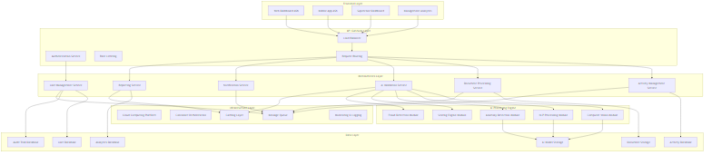

Fig. Diagram 2

2.2.2 Data Flow Architecture

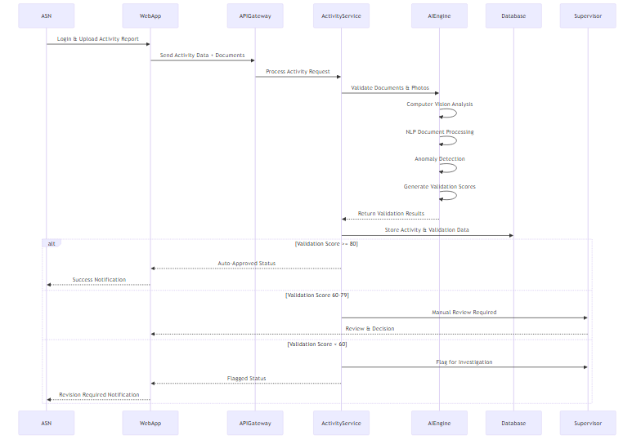

Fig. Diagram 3

2.3 Solusi AI yang Ditawarkan

2.3.1 Computer Vision untuk Validasi Visual

A. Arsitektur Model Computer Vision

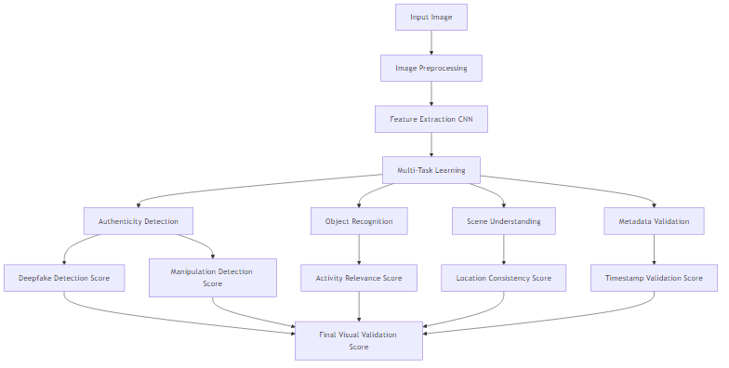

Fig. Diagram 4

B. Teknik AI yang Digunakan

**1. Deepfake Detection:**

* **EfficientNet-B7** untuk feature extraction
* **Temporal Consistency Analysis** untuk video sequences
* **Frequency Domain Analysis** untuk detecting manipulation artifacts
* **Ensemble Method** combining multiple detection approaches

**2. Activity Recognition:**

* **YOLO v8** untuk object detection
* **ResNet-50** untuk activity classification
* **Spatial-Temporal Networks** untuk understanding context
* **Custom Dataset** trained on Indonesian government activities

**3. Metadata Validation:**

# Pseudocode untuk Metadata Validation  
def validate_metadata(image_path, reported_data):  
 exif_data = extract_exif(image_path)  
  
 # Timestamp validation  
 timestamp_score = validate_timestamp(  
 exif_data.timestamp,   
 reported_data.activity_time  
 )  
  
 # GPS validation  
 gps_score = validate_location(  
 exif_data.gps_coordinates,  
 reported_data.activity_location  
 )  
  
 # Camera consistency  
 device_score = validate_device_consistency(  
 exif_data.camera_model,  
 user_profile.registered_devices  
 )  
  
 return {  
 'timestamp_score': timestamp_score,  
 'location_score': gps_score,  
 'device_score': device_score,  
 'overall_metadata_score': calculate_weighted_average()  
 }

2.3.2 Natural Language Processing untuk Analisis Dokumen

A. Arsitektur NLP Pipeline

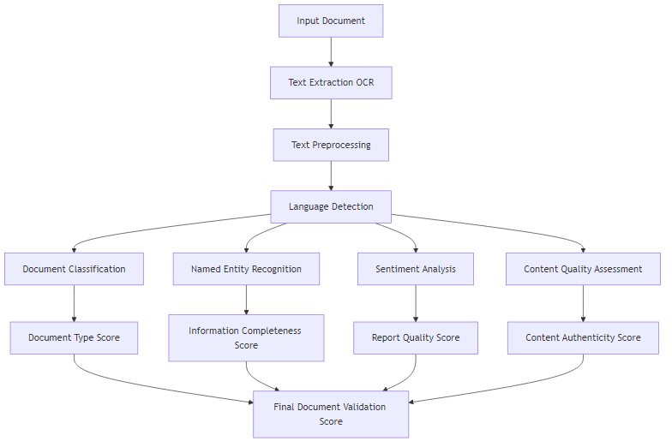

Fig. Diagram 5

B. Model AI untuk NLP

**1. Document Classification:**

* **IndoBERT** fine-tuned untuk Indonesian government documents
* **Multi-label Classification** untuk multiple document types
* **Confidence Scoring** untuk uncertain classifications

**2. Named Entity Recognition (NER):**

# Custom NER untuk Indonesian Government Context  
class GovernmentNER:  
 def __init__(self):  
 self.entities = {  
 'PERSON': ['nama_asn', 'nama_atasan', 'nama_peserta'],  
 'LOCATION': ['tempat_kegiatan', 'alamat', 'kota'],  
 'DATE': ['tanggal_kegiatan', 'deadline', 'periode'],  
 'MONEY': ['biaya', 'anggaran', 'honorarium'],  
 'ORGANIZATION': ['instansi', 'dinas', 'unit_kerja'],  
 'ACTIVITY': ['jenis_kegiatan', 'program', 'proyek']  
 }  
  
 def extract_entities(self, text):  
 # Implementation using spaCy with custom model  
 return extracted_entities  
  
 def validate_consistency(self, entities, reported_data):  
 # Cross-validate extracted entities with reported data  
 return consistency_score

**3. Content Quality Assessment:**

* **Readability Analysis** using Indonesian language metrics
* **Coherence Scoring** untuk logical flow assessment
* **Completeness Check** against required information template
* **Plagiarism Detection** using semantic similarity

2.3.3 Anomaly Detection untuk Monitoring Pola

A. Multi-dimensional Anomaly Detection

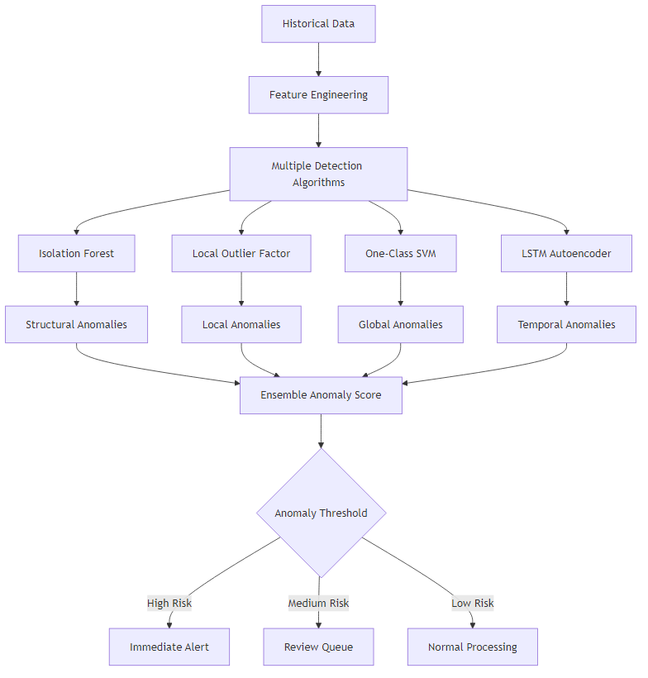

Fig. Diagram 6

B. Implementasi Anomaly Detection

**1. Temporal Pattern Analysis:**

class TemporalAnomalyDetector:  
 def __init__(self):  
 self.lstm_autoencoder = build_lstm_autoencoder()  
 self.seasonal_decompose = SeasonalDecompose()  
  
 def detect_time_anomalies(self, activity_data):  
 # Analyze working hour patterns  
 work_pattern = self.extract_work_patterns(activity_data)  
  
 # Detect unusual timing  
 reconstruction_error = self.lstm_autoencoder.predict(work_pattern)  
 anomaly_score = calculate_reconstruction_error(reconstruction_error)  
  
 # Seasonal analysis  
 seasonal_anomalies = self.seasonal_decompose.detect_anomalies(  
 activity_data.timestamps  
 )  
  
 return {  
 'temporal_anomaly_score': anomaly_score,  
 'seasonal_anomalies': seasonal_anomalies,  
 'pattern_consistency': self.calculate_consistency()  
 }

**2. Behavioral Pattern Analysis:**

* **Activity Frequency Analysis**
* **Location Pattern Recognition**
* **Collaboration Network Analysis**
* **Resource Usage Pattern Detection**

2.3.4 Integrated Scoring Engine

A. Multi-Criteria Decision Analysis (MCDA)

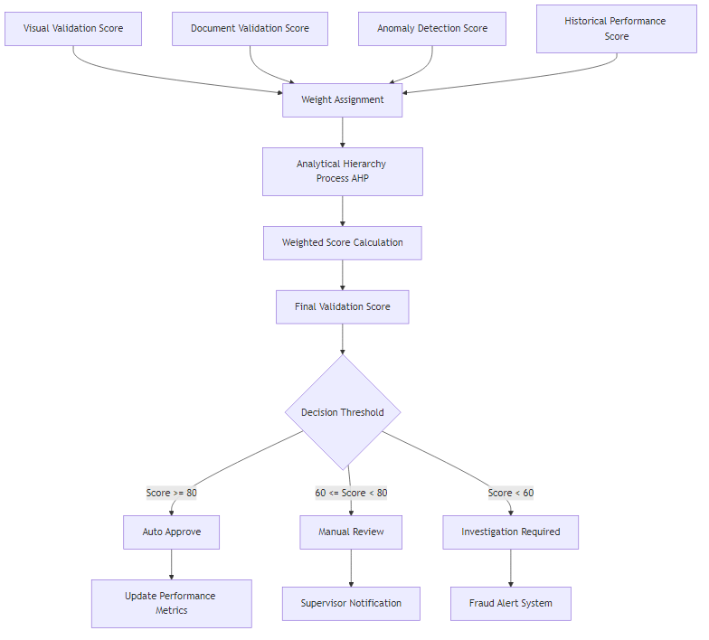

Fig. Diagram 7

B. Dynamic Scoring Algorithm

class DynamicScoringEngine:  
 def __init__(self):  
 self.weights = {  
 'visual_validation': 0.3,  
 'document_validation': 0.25,  
 'anomaly_detection': 0.2,  
 'historical_performance': 0.15,  
 'peer_comparison': 0.1  
 }  
 self.learning_rate = 0.01  
  
 def calculate_final_score(self, validation_results):  
 # Multi-criteria scoring  
 weighted_scores = []  
  
 for criterion, score in validation_results.items():  
 weight = self.weights.get(criterion, 0)  
 weighted_score = score * weight  
 weighted_scores.append(weighted_score)  
  
 final_score = sum(weighted_scores)  
  
 # Apply confidence interval  
 confidence = self.calculate_confidence(validation_results)  
 adjusted_score = final_score * confidence  
  
 # Dynamic weight adjustment based on feedback  
 self.update_weights(validation_results, feedback_data)  
  
 return {  
 'final_score': adjusted_score,  
 'confidence': confidence,  
 'breakdown': self.get_score_breakdown(validation_results)  
 }  
  
 def update_weights(self, results, feedback):  
 # Reinforcement learning untuk weight optimization  
 for criterion in self.weights:  
 if feedback.get('criterion_effectiveness', {}).get(criterion):  
 self.weights[criterion] += self.learning_rate  
 else:  
 self.weights[criterion] -= self.learning_rate  
  
 # Normalize weights  
 total_weight = sum(self.weights.values())  
 self.weights = {k: v/total_weight for k, v in self.weights.items()}

2.4 Workflow Sistem dan User Experience

2.4.1 Complete System Workflow

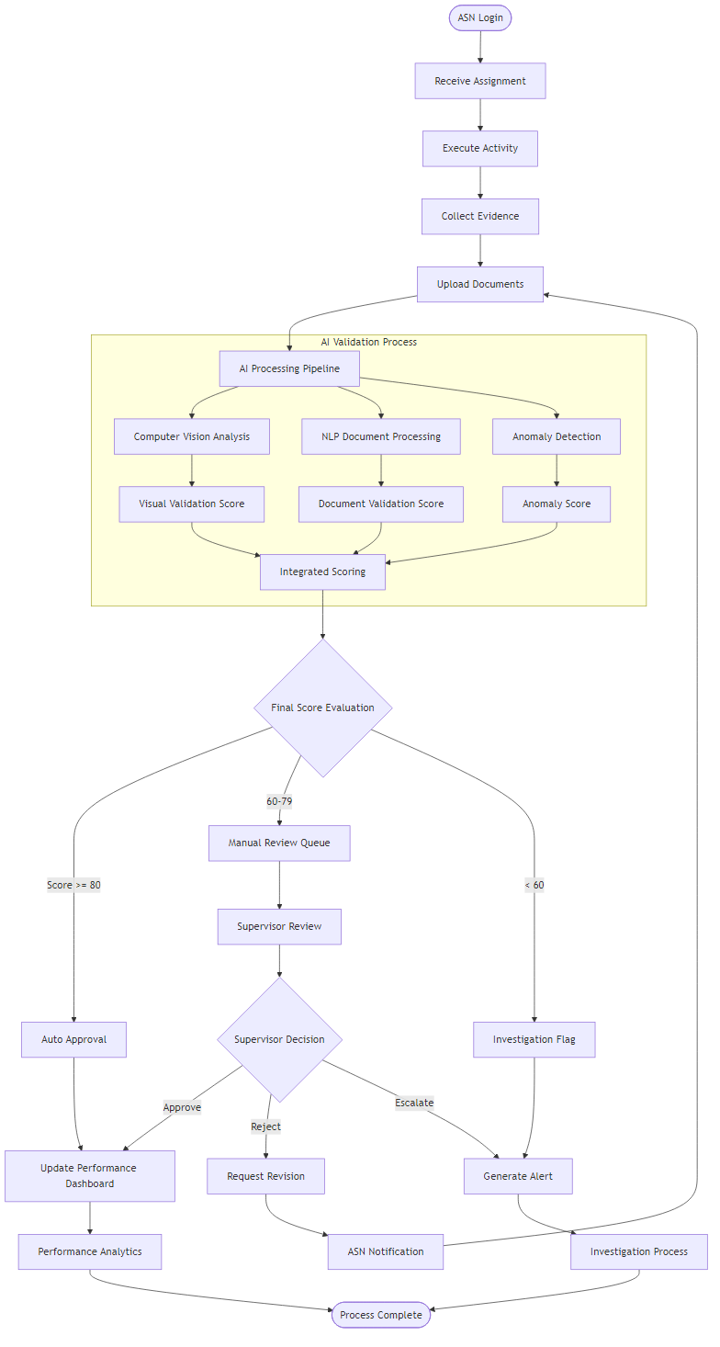

Fig. Diagram 8

2.4.2 User Interface Wireframes

A. ASN Dashboard Wireframe (Mockflow Compatible)

**Layout Structure:**

gambar 1

B. Supervisor Dashboard Wireframe (Mockflow Compatible)

**Layout Structure:** gambar 2

C. Management Analytics Dashboard (Mockflow Compatible)

**Layout Structure:**

gambar3

2.5 AI Model Training dan Optimization

2.5.1 Training Data Strategy

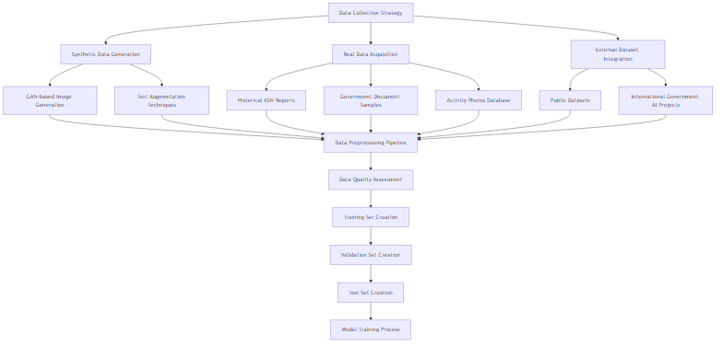

Fig. Diagram 9

2.5.2 Continuous Learning Framework

class ContinuousLearningFramework:  
 def __init__(self):  
 self.model_versions = {}  
 self.performance_metrics = {}  
 self.feedback_queue = []  
  
 def update_model_with_feedback(self, model_name, feedback_data):  
 """  
 Implement continuous learning dari user feedback  
 """  
 # Collect feedback  
 self.feedback_queue.append({  
 'model': model_name,  
 'feedback': feedback_data,  
 'timestamp': datetime.now()  
 })  
  
 # Retrain model jika feedback threshold tercapai  
 if len(self.feedback_queue) >= self.retrain_threshold:  
 self.trigger_model_retraining(model_name)  
  
 def model_performance_monitoring(self):  
 """  
 Monitor model performance dan trigger retraining jika perlu  
 """  
 for model_name, metrics in self.performance_metrics.items():  
 if metrics['accuracy'] < self.performance_threshold:  
 self.schedule_model_improvement(model_name)  
  
 def a_b_testing_framework(self, model_a, model_b, traffic_split=0.5):  
 """  
 A/B testing untuk model comparison  
 """  
 return {  
 'model_a_performance': self.evaluate_model(model_a),  
 'model_b_performance': self.evaluate_model(model_b),  
 'statistical_significance': self.calculate_significance(),  
 'recommendation': self.get_deployment_recommendation()  
 }

2.5.3 Model Interpretability dan Explainable AI

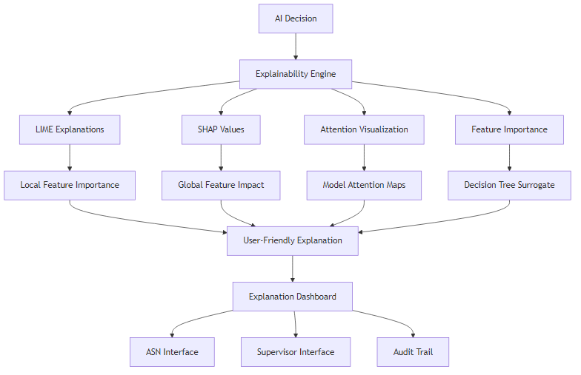

Fig. Diagram 10

2.6 Security dan Compliance Framework

2.6.1 Security Architecture



Fig. Diagram 11

2.6.2 Compliance dan Audit Framework

class ComplianceFramework:  
 def __init__(self):  
 self.regulations = [  
 'UU_ASN_2014',  
 'PP_30_2019',  
 'GDPR_EQUIVALENT',  
 'ISO_27001',  
 'SOC_2'  
 ]  
  
 def generate_audit_trail(self, action, user, timestamp, details):  
 """  
 Generate comprehensive audit trail  
 """  
 audit_entry = {  
 'action_id': generate_uuid(),  
 'action_type': action,  
 'user_id': user.id,  
 'user_role': user.role,  
 'timestamp': timestamp,  
 'ip_address': get_client_ip(),  
 'user_agent': get_user_agent(),  
 'details': details,  
 'hash': calculate_integrity_hash(),  
 'compliance_flags': self.check_compliance_requirements(action)  
 }  
  
 # Store dalam immutable audit database  
 self.store_audit_entry(audit_entry)  
  
 # Generate compliance report jika diperlukan  
 if self.requires_compliance_report(action):  
 self.generate_compliance_report(audit_entry)  
  
 def privacy_impact_assessment(self, data_processing_activity):  
 """  
 Assess privacy impact untuk data processing activities  
 """  
 return {  
 'risk_level': self.calculate_privacy_risk(data_processing_activity),  
 'mitigation_measures': self.suggest_privacy_measures(),  
 'compliance_status': self.check_privacy_compliance(),  
 'recommendations': self.generate_privacy_recommendations()  
 }

2.7 Performance Optimization dan Scalability

2.7.1 System Performance Architecture

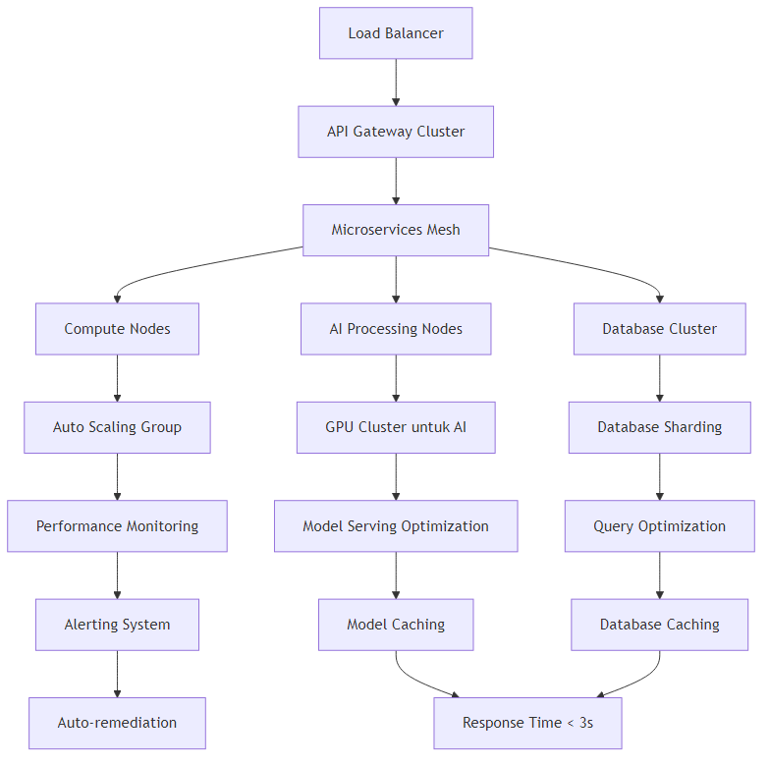

Fig. Diagram 12

2.7.2 Caching Strategy

class IntelligentCachingSystem:  
 def __init__(self):  
 self.cache_layers = {  
 'l1_memory': RedisCache(),  
 'l2_ssd': SSDCache(),  
 'l3_object': ObjectStorageCache()  
 }  
 self.cache_policies = {  
 'ai_models': {'ttl': 3600, 'layer': 'l1_memory'},  
 'user_data': {'ttl': 1800, 'layer': 'l2_ssd'},  
 'static_content': {'ttl': 86400, 'layer': 'l3_object'}  
 }  
  
 def intelligent_cache_decision(self, data_type, access_pattern):  
 """  
 AI-based caching decision  
 """  
 # Analyze access patterns  
 access_frequency = self.analyze_access_frequency(data_type)  
 data_size = self.calculate_data_size(data_type)  
 computation_cost = self.estimate_computation_cost(data_type)  
  
 # ML model untuk prediksi optimal caching strategy  
 optimal_strategy = self.cache_ml_model.predict([  
 access_frequency, data_size, computation_cost  
 ])  
  
 return {  
 'cache_layer': optimal_strategy['layer'],  
 'ttl': optimal_strategy['ttl'],  
 'eviction_policy': optimal_strategy['eviction']  
 }

2.8 Implementation Roadmap dan Testing Strategy

2.8.1 Phased Implementation Plan

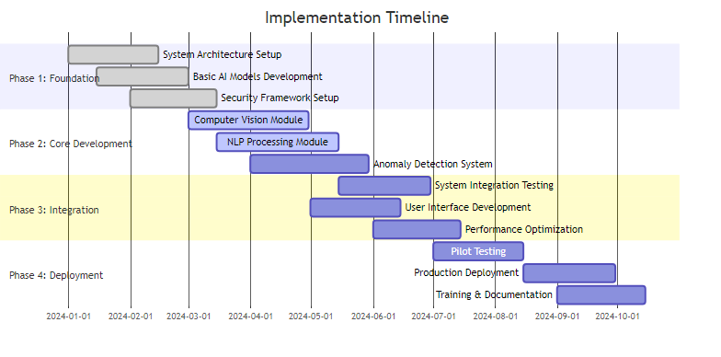

Fig. Diagram 13

2.8.2 Comprehensive Testing Framework



Fig. Diagram 14

2.9 Advanced AI Reasoning dan Decision Making

2.9.1 Multi-Agent AI System Architecture

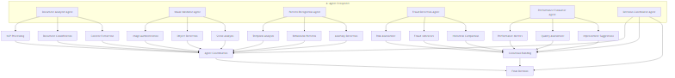

Fig. Diagram 15

2.9.2 Reasoning Engine Implementation

class AIReasoningEngine:  
 def __init__(self):  
 self.knowledge_base = GovernmentKnowledgeBase()  
 self.rule_engine = FuzzyLogicRuleEngine()  
 self.learning_module = ReinforcementLearningModule()  
  
 def multi_modal_reasoning(self, document_data, image_data, metadata):  
 """  
 Advanced reasoning yang menggabungkan multiple modalities  
 """  
 # Stage 1: Individual Analysis  
 doc_analysis = self.analyze_document_semantics(document_data)  
 img_analysis = self.analyze_visual_content(image_data)  
 meta_analysis = self.analyze_metadata_consistency(metadata)  
  
 # Stage 2: Cross-modal Validation  
 consistency_check = self.cross_modal_consistency_check(  
 doc_analysis, img_analysis, meta_analysis  
 )  
  
 # Stage 3: Contextual Reasoning  
 context_analysis = self.contextual_reasoning(  
 document_data, image_data, metadata,   
 self.knowledge_base.get_context()  
 )  
  
 # Stage 4: Decision Making with Uncertainty Quantification  
 decision = self.make_decision_with_uncertainty(  
 doc_analysis, img_analysis, meta_analysis,  
 consistency_check, context_analysis  
 )  
  
 return {  
 'decision': decision,  
 'confidence': decision.confidence,  
 'reasoning_path': decision.reasoning_steps,  
 'evidence': decision.supporting_evidence,  
 'uncertainty': decision.uncertainty_bounds  
 }  
  
 def contextual_reasoning(self, document, image, metadata, context):  
 """  
 Reasoning berdasarkan konteks pemerintahan Indonesia  
 """  
 # Government activity classification  
 activity_type = self.classify_government_activity(document, context)  
  
 # Compliance check dengan regulasi  
 compliance_status = self.check_regulatory_compliance(  
 activity_type, document, context  
 )  
  
 # Historical pattern matching  
 historical_patterns = self.match_historical_patterns(  
 activity_type, metadata, context  
 )  
  
 # Stakeholder impact analysis  
 stakeholder_impact = self.analyze_stakeholder_impact(  
 activity_type, document, context  
 )  
  
 return {  
 'activity_classification': activity_type,  
 'compliance_status': compliance_status,  
 'historical_alignment': historical_patterns,  
 'stakeholder_impact': stakeholder_impact,  
 'context_score': self.calculate_context_score()  
 }

2.9.3 Explainable AI Decision Framework

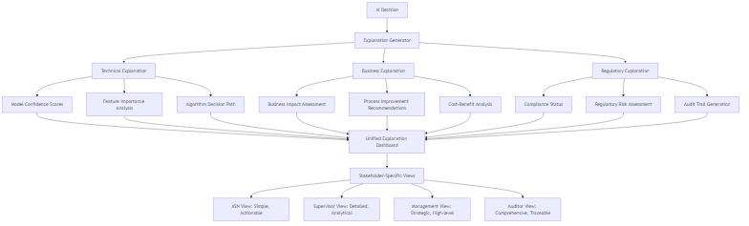

Fig. Diagram 16

2.10 Advanced User Experience Design

2.11 Quality Assurance dan Monitoring Framework

2.11.1 Real-time System Monitoring

class SystemMonitoringFramework:  
 def __init__(self):  
 self.metrics_collector = MetricsCollector()  
 self.anomaly_detector = SystemAnomalyDetector()  
 self.alert_manager = AlertManager()  
 self.dashboard = RealTimeDashboard()  
  
 def comprehensive_monitoring(self):  
 """  
 Comprehensive system monitoring dengan AI-powered insights  
 """  
 # Performance Metrics  
 performance_metrics = {  
 'response_time': self.measure_response_time(),  
 'throughput': self.measure_throughput(),  
 'error_rate': self.calculate_error_rate(),  
 'resource_utilization': self.monitor_resources()  
 }  
  
 # AI Model Performance  
 ai_metrics = {  
 'model_accuracy': self.evaluate_model_accuracy(),  
 'prediction_confidence': self.measure_prediction_confidence(),  
 'drift_detection': self.detect_model_drift(),  
 'bias_monitoring': self.monitor_model_bias()  
 }  
  
 # Business Metrics  
 business_metrics = {  
 'user_satisfaction': self.measure_user_satisfaction(),  
 'process_efficiency': self.calculate_process_efficiency(),  
 'fraud_detection_rate': self.measure_fraud_detection(),  
 'cost_savings': self.calculate_cost_impact()  
 }  
  
 # Integrated Health Score  
 health_score = self.calculate_system_health(  
 performance_metrics, ai_metrics, business_metrics  
 )  
  
 # Predictive Alerts  
 if self.anomaly_detector.predict_system_issues(health_score):  
 self.alert_manager.trigger_preventive_alerts()  
  
 return {  
 'health_score': health_score,  
 'performance': performance_metrics,  
 'ai_performance': ai_metrics,  
 'business_impact': business_metrics,  
 'recommendations': self.generate_optimization_recommendations()  
 }

2.11.2 Automated Quality Assurance Pipeline

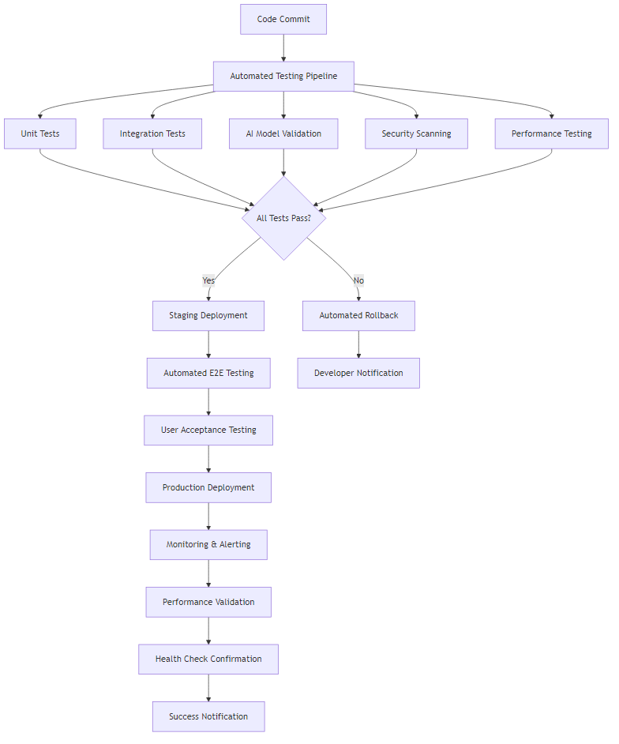

Fig. Diagram 17

Dengan metodologi dan solusi yang komprehensif ini, sistem akan mampu memberikan validasi yang akurat, efisien, dan dapat diandalkan untuk kegiatan ASN, sambil mempertahankan standar keamanan dan compliance yang tinggi.