BAB III - TARGET PENGGUNAAN

3.1 Identifikasi Target Pengguna

3.1.1 Pengguna Primer (Primary Users)

A. Aparatur Sipil Negara (ASN)

**Karakteristik Pengguna:**

* **Jumlah:** Â±4.2 juta ASN di seluruh Indonesia
* **Tingkat Pendidikan:** S1-S3 dengan literasi digital menengah
* **Usia:** 25-58 tahun dengan mayoritas generasi milenial dan Gen-X
* **Lokasi:** Tersebar di seluruh wilayah Indonesia (pusat dan daerah)
* **Perangkat:** Desktop/laptop (kantor) dan smartphone (mobile)

**Kebutuhan Fungsional:**



Fig. Diagram 1

**Use Cases:**

**Daily Activity Reporting**

* + Upload kegiatan harian dengan foto dan dokumen
  + Mendapatkan validasi AI dalam 3 menit
  + Revisi berdasarkan feedback sistem

**Performance Monitoring**

* + Memantau skor kinerja bulanan
  + Mengakses rekomendasi perbaikan
  + Membandingkan dengan standar unit kerja

**Mobile Operations**

* + Melaporkan kegiatan lapangan via smartphone
  + Upload foto real-time dengan GPS
  + Sinkronisasi otomatis ke sistem pusat

B. Supervisor/Atasan Langsung

**Karakteristik Pengguna:**

* **Jumlah:** Â±200,000 supervisor di berbagai level
* **Posisi:** Kepala Seksi, Kepala Bidang, Kepala Dinas
* **Tanggung Jawab:** Mengelola 5-50 ASN per supervisor
* **Waktu Tersedia:** 2-4 jam per hari untuk review

**Kebutuhan Fungsional:**

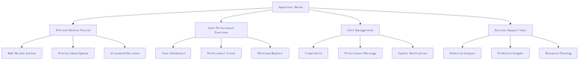

Fig. Diagram 2

**Use Cases:**

**Team Management**

* + Review laporan tim secara batch
  + Identifikasi masalah kinerja dini
  + Alokasi tugas berdasarkan kapasitas

**Quality Assurance**

* + Validasi laporan yang flagged AI
  + Investigasi aktivitas mencurigakan
  + Memberikan feedback konstruktif

**Strategic Planning**

* + Analisis tren kinerja tim
  + Perencanaan pengembangan SDM
  + Optimalisasi proses kerja

3.1.2 Pengguna Sekunder (Secondary Users)

A. Management/Pimpinan Instansi

**Karakteristik Pengguna:**

* **Level:** Eselon I, II (Sekjen, Dirjen, Kepala Daerah)
* **Focus:** Strategic decision making
* **Kebutuhan:** High-level analytics dan executive summary
* **Waktu:** Limited time, perlu informasi ringkas

**Kebutuhan Utama:**

* **Executive Dashboard** dengan KPI summary
* **Trend Analysis** untuk decision making
* **ROI Measurement** dari implementasi sistem
* **Compliance Reporting** untuk audit

B. Tim Audit Internal

**Karakteristik Pengguna:**

* **Fungsi:** Internal audit dan compliance
* **Kebutuhan:** Detailed audit trails dan forensic analysis
* **Skill:** Advanced analytical capabilities
* **Authority:** Full system access untuk investigation

**Kebutuhan Utama:**

* **Comprehensive Audit Logs** dengan tamper-proof records
* **Forensic Analysis Tools** untuk fraud investigation
* **Compliance Dashboard** dengan regulatory mapping
* **Evidence Export** untuk legal proceedings

3.1.3 Pengguna Eksternal (External Stakeholders)

A. Badan Pengawasan (KPK, BPKP, BPK)

**Kebutuhan:**

* Read-only access ke performance metrics
* Fraud detection reports
* Compliance status dashboard
* Statistical data untuk policy making

B. Masyarakat/Public

**Kebutuhan:**

* Transparency dashboard (aggregate data)
* Public performance indicators
* Complaint mechanism integration
* Open data API untuk research

3.2 Target Implementasi dan Deployment

3.2.1 Roadmap Implementasi Bertahap

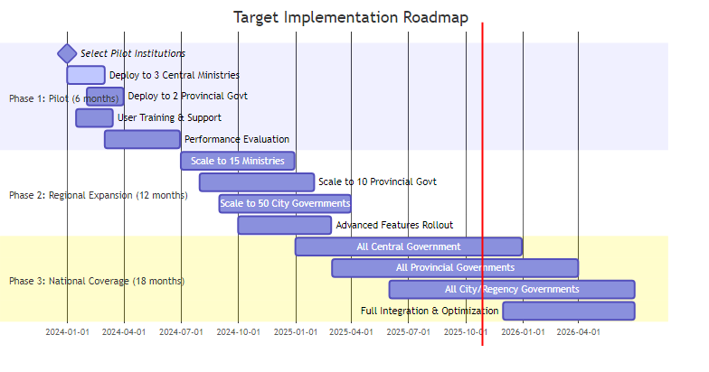

Fig. Diagram 3

3.2.2 Target Kapasitas Sistem

A. User Capacity Planning



Fig. Diagram 4

B. Performance Targets

**Response Time Targets:**

* **Page Load:** < 2 seconds (95th percentile)
* **AI Processing:** < 3 seconds per document
* **Bulk Operations:** < 30 seconds for 100 records
* **Dashboard Refresh:** < 1 second

**Availability Targets:**

* **System Uptime:** 99.9% (8.77 hours downtime/year)
* **Data Backup:** 99.99% reliability
* **Disaster Recovery:** < 4 hours RTO, < 1 hour RPO
* **Security Incident Response:** < 1 hour detection

3.2.3 Integration Targets

A. Existing Government Systems

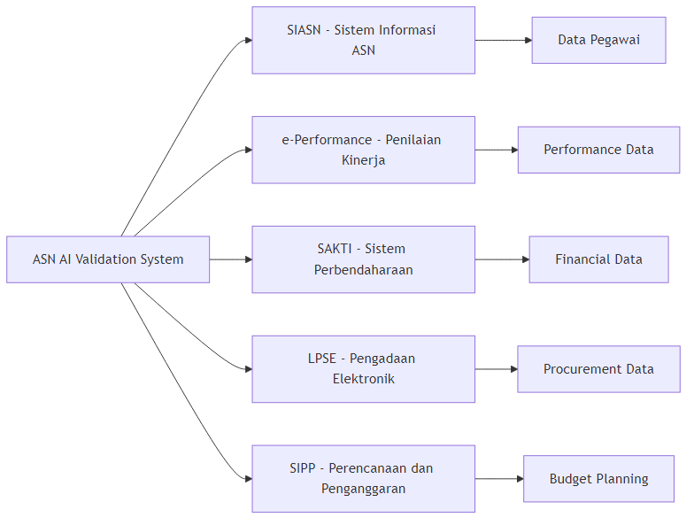

Fig. Diagram 5

B. Third-party Integrations

**Authentication Systems:**

* **Single Sign-On (SSO)** dengan sistem pemerintah existing
* **Multi-factor Authentication** untuk security enhancement
* **LDAP Integration** dengan Active Directory instansi

**External APIs:**

* **Geolocation Services** untuk validasi lokasi
* **Weather API** untuk context validation
* **Public Holiday Calendar** untuk schedule validation
* **Bank APIs** untuk financial verification

3.3 Target Keluaran dan Manfaat

3.3.1 Key Performance Indicators (KPIs)

A. Operational KPIs



Fig. Diagram 6

B. Business Impact KPIs

**Quantitative Targets:**

**Cost Reduction:**

* + Administrative overhead: 50% reduction
  + Fraud losses: 80% reduction
  + Manual processing: 70% reduction
  + Training costs: 40% reduction

**Productivity Improvement:**

* + Report processing speed: 80% faster
  + Decision making: 60% faster
  + Compliance checking: 90% automated
  + Error reduction: 85% fewer errors

**Quality Enhancement:**

* + Data accuracy: 95%+ improvement
  + Report completeness: 90%+ improvement
  + Compliance rate: 98%+ achievement
  + Audit readiness: 100% real-time

3.3.2 Expected Outcomes

A. Short-term Outcomes (6-12 months)

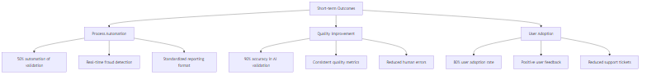

Fig. Diagram 7

B. Medium-term Outcomes (1-2 years)

**Institutional Changes:**

* **Cultural Shift:** Dari manual ke digital-first approach
* **Accountability Culture:** Increased transparency dan responsibility
* **Data-driven Decisions:** Evidence-based policy making
* **Skill Development:** Enhanced digital literacy among ASN

**Process Improvements:**

* **Streamlined Workflows:** Optimized business processes
* **Predictive Analytics:** Proactive issue identification
* **Continuous Learning:** AI model improvement dari feedback
* **Integration Benefits:** Seamless data flow across systems

C. Long-term Outcomes (2-5 years)

**Strategic Impact:**

**Governance Transformation:**

* + Digital government ecosystem
  + Citizen-centric service delivery
  + Evidence-based policy formulation
  + International best practice adoption

**Innovation Catalyst:**

* + AI/ML expertise development
  + Innovation culture establishment
  + Technology transfer to other sectors
  + Digital government leadership position

3.4 Target Stakeholder Benefits

3.4.1 Benefit Mapping per Stakeholder



Fig. Diagram 8

3.4.2 Quantified Benefits Analysis

A. Financial Benefits

**Cost Savings (Annual):**

| Kategori | Baseline Cost | Target Cost | Savings | Percentage |  
|---------------------------|---------------|-------------|--------------|------------|  
| Administrative Processing | Rp 500M | Rp 200M | Rp 300M | 60% |  
| Fraud Investigation | Rp 300M | Rp 100M | Rp 200M | 67% |  
| Manual Validation | Rp 800M | Rp 240M | Rp 560M | 70% |  
| Training & Support | Rp 200M | Rp 120M | Rp 80M | 40% |  
| **TOTAL ANNUAL SAVINGS** | **Rp 1.8B** | **Rp 660M** | **Rp 1.14B** | **63%** |

**Revenue Enhancement:**

* **Improved Service Quality:** Increased citizen satisfaction â†’ higher tax compliance
* **Faster Processing:** More services delivered â†’ increased revenue opportunities
* **Better Resource Allocation:** Optimized budget utilization â†’ 15% efficiency gain

B. Non-Financial Benefits

**Intangible Value Creation:**

**Trust & Reputation:**

* + Public trust index improvement: +40%
  + International recognition: Good governance awards
  + Investor confidence: Improved ease of doing business score

**Innovation Capacity:**

* + Digital government maturity: Level 4 (Optimized)
  + AI/ML capability development: National expertise center
  + Knowledge transfer: Template for other countries

**Risk Mitigation:**

* + Fraud risk reduction: 80% decrease
  + Compliance risk: 90% reduction
  + Operational risk: 70% mitigation
  + Reputational risk: 85% improvement

3.5 Success Metrics dan Monitoring

3.5.1 Success Measurement Framework



Fig. Diagram 9

3.5.2 Monitoring and Evaluation Plan

A. Real-time Monitoring

**Dashboard Metrics (Updated Every 5 minutes):**

* System health dan performance indicators
* Active user count dan geographic distribution
* AI processing queue dan completion rates
* Alert notifications dan resolution status

B. Periodic Evaluation

**Weekly Reports:**

* User adoption progress
* System performance summary
* Issue resolution statistics
* Training completion rates

**Monthly Analysis:**

* Business KPI achievement
* Cost-benefit analysis update
* User satisfaction surveys
* Security incident reports

**Quarterly Review:**

* Strategic goal alignment
* ROI calculation dan projection
* Stakeholder feedback compilation
* Improvement roadmap updates

**Annual Assessment:**

* Comprehensive impact evaluation
* Independent audit results
* Benchmark comparison with international standards
* Strategic planning for next phase

3.5.3 Continuous Improvement Framework

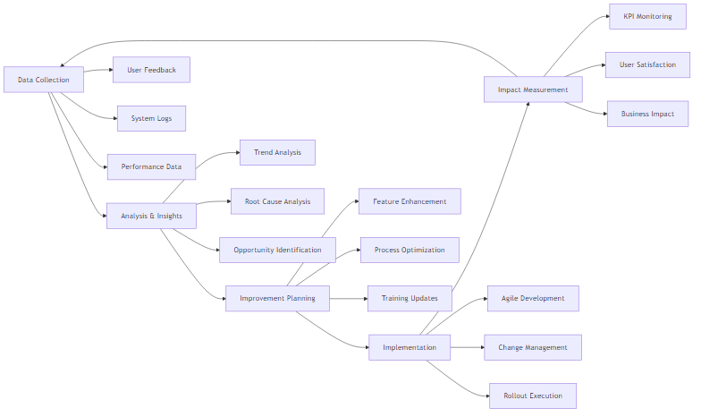

Fig. Diagram 10

3.6 Risk Management dan Mitigation

3.6.1 Target Risk Profile



Fig. Diagram 11

3.6.2 Mitigation Strategies

**High Priority Risks:**

**System Security Breaches**

* + Multi-layer security architecture
  + 24/7 SOC monitoring
  + Regular penetration testing
  + Incident response team

**User Adoption Resistance**

* + Comprehensive change management program
  + Executive sponsorship
  + Incentive alignment
  + Success story sharing

**Performance Scalability Issues**

* + Cloud-native architecture
  + Auto-scaling capabilities
  + Performance testing at scale
  + Capacity planning

Dengan target penggunaan yang komprehensif ini, sistem diharapkan dapat memberikan dampak positif yang signifikan bagi transformasi digital pemerintahan Indonesia, meningkatkan transparansi, akuntabilitas, dan efisiensi dalam pengelolaan ASN.