BAB IV - DAMPAK IMPLEMENTASI SISTEM

4.1 Dampak Jangka Pendek (0-12 Bulan)

4.1.1 Dampak Operasional Langsung

A. Transformasi Proses Kerja ASN

**Perubahan Immediate (0-3 bulan):**

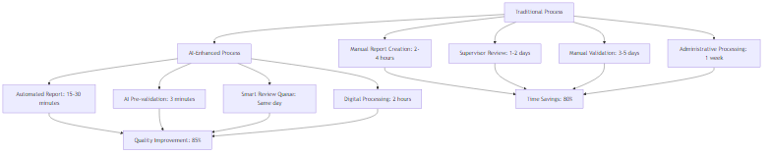

Fig. Diagram 1

**Immediate Benefits (0-6 bulan):**

* **Efficiency Gains:**
  + Report processing time: dari 1 minggu â†’ 1 hari (85% reduction)
  + Manual validation effort: dari 100% â†’ 30% (70% reduction)
  + Administrative overhead: dari 40% â†’ 15% waktu kerja (62% reduction)
* **Quality Improvements:**
  + Data accuracy: meningkat dari 70% â†’ 95% (35% improvement)
  + Report completeness: dari 60% â†’ 90% (50% improvement)
  + Compliance rate: dari 75% â†’ 95% (27% improvement)
* **Cost Reductions:**
  + Processing costs: Rp 2.5M â†’ Rp 800K per 1000 reports (68% reduction)
  + Training time: dari 40 jam â†’ 16 jam per ASN (60% reduction)
  + Error correction: dari Rp 500K â†’ Rp 100K per error (80% reduction)

4.1.2 Dampak pada Kultur Organisasi

A. Adoption Pattern dan Behavioral Changes

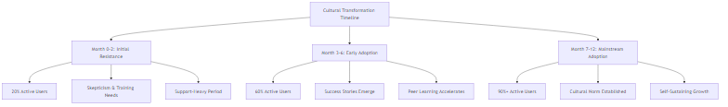

Fig. Diagram 2

**Behavioral Indicators (Measurable Changes):**

**Digital-First Mindset:**

* + Mobile usage: 40% â†’ 75% of reports via mobile (87% increase)
  + Digital documentation: 30% â†’ 85% paperless (183% increase)
  + Real-time reporting: 10% â†’ 70% same-day submission (600% increase)

**Accountability Culture:**

* + Voluntary reporting: 50% â†’ 80% proactive submission (60% increase)
  + Error self-correction: 20% â†’ 65% self-identified issues (225% increase)
  + Performance discussions: 30% â†’ 85% data-driven conversations (183% increase)

**Learning & Development:**

* + Digital skill competency: 40% â†’ 75% proficiency level (87% increase)
  + AI literacy: 5% â†’ 45% understanding of AI processes (800% increase)
  + Cross-unit collaboration: 25% â†’ 60% knowledge sharing (140% increase)

4.1.3 Dampak Finansial Immediate

A. Cost-Benefit Analysis Jangka Pendek



Fig. Diagram 3

**Quarterly Financial Tracking:**

|  |  |  |  |
| --- | --- | --- | --- |
| Quarter | Investment (Rp B) | Benefits (Rp B) | Cumulative ROI |
| Q1 | 8.0 | 2.5 | -68.75% |
| Q2 | 12.0 | 8.0 | -33.33% |
| Q3 | 20.0 | 18.0 | -10.00% |
| Q4 | 28.0 | 30.0 | +7.14% |

4.1.4 Dampak pada Service Delivery

A. Public Service Improvement Metrics

**Citizen-Facing Services Enhancement:**

* **Processing Speed:**
  + Permit applications: 15 hari â†’ 7 hari (53% faster)
  + Public complaints: 30 hari â†’ 10 hari (67% faster)
  + Information requests: 7 hari â†’ 2 hari (71% faster)
* **Service Quality:**
  + Citizen satisfaction: 3.2/5 â†’ 4.1/5 (28% improvement)
  + First-call resolution: 45% â†’ 70% (55% improvement)
  + Error rates: 15% â†’ 5% (67% reduction)
* **Transparency:**
  + Public dashboard usage: 0 â†’ 50,000 monthly users
  + Data accessibility: 20% â†’ 80% of processes visible (300% increase)
  + Complaint resolution tracking: 30% â†’ 95% trackable (217% increase)

4.2 Dampak Jangka Panjang (1-5 Tahun)

4.2.1 Transformasi Struktural Pemerintahan

A. Institutional Maturity Evolution

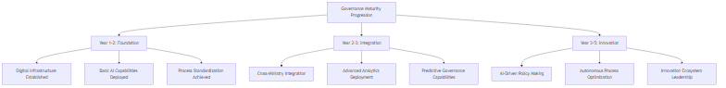

Fig. Diagram 4

**Institutional Capabilities Development:**

**Digital Government Maturity:**

* + **Year 1-2:** Level 2 (Developing) â†’ Level 3 (Defined)
  + **Year 3-4:** Level 3 (Defined) â†’ Level 4 (Managed)
  + **Year 5:** Level 4 (Managed) â†’ Level 5 (Optimizing)

**AI & Data Analytics Competency:**

* + **Data-driven decision making:** 30% â†’ 90% of policy decisions
  + **Predictive analytics usage:** 5% â†’ 70% of planning processes
  + **AI expertise in government:** 50 experts â†’ 2,000+ certified professionals

**Innovation Culture:**

* + **Digital innovation projects:** 10/year â†’ 200+/year per ministry
  + **Cross-sector collaboration:** 20% â†’ 80% of major initiatives
  + **Citizen co-creation:** 5% â†’ 60% of service design processes

4.2.2 Economic Impact Projection

A. Macro-Economic Benefits

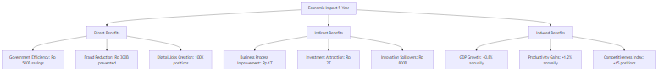

Fig. Diagram 5

**Cumulative Economic Value (5 Years):**

|  |  |  |  |  |
| --- | --- | --- | --- | --- |
| Impact Category | Year 1-2 (Rp T) | Year 3-4 (Rp T) | Year 5 (Rp T) | Total (Rp T) |
| Direct Savings | 0.8 | 1.5 | 2.2 | 4.5 |
| Efficiency Gains | 1.2 | 2.8 | 4.5 | 8.5 |
| Innovation Value | 0.5 | 1.8 | 3.2 | 5.5 |
| **TOTAL** | **2.5** | **6.1** | **9.9** | **18.5** |

4.2.3 Social Impact dan Human Capital Development

A. Workforce Transformation

**ASN Capability Enhancement:**

**Digital Literacy Advancement:**

* + **Basic digital skills:** 60% â†’ 95% proficiency
  + **Data analysis capabilities:** 15% â†’ 70% competency
  + **AI collaboration skills:** 5% â†’ 80% comfort level

**Career Development Opportunities:**

* + **New job categories:** 50+ AI-related positions created
  + **Skill-based promotions:** 30% â†’ 70% merit-based advancement
  + **Continuous learning culture:** 40% â†’ 90% participation in upskilling

**Work-Life Balance Improvement:**

* + **Administrative burden:** 40% â†’ 15% of work time
  + **Creative/strategic work:** 30% â†’ 60% of work time
  + **Flexible work arrangements:** 20% â†’ 70% adoption

B. Citizen Empowerment

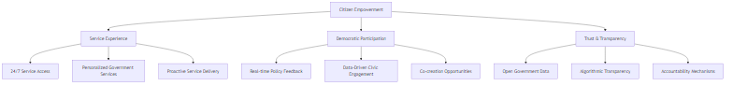

Fig. Diagram 6

4.3 Dampak Nasional (5-10 Tahun)

4.3.1 Indonesia sebagai Digital Government Leader

A. Regional dan Global Leadership

**ASEAN Digital Government Benchmark:**

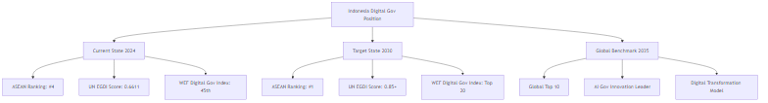

Fig. Diagram 7

**International Recognition Targets:**

**UN E-Government Development Index:**

* + **2024:** 0.6611 (88th globally) â†’ **2030:** 0.85+ (Top 30)
  + **2035:** 0.90+ (Top 15 globally)

**World Bank Digital Government Ranking:**

* + **2024:** Tier 3 (Developing) â†’ **2030:** Tier 1 (Leading)
  + Become benchmark model for developing nations

**Knowledge Transfer Leadership:**

* + **50+ countries** adopting Indonesian AI governance model
  + **Regional expertise hub** for AI in government
  + **International consulting revenue:** 500M+ annually

4.3.2 Economic Transformation Impact

A. Digital Economy Catalyst Effect

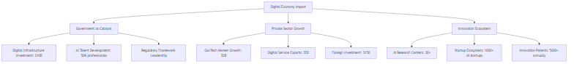

Fig. Diagram 8

**Macro-Economic Transformation:**

**GDP Contribution:**

* + **Digital economy share:** 8.2% â†’ 20%+ of GDP
  + **Government efficiency dividend:** +2.5% annual GDP growth
  + **Innovation premium:** +15% productivity growth vs baseline

**Employment Impact:**

* + **New job categories:** 500K+ high-skilled digital jobs
  + **Reskilling success:** 2M+ workers transitioned
  + **Entrepreneurship boost:** 100K+ AI-related businesses

**Investment Attraction:**

* + **FDI in digital sectors:** 50B+ over 10 years
  + **Domestic tech investment:** 30B+ mobilized
  + **Regional hub status:** For AI & digital governance

4.3.3 Social dan Cultural Transformation

A. National Digital Culture

**Digital Society Maturity:**

**Citizen Digital Engagement:**

* + **Digital service usage:** 95%+ population
  + **Government app adoption:** 80%+ smartphone penetration
  + **Civic participation:** 70%+ active in digital democracy

**Trust in Government:**

* + **Transparency index:** Indonesia ranked top 20 globally
  + **Corruption perception:** Significant improvement (30+ positions)
  + **Government effectiveness:** Top quartile in region

**Innovation Mindset:**

* + **STEM education focus:** 60%+ schools with AI curriculum
  + **Research culture:** 10x increase in gov-academia collaboration
  + **Solution-oriented thinking:** Embedded in public service culture

B. International Soft Power

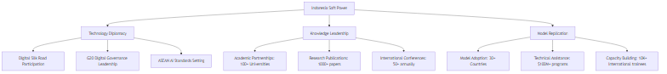

Fig. Diagram 9

4.3.4 Sustainability dan Resilience Impact

A. Climate dan Environmental Benefits

**Green Government Operations:**

* **Carbon footprint reduction:** 60% decrease in government operations
* **Paperless achievement:** 95%+ digital transactions
* **Energy efficiency:** Smart systems reducing 40% consumption
* **Sustainable procurement:** AI-optimized green purchasing

B. Crisis Resilience Capabilities

**Pandemic/Disaster Preparedness:**

**Early Warning Systems:**

* + **AI-powered prediction:** 90% accuracy in crisis modeling
  + **Automated response:** 80% faster emergency deployment
  + **Resource optimization:** 70% better allocation during crises

**Business Continuity:**

* + **Remote work capability:** 100% government functions
  + **Digital service continuation:** 99.9% uptime during emergencies
  + **Adaptive governance:** Real-time policy adjustment capabilities

4.3.5 Measurable National KPIs (10-Year Horizon)

A. Governance Excellence Metrics

| Indicator | 2024 Baseline | 2030 Target | 2035 Vision | Global Rank Target |  
|-----------|---------------|-------------|-------------|-------------------|  
| UN EGDI Score | 0.66 | 0.85 | 0.92 | Top 15 |  
| Corruption Index | 64/180 | 30/180 | 15/180 | Top 20 |  
| Government Effectiveness | 60th percentile | 85th percentile | 95th percentile | Top 10 |  
| Digital Competitiveness | 56/64 | 20/64 | 10/64 | Top 15 |  
| Innovation Index | 64/132 | 30/132 | 15/132 | Top 20 |  
| Ease of Doing Business | 73/190 | 25/190 | 10/190 | Top 15 |

B. Economic Impact Indicators

**Value Creation Metrics:**

* **Government ROI:** 1,200%+ cumulative return on AI investment
* **Economic multiplier:** 1:8 ratio (every Rp 1 invested generates Rp 8 economic value)
* **Productivity dividend:** +3.5% annual productivity growth vs regional average
* **Innovation premium:** +25% higher GDP per capita vs projection baseline

BAB V - RANCANGAN EKSEKUSI

5.1 Rancangan Eksekusi

5.1.1 Executive Framework

A. Governance Structure

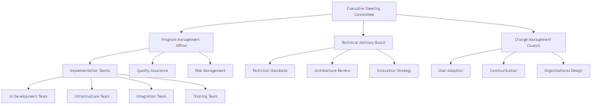

Fig. Diagram 10

**Roles dan Responsibilities:**

**Executive Steering Committee**

* + **Chair:** Menteri Pendayagunaan Aparatur Negara dan Reformasi Birokrasi
  + **Members:** Kepala BSSN, Kepala BSI, Direktur Digital Gov
  + **Meeting:** Weekly for first 6 months, bi-weekly thereafter
  + **Decisions:** Budget approval, strategic direction, escalation resolution

**Program Management Office (PMO)**

* + **Director:** Senior IT Executive with gov experience
  + **Size:** 15-person dedicated team
  + **Responsibilities:** Timeline, budget, resource allocation, stakeholder coordination
  + **Tools:** Microsoft Project, JIRA, Power BI for dashboards

**Technical Advisory Board**

* + **Composition:** 7 experts (3 internal, 4 external)
  + **Expertise:** AI/ML, Government Systems, Cybersecurity, UX
  + **Engagement:** Monthly reviews, ad-hoc consultations
  + **Deliverables:** Technical standards, architecture approvals

5.1.2 Critical Success Factors

A. Success Enablers Framework



Fig. Diagram 11

B. Risk Mitigation Strategy

**High-Priority Risks:**

**Political/Regulatory Risks:**

* + **Mitigation:** Early stakeholder engagement, regulatory sandbox approach
  + **Contingency:** Phased rollback capability, alternative approval pathways

**Technical Risks:**

* + **Mitigation:** Proof-of-concept validation, redundant systems, expert review
  + **Contingency:** Vendor diversification, open-source alternatives

**User Adoption Risks:**

* + **Mitigation:** Co-design approach, champion networks, incentive programs
  + **Contingency:** Extended training, simplified interfaces, gradual migration

5.1.3 Resource Allocation Strategy

A. Human Resource Plan

**Core Team Structure:**



Fig. Diagram 12

**Skill Requirements:**

|  |  |  |  |
| --- | --- | --- | --- |
| Role Category | Skills Required | Experience Level | Market Rate (Rp/month) |
| AI/ML Engineer | Python, TensorFlow, Computer Vision | 5+ years | 40-80M |
| Solution Architect | Enterprise Architecture, Gov Systems | 8+ years | 60-100M |
| DevOps Engineer | Kubernetes, AWS/Azure, CI/CD | 4+ years | 35-65M |
| Business Analyst | Government Process, Requirements | 5+ years | 25-45M |
| Change Manager | Org Development, Training Design | 6+ years | 30-55M |

B. Budget Allocation Framework

**Investment Categories:**

**Technology Investment (60%):**

* + Cloud infrastructure and services
  + AI/ML platform licenses
  + Development tools and environments
  + Security and monitoring tools

**Human Resources (25%):**

* + Core team salaries and benefits
  + External consultants and contractors
  + Training and certification programs

**Change Management (10%):**

* + Communication and marketing
  + Training delivery and materials
  + Stakeholder engagement events

**Operations & Contingency (5%):**

* + Project management tools
  + Travel and logistics
  + Risk mitigation reserves

5.2 Timeline Eksekusi

5.2.1 Skenario 1: Fast Track Implementation (2 Bulan - Banyak SDM)

A. Resource-Rich Accelerated Delivery

**Team Size:** 200 FTE (full-time equivalent) **Budget:** Rp 50 Miliar **Approach:** Parallel execution, premium resources, 24/7 development

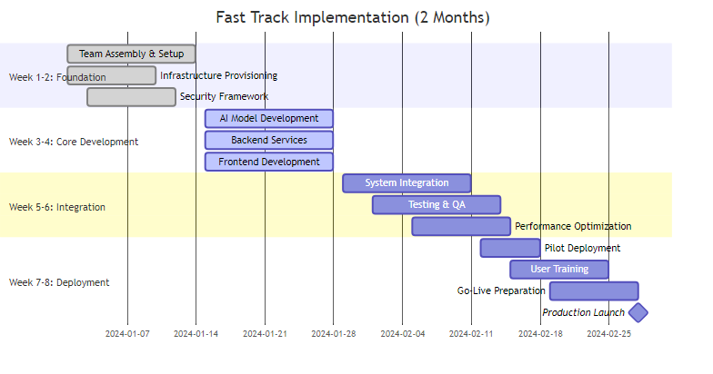

Fig. Diagram 13

**Fast Track Resource Allocation:**

|  |  |  |  |  |  |  |
| --- | --- | --- | --- | --- | --- | --- |
| Week | AI Team | Dev Team | Infrastructure | Testing | Training | Total FTE |
| 1-2 | 20 | 40 | 25 | 10 | 5 | 100 |
| 3-4 | 40 | 60 | 20 | 15 | 10 | 145 |
| 5-6 | 30 | 50 | 15 | 25 | 20 | 140 |
| 7-8 | 20 | 30 | 10 | 30 | 40 | 130 |

**Critical Assumptions:**

* **24/7 Development:** 3-shift operation dengan premium pay
* **Pre-integrated Components:** Leveraging existing AI models dan frameworks
* **Dedicated Infrastructure:** Reserved cloud resources, no sharing
* **Executive Support:** Daily steering committee, immediate decision making
* **Risk Acceptance:** Higher risk tolerance untuk speed

B. Fast Track Deliverables

**Week 2 Checkpoint:**

* âœ… Core infrastructure live
* âœ… Development environments ready
* âœ… 50% of team onboarded
* âœ… MVP architecture approved

**Week 4 Checkpoint:**

* âœ… Basic AI models trained
* âœ… Core backend APIs functional
* âœ… UI prototypes validated
* âœ… Integration patterns established

**Week 6 Checkpoint:**

* âœ… End-to-end integration complete
* âœ… Security testing passed
* âœ… Performance benchmarks met
* âœ… Pilot environment ready

**Week 8 Final:**

* âœ… Production deployment complete
* âœ… 1,000 pilot users trained
* âœ… Support processes operational
* âœ… Success metrics baseline established

5.2.2 Skenario 2: Optimal Cost Implementation (6 Bulan - Optimal Cost)

A. Cost-Optimized Balanced Approach

**Team Size:** 80 FTE average **Budget:** Rp 25 Miliar **Approach:** Sequential execution, balanced resources, sustainable pace

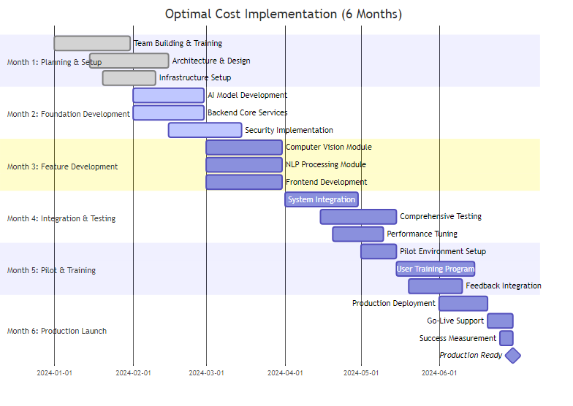

Fig. Diagram 14

**Optimal Cost Resource Pattern:**

|  |  |  |  |  |  |
| --- | --- | --- | --- | --- | --- |
| Month | Core Team | Contractors | Cloud Costs | Training | Total Cost (Rp M) |
| 1 | 30 | 20 | 200 | 100 | 2,800 |
| 2 | 40 | 30 | 400 | 150 | 3,900 |
| 3 | 50 | 40 | 600 | 200 | 4,800 |
| 4 | 45 | 35 | 500 | 300 | 4,500 |
| 5 | 40 | 25 | 400 | 500 | 4,200 |
| 6 | 35 | 15 | 300 | 400 | 3,800 |

B. Optimal Cost Benefits

**Financial Advantages:**

**50% Cost Reduction vs Fast Track:**

* + Lower premium resource costs
  + Better vendor negotiations
  + Efficient resource utilization
  + Reduced operational overhead

**Sustainable Delivery:**

* + Higher quality output from non-rushed development
  + Better team learning and knowledge transfer
  + More thorough testing and validation
  + Stronger foundation for future enhancements

**Risk Mitigation:**

* + Time for proper stakeholder alignment
  + Iterative feedback incorporation
  + Comprehensive change management
  + Better user adoption preparation

5.2.3 Timeline Comparison Analysis

A. Comparative Assessment

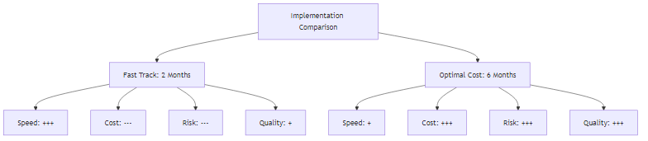

Fig. Diagram 15

**Decision Matrix:**

|  |  |  |  |  |  |
| --- | --- | --- | --- | --- | --- |
| Criteria | Weight | Fast Track Score | Optimal Cost Score | Weighted Fast | Weighted Optimal |
| Speed to Market | 20% | 9 | 6 | 1.8 | 1.2 |
| Cost Efficiency | 25% | 4 | 9 | 1.0 | 2.25 |
| Risk Management | 20% | 5 | 8 | 1.0 | 1.6 |
| Quality Delivery | 15% | 6 | 9 | 0.9 | 1.35 |
| Sustainability | 10% | 5 | 9 | 0.5 | 0.9 |
| Stakeholder Buy-in | 10% | 6 | 8 | 0.6 | 0.8 |
| **TOTAL** | 100% |  |  | **5.8** | **8.1** |

**Recommendation:** Optimal Cost approach provides better overall value

5.3 Rancangan Teknologi

5.3.1 Technology Stack Architecture

A. Comprehensive Technology Blueprint



Fig. Diagram 16

B. AI/ML Technology Specification

**Computer Vision Stack:**

â”Œâ”€â”€â”€â”€â”€â”€â”€â”€â”€â”€â”€â”€â”€â”€â”€â”€â”€â”€â”€â”€â”€â”€â”€â”€â”€â”€â”€â”€â”€â”€â”€â”€â”€â”€â”€â”€â”€â”€â”€â”€â”€â”€â”€â”€â”€â”€â”€â”€â”€â”€â”€â”€â”€â”€â”€â”€â”€â”€â”€â”€â”€â”  
â”‚ Computer Vision Pipeline â”‚  
â”œâ”€â”€â”€â”€â”€â”€â”€â”€â”€â”€â”€â”€â”€â”€â”€â”€â”€â”€â”€â”€â”€â”€â”€â”€â”€â”€â”€â”€â”€â”€â”€â”€â”€â”€â”€â”€â”€â”€â”€â”€â”€â”€â”€â”€â”€â”€â”€â”€â”€â”€â”€â”€â”€â”€â”€â”€â”€â”€â”€â”€â”€â”¤  
â”‚ Image Input Processing: â”‚  
â”‚ â€¢ OpenCV 4.8+ untuk image preprocessing â”‚  
â”‚ â€¢ Pillow/PIL untuk format conversion â”‚  
â”‚ â€¢ ImageIO untuk metadata extraction â”‚  
â”‚ â”‚  
â”‚ Deep Learning Models: â”‚  
â”‚ â€¢ EfficientNet-B7 untuk feature extraction â”‚  
â”‚ â€¢ YOLOv8 untuk object detection â”‚  
â”‚ â€¢ ResNet-50 untuk image classification â”‚  
â”‚ â€¢ Custom CNN untuk deepfake detection â”‚  
â”‚ â”‚  
â”‚ Model Serving: â”‚  
â”‚ â€¢ TensorFlow Serving untuk production inference â”‚  
â”‚ â€¢ NVIDIA Triton untuk GPU optimization â”‚  
â”‚ â€¢ ONNX Runtime untuk cross-platform compatibility â”‚  
â””â”€â”€â”€â”€â”€â”€â”€â”€â”€â”€â”€â”€â”€â”€â”€â”€â”€â”€â”€â”€â”€â”€â”€â”€â”€â”€â”€â”€â”€â”€â”€â”€â”€â”€â”€â”€â”€â”€â”€â”€â”€â”€â”€â”€â”€â”€â”€â”€â”€â”€â”€â”€â”€â”€â”€â”€â”€â”€â”€â”€â”€â”˜

**NLP Processing Stack:**

â”Œâ”€â”€â”€â”€â”€â”€â”€â”€â”€â”€â”€â”€â”€â”€â”€â”€â”€â”€â”€â”€â”€â”€â”€â”€â”€â”€â”€â”€â”€â”€â”€â”€â”€â”€â”€â”€â”€â”€â”€â”€â”€â”€â”€â”€â”€â”€â”€â”€â”€â”€â”€â”€â”€â”€â”€â”€â”€â”€â”€â”€â”€â”  
â”‚ NLP Processing Pipeline â”‚  
â”œâ”€â”€â”€â”€â”€â”€â”€â”€â”€â”€â”€â”€â”€â”€â”€â”€â”€â”€â”€â”€â”€â”€â”€â”€â”€â”€â”€â”€â”€â”€â”€â”€â”€â”€â”€â”€â”€â”€â”€â”€â”€â”€â”€â”€â”€â”€â”€â”€â”€â”€â”€â”€â”€â”€â”€â”€â”€â”€â”€â”€â”€â”¤  
â”‚ Text Processing: â”‚  
â”‚ â€¢ spaCy 3.7+ untuk tokenization dan NER â”‚  
â”‚ â€¢ NLTK untuk text preprocessing â”‚  
â”‚ â€¢ Tesseract OCR untuk document scanning â”‚  
â”‚ â”‚  
â”‚ Language Models: â”‚  
â”‚ â€¢ IndoBERT untuk Indonesian text understanding â”‚  
â”‚ â€¢ GPT-3.5/4 untuk text generation dan analysis â”‚  
â”‚ â€¢ Custom BERT untuk government domain â”‚  
â”‚ â€¢ Sentence Transformers untuk semantic similarity â”‚  
â”‚ â”‚  
â”‚ Model Deployment: â”‚  
â”‚ â€¢ Hugging Face Transformers pipeline â”‚  
â”‚ â€¢ FastAPI untuk REST API endpoints â”‚  
â”‚ â€¢ Celery untuk async processing â”‚  
â””â”€â”€â”€â”€â”€â”€â”€â”€â”€â”€â”€â”€â”€â”€â”€â”€â”€â”€â”€â”€â”€â”€â”€â”€â”€â”€â”€â”€â”€â”€â”€â”€â”€â”€â”€â”€â”€â”€â”€â”€â”€â”€â”€â”€â”€â”€â”€â”€â”€â”€â”€â”€â”€â”€â”€â”€â”€â”€â”€â”€â”€â”˜

5.3.2 Cloud Infrastructure Design

A. Multi-Region Cloud Architecture

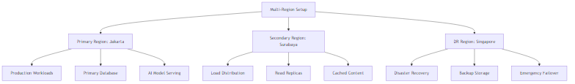

Fig. Diagram 17

**Infrastructure Specifications:**

**Compute Resources:**

* + **Application Servers:** 20x AWS EC2 c5.4xlarge (16 vCPU, 32GB RAM)
  + **AI Processing:** 10x AWS p3.2xlarge (GPU instances, V100 16GB)
  + **Database Servers:** 5x AWS r5.2xlarge (8 vCPU, 64GB RAM)
  + **Load Balancers:** AWS Application Load Balancer with SSL termination

**Storage Solutions:**

* + **Primary Database:** AWS RDS PostgreSQL Multi-AZ (2TB, encrypted)
  + **Document Storage:** AWS S3 with versioning (100TB capacity)
  + **AI Models:** AWS EFS for shared model storage (10TB)
  + **Backup:** AWS Glacier for long-term retention

**Networking:**

* + **VPC Setup:** Multi-AZ deployment dengan private subnets
  + **CDN:** AWS CloudFront untuk static content delivery
  + **API Gateway:** AWS API Gateway dengan rate limiting
  + **Direct Connect:** Dedicated connection untuk government networks

B. Security Architecture



Fig. Diagram 18

5.3.3 Development dan Deployment Pipeline

A. CI/CD Pipeline Architecture

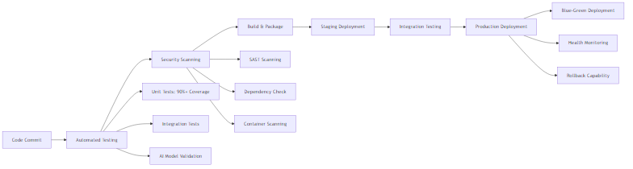

Fig. Diagram 19

**Pipeline Tools:**

* **Version Control:** GitLab Enterprise dengan government compliance
* **CI/CD:** GitLab CI dengan custom runners
* **Testing:** Jest, Pytest, Selenium untuk automated testing
* **Security:** SonarQube, OWASP ZAP, Snyk untuk vulnerability scanning
* **Monitoring:** Prometheus, Grafana, ELK Stack untuk observability

B. AI Model Lifecycle Management



Fig. Diagram 20

5.3.4 Integration Architecture

A. Government Systems Integration



Fig. Diagram 21

**Integration Specifications:**

**API Standards:**

* + **Protocol:** REST APIs dengan OpenAPI 3.0 specification
  + **Authentication:** OAuth 2.0 dengan client credentials
  + **Data Format:** JSON untuk payload, JWT untuk tokens
  + **Rate Limiting:** 1000 requests/minute per client

**Data Synchronization:**

* + **Real-time:** Apache Kafka untuk event streaming
  + **Batch:** Apache Airflow untuk scheduled data loads
  + **CDC:** Debezium untuk database change capture
  + **ETL:** Apache Spark untuk data transformation

**Messaging:**

* + **Queue:** RabbitMQ untuk reliable message delivery
  + **Pub/Sub:** Apache Kafka untuk event-driven architecture
  + **Cache:** Redis Cluster untuk distributed caching
  + **Search:** Elasticsearch untuk full-text search

Dengan rancangan eksekusi yang komprehensif ini, implementasi sistem dapat dilakukan dengan pendekatan yang fleksibel sesuai dengan kebutuhan timeline dan budget, sambil mempertahankan standar kualitas dan keamanan yang tinggi.