# Lab: Polymorphism

In case **Java Zip File** format is required you need to make a .zip file of the package in which the main class is present, together with all other classes if there are any, and submit it in [Judge](https://alpha.judge.softuni.org/contests/1592).

## Math Operation

Create a class MathOperation, which should have method add(). Method add() has to be invoked with **two, three,** or **four Integers.**

You should be able to use the class like this:

|  |
| --- |
| Main.java |
| **public static void** main(String[] args) **throws** IOException {  MathOperation math = **new** MathOperation();  System.***out***.println(math.add(2, 2));  System.***out***.println(math.add(3, 3, 3));  System.***out***.println(math.add(4, 4, 4, 4));  } |

### Examples

|  |  |
| --- | --- |
| **Input** | **Output** |
|  | 4  9  16 |

### Solution

Class MathOperation should look like this:

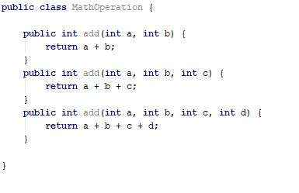

## Shapes

Create class hierarchy, starting with abstract class **Shape**:

* **Fields:**
  + **perimeter: Double**
  + **area: Double**
* **Encapsulation for these fields**
* **Abstract methods:**
  + calculatePerimeter()
  + calculateArea()

Extend Shape class with two children:

* **Rectangle**
* **Circle**

Each of them needs to have:

* **Fields:**

For **Rectangle**

* + **height: Double**
  + **width: Double**

For **Circle**

* + **radius: Double**
* **Encapsulation for these fields**
* **Public constructor**
* **Concrete methods for calculations (perimeter and area)**

## Animals

Create a class Animal, which holds two fields:

* name: String
* favouriteFood: String

The **Animal** has one abstract method explainSelf()**: String.**You should add two new classes - **Cat** and **Dog. Override** the explainSelf() method by adding concrete animal sound on a new line. (Look at examples below)

You should be able to use the class like this:

|  |
| --- |
| Main |
| **public static void** main(String[] args) {  Animal cat = **new** Cat(**"Oscar"**, **"Whiskas"**);  Animal dog = **new** Dog(**"Rocky"**, **"Meat"**);  System.***out***.println(cat.explainSelf());  System.***out***.println(dog.explainSelf()); } |

### Examples

|  |  |
| --- | --- |
| **Input** | **Output** |
|  | I am Oscar and my favourite food is Whiskas  MEEOW  I am Rocky and my favourite food is Meat  DJAAF |

### Solution

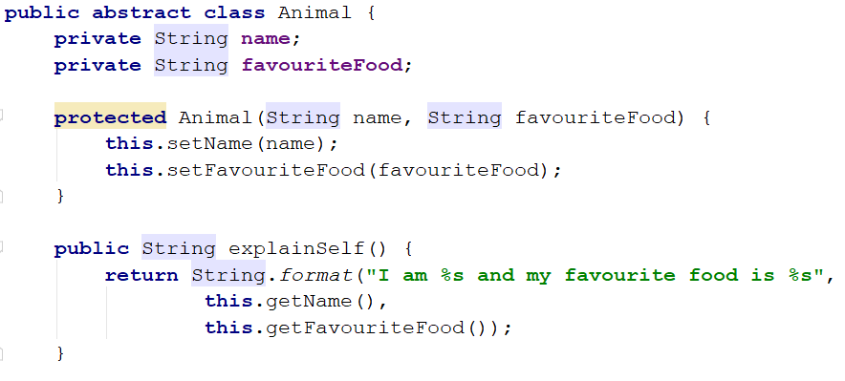

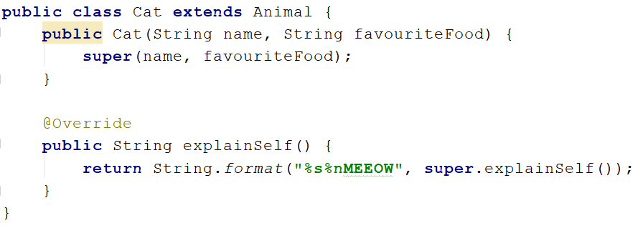

## *Wild Farm

Your task is to create a class **hierarchy** like the picture below. All the classes except **Vegetable**, **Meat**, **Mouse**, **Tiger**, **Cat** & **Zebra** should be **abstract**.

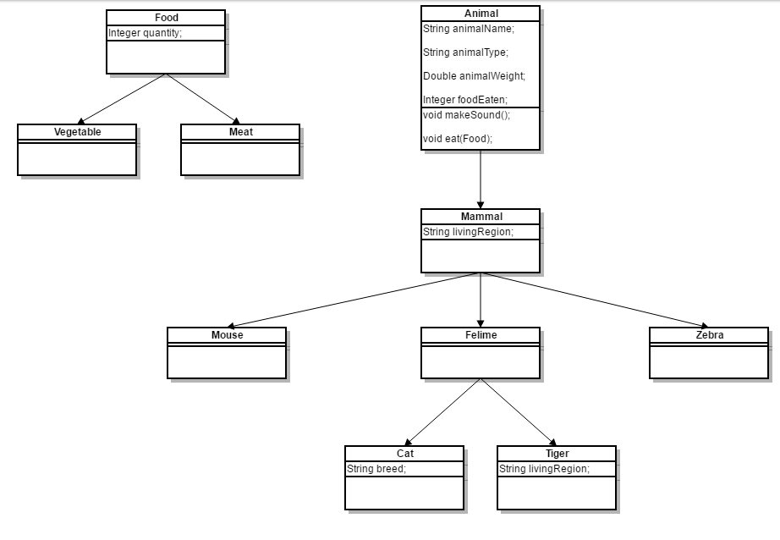

Input should be read from the console. Every **even** line will contain information about the **Animal** in following format:

**"**{AnimalType} {AnimalName} {AnimalWeight} {AnimalLivingRegion}**"**.If the animai is a **cat**: **"**{AnimalType} {AnimalName} {AnimalWeight} {AnimalLivingRegion} {CatBreed}**"**.

On the **odd** lines, you will receive information about the food that you should give to the **Animal**. The line will consist of FoodType and **quantity** separated by whitespace.

You should build the logic to determine if the animal is going to eat the provided food. The Mouse and Zebra should check if the food is Vegetable. If it is they will eat it. Otherwise, you should print a message in the format:

**"**{AnimalType} are not eating that type of food!**"**. AnimalType to be in the plural.

**Cats** eat **any** kind of food, but **Tigers** accept **only Meat**. If a **Vegetable** is provided to a **tiger** message like the one above should be printed on the console.

After you read information about the **Animal** and **Food** then invoke makeSound() method of the current animal and then feed it. In the end, print the whole object in the format:

**"**{AnimalType} [{AnimalName}, {AnimalWeight}, {AnimalLivingRegion}, {FoodEaten}]**"**.

If the animal is a **cat**: **"**{AnimalType} [{AnimalName}, {CatBreed}, {AnimalWeight}, {AnimalLivingRegion}, {FoodEaten}]**"**.

Proceed to read information about the next animal/food. The input will continue until you receive "**End**".

Print all **AnimalWeight** with two digits after the decimal separator. Use the DecimalFormat class.

**Note**: consider overriding toString() method.

### Example

|  |  |
| --- | --- |
| **Input** | **Output** |
| Cat Gray 1.1 Home Persian  Vegetable 4  End | Meowwww  Cat[Gray, Persian, 1.1, Home, 4] |
| Tiger Tom 167.7 Asia  Vegetable 1  End | ROAAR!!!  Tigers are not eating that type of food!  Tiger[Tom, 167.7, Asia, 0] |
| Zebra Jaguar 500 Africa  Vegetable 150  End | Zs  Zebra[Jaguar, 500, Africa, 150] |
| Mouse Jerry 0.5 Anywhere  Vegetable 0  End | SQUEEEAAAK!  Mouse[Jerry, 0.5, Anywhere, 0] |