🌐 LGC – LET’S GET CONNECTED
IoT | Hardware–Software Integration | Industry Collaboration
🏠 HOME / LANDING SECTION
LGC – Let’s Get Connected

Connecting People • Integrating Hardware & Software • Building IoT Solutions

LGC (Let’s Get Connected) is a collaborative technology team focused on designing and developing IoT-based solutions by combining hardware, software, and cloud technologies. We bring together people with diverse technical skills to convert ideas into working, real-world systems.

Our work emphasizes end-to-end IoT development, from sensors and embedded hardware to software applications and data-driven insights.

🧠 ABOUT LGC
Who We Are

LGC (Let’s Get Connected) is a student-driven IoT and embedded systems team built on collaboration, innovation, and practical execution. We specialize in projects that require a tight integration of hardware and software, ensuring that every system we build is functional, scalable, and industry-relevant.

Our team collectively works across:

Embedded hardware development

Circuit and PCB design

Firmware and software development

Web and application interfaces

Research and system optimization

LGC acts as a single platform where complete IoT solutions are designed, developed, tested, and delivered. What Makes LGC Different
Unlike isolated hardware or software teams, LGC focuses on full-system development. We ensure:
Hardware and software are designed together

Sensors, controllers, and communication modules work seamlessly Data flows from physical devices to digital platforms
Systems are tested for real-world usage

This integrated approach allows us to build reliable IoT systems, not just demo projects.

🛠️ CORE FOCUS – IoT & HARDWARE–SOFTWARE INTEGRATION
What LGC Builds

LGC primarily works on IoT-based projects where hardware and software operate as one system.

Our core areas include:

IoT system architecture design

Embedded controllers (ESP32, Arduino, etc.) Sensor integration and data acquisition Circuit design and PCB development Firmware development for device control
Communication protocols (Wi-Fi, BLE, MQTT, HTTP, CAN, etc.)

Backend, dashboards, and web interfaces

Data monitoring, visualization, and automation

We design systems that sense, process, communicate, and act.

🏭 INDUSTRY COLLABORATION & EXPERIENCE
Industry Exposure

LGC actively aligns its work with industry standards and real-world requirements. Our team has prior hands-on experience

and project exposure through collaborations and industrial environments, including: Ashok Leyland
Intrino

Through these experiences, we gained strong understanding of:

Industrial IoT workflows Hardware validation and testing

Software reliability and system integration

Professional engineering practices

These experiences influence how we design and execute every LGC project.

(Industry collaboration images, project photos, and work snapshots will be displayed in this section.)

🎯 OUR APPROACH
How We Work

Every LGC project follows a structured workflow:

Problem identification (real-world or industry-driven) System-level IoT architecture design
Hardware selection and circuit design PCB design and fabrication (if required) Firmware and software development Hardware–software integration Testing, validation, and optimization
Final system demonstration and documentation

This approach ensures professional-quality outcomes, not just prototypes.

🌍 MISSION & VISION
Our Mission

To connect people and skills to build integrated IoT solutions that solve real-world problems through hardware–software collaboration.

Our Vision

To become a trusted IoT-focused collaborative team that bridges students, technology, and industry to deliver meaningful and scalable engineering solutions.

👥 TEAM LGC
Meet the Team

LGC is powered by a multidisciplinary team, ensuring complete IoT system development.

K. Harsha Sai
Founder & Hardware Developer

K. Hemanth Venkat
Co-Founder & Circuit Designer

H. Shalini PCB Designer

V. Shivani Researcher

M. Yeshwanth Kumar Web Developer

K. Kanishk
Software Developer

(Professional team photographs will be displayed.)

📂 PROJECTS
Our IoT Projects

LGC has developed multiple IoT and embedded system projects combining hardware and software. Each project page will include:
Problem statement

System architecture Hardware components used Software and firmware details Communication methods
Project images and results

Visitors can click on any project to view full technical details.

🤝 CONNECT WITH US
Let’s Get Connected

Looking to collaborate on an IoT project, industry solution, or research-based system?
Connect with LGC through the platforms below.

WhatsApp Channel LinkedIn
Instagram

Google Form (for collaborations, project ideas, and inquiries)

We welcome industry partnerships, project collaborations, and innovative ideas.

🔻 FOOTER

LGC – Let’s Get Connected
IoT • Hardware–Software Integration • Industry Collaboration

© LGC. All Rights Reserved.

✅ THIS VERSION CLEARLY SHOWS:

IoT as the main focus


Hardware + software integration Industry seriousness


Professio

K. Harsha Sai K. Hemanth Venkat H. Shalini Founder Co- Founder PCB Designer



K. Kanishk | M. Yeshwanth | V. Shivani
Software developer | Web developer | Researcher

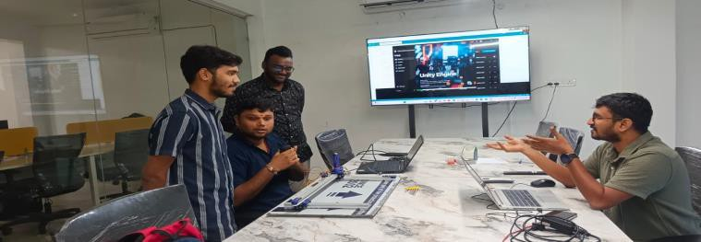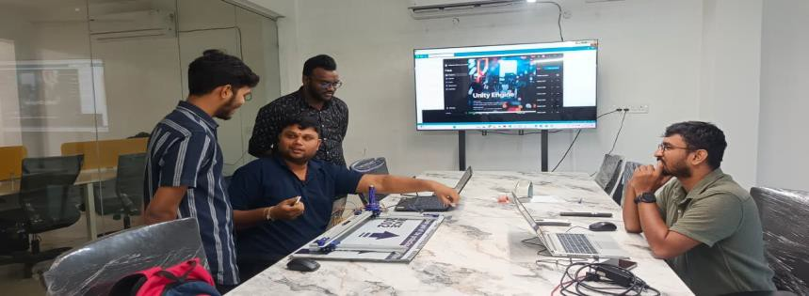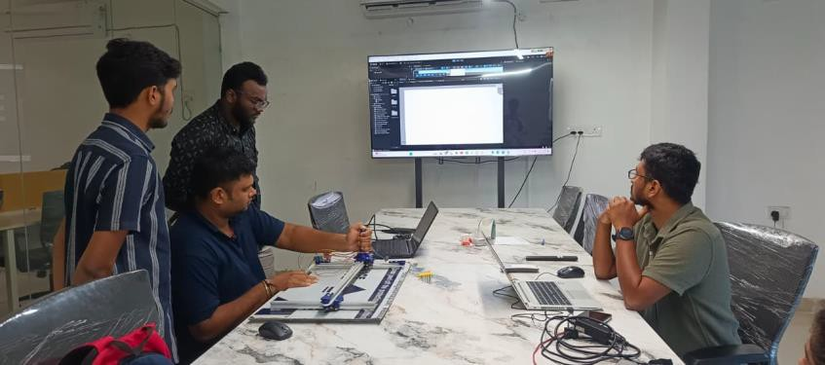Intrino company ceo Mr. Shridhar sirMeeting him on 1st jan 2026
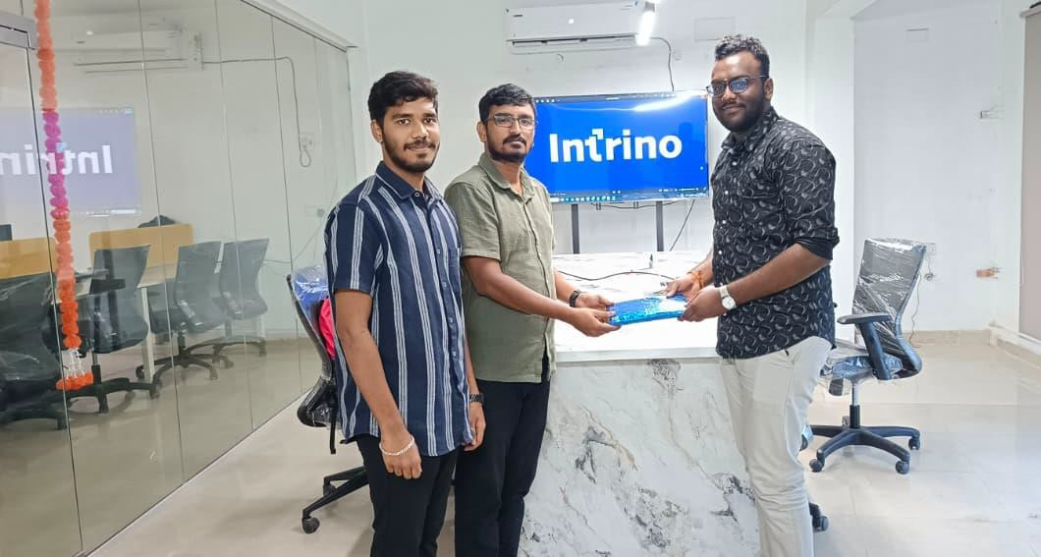

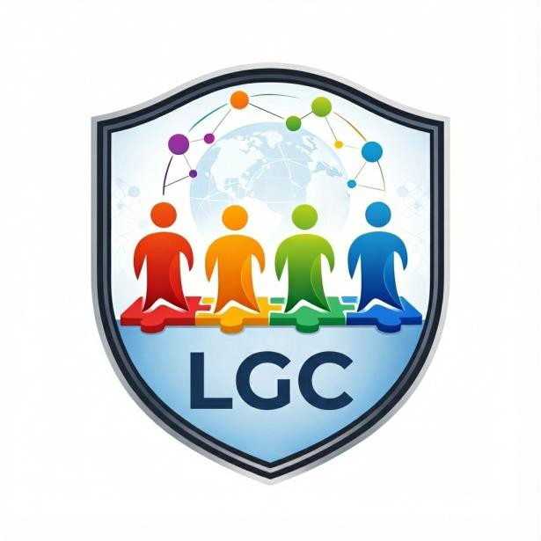
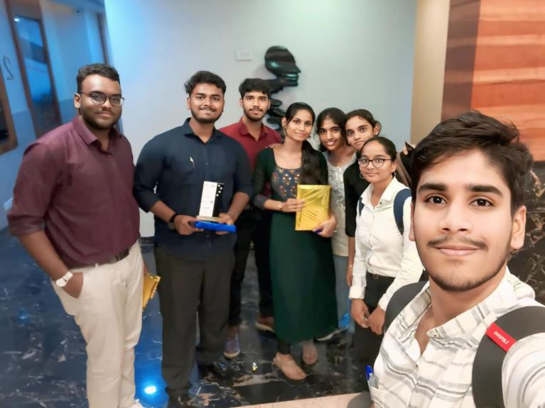
Lgc logo Ieee cas event conducted by us over all madras section
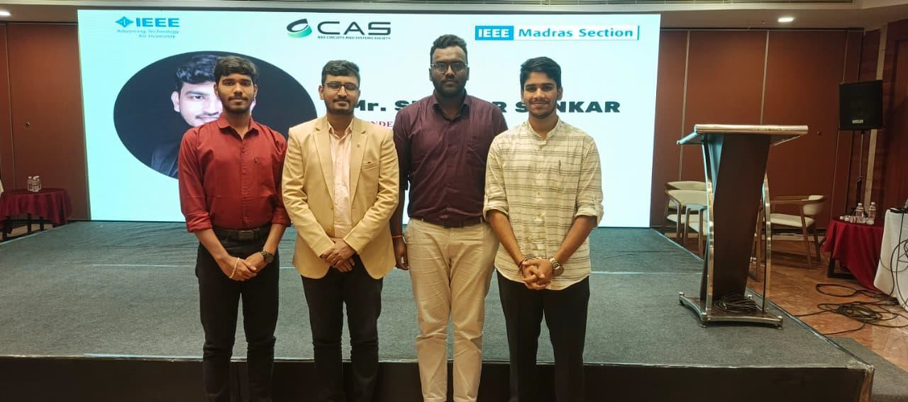
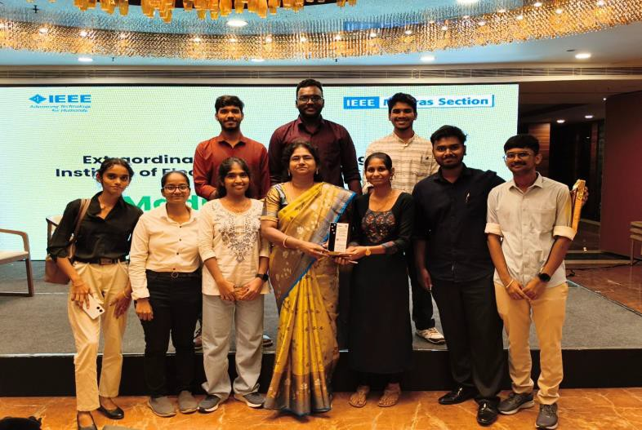
1st place in design contest in hardware track
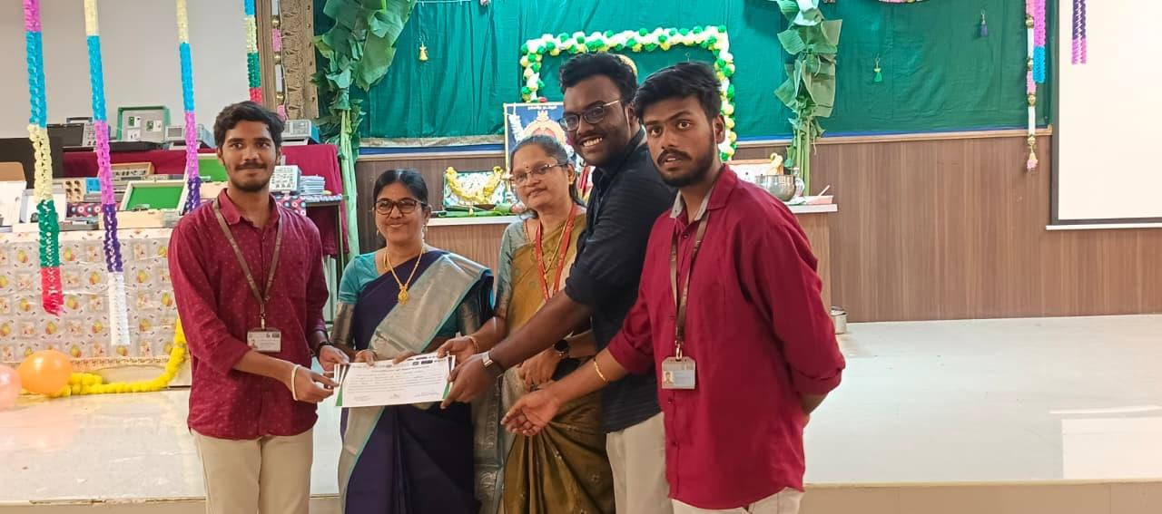

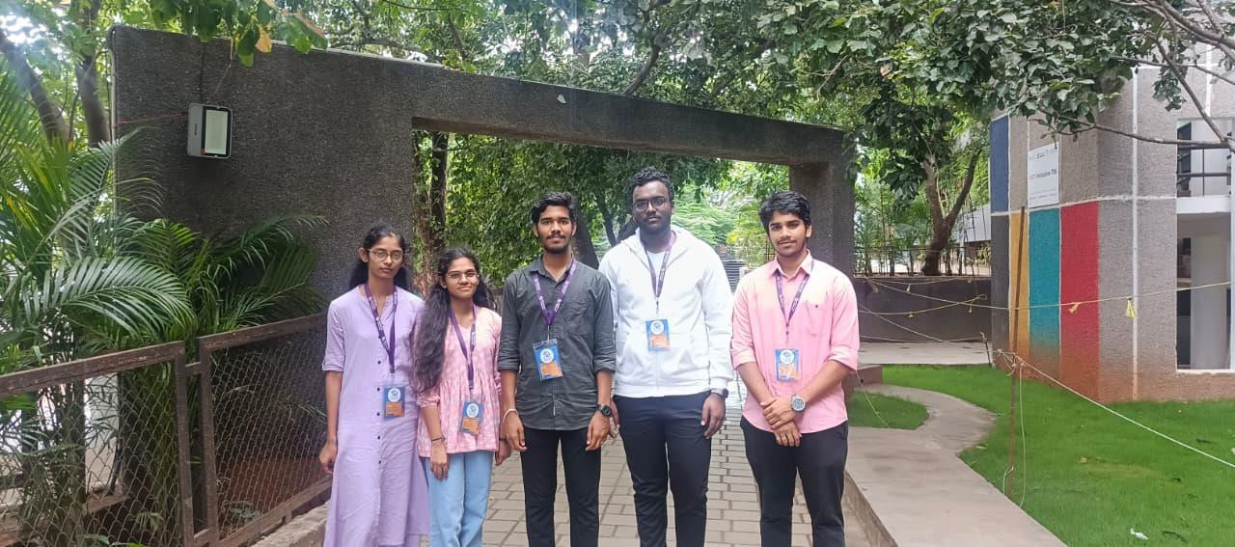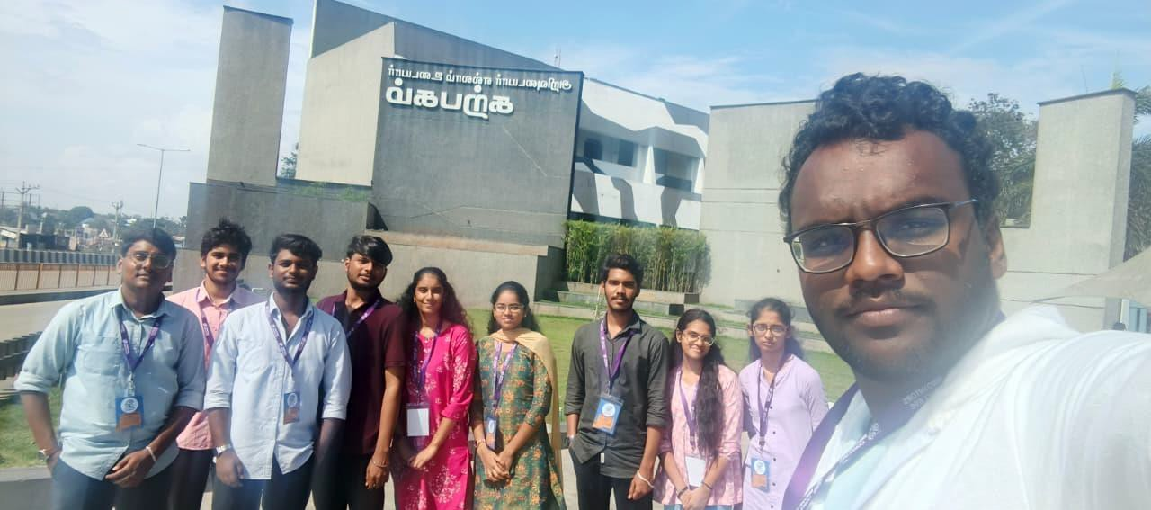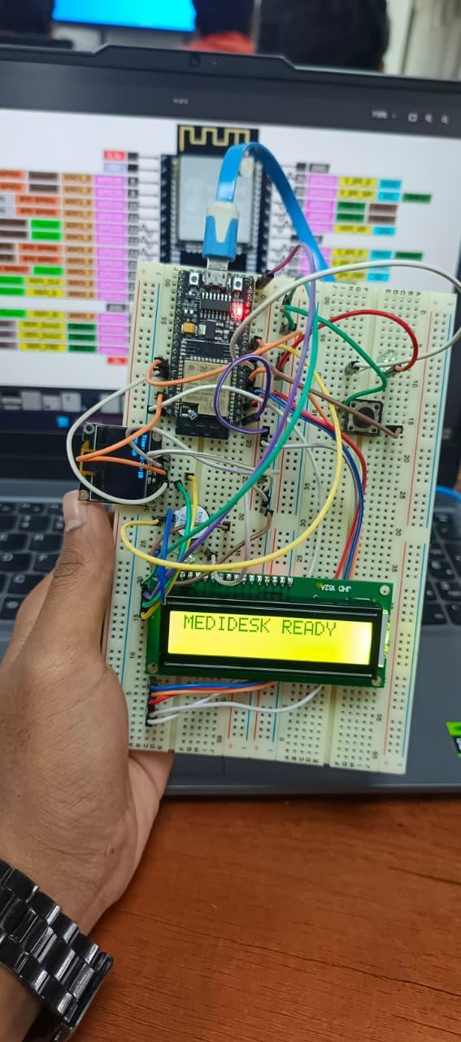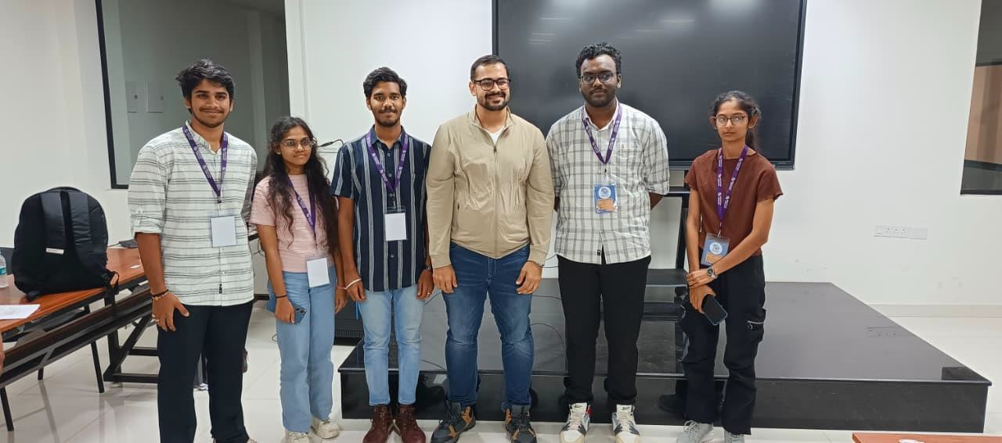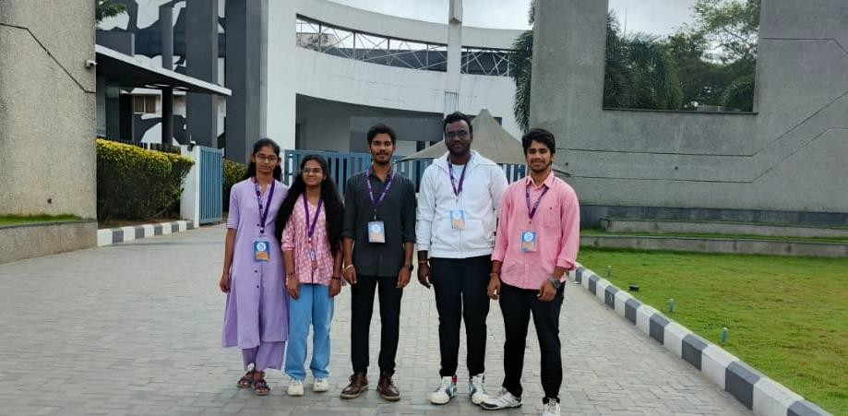In coimbatore Innovators concleva round 1 developed project medi desk and came top 4 in start category
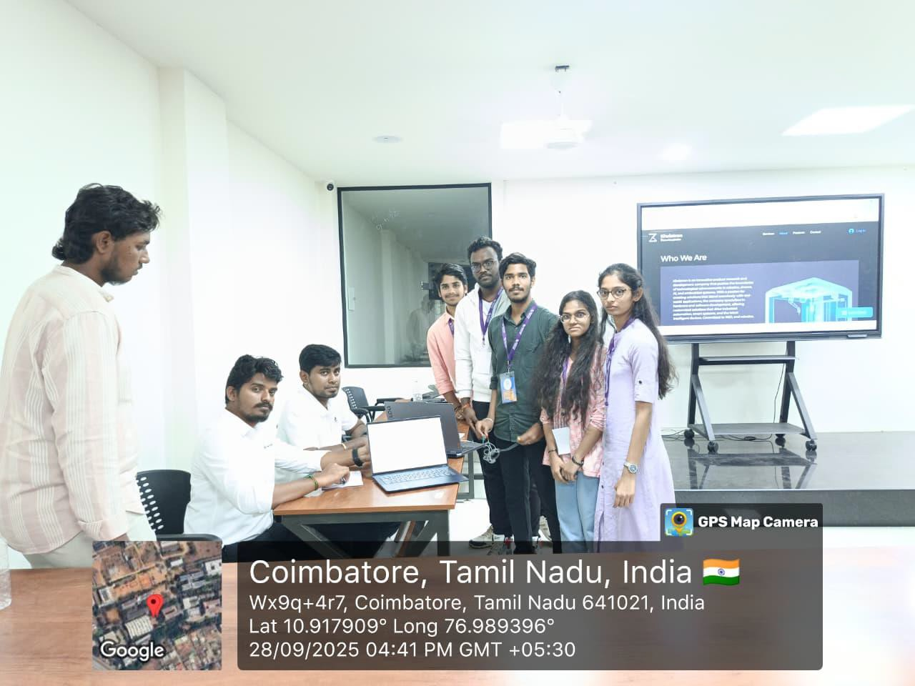

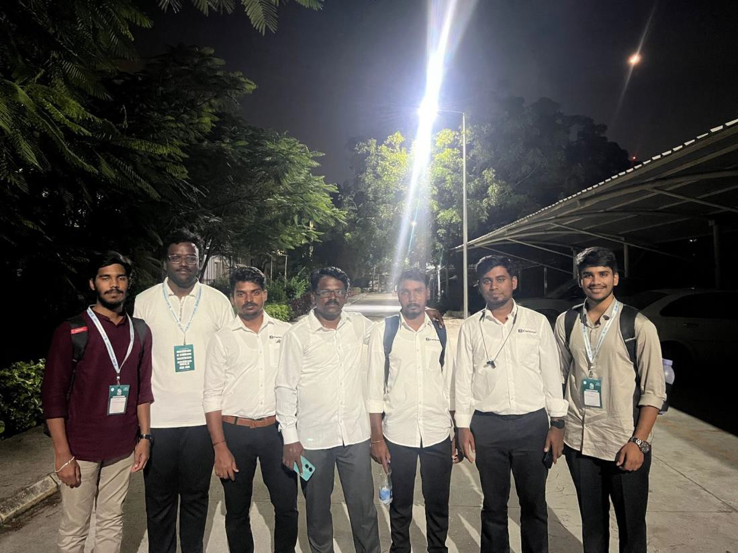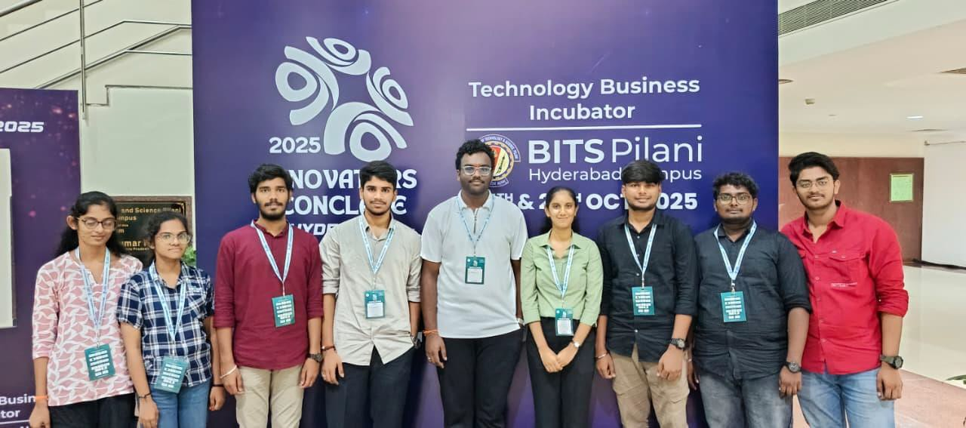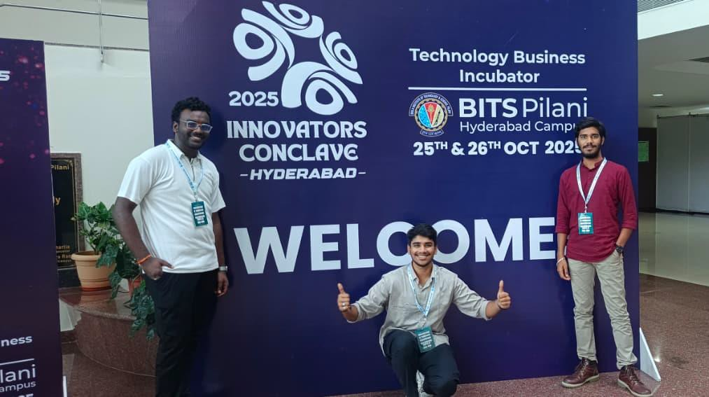Concleva 2025 hackthon final round and combines with kiwistron company in bits pilani hyderabad

And also combined with the kiwistrion company
in the Hyderabad

GOOGLE ACCOUNT DI
lgc.iotsimulator@gmail.com Hemanth@210806

Linkdin:
https://www.linkedin.com/in/lgc-let-s-get-connected-4252243a5/

Insta:
https://www.instagram.com/lgc_official2025?igsh=eHZud2xiYWdqenZ1&utm_source=ig_contact_invite

Whats app channel:
https://whatsapp.com/channel/0029Vb7A7fyFsn0jkSEjbv0K

final one u add the google form link

