**Subject: PRF192-**

**Workshop 1: Input/Output, computations and basic logics Subject**

**PART 1:**

***Program 1:***

Write a C program that prints the following text on the screen:

Hello World!

***Program 2:*** Write a C program to print your name, date of birth. and Address.

***Program 3:*** VIết 1 chương trình hiển thị tổng, hiệu, tích, thương của 2 số 446 và 223 trên màn hình.

Yêu cầu: mỗi biểu thức hiển thị trên một dòng.

Output:

446 + 223 = 669

446 - 223 = 223

446 * 223 = 99458

446 / 223 = 2

***Program 4:*** Write a C program to print a block F using hash (#), where the F has a height of six characters and width of five and four characters.

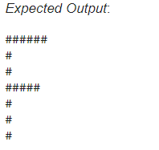

***Program 5:*** Write a program to create 2 integer variables a and b, assign value 125 to a and 600to b then display the following result as output.

Output:

**a+b =725**

***Program 6:*** Write a program to declare 2 variable a and b which are real numbers, assign value 10.5 to a, 7.3 to b and display the following line as output,

Output:

**a/b=1.44**

***Program 7:*** Give a rectangle with the length of 7.8 and the width of 3.6. Write a program to print the area of this rectangle on the screen as below:

**Area= 28.0800**

***Program 8:*** Write a program to display character ‘d’ on the screen.

***Program 9:***

**Sample**

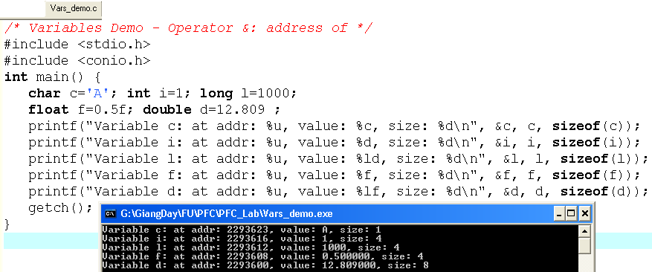

12.809

0.5

1000

‘A’

1

**d:2293600**

**f:2293608**

**l:2293612**

**i:2293616**

**c:2293623**

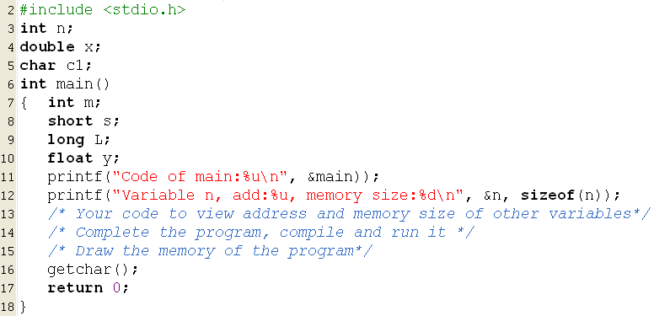

***Program 10:***

: Enter two numbers. Then, the sum of these two integers is calculated and displayed on the screen.

***Program 11:***

: Enter two numbers. Then print swap them.

***Program 12:***

: Swap Numbers Without Using Temporary Variables **(homework)**

**CONDITIONAL LOGIC**

***Program 13:***

: Write a program to accepts an integer n from the user than check whether n is an even or odd number.

***Program 14:***

:Write a program that accepts an integer n from the user then checks the following conditions:

If n is a positive integer, print “ n is a positive integer”

If n is a negative integer, print” n is a negative integer”

If n is equal to 0, print “ n is equal to 0”.

***Program 15:***

: Write a program to read two integers a and b then check whether both a and b are not equal to zero or not.

If two values are not equal to 0, print the following line on the screen:

If a or b is equal to 0, print the following line on the screen:

***Program 16:***

**:** Write a program that accepts three integers from the user and prints the biggest number among them on the screen.

For example, if you enter three numbers as below:

4 7 3

When the code is compiled and executed, it produces the following result:

7

If you enter:

4 4 4

When the code is compiled and executed, it produces the following result:

4

***Program 17:***

**:** Write a program to read an integer a then check whether a is in the range [10, 100] or not.

If a is in the range [10, 100], print the following line on the screen:

{P} is in range (10, 100)

If a is not in the range, print the following line on the screen: :

{P} is not in range (10, 100)

where {P} is the value of a.

***Program 18:***

: Write a program that accepts the test score of a student (knowing that the valid score is greater than or equal to 0 and less than or equal to 10) and checks whether the entered score is valid or not.

If the score is valid, print the following line on the screen:

The score is valid

If the score is invalid, print the following line on the screen:

The score is not valid

***Program 19***: Given 2 integer variables a and b and a character variable c knowing that c is one of 4 characters '+', '-', '*', '/'. Write a program to read 3 variables a, b and c then display the result of expression when applying the operation c on a and b.

For example, if a = 7, c = '+', b = 9, enter the following line:

7 + 9

When the code is compiled and executed, it produces the following result:

16

**LOOP: FOR**

***Program 20***: Write a program that accepts an integer n from the user then displays all the numbers from 1 to n on the screen.

For example, if you enter 10 from the keyboard, the program will produce the following result:

1 2 3 4 5 6 7 8 9 10

***Program* 21**: Write a program that accepts two integers a and b from the user and displays all numbers from a to b on the screen.

For example, if a = 5, b = 9, the screen will display as below:

5 6 7 8 9

***Program* 22:** Write a program that accepts an integer n from the user then displays all numbers from n to -n (n >= -5) in descending order.

For example, if n = 5, the screen will display as below:

5 4 3 2 1 0 -1 -2 -3 -4 -5

***Program* 23**: Write a program that accepts two integers a and b from the user and displays the sum of all the numbers from a to b on the screen:

For example, if a = 5, b = 9, the screen will display as below:

35

Because 5 + 6 + 7 + 8 + 9 = 35

***Program* 24**: Write a program that accepts an integer n from the user and displays the sum of all odd numbers from 0 to n on the screen.

For example, if n = 7, the program will produce the following result:

16

Because 1 + 3 + 5 + 7 = 16

***Program* 25**: Write a program that accepts two integers a and b from the user and prints all the numbers from a to b, which are divisible by 3:

For example, if a = 1, b = 20, the program will display on the screen as below:

3 6 9 12 15 18

***Program* 26**: Write a program that accepts an integer n from the user and displays the result of n! on the screen.

For example, if n = 5, the program will display on the screen as below:

120

Because 1 * 2 * 3 * 4 * 5 = 120.

***Program* 27**: Write a program that accepts an integer n from the user and prints the divisors of n (n > 0) on the screen.

For example, if n = 12, the screen will display as below:

1 2 3 4 6 12

**LOOP: WHILE AND DO-WHILE**

***Program* 28**:**:** Write a program that accepts an integer n and prints all even numbers from n to 100 on the screen.

For example, if n = 90, the program will produce the following result:

90 92 94 96 98 100

***Program* 29**:**:** Write a progarm that accepts an integer n from the user then prints all divisors of n on the screen.

For example, if n = 12 , the program produces the following result:

6

Because all divisors of 12 are 1, 2, 3, 4, 6, 12

***Program* 30**:**:** Write a program that accepts two integers a and b from the user then prints the result of ab on the screen.

For example, if a = 2, b = 3, the program will produce the following result:

8

Because 2 * 2 * 2 = 8.

***Program* 31**:**:** Write a program that accepts two integers a and b from the user then prints all numbers from a to b, which are divisible by 3 and 5.

For example, if a = 1, b = 50, the program produces the following result:

15 30 45

***Program* 32**:**:** Fill in the blank (...) to complete the program that prints all numbers from 1 to 50 on the screen.

***Program* 33**:**:** Fill in the blank (...) to complete the program that prints all odd numbers from 1 to 100.

***Program* 34**:**:** Write a program that prints numbers from 1 to 5 using do-while loop.

***Program* 35**:: Write a program to print all numbers from 1 to 1000 (including 1 and 1000), which end with 0. It means the program will display 10, 20, 30, ..., 990, 1000 on the screen.

**PART 2:**

**Program 1 ( 2 marks)**

Write a program that allows user inputting a simple expression containing one of four operators +, -, *, / then the result is printed out to the monitor. Input format: num1 operator num2,

An example of user interface

Enter an expression (+ - * /): 4*5

Result: 20

**Sample Analysis**

|  |  |  |
| --- | --- | --- |
|  | Content | Implementation |
| ***Nouns*** | Expression,  format num1 operator num2  result | double num1, num2  char op  double result |
| ***Verbs*** | Begin  Accept num1, op, num2  **Calculate result**  Print out result  End | scanf( “%lf %c%lf”, &num1, &op, &num2)  switch (op)  { case ‘+’ : result = num1 + num2;  print out result;  break;  case ‘-’ : result = num1 - num2;  print out result;  break;  case ‘*’ : result = num1 * num2;  print out result;  break;  case ‘/’ : if ( num2==0)  print out “Divide by 0 “  else  { result = num1 / num2;  print out result;  }  break;  default: print out “Op is not supported”  } |

Implement this program.

**Program 2 ( 2 marks) – Yearly Personal Income Tax**

Suppose that:

In Viet Nam, each people must pay for his/her yearly personal income tax as the following description:

**Rules:**

***Tax-free income:***

***tf = Thu nhập không phải chịu thuế***

Personal pending amount (tiền nuôi bản thân) **pa=** 9 000 000$/month

Alimony (tiền cấp dưỡng) for each his/her dependent **pd=** 3 600 000$/month/dependent

With **n** dependents, yearly tax-free income: **tf = 12*(pa + n*pd)**

***Taxable income (thu nhập chịu thuế)***

***Thu nhập bị tính thuế = thu nhập cơ bản – thu nhập không chịu thuế***

**ti = income – tf**

**( If ti<=0 then income tax = 0)**

**Based on taxable income, the employee has to pay his/her income tax with levels pre-defined in the following table:**

|  |  |  |
| --- | --- | --- |
| ***Level*** | ***Taxable Income*** | ***Income tax*** |
| 1 | Less than or equal to 5.000.000 | 5% |
| 2 | From 5.000.001 to 10.000.000 | 10% |
| 3 | From 10.000.001 to 18.000.000 | 15% |
| 4 | Over 18.000.000 | 20% |

if(ti<=5tr)

It=ti*0.05;

else if(ti<=10tr)

it=5tr*0.05+(ti-5tr)*0.1

else if(ti<=18tr)

it=5tr*0.05+ 5tr*0.1+(ti-10tr)*0.15

else

it=5tr*0.05+ 5tr*0.1+8tr*0.15+(ti-18tr)*0.2

**Ti: Thu nhập còn lại sau khi đã trừ đi thuế thu nhập**

Ti= 3tr income tax=3tr*0.05

Ti= 8tr income tax=5tr*0.05+(8tr-5tr)*0.1

Ti=12tr income tax= 5tr*0.05+5tr*0.1+(12tr-10)*0.15

Ti=19tr income tax=5tr*0.05+5tr*0.1+8tr*0.15+(19tr-18tr)*0.2

Write a program which will compute income tax of a people using the following interface:

***Case 1:***

Your income of this year: 240000000

Number of dependent:4

Tax-free income: 280800000

Taxable income: 0

Income tax: 0

***Case 1:***

Your income of this year: 440000000

Number of dependent:4

Tax-free income: 280800000

Taxable income: 159200000

Income tax: 30190000

**Program 3 (1 mark)**

|  |  |
| --- | --- |
| **Objectives** | Practice loop statements |
| **Related knowledge** | None |
| **Problem** | Write a C program that will print out **sum** of **integers** inputted from the keyboard until the value 0 is inputted. |
| **Analysis**  *Nouns: sum 🡪 int S;*  *Accepted integral value 🡪 int x* | **Suggested algorithm****(logical order of verbs)**  Begin  S=0;  Do {  Accept x; //scanf(“%d”, &x);  If (x!= 0) S = S + x;  }  While (x!=0);  Print out S;  End |

**Program 4 (1 mark)**

|  |  |
| --- | --- |
| **Objectives** | Practice loops statement |
| **Related knowledge** | None |
| **Problem** | Write a C program that will carry out sometimes: accept two integers, swap these values, print them out to the monitor. The program will terminate when the value of 0 is inputted. |
| **Analysis**  *Nouns:*  *2 integers 🡪 int x, y;* | **Suggested algorithm (logical order of verbs)**  Begin  Do {  Accept x, y;  int t= x; /* t: temporary variable */  x= y;  y= t;  Print out x, y;  }  While ( x!=0 && y!=0);  End |

**Program 5: (2 marks)**

|  |  |
| --- | --- |
| **Related knowledge** | Use the function **getchar()** –stdio.h**,** to input a character, the function **toupper(ch)** to convert a character to uppercase - **ctype.h**  ASCII code of the ENTER key: ‘\n’ |
| **Problem** | Write a C program that will:   * permit user inputting a string of characters. The input operation will terminate if the ENTER key is stroked. * print out the number of vowels, number of consonants, and number of others to the monitor. |
| **Analysis**  *Nouns:*  *inputted character*  *🡪 char ch*  *Number of vowels*  *🡪 int nVowels =0;*  *Number of consonants*  *🡪 int consonants =0;*  *Number of other characters 🡪 int nOthers =0;* | **Suggested algorithm (logical order of verbs)**  Begin  Do {  Accept ch; /* ch= getchar(); */  Convert ch to its uppercase /* ch= toupper(ch); */  If ( ch>=’A’ and ch <=’Z’) {  switch (ch) {  case ‘A’ :  case ‘E’ :  case ‘I’ :  case ‘O’ :  case ‘U’ : nVowels ++; break;  default: nConsonants++;  }  }  else nOthers = nOthers++;  }  While ( ch != ‘\n’);  Print out nVowels;  Print out nConsonants;  Print out nOthers;  End |

**Program 6: (1 marks)**

|  |  |
| --- | --- |
| **Related knowledge** | Each character will be stored as its ASCII code with value 0..255 |
| **Problem** | Write a C program that will print out the ASCII code table. |
| **Analysis**  ASCII code  🡪 int code | **Suggested algorithm (logical order of verbs)**  Begin  For each code = 0 to 255  { Print out (“%c : %d, %o, %X\n”, code, code, code, code);  If (code !=0 && code %20==0) getchar(); **/* code page of 20 lines */**  }  End. |

**Program 7: (1 marks)**

|  |  |
| --- | --- |
| **Problem** | Write a C program that will accept two characters then print out ASCII code difference between them and characters between them including code values in decimal, octal, hexadecimal expansions in ascending order. |
| **Analysis**  2 character  🡪 char c1, c2  Difference   * 🡪 int d;   Character for swapping operation   * 🡪 char t   Character for looping   * Char c | **Suggested algorithm (logical order of verbs)**  Begin  Accept c1 ;;  Accept c2;  If (c1 > c2 )  { t = c1; c1 = c2; c2= t;  }  d = c2 – c1;  Print out d;  For each c from c1 to c2  { Print out (“%c : %d, %o, %X\n”, c, c, c, c);  }  End. |

**END**