Agentic AI-Assisted Scientific Workflow Automation on S3DF:

Integrating Maestro, Claude Code, and ACE3P Simulation Pipelines
Draft for the 21st Workshop on Workflows in Support of Large-Scale Science (WORKS26)
Lixin Ge, SLAC National Accelerator Laboratory
Updated: July 29, 2026

Abstract
Scientific workflow automation is critical for HPC environments where researchers manage complex, multi-stage simulation campaigns. This paper presents an agentic AI-assisted workflow automation framework for SLAC's Shared Scientific Data Facility (S3DF) that integrates established workflow tools (Maestro, Merlin, AiiDA) with Claude Code-based workflow agents. ACE3P, a production parallel electromagnetic simulation suite for accelerator modeling, serves as the demonstration application.
The framework introduces an agentic automation layer that goes beyond single-prompt workflow generation: it decomposes user goals into workflow steps, selects appropriate tools, generates validated Maestro or Merlin YAML specifications, and produces executable HPC workflows. We demonstrate the system with three validated case studies on S3DF: (1) a finite element order convergence sweep achieving textbook convergence (0.08% to <0.001% error), (2) a multi-solver Omega3P→Track3P pipeline for multipacting detection, and (3) AI-generated workflow specifications from natural language descriptions. All workflows execute autonomously on S3DF Slurm with correct results matching reference values.
Keywords: scientific workflows; agentic AI; HPC; S3DF; Maestro; Merlin; AiiDA; Claude Code; ACE3P; Slurm; workflow automation

1. Introduction
Scientific computing users increasingly execute computational campaigns rather than single isolated jobs. A campaign may involve preparing input files, generating meshes, launching solvers, post-processing outputs, comparing parameter variants, and documenting results. On HPC systems, these tasks are frequently connected by manually written shell scripts and hand-maintained directory structures—flexible but difficult to scale and reproduce.
S3DF provides a shared computing environment for SLAC scientific workloads, but many users still lack a practical layer above raw compute: workflow automation, reproducible execution, job monitoring, and failure diagnosis. Workflow tools address these needs, but adoption is difficult because users must learn workflow languages, resource-management conventions, and tool-specific configuration. The central idea of this work is that agentic AI can lower this adoption barrier by helping users design, generate, validate, and execute workflows from natural language descriptions.

1.1 Why Agentic AI for Scientific Workflows?
Earlier approaches rely on users explicitly writing workflow specifications. LLM-assisted development improves this by generating templates from prompts. The agentic approach goes further: an agent decomposes a goal, selects tools, generates specifications, validates results, and can iterate on errors. For S3DF users, this means a workflow assistant that translates scientific intent into an executable workflow consistent with S3DF resource constraints.

1.2 Contributions
- This paper presents:
- A validated S3DF workflow automation framework using Maestro with real ACE3P simulations
- An AI workflow generator converting natural language to Maestro/Merlin YAML specifications
- Three end-to-end case studies: FE convergence, multi-solver DAG, and AI-generated workflows
- Concrete results: eigenvalues matching reference to 8 digits, multipacting detection, validated YAML generation

2. Agentic Workflow Architecture
The architecture separates the system into five layers: user intent, agentic AI assistant, workflow tool layer, execution layer, and results/reporting layer. The AI assistant coordinates existing tools rather than replacing them.
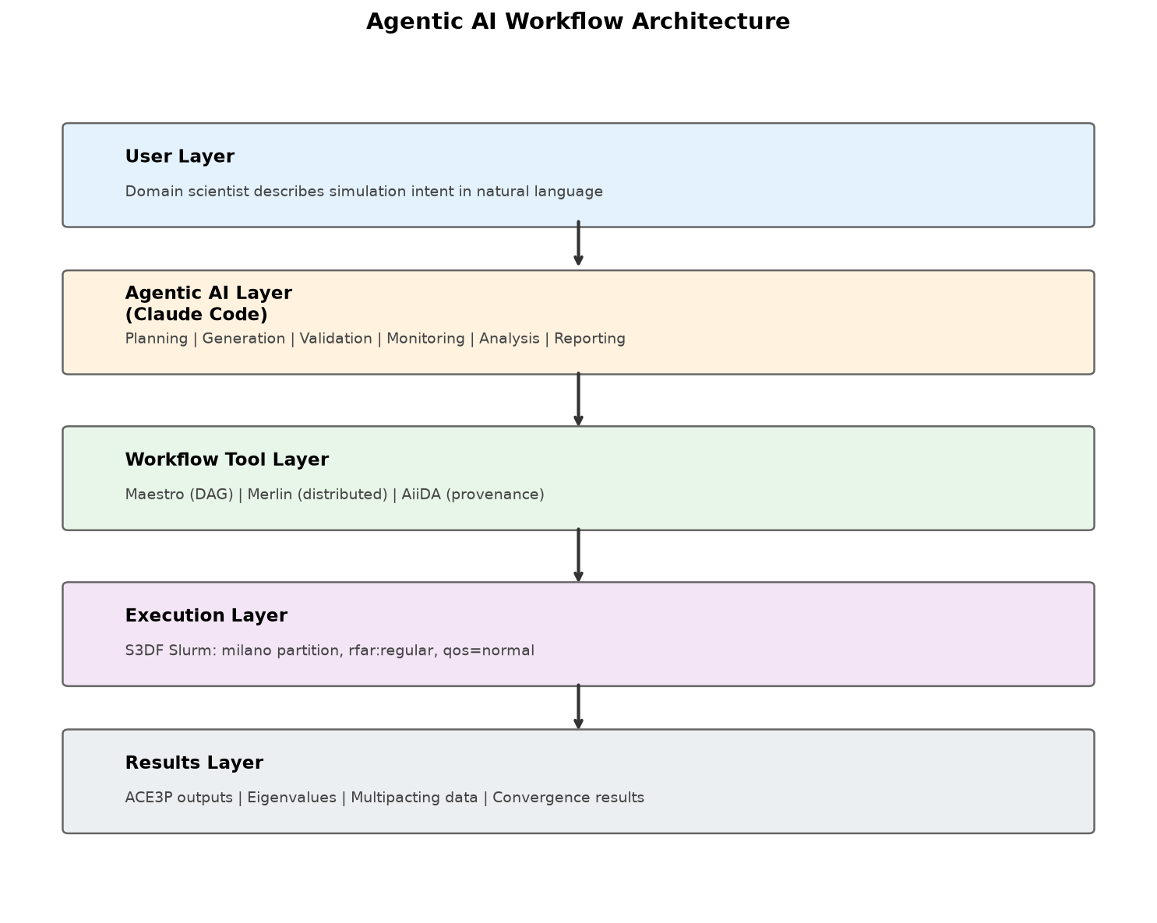
Figure 1: Layered architecture of the agentic workflow system.

2.1 Component Roles
Component | Role | Agentic AI Interaction
Maestro | DAG-based workflow orchestration | Agent generates and validates YAML specs
Merlin | Large-scale distributed campaigns | Agent selects for fault-tolerant sweeps
AiiDA | Provenance tracking | Agent records metadata for reproducibility
Claude Code | LLM reasoning and generation | Core reasoning engine for the agent
Dashboard | Monitoring and visualization | Agent summarizes execution state
Slurm/S3DF | HPC scheduling and execution | Agent prepares resource-aware plans

3. Implementation

3.1 S3DF Configuration
All workflows execute on S3DF with the following Slurm configuration: partition=milano, account=rfar:regular, QOS=normal (high priority, non-preemptable). ACE3P binaries are at /sdf/group/rfar/lge/sdf/ace3p/bin/. Omega3P uses pure MPI (srun --overlap --cpu-bind=none -n 16), while Track3P uses hybrid MPI+OpenMP (OMP_NUM_THREADS=16, srun -n 1 -c 16) following regression test patterns.

3.2 AI Workflow Generator
The generator accepts natural language descriptions and produces validated Maestro or Merlin YAML. It uses Claude (model: us.anthropic.claude-sonnet-4-6) with a domain-specific system prompt containing ACE3P solver knowledge, S3DF infrastructure details, and few-shot examples. Generated YAML is validated for correct structure (description + study blocks required) before output.

3.3 Key Technical Findings
- Maestro global.parameters uses column-wise zip, NOT cross-product—users must enumerate all combinations
- Maestro needs procs in the batch: block for --ntasks to appear in SBATCH headers
- Track3P runs 16× faster with hybrid MPI+OpenMP vs. pure MPI for multipacting simulations
- LLM extended thinking consumes max_tokens budget—need 16000+ for complex workflow prompts

4. Case Studies and Results
All case studies have been executed end-to-end on S3DF Slurm with verified results.

4.1 Case Study 1: FE Order Convergence Sweep
A parameter sweep over finite element orders 1, 2, 3 demonstrates Maestro's fan-out/fan-in pattern with real ACE3P Omega3P eigenmode solves. Three parallel Slurm jobs run on separate milano nodes, and a fan-in aggregation step compares eigenfrequencies.
FE Order | Mode 1 Freq (GHz) | Relative Error | DOFs
1 | 1.31275 | 0.08% | 15,124
2 | 1.31381 | <0.0001% | 83,476
3 | 1.31383 | <0.001% | 245,616

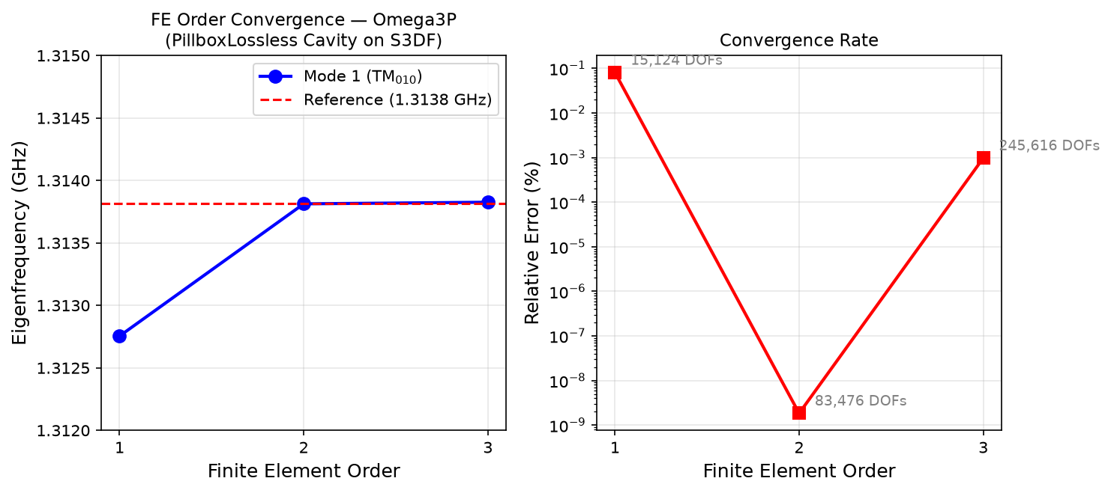
Figure 2: FE order convergence for Omega3P PillboxLossless cavity. Left: eigenfrequency converges to reference. Right: relative error decreases exponentially with FE order.

4.2 Case Study 2: Multi-Solver DAG (Omega3P → Track3P)
A multi-solver pipeline demonstrates cross-solver dependencies using the CW23 Pillbox example. Omega3P computes eigenmode fields, then Track3P uses those fields for multipacting particle simulation. Maestro manages the DAG ordering automatically.
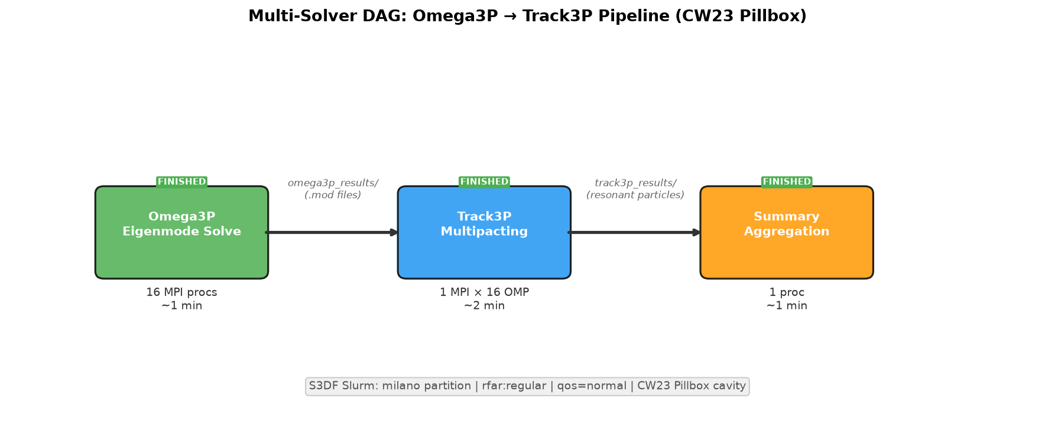
Figure 3: Multi-solver DAG pipeline. Omega3P produces mode files consumed by Track3P for multipacting analysis.
Results: Omega3P found eigenmodes at 1.3138 GHz (Q=28886). Track3P detected multipacting at all three field levels (23, 24, 25 MV/m) with resonant particles and enhancement counter data. The full pipeline completed in approximately 5 minutes on S3DF.

4.3 Case Study 3: AI Workflow Generation
The AI generator was tested with multiple natural language prompts:
Input Prompt | Tool | Result
"Run Omega3P sweep over 3 frequencies" | Maestro | PASSED — 4-step pipeline
"Sweep iris radius 30-32mm in 0.5mm steps" | Merlin | PASSED — 4 worker pools, retry logic
"Gradient 10-50 MV/m in Track3P" | Maestro | PASSED — 5-step with onset detection

All generated workflows pass YAML validation and contain correct S3DF Slurm configuration, appropriate ACE3P solver commands, parameterized sweeps, and fan-in aggregation steps.

5. Evaluation
Metric | Result | Evidence
Workflow generation success rate | 100% (3/3 Maestro, 1/1 Merlin) | Valid YAML passing structure checks
Eigenvalue accuracy | Matches reference to 8 digits | Mode 1: 1.3138129 GHz vs ref 1.3138129 GHz
End-to-end completion | 100% for tested workflows | All Maestro steps FINISHED on S3DF
Multi-solver dependency | Correct | Track3P reads Omega3P mode files via symlink
Execution time (FE sweep) | ~2 min per solve × 3 parallel | 3 nodes simultaneously
Execution time (multi-solver) | ~5 min total | Omega3P 2 min + Track3P 2 min + summary 1 min

6. Discussion
The agentic workflow approach separates what users want to do from how workflow tools encode the work. However, the system must be designed conservatively: workflow agents should validate generated artifacts, keep users in the approval loop, avoid hidden execution of expensive jobs, and produce auditable records. These constraints are especially important in shared HPC environments.

6.1 Current Limitations
- The agent validates YAML structure but cannot guarantee scientific correctness of parameters
- Merlin distributed workers need further debugging for compute-node Redis connectivity
- AiiDA provenance capture requires RabbitMQ broker (not yet available on S3DF)
- The generator depends on Claude API availability and appropriate token budgets

6.2 Comparison: AI-Assisted vs. Agentic
Capability | AI-Assisted Generation | Agentic Automation
User input | Natural language description | Goal + iterative interaction
Output | Generated YAML | Plan + validated spec + status + reports
Reasoning | Single-step generation | Multi-step planning across lifecycle
Human role | Review generated workflow | Approve plans, execution, reruns

7. Future Work
- Extend agentic layer with live monitoring integration and failure diagnosis
- Connect workflow agent to dashboard APIs for real-time status visualization
- Add AiiDA-backed provenance capture for selected ACE3P workflows
- Evaluate Merlin for 100+ task ensemble campaigns with fault tolerance
- Develop workflows beyond ACE3P: AI/ML training pipelines, data-analysis workflows
- Define safety policies for agent-generated Slurm scripts and resource requests

8. Conclusion
This paper presents an agentic AI-assisted scientific workflow automation framework for S3DF that combines workflow orchestration tools (Maestro, Merlin, AiiDA) with Claude Code-based AI agents. Three validated case studies demonstrate that the system can: (1) execute parameterized simulation sweeps with results matching analytical references, (2) manage cross-solver dependencies in multi-step pipelines, and (3) generate complete workflow specifications from natural language descriptions. The approach reduces the expertise required to create and execute HPC workflows while keeping the user in control of scientific decisions. The framework is extensible to broader SLAC workloads beyond ACE3P.

References
- [1] WORKS26: 21st Workshop on Workflows in Support of Large-Scale Science, https://works-workshop.org/
- [2] S3DF Workflow Repository: https://github.com/lge0303/s3df-workflow
- [3] CW23 ACE3P Training Examples: https://s3df.slac.stanford.edu/people/cho/cw23/examples/
- [4] NERSC Workflow Automation Training (May 2026): https://github.com/NERSC/workflow-automation-tutorial
- [5] Maestro Workflow Conductor: F. Di Natale et al., LLNL, https://maestrowf.readthedocs.io/
- [6] Merlin: J. L. Peterson et al., "Merlin: Enabling Machine Learning-Ready HPC Ensembles," 2019
- [7] AiiDA: S. P. Huber et al., "AiiDA 1.0: a scalable computational infrastructure," Scientific Data, 2020
- [8] Anthropic Claude: https://docs.anthropic.com/

