Agentic Scientific Workflow Automation on S3DF
Lixin Ge
SLAC National Accelerator Laboratory
Menlo Park, CA, USA
lge@slac.stanford.edu
Abstract-Scientific workflows are central to large-scale simulation and data-analysis campaigns, but many high-performance computing users still assemble workflows from ad-hoc scripts, manual scheduler commands, and hand-written post-processing procedures. This paper presents an agentic AI framework for scientific workflow automation on SLAC's Shared Scientific Data Facility. The framework uses an agentic workflow assistant with reusable skills for planning, workflow generation, validation, execution assistance, monitoring, analysis, and reporting. Rather than replacing established infrastructure, the assistant coordinates workflow systems, scheduler interfaces, file systems, dashboards, and provenance tools. The prototype is developed in the s3df-workflow repository and uses the ACE3P electromagnetic simulation suite as an initial demonstration application. The framework integrates Maestro and Merlin concepts for workflow orchestration, AiiDA-inspired provenance capture, dashboard-based monitoring, and Model Context Protocol style tool access. We describe the architecture, implementation status, ACE3P case-study workflows, and an evaluation methodology focused on time-to-first-workflow, manual steps eliminated, workflow validity, monitoring quality, troubleshooting usefulness, and reproducibility metadata coverage. The paper argues that agentic AI can lower the barrier to workflow adoption by helping users create, validate, monitor, troubleshoot, and document scientific campaigns while keeping humans in control of scientific and resource-management decisions.
Keywords-agentic AI; scientific workflows; S3DF; high-performance computing; workflow automation; skills; Model Context Protocol; ACE3P; Maestro; Slurm

I. INTRODUCTION
Scientific workflows have become the organizing fabric for modern computational science. A single study may include geometry preparation, input generation, solver execution, data reduction, uncertainty quantification, visualization, and publication-quality reporting. On shared high-performance computing (HPC) systems, these steps are frequently implemented as collections of shell scripts, Python utilities, scheduler commands, and manual file management procedures. These practices are flexible and familiar, but they are also difficult to scale, audit, share, and reproduce when campaigns grow from a few runs to hundreds or thousands of runs.
SLAC's Shared Scientific Data Facility (S3DF) provides compute, storage, and interactive services for a broad scientific community. The facility supports simulation, experimental data processing, artificial intelligence and machine learning (AI/ML), and analysis workloads. A common challenge across these communities is not simply access to compute nodes; it is the ability to express, execute, monitor, and reproduce end-to-end computational campaigns with limited manual overhead. This challenge motivates workflow automation as a facility-level productivity capability rather than as an application-specific convenience.
Workflow management systems provide abstractions for composing and executing tasks, but workflow adoption can impose its own learning curve. Users must learn workflow syntax, scheduler constraints, directory conventions, provenance mechanisms, and tool-specific failure modes. Large language models (LLMs) and agentic AI systems create a new opportunity: they can assist users in translating scientific intent into workflow artifacts, validating those artifacts, monitoring execution state, interpreting failures, and producing documentation. The central question explored in this paper is how to combine agentic AI with established workflow and HPC infrastructure in a way that improves usability without replacing reliable tools such as Slurm, Maestro, Merlin, and AiiDA.
This paper presents an ongoing effort to develop an agentic AI-assisted workflow automation framework for S3DF. The framework is developed around the public s3df-workflow prototype and uses ACE3P as the first demonstration application. ACE3P is a suitable initial case because it is a production HPC simulation suite with realistic workflow patterns, including multi-stage solver pipelines, parameter sweeps, performance studies, post-processing, and result visualization. At the same time, the proposed architecture is application agnostic: ACE3P is a demonstration, while the framework is intended to support broader S3DF workflows in simulation, AI/ML, and data analysis.

A. Contributions
The paper makes the following contributions:
• an agentic workflow architecture for S3DF that separates user intent, skills, tool access, workflow infrastructure, execution, monitoring, and reporting;
• a skills-based model in which agents perform planning, workflow generation, validation, submission assistance, monitoring, analysis, and reporting;
• a design that coordinates existing workflow and HPC tools rather than replacing them;
• an ACE3P case study showing how the framework can support parameter sweeps and MPI/OpenMP performance studies; and
• an evaluation methodology that measures workflow validity, effort reduction, monitoring quality, failure diagnosis, and reproducibility metadata coverage.

II. RELATED WORK
The proposed framework builds on scientific workflow systems, HPC workflow practices, and emerging agentic AI tool-integration mechanisms. WORKS26 explicitly targets scientific workflow composition, management, sustainability, execution in distributed and heterogeneous environments, workflow provenance, scheduling, resource management, fault tolerance, debugging, workflow portals, and AI/ML in workflow management [1]. This scope motivates a paper that considers both workflow-management infrastructure and AI-augmented user environments.
Maestro is a lightweight workflow conductor developed at Lawrence Livermore National Laboratory (LLNL). It allows users to define studies in YAML, expands parameterized studies into task graphs, and can execute workflows locally or on supercomputing resources [2]. Maestro is attractive for an initial S3DF prototype because it provides an understandable bridge from shell scripts and batch jobs to dependency-managed workflows. Merlin extends workflow execution toward large ensembles and machine-learning-ready HPC campaigns through distributed task coordination [3]. AiiDA addresses a complementary need by emphasizing provenance graphs, traceability, and reproducibility for computational science workflows [4].
LLM-based coding assistants can generate scripts and explain failures, but they do not provide durable workflow execution by themselves. The Model Context Protocol (MCP) addresses a different layer of the problem: it defines a standard for connecting AI assistants to external data sources and tools through client-server interfaces [5]. In our design, MCP-style tool access is complementary to workflow engines. MCP can expose file systems, scheduler information, dashboards, code repositories, or domain-specific services to an agent, while workflow systems retain responsibility for dependency management, execution state, and reproducibility.
The S3DF workflow prototype is also informed by workflow training practices at NERSC, where a progressive workflow model spans simple task parallelism, parameter-space organization, dependency-based workflows, large campaign execution, and provenance-aware reproducibility [6]. The s3df-workflow repository adapts those ideas to the S3DF setting and organizes experiments around Maestro, Merlin, AiiDA, AI-assisted workflow generation, and dashboard integration [7].

III. AGENTIC WORKFLOW ARCHITECTURE
The framework is organized around the principle that AI should coordinate existing tools rather than replace them. HPC schedulers, workflow engines, provenance systems, and dashboards are mature tools with well-defined responsibilities. The agentic layer improves usability by helping users assemble, validate, monitor, interpret, and document workflows. Fig. 1 illustrates the high-level architecture.

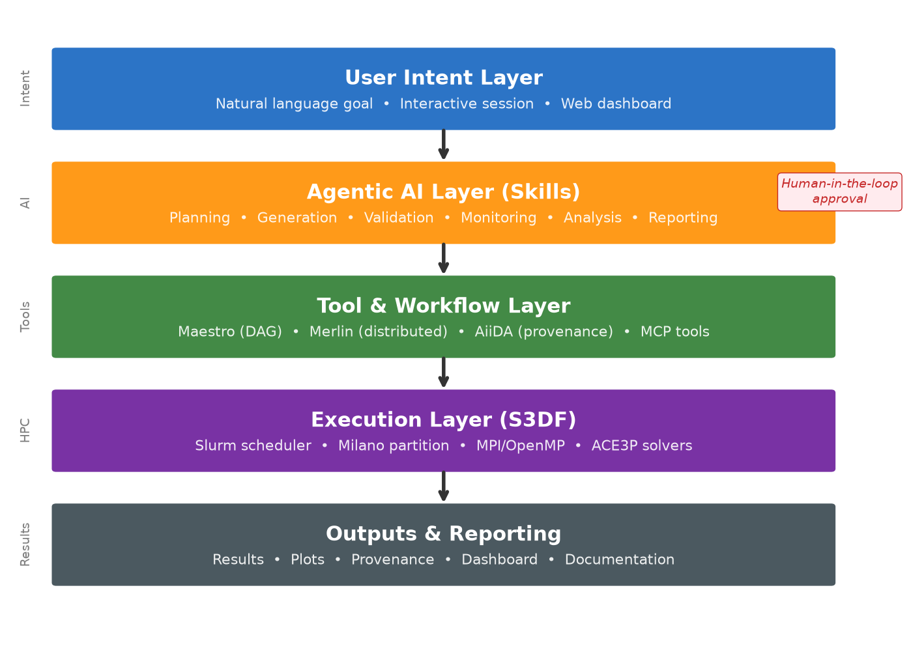
Fig. 1. Agentic workflow architecture for S3DF. The assistant coordinates skills, workflow tools, scheduler access, and dashboard reporting while leaving execution to established infrastructure.
The user-facing entry point may be a command-line interface, a web dashboard, or an interactive coding assistant. The user states a goal such as running a Track3P parameter sweep or comparing MPI/OpenMP configurations. The agentic assistant decomposes the request into a workflow plan, chooses appropriate skills, generates workflow artifacts, validates them, and prepares execution instructions. The execution itself remains under human approval and is performed by standard S3DF mechanisms.
The architecture is intentionally layered. The agent does not need to understand every implementation detail of Slurm or Maestro. Instead, reusable skills expose bounded capabilities. For example, a workflow generation skill creates a Maestro specification, a validation skill checks required files and dependencies, a monitoring skill summarizes scheduler or workflow status, and a reporting skill creates a reproducibility note. This factoring makes the system extensible and safer than a monolithic autonomous agent.

A. Human-in-the-loop execution
The framework is designed for human-in-the-loop operation. The agent can suggest plans, generate scripts, summarize failures, and recommend fixes, but domain-specific decisions remain with the user. This design is important in a shared HPC environment. Generated resource requests may affect facility utilization, generated input files can affect scientific validity, and automatic reruns can consume substantial allocation. In our model, the user approves workflow artifacts before launch and approves any rerun or repair action proposed after failure diagnosis.

IV. SKILLS AND MCP-BASED TOOL INTEGRATION
A skill is a reusable agent capability with a defined purpose, inputs, outputs, and validation expectations. Skills provide an intermediate layer between free-form language and low-level infrastructure calls. Table I summarizes the skills currently targeted by the prototype.
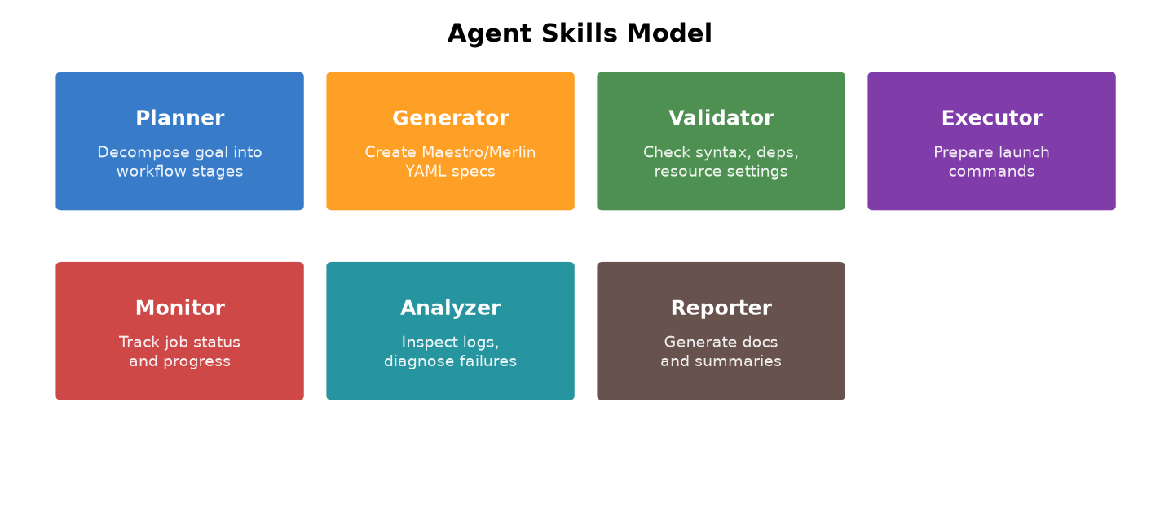
TABLE I. Agent skills considered in the S3DF workflow prototype.
Skill | Responsibility | Representative artifact
Planning | Decompose user goals into workflow stages and dependencies. | Workflow plan
Generation | Create workflow specifications, templates, and scripts. | Maestro YAML, Slurm script
Validation | Check files, parameters, dependencies, and resource settings. | Validation report
Submission | Prepare launch commands and execution checklist. | maestro run command
Monitoring | Summarize queued, running, completed, and failed states. | status.json
Analysis | Parse logs, detect failures, and summarize results. | summary.csv, diagnosis
Reporting | Generate documentation and reproducibility notes. | report.md
Skills may call local scripts, workflow tools, or MCP-enabled tools. MCP is relevant because it standardizes how AI applications connect to external services such as repositories, file systems, databases, or development environments [5]. In the S3DF context, future MCP servers could expose scheduler queries, project directories, GitHub repositories, dashboard state, or ACE3P-specific metadata. The agent would remain a coordinator, while the MCP servers and workflow systems would provide controlled access to real infrastructure.
This distinction clarifies why workflow tools and AI assistants are complementary. Claude Code or another LLM can help generate a workflow, but it is not itself a durable workflow engine. Maestro can run dependency-based studies, Merlin can coordinate large campaigns, AiiDA can preserve provenance, and Slurm can schedule jobs. The agentic layer helps users select and combine these tools in response to scientific goals.

V. IMPLEMENTATION ON S3DF
The prototype implementation is organized in the s3df-workflow repository [7]. The repository describes an effort to evaluate and enable scientific workflow automation technologies on S3DF, including workflow orchestration, AI-assisted workflow generation, and workflow monitoring interfaces. It contains directories for documentation, Maestro specifications, Merlin examples, AiiDA concepts, AI-assisted workflow generation, dashboard integration, and a conda environment.
s3df-workflow/
docs/
maestro/
merlin/
aiida/
ai-assist/workflow-generator/
dashboard-integration/
environment.yml
Fig. 2. Current repository organization used to separate workflow tools, agentic workflow development, and dashboard integration.
The AI-assisted workflow generator translates natural-language workflow descriptions into workflow specifications. Example requests include Omega3P frequency sweeps, Track3P gradient studies, mesh convergence studies, or large geometry sweeps. In the agentic model, this generator becomes one skill within a broader lifecycle that also includes validation, monitoring, analysis, and reporting.
The dashboard component is treated as a user-facing interface rather than as the workflow engine itself. The dashboard can display workflow status, job progress, input summaries, and result visualizations. The workflow repository provides the automation and execution logic, while the dashboard exposes that logic to users in a more accessible form. This separation makes the framework applicable to other applications beyond ACE3P.

VI. ACE3P CASE STUDY
ACE3P is a parallel electromagnetic simulation suite used for accelerator modeling. It includes modules such as Omega3P, S3P, T3P, Track3P, Pic3P, and TEM3P [8]. ACE3P workflows commonly involve input preparation, mesh generation, solver execution, post-processing, parameter studies, and visualization. These characteristics make ACE3P a realistic demonstration application for the proposed framework.

A. MPI/OpenMP performance workflow
The primary demonstration workflow is an MPI/OpenMP performance study. The user specifies a solver configuration, a set of node counts, MPI ranks, and OpenMP thread counts. The planning skill constructs a parameter matrix. The generation skill creates a Maestro workflow and Slurm templates. The validation skill checks that all parameter combinations are represented and that output directories are unique. After user approval, the workflow is launched on S3DF. The monitoring skill produces a status summary, and the analysis skill extracts runtime and scaling metrics. The reporting skill generates a summary suitable for the dashboard and for later reproducibility.
This case is attractive because it produces measurable outputs: runtime, speedup, efficiency, failure counts, and workflow setup overhead. It also connects directly to an important HPC modernization use case. The same pattern can support performance studies for other codes running on S3DF.

B. Track3P parameter sweep
A second candidate workflow is a Track3P gradient sweep. The user specifies a field-level range, a baseline input template, and post-processing quantities of interest. The workflow assistant generates a sweep table, creates per-case input directories, constructs a workflow specification, prepares Slurm submission scripts, and collects summary results. Compared with the performance study, this workflow more directly shows scientific campaign automation but may require more domain-specific parsing. Both cases are useful: the performance workflow emphasizes measurable evaluation, while the Track3P sweep demonstrates physics-oriented workflow automation.
Fig. 4. End-to-end execution pipeline from natural language input to physics results (~5 minutes total on S3DF).
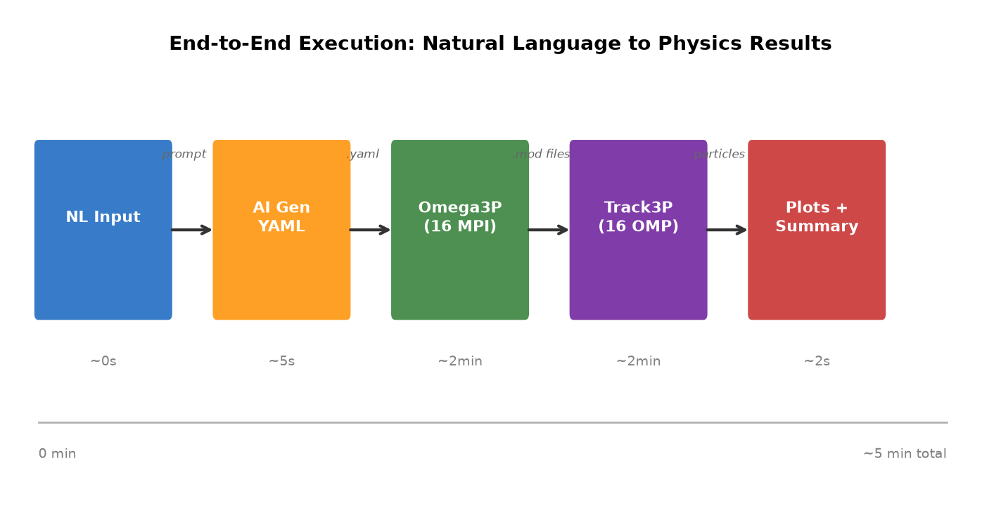
Fig. 5. Multipacting analysis results: impact energy vs. field level for the CW23 Pillbox cavity (auto-generated by workflow post-processing).
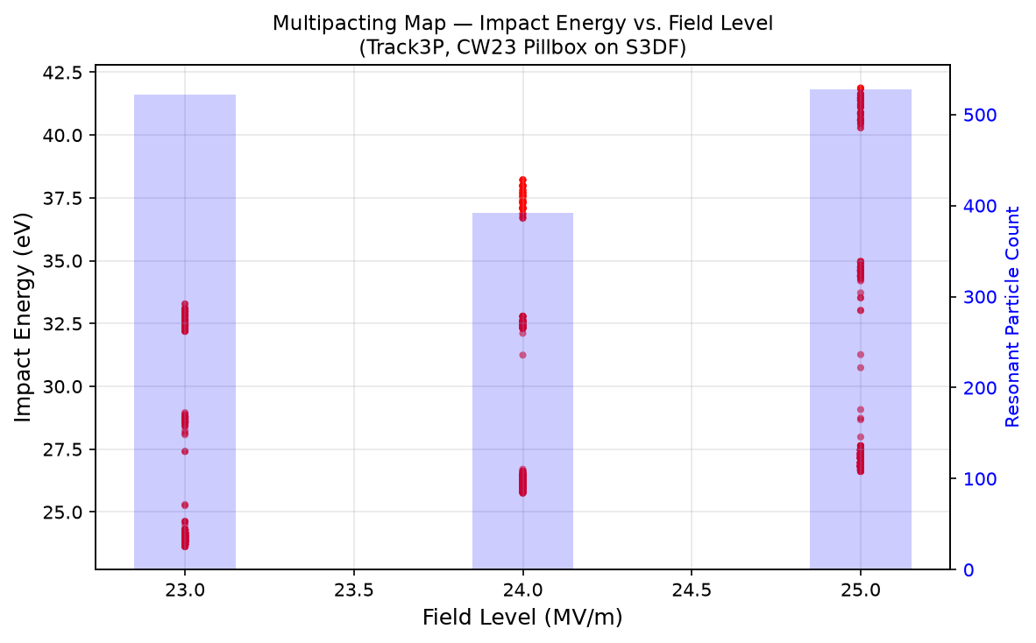

C. Application-agnostic workflow design
Although ACE3P is used as the first demonstration, the framework is not ACE3P-specific. The same agentic workflow pattern can be applied to AI/ML training workflows, detector simulations, Geant4 studies, data-analysis pipelines, or other scientific applications that require multi-step execution, monitoring, and reporting. The application-specific pieces are primarily prompt templates, parsers, and validation rules; the lifecycle architecture remains the same.

VII. EVALUATION
The evaluation strategy focuses on workflow utility rather than model benchmarks. The goal is to determine whether agentic assistance reduces effort and improves reliability for workflow creation and operation. Table II summarizes the planned metrics.
TABLE II. Evaluation metrics for agentic workflow automation.
Metric | Definition | Evidence
Time-to-first-workflow | Elapsed time from user request to first executable workflow. | Manual vs agent-assisted comparison.
Manual steps eliminated | Number of shell, scheduler, and editing steps replaced by generated artifacts. | Workflow logs and user action counts.
Workflow validity | Fraction of generated workflows passing validation before launch. | Validation results.
Execution completion | Fraction of workflow steps completed successfully. | Maestro/Slurm status.
Monitoring coverage | Ability to expose queued, running, completed, and failed states. | status.json and dashboard output.
Failure diagnosis usefulness | Quality of log interpretation and recommended actions. | Representative failure cases.
Reproducibility coverage | Metadata captured for rerun and interpretation. | Parameters, scripts, versions, outputs.
The current prototype already provides the repository structure, workflow-tool evaluation path, AI-assisted workflow generation component, and dashboard integration concept. The next evaluation step is to execute a controlled ACE3P demonstration and compare manual implementation against agent-assisted workflow construction. The paper draft therefore distinguishes between implemented prototype artifacts and planned evaluation metrics. A mature submission should include at least one end-to-end workflow execution and a small productivity comparison.
Reproducibility is a central evaluation criterion. WORKS26 encourages software and data artifacts where appropriate [1]. For this project, reproducible artifacts can include sanitized workflow specifications, synthetic or shareable input templates, generated Slurm scripts, status logs, post-processing scripts, and dashboard screenshots. Sensitive SLAC paths, credentials, and non-public project data should be excluded from public artifacts.

VIII. PROTOTYPE WORKFLOW LIFECYCLE
To make the agentic workflow model concrete, this section describes the intended lifecycle of a representative ACE3P scaling workflow. The user starts with a goal rather than a precise workflow specification. For example, the user may ask the assistant to compare Track3P performance across several node counts, MPI ranks, and OpenMP thread counts and to summarize runtime behavior. The planning skill converts this request into a workflow plan consisting of case generation, execution, monitoring, log parsing, metric aggregation, and reporting.
The generation skill then creates three classes of artifacts. First, it creates a parameter table describing the run matrix. Second, it creates a workflow specification, initially using Maestro because Maestro provides a compact and readable representation of dependencies and command templates. Third, it creates supporting scripts, including Slurm templates and post-processing scripts for extracting runtime and convergence information. These generated artifacts are stored in a workflow workspace so that the user can inspect them before execution.
The validation skill performs a preflight check. This check should confirm that the workflow contains expected stages, that generated directories are unique, that required input templates exist, that resource requests are within user-specified ranges, and that post-processing scripts reference known output files. The goal is not to prove scientific correctness, but to catch common workflow construction errors before using shared resources. The validation report becomes part of the reproducibility record.
The submission skill prepares launch instructions but does not automatically submit expensive runs without user approval. For a small demonstration workflow, the user may approve immediate execution. For larger campaigns, the assistant can generate a dry-run summary and ask for confirmation. During execution, the monitoring skill collects scheduler and workflow state and converts it into a compact representation suitable for a dashboard. After execution, the analysis skill extracts metrics and the reporting skill writes a short summary describing the workflow, inputs, resource choices, outputs, failures, and suggested follow-up actions.
Goal: compare Track3P MPI/OpenMP performance
Plan: generate cases -> validate workflow -> launch -> monitor -> analyze -> report
Artifacts: cases.csv, workflow.yaml, submit.slurm, status.json, summary.csv, report.md
Human control: approve generated artifacts and approve any large rerun
Fig. 3. Example user-visible lifecycle for an agent-assisted ACE3P workflow.

IX. DESIGN CONSIDERATIONS FOR SHARED HPC FACILITIES
Deploying agentic workflow assistance in a shared HPC environment introduces practical constraints that are different from those of a local coding assistant. First, resource usage must be explicit. An agent should not silently increase node counts, wall time, or job arrays without user approval. Second, credential boundaries must be respected. The assistant should not expose tokens, private paths, or internal project information in public artifacts or logs. Third, generated workflows should be auditable. Users and support staff should be able to inspect exactly what the assistant produced and what commands were executed.
These constraints motivate a conservative implementation strategy. The framework should start with advisory and artifact-generation capabilities, then gradually add controlled execution support. The first useful version can generate workflows, Slurm scripts, validation reports, and documentation while requiring the user to execute or approve runs. A later version can integrate MCP-enabled tools for scheduler queries and dashboard updates, but should continue to preserve visible intermediate artifacts and user approval points.
A second design consideration is portability across communities. S3DF users include simulation, data-analysis, and AI/ML users. A framework that hard-codes ACE3P logic would have limited facility-level value. Therefore, the architecture separates generic workflow skills from application-specific templates and parsers. The same planning, validation, monitoring, and reporting skills can be reused, while ACE3P-specific logic is isolated in templates, prompt context, and post-processing scripts. This design makes it possible to add new applications without redesigning the agentic framework.

X. DISCUSSION
The core design principle is that AI coordinates existing tools. This principle is important for both technical reliability and organizational adoption. Replacing Slurm, Maestro, Merlin, or AiiDA with an LLM would be neither robust nor desirable. Instead, agentic AI can make these tools easier to use by generating initial artifacts, explaining configuration choices, checking workflow structure, interpreting logs, and creating documentation.
The skills model also supports gradual adoption. The first useful version of the system does not need full autonomy. A workflow generation skill and validation skill can already reduce friction for users who are learning Maestro. A monitoring skill can help summarize large job campaigns. A reporting skill can improve reproducibility and onboarding. These skills can be added incrementally, tested independently, and connected to MCP-style tool access as the S3DF AI infrastructure matures.
There are also risks. Generated workflows may be syntactically valid but scientifically inappropriate. LLMs can produce invalid resource requests or hallucinated tool options. Automated agents may be tempted to rerun jobs without understanding compute cost. For these reasons, the design retains human approval, explicit artifacts, validation checks, and transparent logs. The goal is assisted automation, not unchecked autonomy.

XI. ARTIFACT PLAN AND REPRODUCIBILITY
The project is intended to produce artifacts that are useful both to reviewers and to future S3DF users. The first artifact category is workflow specifications. These include sanitized Maestro YAML files, generated parameter tables, and Slurm templates that demonstrate the transformation from a user goal to executable workflow artifacts. The second category is execution evidence, including status files, standard output logs, post-processing summaries, and dashboard-ready JSON records. The third category is documentation, including agent-generated reports that describe input assumptions, resource choices, workflow stages, outputs, and failures.
For a WORKS26 submission, the most useful artifact is a self-contained small workflow that can be run without access to internal SLAC data. A synthetic ACE3P-like workflow can demonstrate the same lifecycle as the production workflow: parameter generation, workflow validation, scheduler script generation, status collection, and summary reporting. The actual production demonstration on S3DF can be described separately, while the public artifact can preserve the software pattern without exposing sensitive paths or inputs.
A reproducibility record should include the user request, generated plan, workflow specification, scheduler template, environment description, validation results, status summary, and final report. This record is intentionally lightweight. The goal is not to require every user to operate a full database-backed provenance system for every exploratory run, but to make reproducibility metadata available by default and to provide a path toward deeper AiiDA integration when publication-grade provenance is needed.
The artifact plan also supports facility adoption. S3DF support staff could use small demonstration workflows for training, benchmarking, and onboarding. Domain teams could adapt the templates to their own applications. The agent skills would remain generic, while application-specific prompt context and parsers could be added gradually. This makes the prototype useful as a facility-facing capability rather than as a single-application script collection.

XII. LIMITATIONS AND THREATS TO VALIDITY
The current work is a prototype and should be interpreted as such. The main limitation is that the evaluation is not yet a large user study. Productivity claims must therefore be framed carefully. The paper can measure time-to-first-workflow and manual steps eliminated for controlled demonstrations, but broader claims about scientific productivity require future evaluation with multiple users and applications.
A second limitation is the dependence on generated text. LLMs can produce plausible but incorrect workflow specifications. They may invent command-line options, omit environment modules, or generate resource combinations that are not appropriate. This risk is reduced by constraining the assistant through skills, templates, validation checks, and human approval, but it cannot be eliminated entirely. The framework therefore treats generated artifacts as drafts requiring review rather than as final authoritative results.
A third limitation is that workflow systems have different strengths. Maestro is clear and lightweight for dependency-based workflows, but it is not the only possible execution backend. Merlin is more appropriate for very large campaigns, while AiiDA is stronger for provenance-heavy studies. The proposed architecture avoids committing to a single workflow engine by placing engine-specific logic behind skills and tool interfaces. However, this also means that different application teams may need different skill implementations.
Finally, a shared HPC environment imposes policy and security constraints. Agents must not expose credentials, violate file-system permissions, or issue expensive job submissions without explicit approval. These constraints may make the system less autonomous than some agentic AI demonstrations, but this conservatism is appropriate for scientific computing facilities. Usability, transparency, and auditability are more important than maximizing autonomy.

XIII. FUTURE WORK
Future work will proceed in four directions. First, the prototype will be extended from workflow generation toward full lifecycle support, including validation, monitoring, failure analysis, and reporting. Second, MCP-style tool interfaces will be explored for scheduler queries, repository access, file-system interactions, dashboard data, and domain-specific ACE3P metadata. Third, provenance capture will be expanded using AiiDA-inspired metadata models and, where appropriate, AiiDA integration. Fourth, the framework will be demonstrated on additional S3DF workloads beyond ACE3P to test application-agnostic design assumptions.
A longer-term vision is an S3DF workflow assistant that helps users express scientific goals, select appropriate workflow tools, generate executable artifacts, monitor execution, interpret failures, and produce reproducibility records. Such an assistant would not replace existing workflow tools; it would provide a more accessible front end and coordination layer for those tools.

XIV. CONCLUSION
This paper presented a draft architecture and implementation direction for agentic scientific workflow automation on S3DF. The framework combines workflow skills, MCP-style tool integration, workflow technologies, scheduler interfaces, and dashboard monitoring to assist users across the workflow lifecycle. ACE3P provides a realistic first case study, but the architecture is intended to benefit the broader S3DF community. The key insight is that agentic AI should coordinate existing workflow and HPC tools rather than replace them. By reducing manual workflow setup, improving monitoring, supporting troubleshooting, and producing reproducibility documentation, agentic workflow assistants may become a practical mechanism for improving productivity in large-scale scientific computing environments.

ACKNOWLEDGMENT
The author thanks Cho-Kuen Ng, Jay, Yee, and colleagues in the SLAC scientific computing community for discussions on workflow automation, S3DF user productivity, and AI-assisted development. This work was motivated in part by workflow automation training materials and by ongoing efforts to improve scientific workflow usability on shared HPC systems.

REFERENCES
[1] WORKS26, "21st Workshop on Workflows in Support of Large-Scale Science," 2026. [Online]. Available: https://works-workshop.org/
[2] LLNL, "Maestro Workflow Conductor." [Online]. Available: https://github.com/LLNL/maestrowf
[3] LLNL, "Merlin: Machine Learning for HPC Workflows." [Online]. Available: https://github.com/LLNL/merlin
[4] AiiDA Team, "AiiDA computational science workflow manager." [Online]. Available: https://aiida.net/
[5] Anthropic, "Introducing the Model Context Protocol," Nov. 2024. [Online]. Available: https://www.anthropic.com/news/model-context-protocol
[6] NERSC, "Automating HPC Research Workflows on Perlmutter," 2026. [Online]. Available: https://www.nersc.gov/news-and-events/calendar-of-events/workflows-may-2026
[7] L. Ge, "s3df-workflow: Scientific workflow automation for S3DF," GitHub repository, 2026. [Online]. Available: https://github.com/lge0303/s3df-workflow
[8] SLAC, "ACE3P - Advanced Computational Electromagnetic Simulation Suite." [Online]. Available: https://confluence.slac.stanford.edu/spaces/AdvComp/pages/59146951/ACE3P+-+Advanced+Computational+Electromagnetic+Simulation+Suite
[9] SchedMD, "Slurm Workload Manager." [Online]. Available: https://slurm.schedmd.com/
[10] L. Ge, "ace3p-dashboard," GitHub repository, 2026. [Online]. Available: https://github.com/lge0303/ace3p-dashboard

