
Annex E – Participant Connectivity
  - Automated Transfer System Upgrade Delivery Project

Copyright © 2025 Montran
  - National Bank of Georgia
Version: | 1.03
Date: | 2025-11-11

Document Control
Title: | Annex E – Participant Connectivity
Code: | GE_ATS_Upgrade_D001_Participant_Connectivity
Project: | Georgia Automated Transfer System Upgrade Delivery Project
Confidentiality: | BUSINESS USE ONLY
Integrity: | HIGH
Availability: | MEDIUM
Deliverable: | YES
Version: | 1.03

Document Ownership
Nature of involvement | Name | Institution | Role
Owned by: | Adrian Sover | Montran | Technical Lead
First Draft by: | Adrian Sover | Montran | Technical Lead
Last Verified by: | Andreea Radu | Montran | Business Analyst
Reviewed by: | Nucu Dumitrascu | Montran | Project Manager
Approved by: | NBG Payments, IT and Security Teams | National Bank of Georgia | NBG Payments, IT and Security Teams
Distributed to: | Malkhaz Nikolashvili | National Bank of Georgia | Project Manager

Document History
Date | Version | Status | Changes
2025-02-12 | 0.01 | DRAFT | First draft sent to National Bank of Georgia
2025-03-27 | 0.02 | DRAFT | Applied changes to the document according to the NBGs comments and Montran responses. Closed all comments where responses were offered. Version sent to NBG for review and clarifications.
2025-06-17 | 1.00 | FINAL | Final version approved by NBG. Version sent for sign-off.
2025-10-13 | 1.01 |  | Changed digital signature approach and fixed typos.
2025-11-03 | 1.02
2025-11-11 | 1.03 |  | Digital signature update.

Use of this document, in conjunction with the PRODUCT is subject to the written agreement(s) between Montran and its customer. Use not contemplated by the written agreement(s) is expressly not permitted. This document may not be copied, redistributed, or used in any manner outside that which is permitted in the written agreement(s), except with written consent of Montran. Ownership in and copyright to this document remains with Montran at all times.

Table of Contents
Table of Contents 4
1. Introduction 6
Overview 6
2. Overview of the System Interface 7
2.1. Prerequisites for participants 7
2.2. Running the Gateway Application 8
2.3. Gateway Configuration 9
2.4. Gateway Monitor 11
3. Technical information 12
3.1. Gateway files and structure 12
3.2. Interface between Participant Core Banking and Montran Gateway 13
3.2.1. JMS API Based Interface 13
3.2.2. File-based Interface 14
3.3. Message Formats 15
3.4. Message signing technical requirements 15
3.4.1. Overview 15
3.4.2. Digital signature format 15
3.5. Direct API access 24
3.5.1. Technical details 25
3.5.2. Supported Transport Message Types 26
3.5.3. JMS Message Header Properties 26
3.5.4. Confirmation Protocol 27

Introduction

Overview
Montran Gateway is a complete solution to integrate ATS System with Participant bank’s back-office and client services. It links the bank’s existing internal systems with the ATS via JMS API over Virtual Private Network (VPN) for Straight-Through Processing (STP) of all payment and message traffic.
Montran Gateway communicates with the Back-Office Applications through a file-based connection or through JMS API message-oriented middleware (referred to as MQ below). These two connection types are explained in the following sections.

Overview of the System Interface

Prerequisites for participants
To run Montran Gateway application on the workstation, a set of steps should be followed. Please note that this configuration should be done for each workstation that needs to run the Gateway application.
The following steps are needed for the Gateway environment:
- Java installation. Oracle Java can be used if a usage license is acquired from Oracle. As an alternative an open-source JAVA version can be used. We recommend Azul implementation of IcedTea-Web and Zulu OpenJDK build version 8.
- Download Zulu OpenJDK version 8 as zip and extract it. The following link https://www.azul.com/downloads/?version=java-8-lts&package=jdk can be used. The extracted result can be placed anywhere on disk. Remember the path location. E.g.: c:\Java\jdk8.0.312-zulu8.58.0.13.
- Set the JAVA_HOME and PATH variables to the location where the JDK was extracted. In Windows using Command Prompt (cmd), run the following two commands:
setx JAVA_HOME "C:\Java\<jdk8_location>"
setx PATH "%PATH%;%JAVA_HOME%\bin"
Where <jdk8_location> is the location of the extracted JDK as described at point 2. E.g.: c:\Java\jdk8.0.312-zulu8.58.0.13.
After the above commands are executed, open a new command prompt and run the command:
java -version
The following output (or similar) should be displayed:
openjdk version "1.8.0_312"
OpenJDK Runtime Environment (Zulu 8.58.0.13-CA-win64) (build 1.8.0_312-b07)
OpenJDK 64-Bit Server VM (Zulu 8.58.0.13-CA-win64) (build 25.312-b07, mixed mode)
- Download Java Webstart. This software does not come with the JDK package anymore and needs to be installed manually. The product is also open-source and is called IcedTea-Web. Please follow the instructions provided here https://docs.azul.com/core/icedteaweb/installation to install IcedTea-Web.
There will be two important applications inside it:
- itweb-settings.exe
- javaws.exe
- IcedTea-Web has to be configured to use the Java JDK as follows: Open its settings by running itweb-settings.exe.
From the configuration, go to “JVM Settings” and on the second text box labeled “Set JVM for IcedTea-Web” set the path to your JAVA. E.g: C:\Java\jdk8.0.312-zulu8.58.0.13\jre.
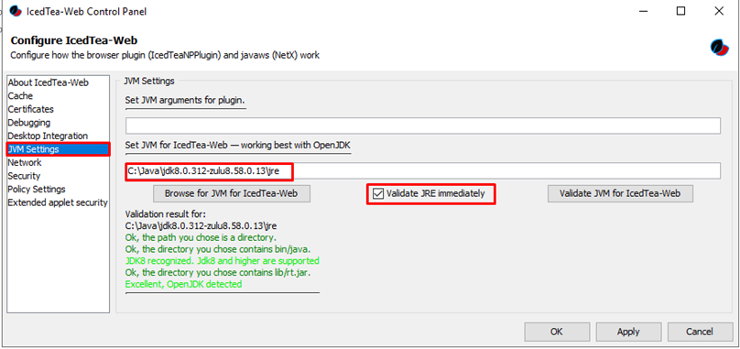
Check that it passed the auto validation, then save the settings.
- Next, enable Java Console logging. This helps when debugging is required.
Go to “Debugging”.
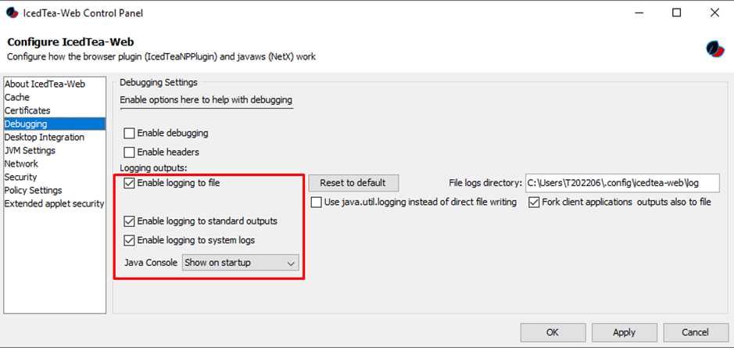

Running the Gateway Application
Montran Gateway application uses JAVA Web Start technology to facilitate application delivery via HTTPS.
To start Montran Gateway, participants must use the ATS menu entry: Routing -> Gateway.
Click Start.
The Gateway is downloaded to the workstation (file name “Gateway(x)”, extension “. jnlp”).
Please note that is not necessary to click Start each time Gateway requires starting. When a new session is started, after the selected Gateway configuration was complete and saved on disk (details in sub-chapter “Gateway Configuration”), open the previous saved jnlp file, click OK and follow the steps described in the second paragraph below.
Open the jnlp file.
- If Gateway is accessed for the first time:
A screen with Gateway configuration options is displayed (details in sub-chapter “Gateway Configuration”). This allows the user to specify the operation mode and the transport queues.
- If Gateway is accessed after the initial configuration:
A screen with Gateway reconfiguration options is displayed. If the initial configuration persisted on the disk is ok, click No.
Click OK.
Now the Gateway session is open and the Monitoring Screen of the Gateway opens (details in the section “Gateway Monitor”).

Gateway Configuration
Gateway configuration allows the user to specify the operation mode and the MQ message queues or directories on Participant’s Core Banking used in the STP process.
Two connectivity modes between the Gateway and the Participant Core Banking System are available.
- File connection
In this mode communication is done through a shared set of input and output directories through which payment files are exchanged between Gateway and the Participant core banking.
Select the File Settings tab, and fill in the Input/Output Folder fields, using the browse button (...).
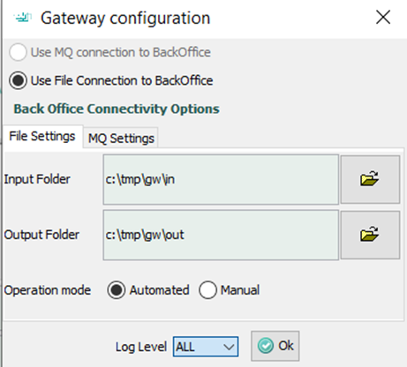
Neither the input nor the output folder cannot be the root of a drive or located in a directory where Gateway has no access rights.
If the mode of operation is Automated, the files will be automatically collected by the Gateway and will be sent to the ATS.
If the mode is Manual, no files will be automatically collected and sent by the Gateway to the ATS. In this case, the user must select the message required to be sent, by right clicking each file and choosing the option "Send".
Then click OK.
- MQ connection
Select the MQ Settings tab and fill in
  - the Inbound/Outbound Queue and Factory text fields
  - context type that can be either
    - generic JMS API (FsContext) and it is using a .bindings path field
    - specific MQ provider such as WEBSPHERE SIB.
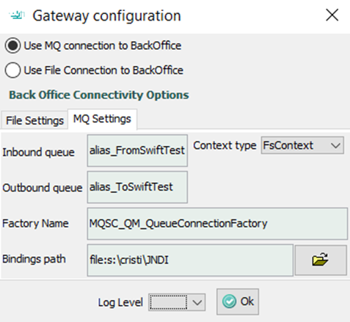
Then click OK.
The selected configuration is stored on disk, the next time Gateway is started the same settings will be used.
Log Level

Gateway Monitor
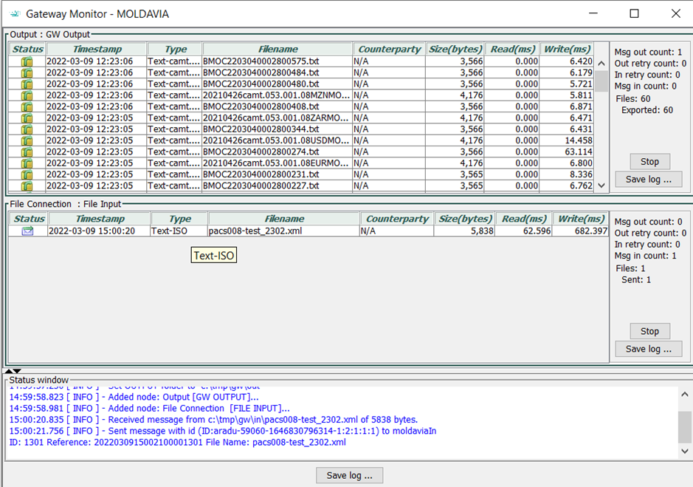
Gateway Monitor shows statistics for input and output in both cases:
- Msg in – messages received;
- Msg out – messages sent;
- In/Out Retry count – number of retries to perform the receive/send operation in case of communication failure.
Use the Stop buttons to stop the file transmission.
To close the application, use the Close Window button.

Technical information

Gateway files and structure
The gateway configuration is stored in the <USERPROFILE>\gateway folder. The filename is gatewayConfiguration.xml.
The gateway logs are stored in the <USERPROFILE>\gateway\log folder. The filename is either gateway.log (for the latest log) or gateway.log.<YYYY-MM-DD> (for the archived logs).
If JAVA console is enabled for the Java WebStart then at each Gateway run the console log will show up and list debugging information.
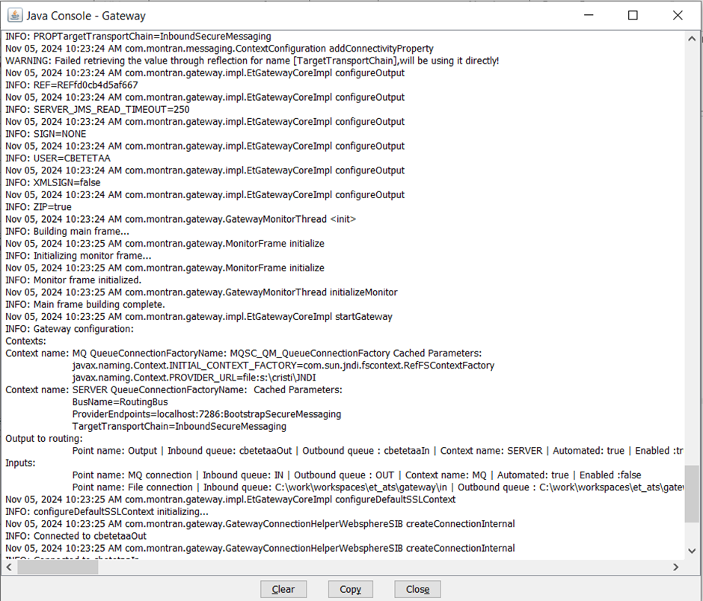

Interface between Participant Core Banking and Montran Gateway

JMS API Based Interface
This interface provides communication through a pair of input and output queues, that reside on an MQ Server through which payment messages are exchanged between Gateway and the Participant Core Banking
Two queues need to be created in Participant’s MQ:
- One for the messages from the back-office application to the Montran gateway (IN) and
- One for the messages from the Montran gateway to the back-office application (OUT).
- Queue names and JMS API connectivity details (e.g. JNDI descriptor) are defined when the Gateway is first started. Any JMS compliant server can be used, such as IBM MQ, IMQ, ActiveMQ, etc.
If plain JMS API mode is used then Gateway requires the existence of a .bindings file whose location has to be specified in Gateway configuration screen as previously shown.

Bindings file:
The .bindings file is created by the Participant (for example when using IBM MQ there is a GUI as well as script option for creating the .bindings file using MQExplorer util).
For other JMS server providers, the .bindings file can be created either programmatically using a Java program or via the tools provided by the JMS provider.
The .bindings file can be programmatically loaded with the help of “com.sun.jndi.fscontext.RefFSContextFactory” initial context. See https://docs.oracle.com/cd/E19340-01/820-6767/aeqbb/index.html

JMS Providers
JMS providers IBM MQ and Glassfish iMQ are supported by default. Other JMS providers also supported if client libraries (each provider has a specific set of needed client libraries) of the provider are copied to the JRE’s lib\ext\ directory on the workstation running Gateway.

JMS requirements for exchanged data
When using the JMS interface please note the following requirements:
- Exchanged messages are instances of JMS API TextMessage class.
- The following JMS string properties are mandatory:
  - DESTINATION with value
    - ‘RTGS’ for high value payments
    - ‘FP’ for low value payments
  - MSG_TYPE with value
    - ‘ISO’ for high value payments
    - ‘SEPA’ for low value payments
  - FILENAME containing the name of the file
Messages received by the Gateway from central systems (ATS/CSD) have other JMS properties but they should be ignored by the Participant’s core banking system unless specifically instructed that some property is to be interpreted

File-based Interface
This interface uses two directories IN and OUT (the exact location is defined when the Gateway is first started).
In the IN directory, the back-office application will place files (in ISO 20022 format) and Gateway will scan the directory for new files every few seconds. As soon as a new file is placed in the IN directory, the Montran gateway reads it, validates it and sends it to the ATS system.
In the OUT directory, the Montran Gateway will place the files received from the ATS System.
The participant has the responsibility of transferring the files from the back-office application to the IN directory and taking the received files from the OUT directory.
The folder structure for file connection option is:
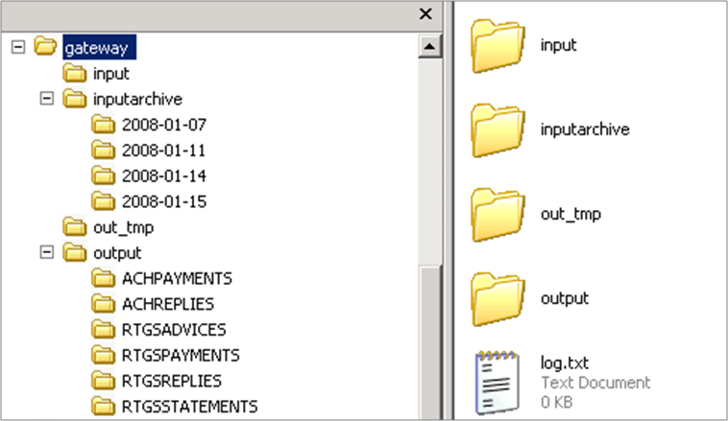
Where:
- “input” and “output” are the folders selected in the configuration dialog. “input” folder is used to pick up messages prepared by the Participant Core Banking system. The “output” folder contains several subfolders that will hold the different categories of messages. These folders must be polled by the Participant Core Banking system.
- “inputarchive” and “log.txt” are placed in the same folder as “input”. “inputarchive” contains subfolders containing daily archived messages that were received by the CBS and sent to ATS
- “out_tmp” is placed in the same folder as “output”. “out_tmp” is for the gateway's internal use

Message Formats
Messages exchanged between Participant Core Banking system and the ATS System are ISO 20022 IAP1.2 for high value payments (RTGS) and ISO 20022 for low value payments (ACH).

Message signing technical requirements
There are some technical requirements that must be implemented by Core Banking System in order to support signing/verification of messages.

Overview
All messages exchanged via STP are digitally signed. Montran Gateway can digitally sign the messages itself just before sending to ATS or the Participant Core Banking System can digitally sign the messages before sending them through the Gateway.

Digital signature format
The exchanged XML messages are digitally signed using XML Signature. This provides authentication, message integrity and non-repudiation of origin.
The standard for XML Signature type digital signature is described in the following URL: https://www.w3.org/TR/xmldsig-core1/ and it is configured with the following parameters:
- Signature: http://www.w3.org/2000/09/xmldsig#
- CanonicalizationMethod / Content Encoding: http://www.w3.org/TR/2001/REC-xml-c14n-20010315
- Enveloped Transformation: http://www.w3.org/2000/09/xmldsig#enveloped-signature
- Signature Method: http://www.w3.org/2001/04/xmldsig-more#rsa-sha256
- Digest Method: http://www.w3.org/2001/04/xmlenc#sha256
The signature is placed in the AppHdr tag in accordance with header schema (head.001.001.01 used for ACH messages and head.001.001.02 used for RTGS messages).
The signature must be applied to the whole document, i.e. the reference of the digital signature is the “Message” tag, meaning that the Reference URI must be empty, i.e. “”.
The certificate (PKI public key) used to sign the XML message must be attached in the signature information under the KeyInfo tag, as seen below.

Example messages:
- RTGS:
<Message xmlns="urn:montran:message.02">
<AppHdr xmlns="urn:iso:std:iso:20022:tech:xsd:head.001.001.02">
<Fr>
<FIId>
<FinInstnId>
<BICFI>PAVEGE22</BICFI>
</FinInstnId>
</FIId>
</Fr>
<To>
<FIId>
<FinInstnId>
<BICFI>BNLNGE22</BICFI>
</FinInstnId>
</FIId>
</To>
<BizMsgIdr>PAVE202509159722866080</BizMsgIdr>
<MsgDefIdr>pacs.008.001.08</MsgDefIdr>
<BizSvc>swift.iap.02</BizSvc>
<CreDt>2025-10-29T09:27:46+02:00</CreDt>
<Sgntr>
<Signature xmlns="http://www.w3.org/2000/09/xmldsig#" Id="MONT">
<SignedInfo>
<CanonicalizationMethod Algorithm="http://www.w3.org/TR/2001/REC-xml-c14n-20010315" />
<SignatureMethod Algorithm="http://www.w3.org/2001/04/xmldsig-more#rsa-sha256" />
<Reference URI="">
<Transforms>
<Transform Algorithm="http://www.w3.org/2000/09/xmldsig#enveloped-signature" />
<Transform Algorithm="http://www.w3.org/TR/2001/REC-xml-c14n-20010315" />
</Transforms>
<DigestMethod Algorithm="http://www.w3.org/2001/04/xmlenc#sha256" />
<DigestValue>Stv9Rasxe4WNK5NY+WKY7oQucGlL9QHPQHfaWoI0s4M=</DigestValue>
</Reference>
</SignedInfo>
<SignatureValue>Ma+fsnXz25mc2DartufkmgJem0FDH+uDOYV1kiSGijNODLkdFG/0RKTMz2RQq3C3PIu2uSA0OSe3 iZYwd1x7UZHMU0taAk+a5Ve+sBUKC7emn2uZti0ZyH9xWvuEh+MbcYBir1ncdEOPlHfa9Wjrb3Qe DuAoygxnyXStdkc+Qi/5DepCfumil88jOFl0Ko+3u4G3TazmlTcPGPfNpYXeW/c7HLJhzLuFxz0t aLqU7wsVjDcYORAwRqX747lKFNqBdciFjMnUa+Frd3q0QNzbhiW1YX63Csvng6rnAJnv3dBg5Xhp tkIsLrakDFksxQJxmb4rlUNEYwVcnPBlsSijeg==</SignatureValue>
<KeyInfo>
<X509Data>
<X509SubjectName>CN=pave</X509SubjectName>
<X509Certificate>MIIDaDCCAlCgAwIBAgIHA5uvwjS+XzANBgkqhkiG9w0BAQsFADB/MQswCQYDVQQGEwJVUzEMMAoG A1UEChMDSUJNMRcwFQYDVQQLEw5kZW1vcnRnc05vZGUxMjEbMBkGA1UECxMSZGVtb3J0Z3NOb2Rl MTJDZWxsMRkwFwYDVQQLExBSb290IENlcnRpZmljYXRlMREwDwYDVQQDEwhkZW1vcnRnczAeFw0y NTEwMjcxMTI3NDBaFw0zNTEwMjUxMTI3NDBaMA8xDTALBgNVBAMTBHBhdmUwggEiMA0GCSqGSIb3 DQEBAQUAA4IBDwAwggEKAoIBAQCzROKrlbfc5oPW+rOB194H+FVbr+jJYEVkb3p0NHnVt0Lvh0EI 9lU9+qct2XZBYbzp3cjrUv6p7Kzm+LApWCR4POYpqtilfoz4sZmtycpgZitLmISMHQB6X3X3siNZ 6BSicA2z/KWrJkpmZ3JHkiyKVgqCKwCz3k/CFen31xHLT3snOeBMbNmwwoOk0floRCxLrH1I4wB7 GWSbxCZW2MPUu44YExZQY/6JFcAYCFfdqQ+EoYV6F3cMQ31V25532F0ytODbwpA3dWae5S9YUdHu CIi9WTk9NnBBffxmVccImoDuAZ1JVwj6X/b17C93Q03LfJl1G8ESnqQe/tPdDK/3AgMBAAGjWTBX MBMGA1UdIwQMMAqACET00tkrnRteMB0GA1UdJQQWMBQGCCsGAQUFBwMBBggrBgEFBQcDAjAOBgNV HQ8BAf8EBAMCBsAwEQYDVR0OBAoECE80DqQ5ur8ZMA0GCSqGSIb3DQEBCwUAA4IBAQARiYo8ipq+ t2sQYPlnvPWN8Ashuu93BK4H4tNicHolgrgO44eIP6q54UFhAGBBkWmMFF3BNvBi3tuKX7i4kEPa P+sH4Ld23PcuRI8glJAJbkkI4foIfG7HvjF1hHoHp7PbuUCuGKYpWxxtu3xCj2J7e52A8YpCb2UX X5I0P0aLSgNZibPnfLMk5SUK3myMEqh8aid1mdNPIOLfvwg9Khml+bceoWqcLF7iejJoDH7kMDWU NxymqxEXWBu8jYyfIZ++sNnuE7lEUBvnvMs1BPiKvVhZPA3pIaI6RW2hJ4XyASOMoTWnGg7s4oHO OP0csvx+iTLs4b7DbEPtVWEdUKZp</X509Certificate>
</X509Data>
</KeyInfo>
</Signature>
</Sgntr>
</AppHdr>
<Document xmlns="urn:iso:std:iso:20022:tech:xsd:pacs.008.001.08">
<FIToFICstmrCdtTrf>
<GrpHdr>
<MsgId>PAVE202509159722866080</MsgId>
<CreDtTm>2025-10-29T09:27:46+02:00</CreDtTm>
<NbOfTxs>1</NbOfTxs>
<SttlmInf>
<SttlmMtd>CLRG</SttlmMtd>
<ClrSys>
<Cd>RTG</Cd>
</ClrSys>
</SttlmInf>
</GrpHdr>
<CdtTrfTxInf>
<PmtId>
<InstrId>PAVER92025091522866080</InstrId>
<EndToEndId>NOTPROVIDED</EndToEndId>
<TxId>PAVER92025091522866080</TxId>
<UETR>e3166c2e-c2be-4e0b-bc61-ad044eb99e45</UETR>
</PmtId>
<PmtTpInf>
<InstrPrty>HIGH</InstrPrty>
<SvcLvl>
<Prtry>TTC:1103</Prtry>
</SvcLvl>
<LclInstrm>
<Prtry>RTGSFIToFICustomerCredit</Prtry>
</LclInstrm>
<CtgyPurp>
<Cd>CASH</Cd>
</CtgyPurp>
</PmtTpInf>
<IntrBkSttlmAmt Ccy="GEL">123.00</IntrBkSttlmAmt>
<IntrBkSttlmDt>2025-09-15</IntrBkSttlmDt>
<ChrgBr>DEBT</ChrgBr>
<InstgAgt>
<FinInstnId>
<BICFI>PAVEGE22</BICFI>
</FinInstnId>
</InstgAgt>
<InstdAgt>
<FinInstnId>
<BICFI>BNLNGE22</BICFI>
</FinInstnId>
</InstdAgt>
<UltmtDbtr>
<Nm>Ultimate Debtor Mario Luca</Nm>
<PstlAdr>
<Dept>NOT_PROVIDED</Dept>
<SubDept>NOT_PROVIDED</SubDept>
<StrtNm>NOT_PROVIDED</StrtNm>
<BldgNb>NOT_PROVIDED</BldgNb>
<BldgNm>NOT_PROVIDED</BldgNm>
<Flr>NOT_PROVIDED</Flr>
<PstBx>NOT_PROVIDED</PstBx>
<Room>NOT_PROVIDED</Room>
<PstCd>NOT_PROVIDED</PstCd>
<TwnNm>NOT_PROVIDED</TwnNm>
<TwnLctnNm>NOT_PROVIDED</TwnLctnNm>
<DstrctNm>NOT_PROVIDED</DstrctNm>
<CtrySubDvsn>NOT_PROVIDED</CtrySubDvsn>
<Ctry>GE</Ctry>
</PstlAdr>
<Id>
<OrgId>
<Othr>
<Id>123456786</Id>
</Othr>
</OrgId>
</Id>
</UltmtDbtr>
<Dbtr>
<Nm>John Smith</Nm>
<PstlAdr>
<AdrLine>260</AdrLine>
</PstlAdr>
<Id>
<PrvtId>
<DtAndPlcOfBirth>
<BirthDt>1985-03-31</BirthDt>
<CityOfBirth>New Jersey</CityOfBirth>
<CtryOfBirth>US</CtryOfBirth>
</DtAndPlcOfBirth>
<Othr>
<Id>123456786</Id>
<SchmeNm>
<Cd>0000</Cd>
</SchmeNm>
</Othr>
<Othr>
<Id>7777788888</Id>
<SchmeNm>
<Cd>BILL</Cd>
</SchmeNm>
</Othr>
</PrvtId>
</Id>
</Dbtr>
<DbtrAcct>
<Id>
<IBAN>GE73HS5756486915421521</IBAN>
</Id>
</DbtrAcct>
<DbtrAgt>
<FinInstnId>
<BICFI>PAVEGE22</BICFI>
<ClrSysMmbId>
<ClrSysId>
<Cd>RTG</Cd>
</ClrSysId>
<MmbId>VRMPGE22</MmbId>
</ClrSysMmbId>
</FinInstnId>
</DbtrAgt>
<CdtrAgt>
<FinInstnId>
<BICFI>BNLNGE22</BICFI>
<ClrSysMmbId>
<ClrSysId>
<Cd>RTG</Cd>
</ClrSysId>
<MmbId>ZXPLGE22</MmbId>
</ClrSysMmbId>
</FinInstnId>
</CdtrAgt>
<Cdtr>
<Nm>Bill Johnson</Nm>
<PstlAdr>
<AdrLine>260</AdrLine>
</PstlAdr>
<Id>
<PrvtId>
<DtAndPlcOfBirth>
<BirthDt>1985-03-31</BirthDt>
<CityOfBirth>New Jersey</CityOfBirth>
<CtryOfBirth>US</CtryOfBirth>
</DtAndPlcOfBirth>
<Othr>
<Id>Cdtr Id</Id>
<SchmeNm>
<Cd>0000</Cd>
</SchmeNm>
</Othr>
</PrvtId>
</Id>
</Cdtr>
<CdtrAcct>
<Id>
<IBAN>GE74BS0693582930686165</IBAN>
</Id>
</CdtrAcct>
<UltmtCdtr>
<Nm>Ultimate Creditor Mario Luca</Nm>
<PstlAdr>
<Dept>NOT_PROVIDED</Dept>
<SubDept>NOT_PROVIDED</SubDept>
<StrtNm>NOT_PROVIDED</StrtNm>
<BldgNb>NOT_PROVIDED</BldgNb>
<BldgNm>NOT_PROVIDED</BldgNm>
<Flr>NOT_PROVIDED</Flr>
<PstBx>NOT_PROVIDED</PstBx>
<Room>NOT_PROVIDED</Room>
<PstCd>NOT_PROVIDED</PstCd>
<TwnNm>NOT_PROVIDED</TwnNm>
<TwnLctnNm>NOT_PROVIDED</TwnLctnNm>
<DstrctNm>NOT_PROVIDED</DstrctNm>
<CtrySubDvsn>NOT_PROVIDED</CtrySubDvsn>
<Ctry>GE</Ctry>
</PstlAdr>
<Id>
<PrvtId>
<Othr>
<Id>Ultimate Creditor Id</Id>
</Othr>
</PrvtId>
</Id>
</UltmtCdtr>
<RgltryRptg>
<Dtls>
<Inf>45.7640N 4.8357E</Inf>
</Dtls>
</RgltryRptg>
<RltdRmtInf>
<RmtId>QR channel</RmtId>
</RltdRmtInf>
<RmtInf>
<Ustrd>Payment details</Ustrd>
<Strd>
<RfrdDocInf>
<Nb>123</Nb>
<RltdDt>2025-05-30</RltdDt>
<LineDtls>
<Id>
<RltdDt>2025-05-31</RltdDt>
</Id>
</LineDtls>
</RfrdDocInf>
<CdtrRefInf>
<Tp>
<CdOrPrtry>
<Prtry>MCC</Prtry>
</CdOrPrtry>
</Tp>
<Ref>4655</Ref>
</CdtrRefInf>
<AddtlRmtInf>Electricity Invoice Nr: 89123123</AddtlRmtInf>
</Strd>
</RmtInf>
</CdtTrfTxInf>
</FIToFICstmrCdtTrf>
</Document>
</Message>

- ACH:
<env:Message xmlns:env="urn:montran:message.01">
<env:AppHdr xmlns="urn:iso:std:iso:20022:tech:xsd:head.001.001.01">
<Fr>
<FIId>
<FinInstnId>
<BICFI>PAVEGE22</BICFI>
</FinInstnId>
</FIId>
</Fr>
<To>
<FIId>
<FinInstnId>
<BICFI>GEATSAAA</BICFI>
</FinInstnId>
</FIId>
</To>
<BizMsgIdr>PAVE2025091597233568740</BizMsgIdr>
<MsgDefIdr>pacs.008.001.07</MsgDefIdr>
<BizSvc>ACH</BizSvc>
<CreDt>2025-10-29T07:35:56Z</CreDt>
<Sgntr>
<Signature xmlns="http://www.w3.org/2000/09/xmldsig#" Id="MONT">
<SignedInfo>
<CanonicalizationMethod Algorithm="http://www.w3.org/TR/2001/REC-xml-c14n-20010315" />
<SignatureMethod Algorithm="http://www.w3.org/2001/04/xmldsig-more#rsa-sha256" />
<Reference URI="">
<Transforms>
<Transform Algorithm="http://www.w3.org/2000/09/xmldsig#enveloped-signature" />
<Transform Algorithm="http://www.w3.org/TR/2001/REC-xml-c14n-20010315" />
</Transforms>
<DigestMethod Algorithm="http://www.w3.org/2001/04/xmlenc#sha256" />
<DigestValue>yjTeGVUaWZdjEDy7AGimdJPHflpVDek0JgyzlyrbmsI=</DigestValue>
</Reference>
</SignedInfo>
<SignatureValue>qWol2+9SbdCexqLXwYqulobQSsA0R3zYHHIt0kvTBztPhkkPw55frVeMHSeDD8imBMBudMF2pq+d NL9KVnLaAqg2whtDhCGneYt7a+CCh7K1UOHPpc7z72Gnyt0RZFicTLFoiHFhwutTxNQJHIEFAJ7L hCLoluy+HOPjsSjQb9vxteNxb2XTOROtQDlJqZGxUTd+CNC3i5s28gnOPwhz2JyEMwGLOB1+nMgZ VXcQrn4yuw66hCxKr2h9Rr6NyPZ98bNyDcDB6dH5kNS39Yi9uP/XQUw8ECBZI9lQpxX/W1ZqjXek 4vIst3ALudDtnXYFOYF6oGHYm4IpT7ghx8qygw==</SignatureValue>
<KeyInfo>
<X509Data>
<X509SubjectName>CN=pave</X509SubjectName>
<X509Certificate>MIIDaDCCAlCgAwIBAgIHA5uvwjS+XzANBgkqhkiG9w0BAQsFADB/MQswCQYDVQQGEwJVUzEMMAoG A1UEChMDSUJNMRcwFQYDVQQLEw5kZW1vcnRnc05vZGUxMjEbMBkGA1UECxMSZGVtb3J0Z3NOb2Rl MTJDZWxsMRkwFwYDVQQLExBSb290IENlcnRpZmljYXRlMREwDwYDVQQDEwhkZW1vcnRnczAeFw0y NTEwMjcxMTI3NDBaFw0zNTEwMjUxMTI3NDBaMA8xDTALBgNVBAMTBHBhdmUwggEiMA0GCSqGSIb3 DQEBAQUAA4IBDwAwggEKAoIBAQCzROKrlbfc5oPW+rOB194H+FVbr+jJYEVkb3p0NHnVt0Lvh0EI 9lU9+qct2XZBYbzp3cjrUv6p7Kzm+LApWCR4POYpqtilfoz4sZmtycpgZitLmISMHQB6X3X3siNZ 6BSicA2z/KWrJkpmZ3JHkiyKVgqCKwCz3k/CFen31xHLT3snOeBMbNmwwoOk0floRCxLrH1I4wB7 GWSbxCZW2MPUu44YExZQY/6JFcAYCFfdqQ+EoYV6F3cMQ31V25532F0ytODbwpA3dWae5S9YUdHu CIi9WTk9NnBBffxmVccImoDuAZ1JVwj6X/b17C93Q03LfJl1G8ESnqQe/tPdDK/3AgMBAAGjWTBX MBMGA1UdIwQMMAqACET00tkrnRteMB0GA1UdJQQWMBQGCCsGAQUFBwMBBggrBgEFBQcDAjAOBgNV HQ8BAf8EBAMCBsAwEQYDVR0OBAoECE80DqQ5ur8ZMA0GCSqGSIb3DQEBCwUAA4IBAQARiYo8ipq+ t2sQYPlnvPWN8Ashuu93BK4H4tNicHolgrgO44eIP6q54UFhAGBBkWmMFF3BNvBi3tuKX7i4kEPa P+sH4Ld23PcuRI8glJAJbkkI4foIfG7HvjF1hHoHp7PbuUCuGKYpWxxtu3xCj2J7e52A8YpCb2UX X5I0P0aLSgNZibPnfLMk5SUK3myMEqh8aid1mdNPIOLfvwg9Khml+bceoWqcLF7iejJoDH7kMDWU NxymqxEXWBu8jYyfIZ++sNnuE7lEUBvnvMs1BPiKvVhZPA3pIaI6RW2hJ4XyASOMoTWnGg7s4oHO OP0csvx+iTLs4b7DbEPtVWEdUKZp</X509Certificate>
</X509Data>
</KeyInfo>
</Signature>
</Sgntr>
</env:AppHdr>
<env:FIToFICstmrCdtTrf xmlns="urn:iso:std:iso:20022:tech:xsd:pacs.008.001.07">
<GrpHdr>
<MsgId>PAVE2025091597233568740</MsgId>
<CreDtTm>2025-10-29T07:35:56Z</CreDtTm>
<NbOfTxs>1</NbOfTxs>
<TtlIntrBkSttlmAmt Ccy="GEL">94.09</TtlIntrBkSttlmAmt>
<IntrBkSttlmDt>2025-09-15</IntrBkSttlmDt>
<SttlmInf>
<SttlmMtd>CLRG</SttlmMtd>
<ClrSys>
<Prtry>ACH</Prtry>
</ClrSys>
</SttlmInf>
<InstgAgt>
<FinInstnId>
<BICFI>PAVEGE22</BICFI>
</FinInstnId>
</InstgAgt>
</GrpHdr>
<CdtTrfTxInf>
<PmtId>
<InstrId>PAVE202509159723356874-1</InstrId>
<EndToEndId>PAVE202509159723356874-1</EndToEndId>
<TxId>PAVE202509159723356874-1</TxId>
</PmtId>
<PmtTpInf>
<SvcLvl>
<Cd>SEPA</Cd>
</SvcLvl>
<LclInstrm>
<Cd>B2B</Cd>
</LclInstrm>
<CtgyPurp>
<Cd>PENS</Cd>
</CtgyPurp>
</PmtTpInf>
<IntrBkSttlmAmt Ccy="GEL">94.09</IntrBkSttlmAmt>
<ChrgBr>SLEV</ChrgBr>
<UltmtDbtr>
<Nm>Ultimate Debtor Mario Luca</Nm>
<Id>
<PrvtId>
<Othr>
<Id>123456786</Id>
</Othr>
</PrvtId>
</Id>
</UltmtDbtr>
<Dbtr>
<Nm>Mario Luca</Nm>
<PstlAdr>
<StrtNm>5th Avenue</StrtNm>
<TwnNm>New York</TwnNm>
<AdrLine>260</AdrLine>
</PstlAdr>
<Id>
<PrvtId>
<DtAndPlcOfBirth>
<BirthDt>1985-03-31</BirthDt>
<CityOfBirth>New Jersey</CityOfBirth>
<CtryOfBirth>US</CtryOfBirth>
</DtAndPlcOfBirth>
<Othr>
<Id>123456786</Id>
</Othr>
<Othr>
<Id>7777788888</Id>
<SchmeNm>
<Cd>BILL</Cd>
</SchmeNm>
</Othr>
</PrvtId>
</Id>
</Dbtr>
<DbtrAcct>
<Id>
<IBAN>GE68BG4115862999602407</IBAN>
</Id>
</DbtrAcct>
<DbtrAgt>
<FinInstnId>
<BICFI>PAVEGE22</BICFI>
<ClrSysMmbId>
<MmbId>ZXPLGE22</MmbId>
</ClrSysMmbId>
</FinInstnId>
</DbtrAgt>
<CdtrAgt>
<FinInstnId>
<BICFI>BNLNGE22</BICFI>
<ClrSysMmbId>
<MmbId>VRMPGE22</MmbId>
</ClrSysMmbId>
</FinInstnId>
</CdtrAgt>
<Cdtr>
<Nm>Maria Gonza</Nm>
<PstlAdr>
<StrtNm>Sillicon Valley</StrtNm>
<TwnNm>San Francisco</TwnNm>
<AdrLine>260</AdrLine>
</PstlAdr>
<Id>
<PrvtId>
<DtAndPlcOfBirth>
<BirthDt>1985-03-31</BirthDt>
<CityOfBirth>San Francisco</CityOfBirth>
<CtryOfBirth>US</CtryOfBirth>
</DtAndPlcOfBirth>
<Othr>
<Id>12345678901</Id>
</Othr>
</PrvtId>
</Id>
</Cdtr>
<CdtrAcct>
<Id>
<IBAN>GE97PS5086743715557336</IBAN>
</Id>
</CdtrAcct>
<UltmtCdtr>
<Nm>Ultimate Creditor Mario Luca</Nm>
<Id>
<PrvtId>
<Othr>
<Id>Ultimate Creditor Id</Id>
</Othr>
</PrvtId>
</Id>
</UltmtCdtr>
<RgltryRptg>
<Dtls>
<Inf>45.7640N 4.8357E</Inf>
</Dtls>
</RgltryRptg>
<RltdRmtInf>
<RmtId>QR channel</RmtId>
</RltdRmtInf>
<RmtInf>
<Ustrd>April 2025 electricity invoice</Ustrd>
<Strd>
<RfrdDocInf>
<Nb>123</Nb>
<RltdDt>2025-05-30</RltdDt>
<LineDtls>
<Id>
<RltdDt>2025-05-31</RltdDt>
</Id>
</LineDtls>
</RfrdDocInf>
<CdtrRefInf>
<Tp>
<CdOrPrtry>
<Prtry>MCC</Prtry>
</CdOrPrtry>
</Tp>
<Ref>4655</Ref>
</CdtrRefInf>
<AddtlRmtInf>Electricity Invoice Nr: 89123123</AddtlRmtInf>
</Strd>
</RmtInf>
</CdtTrfTxInf>
</env:FIToFICstmrCdtTrf>
</env:Message>

Direct API access
The Gateway central system connection infrastructure can be used directly by a participant which wants to integrate more tightly with the ATS. This requires implementing the ATS transport layer protocol using JMS (Java Message Service) API and JMS connectivity model – offered by the central installation. This means that instead of the Java Web Start launcher file, the bank will receive a new session key when using the Gateway option (Routing->Gateway).
The information included is:
- The jms QueueConnection user
- The jms QueueConnection password
- The jms produce queue name (BANK to ATS)
- The jms consume queue name (ATS to BANK)
The roles of the queues are secured, the produce queue will only accept writes for the specified QueueConnection user, while the consume queue will only accept de-queue operations.

Technical details
In addition to the information in the previous section, NBG will provide the hostname and the port used to initiate connection to ATS. ATS uses Active MQ 5.19 to provide direct access to participants.
The following sections list the requirements for connecting to ATS.
The required information can be found on ActiveMQ website: https://activemq.apache.org/

ActiveMQ client libraries
ActiveMQ 5.19.0 client libraries are required for clients to connect to ATS.

JMS libraries
- connector-api-1.5.jar
- fscontext-4.6-b01.jar
- jms-1.1.jar
- providerutil-7.5.0.0.jar

Security
The API connection to ATS is secured using SSL. A certificate generated by the ATS Certification Authority must be used when establishing connections. This certificate will be provided by the NBG on request.

Initiating the connection
Example for ActiveMQ connectivity can be found at this address: https://activemq.apache.org/components/classic/documentation/hello-world
SSL connectivity example: https://activemq.apache.org/components/classic/documentation/how-do-i-use-ssl

Supported Transport Message Types
The ATS JMS API supports 2 message types:
- javax.jms.TextMessage – used to pass the files as a cleartext string
- javax.jms.BytesMessage – used to pass the files as a byte array (gzipped). When this is used it must be accompanied by the ZIPPED property with value true. This approach saves bandwidth.

JMS Message Header Properties
The messages use the following properties set as a header field
Propery Name | Property Type | Details
DESTINATION | String | The routing destination of the message.  When the message is sent by the participant to ATS it should have as value:  - FP for ACH messages  - RTGS for RTGS messages  When the message is sent by the ATS to participant the value is Bank BIC
SOURCE | String | The routing source of the message.  When the message is sent from participant to ATS it should have as value the participant BIC  When the message is sent by the ATS to participant the value is:  - FP for ACH messages  - RTGS for RTGS messages
FILENAME | String | The filename of the message.
REF | String | The transport reference of the message. The receiver must check for duplication
RELREF | String | Used only in the confirmation protocol. It takes the value of the original message REF property
DUP | Integer | When a file is being resent (due to lack of timely confirmation), the count of the retransmission.
ZIPPED | Boolean | When the message contents have been compressed with gzip
MSG_TYPE | String | The type of the message:  SEPA – ACH business message (.ach.xml files)  ISO – RTGS ISO business message (.rtgs.xml files)  ACK – delivery confirmation  NAK – delivery negative confirmation
SIGNED | Boolean | Must be “true” so that the central ATS system sees the message as signed, since the signature is embedded in the XML message

Confirmation Protocol
Every message sent by the bank to the ATS or by the ATS to the bank needs to be confirmed. The confirmation is using a special message type (property MSG_TYPE with value ACK) accompanied by the reference of the message being confirmed (property RELREF with value <original message REF>). The body of the message can contain any text.
As an example, the Gateway client uses the following format: Message exported at <datetime >as User <username> Home Folder <foldername> Java Version <version info> Host info <hostname/hostaddress>, while the ATS replies with Message processed.
For negative confirmation, the NAK value will be set on the MSG_TYPE property and a message body with the reason will be included: Duplicated delivery
e.g.
a. Participant (API/Gateway) sends a pacs.008 to ATS
b. ATS accepts the pacs.008 and replies with the above described ACK
c. ATS sends a pacs.002 ACTC back to the Participant
d. The participant accepts the message and sends back to ATS the ACK
etc…

Project: GE_ATS_Upgrade_Delivery_Project
Date | 2025-06-17 | Deliverable Management Module
Deliverable ID | 001
Deliverable Name | Annex E – Participant Connectivity
Deliverable Code | GE_ATS_Upgrade_D001_Annex_E_Participant_Connectivity_v.1.00
Deliverable Type | DOCUMENT
Version | 1.00
Description | Participant Connectivity specifications
Montran QA | QA Team
Deliverable Review and Approval
Delivered by: | Nucu Dumitrascu  Project Manager  Montran |  | Signature:
Approved by: | Beka Dotchviri  Executive Director  National Bank of Georgia |  | Signature:
Expected review date: | 2025-06-18 |  | Actual review date:

