COMPREHENSIVE DATA ANALYSIS
AND MACHINE LEARNING PROJECT
Student Performance Analysis
Week 5 — Final Project Report
Prepared by: L.Geerthana
Course / Internship: Virtual Data Science with Python Apprentice Intern
Institution: YUVA Intern
Submission Date:9/10/26

Executive Summary
This report consolidates the student-performance analysis completed across the project weeks. The workflow includes data-quality checks, feature engineering, exploratory data analysis (EDA), statistical hypothesis testing, recommendations, limitations, and a section for the Week 4 machine-learning evaluation.
The dataset contains 1,000 student records and eight original variables. In the checked file, no missing values or duplicate rows were found. Mean scores were 66.09 in mathematics, 69.17 in reading, and 68.05 in writing. The overall mean average score was 67.77. Students who completed test preparation averaged 72.67, compared with 65.04 for students recorded as having no preparation. These are observational associations and do not prove causation.
Note: the exact Week 4 model metrics were not available in the information used to prepare this document. Clearly marked fields are provided for inserting the actual Colab results; no model performance values have been invented.

1. Introduction and Objectives
Student performance data can help educators understand score patterns and identify groups that may benefit from further support. This project demonstrates a reproducible Python workflow for preparing data, exploring student scores, testing selected relationships, and translating results into cautious recommendations.
- Inspect data quality, missing values, and duplicate records.
- Create an overall average score and project-defined performance categories.
- Compare subject means and selected student groups using charts.
- Apply a t-test, chi-square test, ANOVA, and confidence interval.
- Document the Week 4 machine-learning evaluation using actual model outputs.
- Suggest evidence-informed and equitable educational support strategies.

2. Dataset Description
The public Students Performance in Exams dataset contains gender, race/ethnicity, parental level of education, lunch type, test-preparation status, and mathematics, reading, and writing scores.
Item | Description
Records | 1,000 students
Original columns | 8
Missing values | 0 in the checked file
Duplicate rows | 0 in the checked file
Score fields | Math, reading, writing
Context fields | Gender, race/ethnicity, parental education, lunch, test preparation

These quality results apply to the downloaded file used in the notebook. Repeat the checks if using another copy or version.

3. Methodology

3.1 Data preparation and feature engineering
The CSV was loaded into pandas and inspected using shape, data types, descriptive statistics, missing-value counts, and duplicate checks. An average_score variable was calculated as the mean of mathematics, reading, and writing scores.
A project-defined performance_category was created: Low for average_score below 60, Medium for 60 through 75 inclusive, and High for above 75. These thresholds are analysis choices for this project, not official grading boundaries.

3.2 Analytical methods
- Descriptive statistics and bar charts for subject and group averages.
- Independent-samples t-test for average score by test-preparation status.
- Chi-square test of independence for lunch type and performance category.
- One-way ANOVA for average scores across parental-education groups.
- 95% confidence interval for the overall mean average score.

4. Exploratory Data Analysis

4.1 Subject-wise mean scores
Subject | Mean score
Mathematics | 66.09
Reading | 69.17
Writing | 68.05
Overall average_score | 67.77

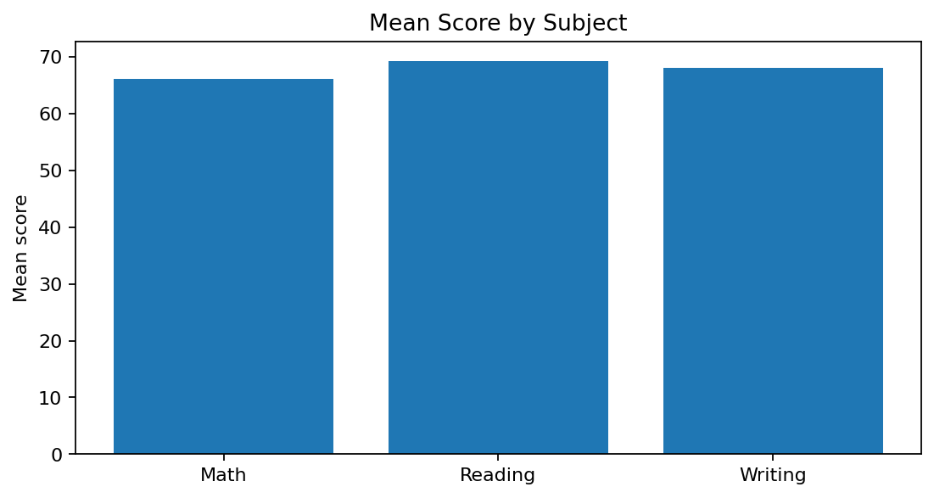
Reading had the highest mean score (69.17), followed by writing (68.05), while mathematics had the lowest (66.09). This suggests mathematics may warrant further investigation, but the averages alone do not explain the causes of the differences.

4.2 Performance-category distribution
Category | Rule | Count | Percentage
Low | Score < 60 | 285 | 28.5%
Medium | 60 ≤ score ≤ 75 | 402 | 40.2%
High | Score > 75 | 313 | 31.3%

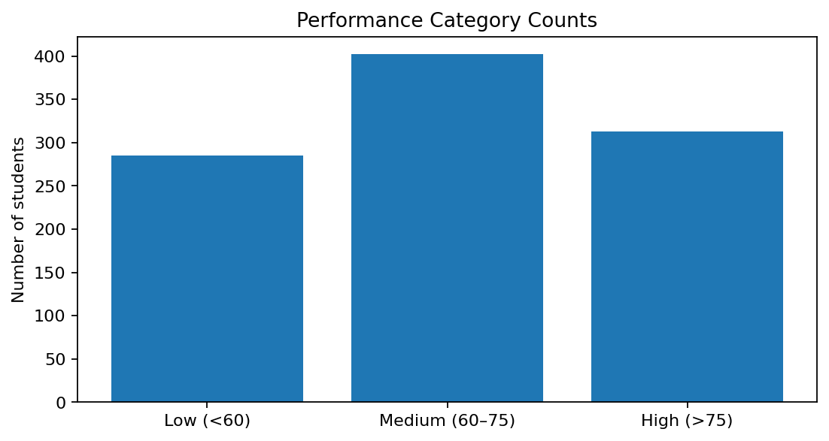
Medium was the largest category at 40.2%; 28.5% of records were in the Low category. Counts depend on the project-defined thresholds.

4.3 Test-preparation status
Status | Mean average score | Sample size
Completed | 72.67 | 358
None | 65.04 | 642

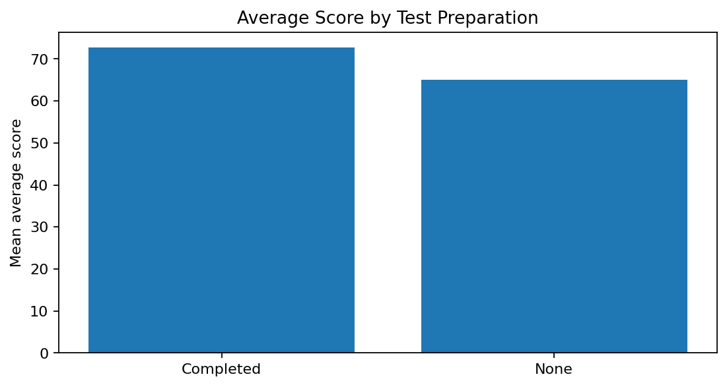
The completed group scored 7.63 points higher on average. This association may be affected by other factors such as motivation, study habits, and access to resources; the comparison does not establish causation.

4.4 Parental education
Parental education | Mean average score
Master's degree | 73.60
Bachelor's degree | 71.92
Associate's degree | 69.57
Some college | 68.48
Some high school | 65.11
High school | 63.10

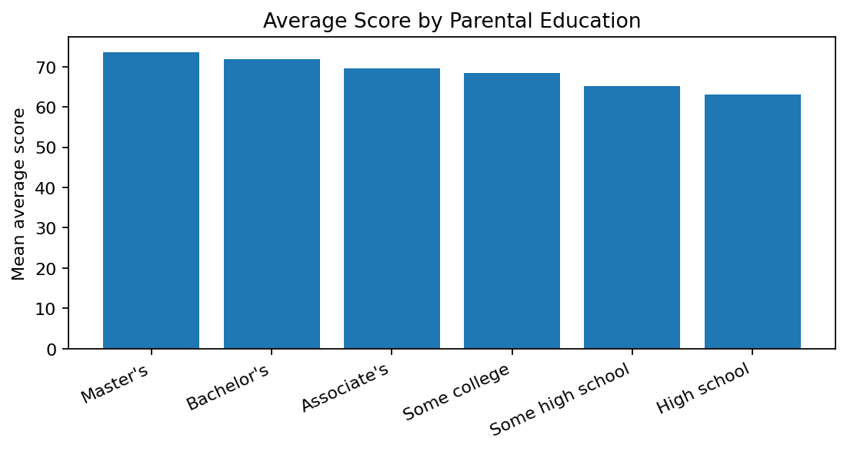
The master's-degree group had the highest mean (73.60), while the high-school group had the lowest (63.10). Parental education should not be treated as the sole explanation for an individual student's performance.

4.5 Lunch type
Lunch type | Mean average score
Standard | 70.84
Free/reduced | 62.20

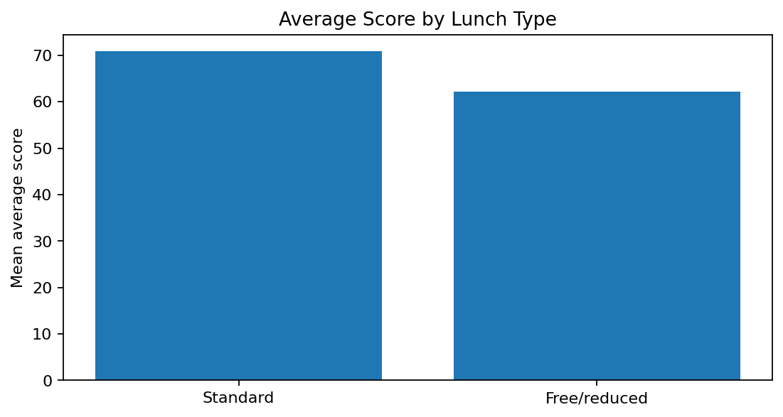
The standard-lunch group had a higher mean than the free/reduced group. Lunch type may reflect broader socioeconomic circumstances, but the data do not establish a causal mechanism. Findings should motivate supportive and equitable investigation, not student labelling.

4.6 Gender and subject averages
Group | Mathematics | Reading | Writing
Female | 63.63 | 72.61 | 72.47
Male | 68.73 | 65.47 | 63.31

In this dataset, the female group had higher mean reading and writing scores, while the male group had a higher mean mathematics score. These group averages do not predict an individual student's ability.

5. Statistical Analysis and Hypothesis Testing
The significance threshold was α = 0.05. A small p-value is evidence against the test's null hypothesis under its assumptions; it does not prove causation or automatically imply practical importance.

5.1 Independent-samples t-test: test preparation
Measure | Result
Completed group mean | 72.67
No-preparation group mean | 65.04
Mean difference | 7.63 points
t statistic (equal-variance test) | 8.3909
p-value | 1.63378 × 10⁻¹⁶
Decision | Reject equal-means null hypothesis

The test indicates strong statistical evidence of a difference in mean scores between the two groups. The result remains observational and should not be described as proof that the preparation course caused the difference.

5.2 Chi-square test: lunch type and performance category
Lunch type | High | Low | Medium | Total
Free/reduced | 72 | 155 | 128 | 355
Standard | 241 | 130 | 274 | 645

Statistic | Result
Chi-square statistic | 68.0937
Degrees of freedom | 2
p-value | 1.63543 × 10⁻¹⁵
Decision | Reject independence null hypothesis

The performance-category distribution differed by lunch type in this dataset. This is an association, not proof that lunch type causes a particular score.

5.3 One-way ANOVA: parental education
Statistic | Result
F statistic | 10.7531
p-value | 4.38105 × 10⁻¹⁰
Decision | Reject equal-group-means null hypothesis

The ANOVA indicates evidence that at least one parental-education group's mean differs. ANOVA alone does not identify which pairs differ; post-hoc comparisons are needed for that.

5.4 Confidence interval
The overall mean average score was 67.77, with a 95% confidence interval of [66.89, 68.66]. The interval expresses uncertainty around the estimated mean under the method's sampling assumptions.

6. Week 4 Machine-Learning Model Evaluation
The project author reports that Week 4 model training is complete. Insert the actual model names, evaluation metrics, and confusion matrix from the Week 4 Colab notebook in the table below before submitting this report. These values were not available here, so placeholders are used instead of invented results.
Model / metric | Verified Week 4 result
Model 1 name | [Enter actual model name]
Model 1 accuracy | [Enter actual accuracy]
Precision / recall / F1-score | [Enter actual values]
Model 2 name, if used | [Enter actual model name]
Model 2 accuracy | [Enter actual accuracy]
Confusion matrix | [Insert actual matrix/figure]
Best model and reason | [Compare actual metrics]

Evaluation notes
For a three-class target, report macro or weighted precision, recall, and F1-score alongside accuracy. Use the confusion matrix to see which classes are confused. If performance_category is the target, do not use average_score or the three subject scores as predictors because they directly define the target and would cause target leakage. Fit encoders/scalers on training data only, preferably through a pipeline.

7. Key Findings
- The checked file has 1,000 records, eight original columns, no missing values, and no duplicate rows.
- Overall mean average score: 67.77; reading mean: 69.17; mathematics mean: 66.09.
- Completed test preparation is associated with a 7.63-point higher mean average score.
- Lunch type and performance category were statistically associated in the chi-square test.
- Average scores differed across parental-education groups according to ANOVA.
- All results are observational and should not be interpreted as proof of cause and effect.

8. Strategic Recommendations

8.1 Improve access to preparation
Offer guided practice sessions, revision materials, and mock tests that are accessible to all students. Evaluate the programme with before-and-after or comparison-group data.

8.2 Provide targeted academic support
Use regular assessments to identify learners who may benefit from additional help, including mathematics support. Avoid treating a single score as a permanent label.

8.3 Reduce learning-resource barriers
Investigate whether students have equitable access to study materials, devices, quiet study spaces, and tutoring. Design support around needs rather than assumptions about individuals.

8.4 Monitor progress fairly
Track participation and progress over time, protect student privacy, and check whether interventions benefit different groups equitably.

9. Educational Impact
This workflow shows how descriptive summaries, visualizations, and statistical tests can support evidence-informed planning. The findings can help educators identify questions for follow-up and plan support, but any real intervention should be validated with local data and feedback from educators and students.

10. Limitations
- The dataset has a limited set of variables and may not represent all schools or student populations.
- Attendance, study time, teaching quality, language background, and resource access are not included.
- Observed associations do not establish causation and may be confounded by unmeasured factors.
- Performance categories depend on project-defined thresholds.
- Statistical significance does not necessarily indicate practical importance.
- Machine-learning results must be evaluated on held-out data and without target leakage.

11. Future Improvements
- Validate results on another dataset or a later student cohort.
- Collect relevant context only with suitable consent, governance, and privacy safeguards.
- Compare multiple models using stratified splits and cross-validation where appropriate.
- Report macro-F1 and per-class recall when class balance matters.
- Review confusion-matrix errors to guide model improvements.
- Build a privacy-conscious dashboard for group-level trends.
- Evaluate educational interventions prospectively rather than assuming impact.

12. Conclusion
This project demonstrates an end-to-end Python workflow for student-performance analysis. The checked dataset had no missing values or duplicates. EDA identified differences in subject averages and group means, while the t-test, chi-square test, and ANOVA provided statistical evidence for the comparisons examined. These findings can inform further investigation and support planning, but they do not prove causation. Add the verified Week 4 model metrics and confusion matrix before final submission.

13. Python Code Appendix
The full executable code is maintained in the Google Colab notebook. Include the notebook URL with the final submission and preserve the full code cells there. Core snippets are shown below.
# Load and inspect
import pandas as pd
df = pd.read_csv("StudentsPerformance.csv")
print(df.shape)
print(df.isnull().sum())
print("Duplicate rows:", df.duplicated().sum())
# Feature engineering
score_cols = ["math score", "reading score", "writing score"]
df["average_score"] = df[score_cols].mean(axis=1)
def categorize_score(score):
if score < 60:
return "Low"
elif score <= 75:
return "Medium"
return "High"
df["performance_category"] = df["average_score"].apply(categorize_score)
# Statistical tests
from scipy import stats
completed = df.loc[df["test preparation course"] == "completed", "average_score"]
not_completed = df.loc[df["test preparation course"] == "none", "average_score"]
t_stat, t_p = stats.ttest_ind(completed, not_completed, equal_var=True)
contingency = pd.crosstab(df["lunch"], df["performance_category"])
chi_stat, chi_p, chi_df, expected = stats.chi2_contingency(contingency)
education_groups = [
g["average_score"].values for _, g in df.groupby("parental level of education")
]
f_stat, anova_p = stats.f_oneway(*education_groups)
Notebook name: Week_5_Comprehensive_Final_Project. Replace this line with the shareable Google Colab URL.

14. References
- Kaggle. Students Performance in Exams Dataset. https://www.kaggle.com/datasets/spscientist/students-performance-in-exams
- McKinney, W. (2022). Python for Data Analysis: Data Wrangling with pandas, NumPy, and Jupyter (3rd ed.). O'Reilly Media.
- Pedregosa, F., et al. (2011). Scikit-learn: Machine Learning in Python. Journal of Machine Learning Research, 12, 2825–2830. https://jmlr.org/papers/v12/pedregosa11a.html
- Hunter, J. D. (2007). Matplotlib: A 2D Graphics Environment. Computing in Science & Engineering, 9(3), 90–95. https://doi.org/10.1109/MCSE.2007.55
- SciPy Community. SciPy Statistical Functions Documentation. https://docs.scipy.org/doc/scipy/reference/stats.html
- Seaborn Development Team. Seaborn Statistical Data Visualization. https://seaborn.pydata.org/

