ECE 282 Lab06

Lab Due: 11 pm, March 21, 2022

1. Command practice

**Tutorial:** [**http://eecs.mines.edu/Courses/csci274/Content/09_output.html**](http://eecs.mines.edu/Courses/csci274/Content/09_output.html) **Scripting help:** [**https://www.tutorialspoint.com/unix/unix-vi-editor.htm**](https://www.tutorialspoint.com/unix/unix-vi-editor.htm)

What do the following commands do?

* 1. mount / umount (**Hint:** [**http://www.tutorialspoint.com/unix/unix-file-system.htm**)](http://www.tutorialspoint.com/unix/unix-file-system.htm) – "mounts" a storage device or filesystem, making it accessible and attaching it to an existing directory structure, and "unmounts" a "mounted" filesystem, informing the system to complete any incomplete read or write operations, and safely detaches it
  2. tty - prints the file name of the terminal connected to standard input
  3. stty - used to change and print terminal line settings
  4. seq - generates numbers from first to last in steps of increment, seq 5 2 20 = 5,7,9...
  5. head - reads a file and outputs the first part of it
  6. tail - reads a file and outputs the last part of it
  7. echo - displays a line of text
  8. sed - stands for stream editor and it can perform functions on file like searching, find and replace, insertion or deletion

Write down the commands that can do the following tasks:

* 1. Create a file s1.txt that has 100 lines, each line is a number from 1 to 100

seq 0 100 > s1.txt

* 1. Create a file s2.txt that has 50 lines with the pattern 2 4 6… 100 **Hint: man seq**

seq 2 2 100 > s2.txt

* 1. Output the first 5 lines of s1.txt to the **terminal**

head 05 s1.txt

* 1. Output the last 5 lines of s2.txt to a file **temp.txt**

-5 s2.txt>temp.txt

* 1. Output the lines 5 to 9 **from the file s1.txt** to the terminal **Hint: head pipeline to tail**

head -9 s1.txt | tail -5

* 1. Filter the input file (acmart.html) to find the lines including link to .png files **Hing: try grep png**

grep -n .png acmart.html

1. Some sed (from http://www.grymoire.com/Unix/Sed.html#uh-1)

Sed is the ultimate stream editor. If that sounds strange, picture a stream flowing through a pipe. Okay, you can't see a stream if it's inside a pipe. That's what I get for attempting a flowing analogy. You want literature, read James Joyce.

Anyhow, sed is a marvelous utility. Unfortunately, most people never learn its real power. The language is very simple, but the documentation is terrible. The Solaris on-line manual pages for sed are five pages long, and two of those pages describe the 34 different errors you can get. A program that spends as much space documenting the errors as it does documenting the language has a serious learning curve.

Do not fret! It is not your fault you don't understand sed. I will cover sedcompletely. But I will describe the features in the order that I learned them. I didn't learn everything at once. You don't need to either.

Sed has several commands, but most people only learn the substitute command: s. The substitute command changes all occurrences of the regular expression into a new value. A simple example is changing "day" in the "old" file to "night" in the "new" file: sed s/day/night/ <old >new

Or another way (for UNIX beginners),

sed s/day/night/ old >new

and for those who want to test this:

echo day | sed s/day/night/

This will output "night".

If you are replacing simple texts, you can avoid using quotes. Otherwise, your string need to be enclosed with quotes:

sed 's/day/night/' <old >new

I must emphasize that the sed editor changes exactly what you tell it to. So if you executed

echo Sunday | sed 's/day/night/'

This would output the word "Sunnight" because sed found the string "day" in the input.

Another important concept is that sed is line oriented. Suppose you have the input file: one two three, one two three four three two one one hundred

and you used the command

sed 's/one/ONE/' <file

The output would be

ONE two three, one two three four three two ONE ONE hundred

And some more:

Backslash as the escape character. Just like strings in C.

& as matched string. Search a string and at some characters

sed 's/abc/(abc)/' <old >new sed 's/abc/(&)/' <old >new

* for multiple occurrence of a pattern

sed 's/[a-z]*/(&)/' <old >new

. for any character

sed 's/a.*c/(&)/' <old >new # find and replace any string starting with ‘a’ and ending with ‘c’

3. Lab assignment

In HTML, links are indicated by the <a href="PATH">TEXT</a>. PATH is a relative or absolute path to a file or resource and TEXT is the text that is going to be displayed in for that link. Ex:

Click <a href="www.google.com">here</a> to be redirected to www.Google.com

To see the result, just copy the above line in a text file, save it with html extension (file.html) and open it with a browser. In the following is the same webpage, opened with Chrome,

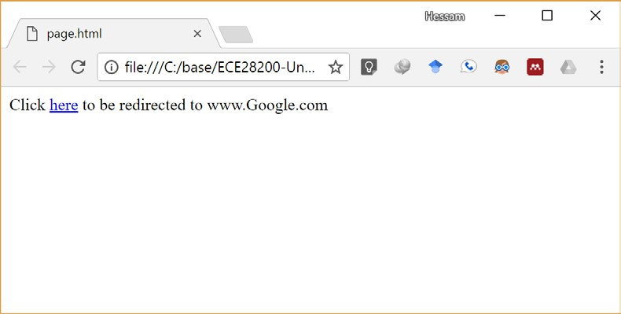

Get the acmart.html from Canvas. This file is downloaded from the following link:

http://ctan.math.utah.edu/ctan/tex-archive/macros/latex/contrib/acmart/

Extract all web links from this file, convert them to absolute paths (instead of relative), and store them in a file named links.

The links in this file are like the following:

<a href="**ACM-Reference-Format.dbx**">ACM-Reference-Format.dbx</a>

These paths are relative to the current directory on the server. However, for our case, you need to convert the links to absolute paths, preceding with the link of the webpage where the file was downloaded from. The above html link must be converted to the following. http://ctan.math.utah.edu/ctan/tex-archive/macros/latex/contrib/acmart/**ACMReference-Format.dbx**

For this, you need to first filter all the line that include the string ‘href=’. Use grep for this.

Then use sed and proper string substitution multiple times to rip away any string before ‘href="’ and after </a>.

Finally redirect the generated lines to the file links. The generated output is already on Canvas, named links-lab06. You could compare you output against contents of this file.

Include the script(s) in a bash file, so that after running the bash file, the input file will be processed and the corresponding output be generated.

To make a bash script file:

1. Make a text file (ex. Lab06.sh)
2. First line must be #!<path to bash program>

Usually bash is located at /bin/bash, so the first line of this line will be #!/bin/bash

1. Set the executable permission of the bash file chmod +x lab6.sh (this command will set x permission of the file for all fields)
2. Include the Linux commands in the bash script file
3. Run the file ./lab06.sh

You could just see the sample-script.sh bash script on canvas and modify it. Just remove the Unix commands and insert you own command instead, or you could do every other thing that you want. Explore and be creative.

Submit all your files to Canvas as a single ZIP file.

