一、Uboot源码vscode工程创建

二、顶层Makeile分析
AS = $(CROSS_COMPILE)as
AS = arm-linux-gnueabihf-as

2、变量值
ARCH = arm
CPU = armv7
BOARD = mx6ullevk
VENDOR = freescale
SOC = mx6
CPUDIR = arch/arm/cpu/armv7
BOARDDIR = freescale/mx6ullevk

三、编译处理过程

make distclean

make mx6ull_14x14_ddr512_emmc_defconfig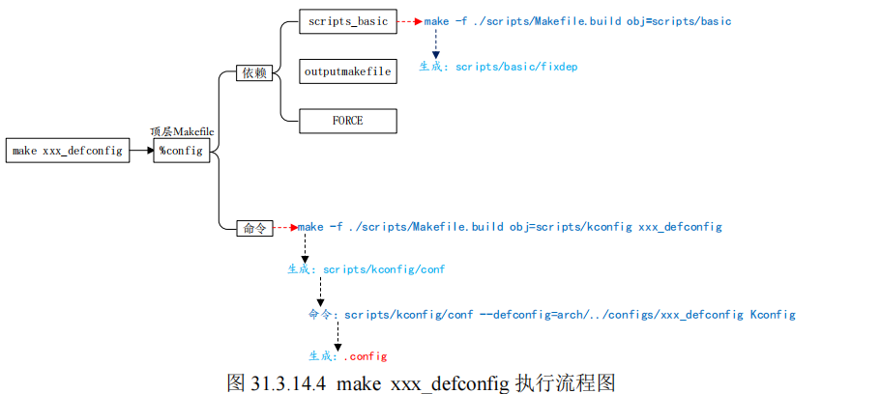

no-dot-config-targets := clean clobber mrproper distclean \
help %docs check% coccicheck \
ubootversion backup

config-targets := 0
mixed-targets := 0
dot-config := 1
ifneq ($(filter $(no-dot-config-targets), $(MAKECMDGOALS)),)
ifeq ($(filter-out $(no-dot-config-targets), $(MAKECMDGOALS)),)
dot-config := 0
endif
endif
这段代码的目的是：判断当前 make 命令是否需要依赖 .config 配置文件。
用户输入 | filter 结果 | filter-out 结果 | dot-config 值 | 含义
make clean | clean | 空 | 0 | 不需要 .config
make clean all | clean | all | 1 | 因为有 all，需要 .config
make all | 空 | all | 1 | 需要 .config
make help | help | 空 | 0 | 不需要 .config

ifeq ($(KBUILD_EXTMOD),)
ifneq ($(filter config %config,$(MAKECMDGOALS)),)
config-targets := 1
ifneq ($(words $(MAKECMDGOALS)),1)
mixed-targets := 1
endif
endif
endif

$(words ...)：GNU Make 的内置函数，统计单词数量。
$(words $(MAKECMDGOALS))：统计用户输入了多少个目标。
make menuconfig → 1 个目标 → words = 1
make menuconfig all → 2 个目标 → words = 2

make M=/path/to/module
这时 KBUILD_EXTMOD 等于 /path/to/module。

条件 | 结果
编译外部模块（KBUILD_EXTMOD 非空） | 跳过整段逻辑
主源码树 + 无配置目标 | 跳过
主源码树 + 有配置目标 + 仅一个目标 | config-targets := 1
主源码树 + 有配置目标 + 多个目标 | config-targets := 1，mixed-targets := 1

make xxx_defconfig的规则：

%config: scripts_basic outputmakefile FORCE
$(Q)$(MAKE) $(build)=scripts/kconfig $@

1、目标为scripts_basic
scripts_basic:
$(Q)$(MAKE) $(build)=scripts/basic
展开以后就是：
make -f ./scripts/Makefile.build obj= scripts/basic

build定义在scripts\Kbuild.include
build := -f $(srctree)/scripts/Makefile.build obj
build := -f ./scripts/Makefile.build obj

2、outputmakefile，
因为KBUILD_SRC，因此outputmakefile无效。

最终要执行的命令
make -f ./scripts/Makefile.build obj=scripts/basic
- Make -f ./scripts/Makefile.build obj=scripts/kconfig xxx_defconfig

第一条命令：
src = scripts/basic
kbuild-dir = ./scripts/basic
kbuild-file = ./scripts/basic/Makefile
include ./scripts/basic/Makefile

__build: $(if $(KBUILD_BUILTIN),$(builtin-target) $(lib-target) $(extra-y)) \
$(if $(KBUILD_MODULES),$(obj-m) $(modorder-target)) \
$(subdir-ym) $(always)
@:

__build: $(builtin-target) $(lib-target) $(extra-y) $(subdir-ym) $(always)
@:

scripts/basic/fixdep

__build: scripts/basic/fixdep
因此需要编译出scripts/basic/fixdep，对应的.c是scripts/basic/fixdep.c，

第二条命令：
Make -f ./scripts/Makefile.build obj=scripts/kconfig xxx_defconfig

src = scripts/kconfig
kbuild-dir = ./scripts/ kconfig
kbuild-file = ./scripts/ kconfig/Makefile
include ./scripts/kconfig/Makefile

%_defconfig: $(obj)/conf
$(Q)$< $(silent) --defconfig=arch/$(SRCARCH)/configs/$@ $(Kconfig)

xxx_defconfig: scripts/kconfig/conf
$(Q)$< $(silent) --defconfig=arch/$(SRCARCH)/configs/$@ $(Kconfig)
scripts/kconfig/conf --defconfig=arch/../configs/ xxx_defconfig Kconfig

make V=1 -j12
默认目标
PHONY := _all
_all:
_all: all
all: $(ALL-y)
ALL-y += u-boot.srec u-boot.bin u-boot.sym System.map u-boot.cfg binary_size_check

u-boot.bin: u-boot-nodtb.bin FORCE
$(call if_changed,copy)

u-boot-nodtb.bin: u-boot FORCE
$(call if_changed,objcopy)
$(call DO_STATIC_RELA,$<,$@,$(CONFIG_SYS_TEXT_BASE))
$(BOARD_SIZE_CHECK)

u-boot: $(u-boot-init) $(u-boot-main) u-boot.lds FORCE
$(call if_changed,u-boot__)

u-boot-init := $(head-y)
u-boot-main := $(libs-y)

head-y= arch/arm/cpu/armv7/start.o

libs-y=保存源码的目录
libs-y += lib/ -》lib/built-in.o
libs-y保存大量的built-in.o

u-boot就是将start.o 和大量的built-in.o链接在一起。

假如
CONFIG_ONENAND_U_BOOT =y
ALL-$(CONFIG_ONENAND_U_BOOT)
ALL-y += u-boot-onenand.bin

四、链接
链接脚本为u-boot.lds，uboot链接首地址为0X87800000，
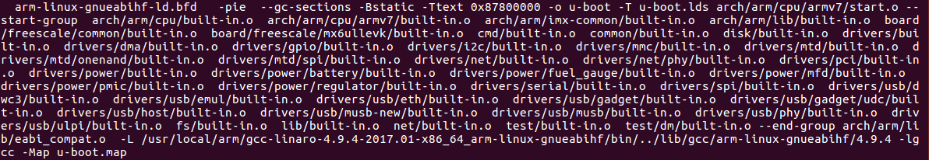
在mx6_common.h文件中设置CONFIG_SYS_TEXT_BASE=0X87800000

