Project report
Anuj Araguai
Genghua Li
Shunya

Discriminiant function Analysis:

In this session, I will use scorings of discriminant function to classify records. The performance of the classification depends on the followings: Mulivariate Normality of variables for both classes, the absence outliers and similarity of covariance matrices across classes.

I selected three variables into my model: balance, duration and previous. I first explored the multivariate normality condition of the vector of these three variables.
If the vector of the variables is multi-variate normal, the scatter plot of U (a function of Manhabolis distance) and V (a beta distribution statistics dependent on sample size and number of variables) should be linear.
The U vs V plot for class of y=no is in red and that for class of y=yes is in blue.

We can see the vector of variables is not satisfyingly multivariate normal; but we are not very discouraged because discriminant analysis is very robust to deviation of normality and the vector of variables do not depart from normality terribly.
Comparing to the deviation of normality of our variables, the prevalent presence of outliers for each variable in different classes concern us much more. From the boxplot below, you can see how blatant these outliers are.
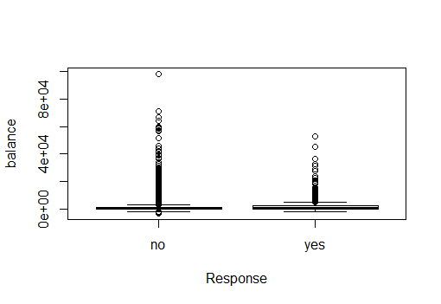
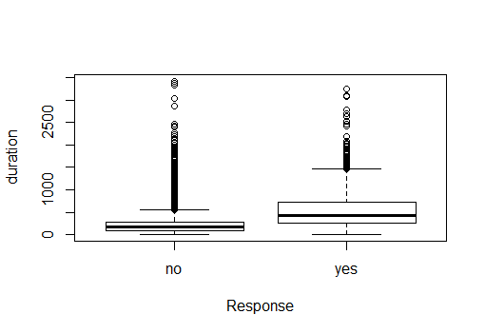
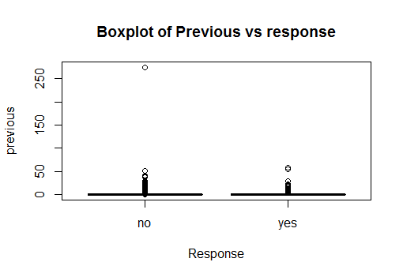
Next, we will check compare the covariance matrices of the three variables with response=yes and response=no.

Y=yes
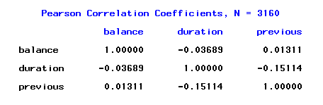
Y=No
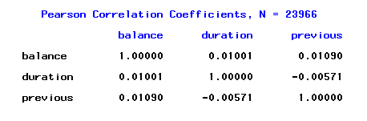
Comparing the correlation structure of the three variables for y=yes and y=no, we found that they are very similar. For both classes, all the variables are almost independent from each other.

With the situation of outliers, our expectation of the performance of discriminant analysis in predicting response is rather low. Later we will try transformation technique and check if that will improve the performance of classification.

Using the training dataset, we trained the following linear discriminant functions.
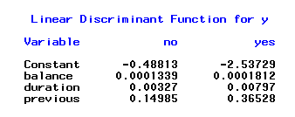

We then applied the linear discriminant function to the testing data. The scoring and classifications of the first 20 observations is listed below.
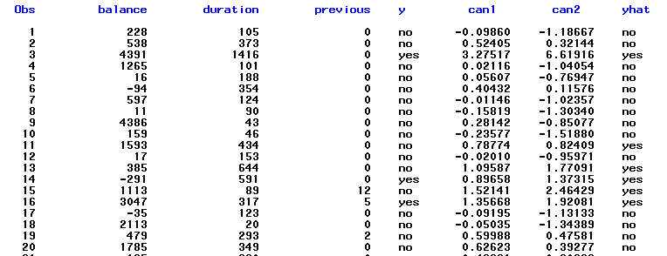

The confusion matrix for discriminant function analysis follows below:

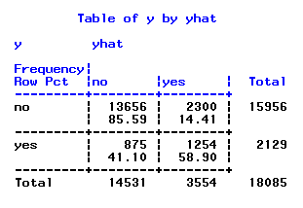
Next, I will compute the classification probability for each record, sort the probability and compute the lift curve for discriminant analysis. We have the following lift curve:
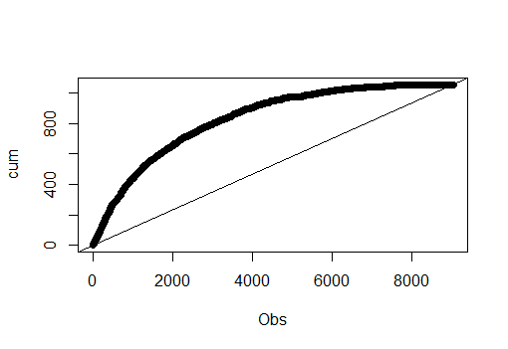
The lift curve shows that lift from classification using discriminant function scoring is much more efficient than random classification.

The scatter plot of discriminant scores color coded with response also shows that the linear discriminant functions did a good job at discriminating responses because we do see a pattern that records with response of yes tends to have larger score on the second discriminant function.

It appears that discriminant analysis did a decent job at classification given the presence of outliers. It only made us more curious if we can improve classification by using techniques to minimize the effect of the outliers. One idea we would like to try is winsorization. To winsor variable simply means to set values of outliers at the value of a certain percentile.
For balance, duration and previous, we set the values of the low outliers to be the value of first percentile and the values of high outliers at the value of 99th percentile. Below, we list the comparison of first ten observations before and after winsoring for the variable balance. The left column is balance before winsoring and the right column is balance after winsoring. 39385 is above the 99th percentile and is capped with the value of 99th percentile 13107.
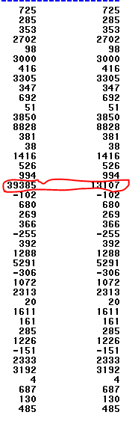

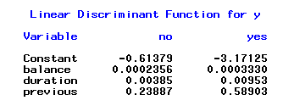
Above are the coefficients of linear discriminant functions.
Below is the confusion matrix from the classifications using these discriminant functions on the testing data.
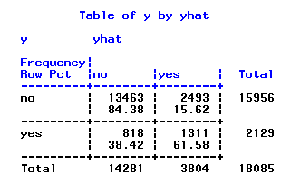

We see that by using the winsoring technique, sensitivity improved by almost 3% and the specificity decreased by 0.91%. Considering that the bank gets much more profit by giving offers to those who accept then than not sending offers to those who will refuse them. We consider this improvement amenable to profitability.

