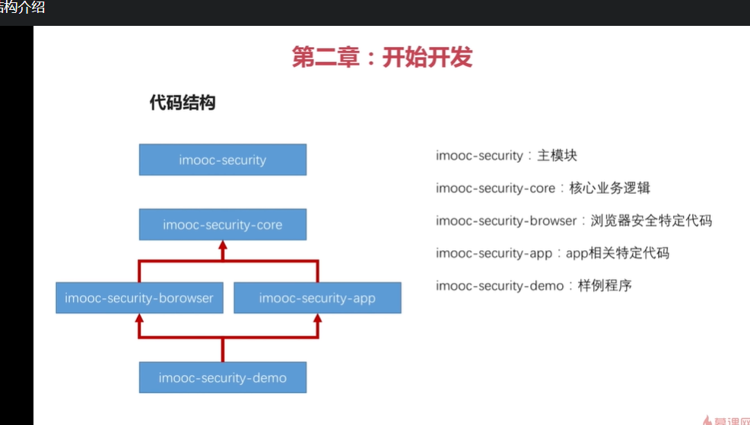

<**dependencyManagement**>  
 <**dependencies**>  
 <**dependency**>  
 <**groupId**>io.spring.platform</**groupId**>  
 <**artifactId**>platform-bom</**artifactId**>  
 <**version**>Brussels-SR4</**version**>  
 <**type**>pom</**type**>  
 <**scope**>import</**scope**> 统一版本号第三方  
 </**dependency**>

<properties>

<foo.version>1.1.0.RELEASE</foo.version></properties>

<**dependency**>  
 <**groupId**>org.springframework.cloud</**groupId**>  
 <**artifactId**>spring-cloud-dependencies</**artifactId**>  
 <**version**>Dalston.SR2</**version**>  
 <**type**>pom</**type**>  
 <**scope**>import</**scope**>//管理spring版本兼容  
 </**dependency**>  
 </**dependencies**>  
</**dependencyManagement**>

Core pom

<**dependency**>  
 <**groupId**>org.springframework.cloud</**groupId**>  
 <**artifactId**>spring-cloud-starter-oauth2</**artifactId**>  
</**dependency**> 验证  
<**dependency**>  
 <**groupId**>org.springframework.boot</**groupId**>  
 <**artifactId**>spring-boot-starter-data-redis</**artifactId**>  
</**dependency**>  
<**dependency**>  
 <**groupId**>org.springframework.boot</**groupId**>  
 <**artifactId**>spring-boot-starter-jdbc</**artifactId**>  
</**dependency**>  
<**dependency**>  
 <**groupId**>mysql</**groupId**>  
 <**artifactId**>mysql-connector-java</**artifactId**>  
</**dependency**> 驱动  
<**dependency**>  
 <**groupId**>org.springframework.social</**groupId**>  
 <**artifactId**>spring-social-config</**artifactId**>  
</**dependency**>  
<**dependency**>  
 <**groupId**>org.springframework.social</**groupId**>  
 <**artifactId**>spring-social-core</**artifactId**>  
</**dependency**>  
<**dependency**>  
 <**groupId**>org.springframework.social</**groupId**>  
 <**artifactId**>spring-social-security</**artifactId**>  
</**dependency**>  
<**dependency**>  
 <**groupId**>org.springframework.social</**groupId**>  
 <**artifactId**>spring-social-web</**artifactId**>  
</**dependency**> 4个搜索  
<**dependency**>  
 <**groupId**>commons-lang</**groupId**>  
 <**artifactId**>commons-lang</**artifactId**>  
</**dependency**>  
<**dependency**>  
 <**groupId**>commons-collections</**groupId**>  
 <**artifactId**>commons-collections</**artifactId**>  
</**dependency**>  
<**dependency**>  
 <**groupId**>commons-beanutils</**groupId**>  
 <**artifactId**>commons-beanutils</**artifactId**>  
</**dependency**>  
<**dependency**>  
 <**groupId**>org.springframework.boot</**groupId**>  
 <**artifactId**>spring-boot-configuration-processor</**artifactId**>  
</**dependency**>

关第一个是session第二个是密码登录

<**build**>  
 <**plugins**>  
 <**plugin**>  
 <**groupId**>org.springframework.boot</**groupId**>  
 <**artifactId**>spring-boot-maven-plugin</**artifactId**>  
 <**version**>1.5.6.RELEASE</**version**>  
 <**executions**>  
 <**execution**>  
 <**goals**>  
 <**goal**>repackage</**goal**>  
 </**goals**>  
 </**execution**>  
 </**executions**>  
 </**plugin**>  
 </**plugins**>  
 <**finalName**>demo</**finalName**>  
</**build**>

重打一个jar

默认密码use

**public class** BrowserSecurityConfig **extends** WebSecurityConfigurerAdapter

**protected void** configure(HttpSecurity http) **throws** Exception {

http.formLogin().and().authorizeRequest()授权.anyRequest() 全部请求.authenticated（）都需要身份验证

http.httpbasic()小框密码

}

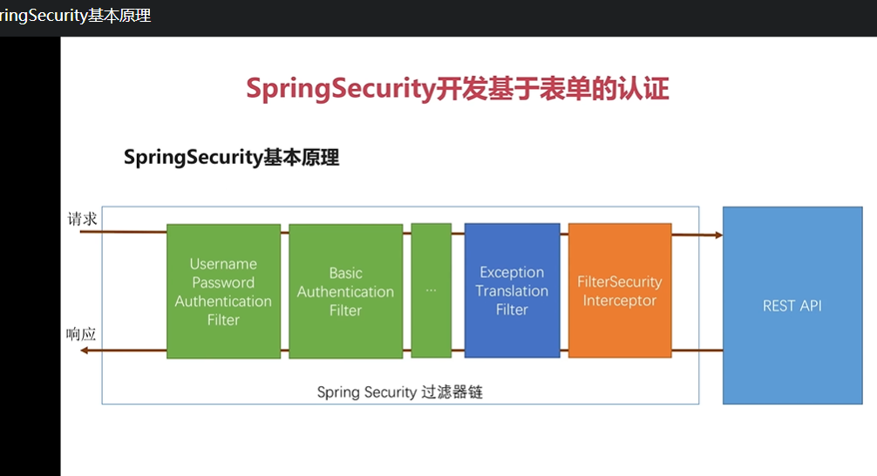

绿色过滤器 诚实是收集认证最终确定