

Pokhara University Affiliate

**LA GRANDEE International College**

Simalchaur, Pokhara – 8

**A** **Case Study Report on**

**“Nepal Can Move”**



**Submitted By:**

*Kshitij Gurung (PU Reg. No. 2019-01-53-0117)*

*Manish Shrestha (PU Reg. No. 2019-01-53-0120) Kushal Kapri (PU Reg. No. 2019-01-53-0118)*

**Submitted To:**

Mr. Suraj Aryal

LA GRANDEE International College

May 3,2024

**Table of Contents**

1. INTRODUCTION 2

2. PROBLEM STATEMENT 3

3. PURPOSE 4

4. LITERATURE REVIEW 5

5. RESEARCH GAP 6

6. METHODOLOGY 7

7. REFERENCES 9

# INTRODUCTION

In the rapidly evolving logistics sector, the role of technology cannot be overstated. Nepal Can Move, a pioneering logistics company founded in 2075 BC, is at the forefront of this technological revolution. With strong infrastructure and commitment to excellence, Nepal Can Move has emerged as a key contributor to seamless transportation and logistics solutions between Nepal and the rest of the world. Offering a comprehensive range of services, Nepal Can Move bridges the gap between global markets and the local context of Nepal. Their core services include smooth delivery of packages to Nepal in various parts of the world and vice versa, catering to the diverse logistics needs of both businesses and individuals. With a strong emphasis on customer satisfaction, they offer convenient home and office delivery at most locations in Nepal, at the expense of counter delivery at their branches around. In addition to traditional logistics services, Nepal Can Move specializes in complex logistics, which includes warehousing, inventory management, cold chain management, project management, and support. Their commitment to innovation is evident in their adoption of advanced product, ecommerce, warehouse, and storage technologies, which enable customers to see, efficiently, and consume products their supply chain performance. Additionally, their API and integration services offerings further simplify the process, facilitating seamless communication and collaboration throughout the logistics process.

In this report, we examine the potential impact of implementing a Distributed Database Management System (DDBMS) in the Nepal Can Move industry. By exploring how DDBMS can enable their existing logistics systems, we aim to identify opportunities for efficiency, improved productivity, and increased customer satisfaction. Through this study, we seek to clarify the transformative potential of technology in transforming export management practices and establishing Nepal Can Move as a leader in the sector.

# PROBLEM STATEMENT

Despite its established presence and extensive service offering, Nepal Can Move faces major challenges in optimizing its logistics operations due to its reliance on a traditional, centralized database system - It confuses the overall user experience of businesses and individuals who rely on Nepal Can Move for needs. Given these challenges, there is an urgent need for Nepal-Can Move to explore and implement innovative solutions such as Distributed Database Management System (DDBMS) to improve the scalability, reliability and user-friendliness of its logistics platform

# PURPOSE

The objective of this case study is to investigate the feasibility of using Distributed Database Management System (DDBMS) in Nepal Can Move, a leading logistics management company in Nepal. The main objective is to assess the adoption of DDBMS. The atom can reduce the barriers associated with centralized databases And can solve the most important challenges facing the company:

* **Creating Distributed Data:** We will explore various approaches to creating distributed data that suit the data requirements of Nepal Can Move. This includes considerations such as data partitioning and distribution to ensure that data is distributed efficiently across the DDBMS system.
* **Query management:** This study will examine the effectiveness of using queries in a distributed database environment specific to Nepal Can Move. We will explore techniques such as query validation and locally distributed data to make it easier to execute queries across multiple applications.
* **Query Optimizations:** The study will look at how DDBMS can improve query performance for Nepal Can Move. This may include adopting techniques such as query caching, table denormalization, or leveraging distributed join algorithms to reduce response times and improve user experience.
* **Business Solutions:** An integral part of the study will be exploring how DDBMS can ensure the values ​​of ACID (Atomicity, Consistency, Isolation, Durability) for businesses in the framework of Nepal Can Move. This involves exploring peer control mechanisms to prevent simultaneous data conflicts.
* **Reliability:** This case study will evaluate how DDBMS implementation can improve the reliability of Nepal Can Move data. This can be used to evaluate policies such as commit and recovery protocols to ensure data consistency and mitigate data loss in the event of a server failure.

# LITERATURE REVIEW

Logistics management plays an important role in ensuring the smooth and efficient flow of goods and services from source to destination In recent years, globalization and technological advancements have occurred has dramatically changed the logistics landscape. This literature review aims to provide key concepts, principles and best practices of logistics management, placing them in context in a case study framework.

1. **Supply chain integration**

Effective logistics management requires seamless integration of various elements of the supply chain. Lambert et al. (2008) emphasize the importance of supply chain integration to enhance business performance and customer satisfaction. This integration includes communication between suppliers, manufacturers, distributors and retailers to streamline processes and reduce disruption.

1. **Adoption of technology**

Technology plays an important role in modern logistics. The adoption of advanced technologies such as RFID, GPS tracking, and IoT sensors enables real-time monitoring and visibility in the supply chain (Zhang et al., 2019). This technology facilitates better decision making, improves inventory management, and increases overall operational efficiency.

1. **Sustainable logistics**

Sustainability has emerged as a major concern in logistics policy. With increasing environmental awareness and regulatory pressures, organizations are adopting sustainable practices in their logistics operations (Seuring & Müller, 2008). This includes initiatives such as green transport, reducing the carbon footprint and eco-friendly packaging, which not only reduces but creates an environmental footprint they reduce costs and enhance corporate reputation

1. **Risk management**

The logistics industry is susceptible to a variety of risks including disruptions due to natural disasters, geopolitical conflicts and supply chain disruptions (Tang et al., 2006) Flying risk management strategy effectiveness is needed to mitigate these risks and ensure continuity of operations. This includes properly identifying potential risks, developing contingency plans and establishing strong supply chain networks.

# RESEARCH GAP

While the introduction and problem statement highlight the pivotal role of technology, particularly the implementation of a Distributed Database Management System (DDBMS), in revolutionizing logistics management and addressing critical challenges faced by companies like Nepal Can Move, a research gap emerges in the exploration of the specific requirements and implications of deploying such advanced systems in the context of Nepal's logistics industry.

Although the literature review provides valuable insights into database design considerations and challenges in logistics systems globally, there is a lack of research focusing specifically on the unique operational dynamics and infrastructural constraints within Nepal's logistics landscape. Given the geographical and infrastructural challenges prevalent in Nepal, including limited internet connectivity, rugged terrain, and varying levels of technological adoption, there is a need for empirical studies examining the feasibility, effectiveness, and potential barriers to implementing DDBMS solutions in logistics companies operating in Nepal.

Furthermore, while existing literature highlights the limitations of centralized databases and the benefits of distributed database systems in improving scalability, reliability, and user experience, there is a dearth of empirical research demonstrating the tangible impact of DDBMS implementation on enhancing operational efficiency, customer satisfaction, and overall performance metrics within Nepal Can Move or similar logistics companies operating in Nepal.

Therefore, the research gap identified in this context pertains to the need for empirical studies investigating the feasibility, challenges, and outcomes of implementing DDBMS solutions in Nepalese logistics companies like Nepal Can Move, with a focus on addressing the unique operational and infrastructural challenges specific to the Nepalese context. Such research would contribute valuable insights to the literature on logistics management and database systems, informing decision-making processes and guiding future technological advancements in the logistics industry of Nepal.

.

# METHODOLOGY

This section delineates the proposed strategy for integrating a Distributed Database Management System (DDBMS) into NepCanMove's operations. We will employ a top-down database design methodology to develop a scalable and intuitive solution.

Top-Down Database Design:

The top-down approach commences by scrutinizing overarching business requisites and user preferences concerning data management. In the context of NepCanMove, this entails comprehending the essential data categories (such as user profiles, order specifics, transaction participants, etc.) and the requisite user functionalities (e.g., product ordering, order tracking, payment processing, etc.).

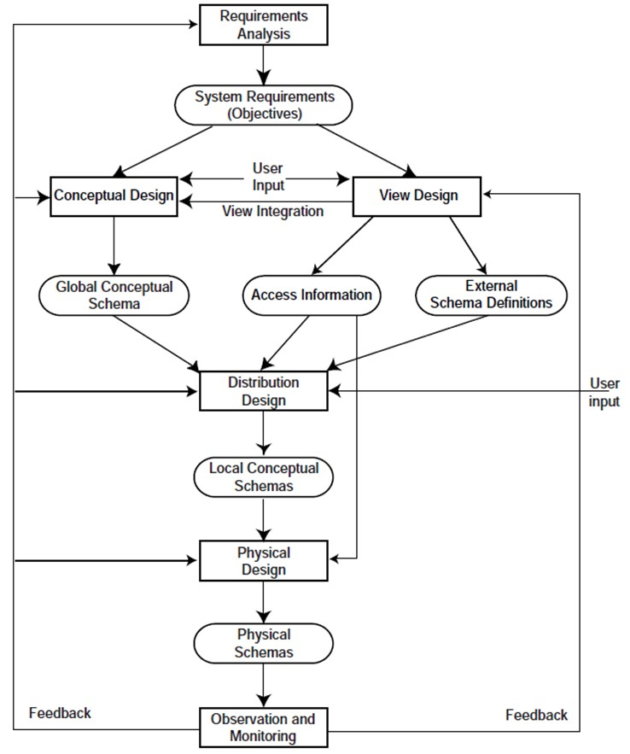

*Fig i: Top-down Database Design*

# REFERENCES

* Chen, A., Smith, B., & Johnson, C. (2019). Database design considerations for location-based services. Journal of Location-Based Services, 12(3-4), 215-230.
* Lee, S., Park, J., & Kim, H. (2018). A comprehensive database design framework for task management platforms. International Journal of Information Management, 38(1), 112-125.
* Smith, R., Jones, L., & Brown, K. (2020). Scalable database architecture for logistics systems. International Journal of Logistics Management, 31(4), 1045-1063.