

**LA GRANDEE INTERNATIONAL COLLEGE**

**Simalchaur, Pokhara, Nepal**

A Project Mid-Term Report

on

**Online Book Store Management System**

**Submitted to**

La Grandee International College

Bachelor of Computer Application (BCA) Program

In partial fulfillment of the requirements for the degree of Program Name under

Pokhara University

**Submitted by**

|  |  |  |  |
| --- | --- | --- | --- |
| **Name:** | **Course** | **Semester** | **P.U. Registration Number** |
| Bishal Adhikari | BCA | 6th | 2021-1-53-0348 |
| Deepak Chhantyal | BCA | 6th | 2021-1-53-0349 |
| Roshan Adhikari | BCA | 6th | 2021-1-53-0363 |
|  |  |  |  |

**Date: 16 December 2024**

# Table of Contents

**Table of Contents ii**

**Table of Figures iii**

**1. Introduction 1**

**2. Problem Statement 2**

**3. Objectives 3**

**4. Methodology 4**

**5. System Design 5**

**5.1 DFD 5**

**5.2 ER Diagram 7**

**6. Project Gantt Chart 8**

**7. Project Progress Report 9**

**8. Conclusion 10**

**9. References 11**

# Table of Figures

Figure 4.1: Spiral Model 4

Figure 5.1 User side DFD Level-1 6

Figure 6.2 Admin Side DFD Level-1 6

Figure 5.2 ER Diagram 7

Figure 6.1: Gantt Chart 8

# Introduction

Bookly is a website specially designed for the purpose of simplifying the process of purchasing, managing, and classifying books, whether for the user or an admin. In the world of e-commerce today, shopping systems have become a thing of grand standing, and they have been bringing comfort to users who would instead be sitting at home. Although this is a prevalent topic, many of these e-commerce platforms are not equipped with all the features required for a satisfying user experience.

For book lovers, Bookly provides an intuitive interface to browse a wide range of books, view detailed information about them, and add their selections to a cart for purchase. Additionally, advanced search options allow readers to filter books by genre, author, or keywords, making the discovery of new titles easier and more engaging.

On the administrative side, Bookly equips managers with tools to maintain the platform efficiently. Administrators can perform essential CRUD (Create, Read, Update, Delete) operations on books to keep the inventory up-to-date. They monitor and manage orders placed by users, with options to accept or decline orders based on availability and other factors.

While significant progress has been made, such as implementing user login, registration, and order placement features, some functionalities are still in development. For example, integrating a secure and user-friendly payment system is a key focus for the upcoming phases. The platform plans to incorporate payment gateways like Khalti and eSewa, which are popular in the local market.

Bookly aims to deliver more than just a transactional eCommerce experience. By offering features like personalized recommendations and a seamless checkout process, it hopes to foster a community of book enthusiasts who find joy in exploring and purchasing their favorite reads. The ongoing development focuses on ensuring a balance between functionality and user satisfaction, making Bookly a comprehensive and innovative solution in the eCommerce space.

# Problem Statement

Despite the increasing digitization of book shopping, existing online systems still face several challenges:

* Poor Search Capabilities: Many platforms lack advanced search features, making it difficult for users to find books based on author, genre, or keywords.
* Inefficient Cart Management: Users often encounter difficulty in managing items in their cart, such as updating quantities or removing books.
* Limited Administrative Tools: Administrators face challenges in performing CRUD operations, monitoring orders, and keeping track of inventory.
* Lack of Payment Integration: Existing systems often fail to support region-specific payment gateways, leading to inconvenience for users

# Objectives

* To make user-friendly online platform where customers can shop book of their choice on their comfort.
* To increase the bookstore’s customer base by providing wide variety of books to the readers.

# Methodology

On the development of the Online book store system, we use the Spiral Model Approach which is the combination of the waterfall model and the iterative model.

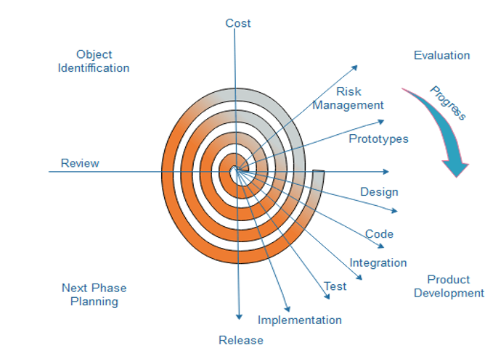

Figure 4.1: Spiral Model

Each phase of the spiral model is divided into four quadrants as shown in the above figure. These are implemented in our system on following basis.

* Object Identification: On this phase, we conduct feasibility study to understand about the online book store. Gather requirements and Identify Objectives of the online bookstore.
* Evaluation: On this phase, we identify potential risks which are associated with various modules like payment gateways, database handling and site traffic and evaluate them using risk mitigation strategies.
* Product Development: During this phase, we develop a prototype, different components (User login, shopping cart, add/ remove items.) and test them, then address risk based on test results.
* Next phase planning: Evaluate the current progress whether it’s met the initial objectives. Plan the next set of features.

# System Design

## 5.1 DFD

Indexes:

1.0 - Register/Login

Allows users and admins to register or log in to the system.

1.1 - Manage Books (CRUD)

Admin functionality for creating, reading, updating, and deleting books in the database.

1.2 - Browse Books

User functionality to browse the list of books available in the system.

1.3 - Payment

Handles payment information and provides payment confirmation.

1.4 - Order Books

User functionality to order books.

1.5 - View Order

Admin functionality to view order details.

1.6 - View Payment

Admin functionality to view payment information.

1.7 - Approve Order

Admin functionality to approve or decline an order.

## DFD Level-0

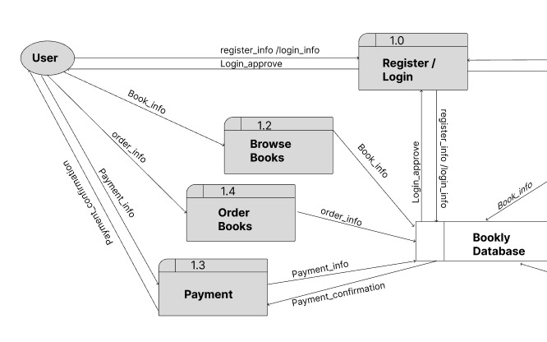

Figure 5.1 User side DFD Level-1

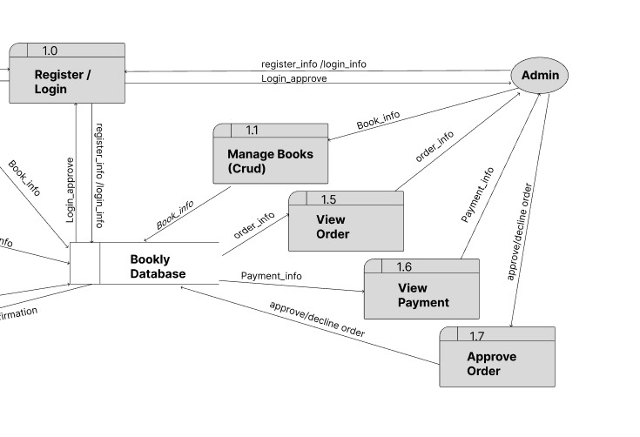

Figure 6.2 Admin Side DFD Level-1

## 5.2 ER Diagram

Figure 5.2 ER Diagram

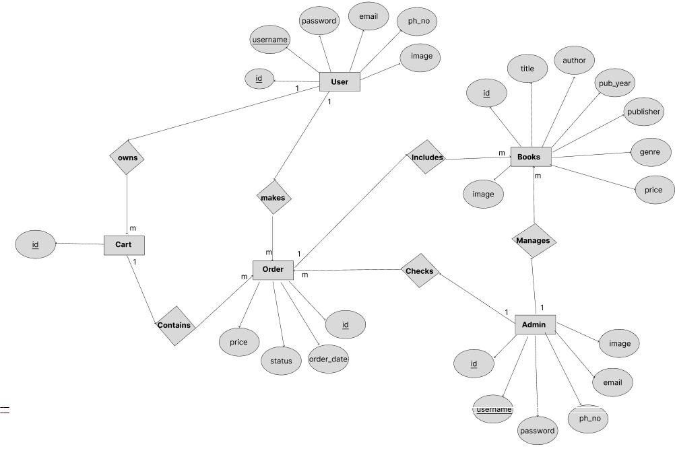

# Project Gantt Chart

Figure 6.1: Gantt Chart

# Project Progress Report

**Completed Features:**

* User Login and Registration: Fully functional for secure access.
* Interface Development: Rough interface created for both users and admins.

**Admin Features:**

* CRUD operations on books.
* Search functionality for easier inventory management.

**User Features:**

* Book browsing with detailed information.
* Cart functionalities to add and manage books.
* Order placement mechanism for finalized purchases.

**Pending Features:**

* Payment Integration: APIs for Khalti or eSewa will be incorporated.
* Order Tracking: Users will have a detailed history of their orders.
* Interface Refinement: Enhancements for a more polished and intuitive user experience.

**Challenges and Mitigations:**

* API Integration: Researched APIs to prepare for a seamless payment integration process.
* User Feedback Incorporation: Early feedback has been addressed, ensuring usability improvements.

# Conclusion

Bookly represents a significant step forward in creating a dedicated eCommerce platform for book enthusiasts. The project has already achieved several key milestones, including a fully functional user authentication system and basic features for browsing books, managing a cart, and placing orders. These developments mark an essential foundation for the platform, showcasing its potential to cater to a broad audience of readers and administrators.

One of the standout aspects of Bookly is its dual focus on user and administrative needs. For users, it simplifies the process of finding and purchasing books, offering advanced search features and a clean, user-friendly interface. For administrators, it provides essential tools to manage inventory and monitor orders, ensuring the system remains efficient and organized. These combined efforts aim to create a seamless experience for everyone involved.

However, the journey doesn’t end here. Several important features are under development, including the integration of Khalti and eSewa payment systems. This addition will allow users to complete their transactions securely and conveniently, further enhancing their overall experience. Additionally, improvements to the platform’s interface and functionality will ensure that Bookly remains a competitive and attractive option in the eCommerce space.

The challenges encountered during the development process, such as designing a database and designing UI. These experiences have contributed to a stronger, more reliable system.

Bookly is not just a tool for buying books; it’s a platform designed to bring joy and convenience to readers. As development progresses, the team remains committed to delivering a user-friendly solution that meets the needs of book lovers. The project’s dedication to quality and innovation ensures that Bookly will become a valuable resource for its users.

# References

tutorials point. (2019). *SDLC Spiral Model*. Www.tutorialspoint.com. https://www.tutorialspoint.com/sdlc/sdlc_spiral_model.htm

Acharya, K. (2020, February 10). *ONLINE BOOK STORE MANAGEMENT SYSTEM PROJECT REPORT.* ResearchGate; unknown. https://www.researchgate.net/publication/380729587_ONLINE_BOOK_STORE_MANAGEMENT_SYSTEM_PROJECT_REPORT