

**LA GRANDEE INTERNATIONAL COLLEGE**

**Simalchaur, Pokhara, Nepal**

A Project Report

On

**“Hamro Booking Sewa”**

(Online Hotel Booking App)

**Submitted to:**

LA Grandee International College

Bachelor of Computer Application (BCA) Program

In partial fulfilment of the requirements for the degree of BCA under

Pokhara University

**Submitted by:**

|  |  |  |  |
| --- | --- | --- | --- |
| **Name:** | **Program** | **Semester** | **P.U. Registration Number** |
| Laxman Parajuli | BCA | 8th | 2019-01-53-0119 |
| Sandhya Banstola | BCA | 8th | 2019-01-53-0132 |
| Ujjwal Adhikari | BCA | 8th | 2019-01-53-0138 |
|  |  |  |  |

**Date: 26 May 2024**

# STUDENT’S DECLARATION

We hereby declare that the project midterm report submitted to **LA Grandee International College**, Faculty of Science and Technology, under the affiliation of Pokhara University is our original work to be done in the form of partial fulfillment of Bachelor of Computer Application (B.C.A) under the supervision of **Mr. Sunil Sapkota**. We confirm that the report is only prepared for our academic requirement. Furthermore, it has not been and will not be used elsewhere for any other purposes.

* Laxman Parajuli
* Sandhya Banstola
* Ujjwal Adhikari

# TABLE OF CONTENTS

STUDENT’S DECLARATION i

TABLE OF CONTENTS ii

TABLE OF FIGURES iii

1. INTRODUCTION 1

2. PROBLEM STATEMENT 2

3. OBJECTIVES 3

4. METHODOLOGY 4

5. PROJECT GANTT CHART 5

6. DELIVERABLES 6

7. REFERENCES 7

# TABLE OF FIGURES

Figure 4.1 : Agile Model 4

Figure 5.1 :Gantt Chart 5

# INTRODUCTION

Hamro Booking Sewa is a laravel and react native based android application project on online hotel booking where users can view, select and book hotel. The system is fully computerized; the users can book the hotels very easily. The project completely user-friendly to attract more users into the platform.

While this project is being built across different development areas, the primary features included are uploading hotel details by hotel owners and online hotel booking by users. The rooms can also be viewed, selected and reviewed. The project has different modules in the development work, which are divided among super admin, hotel owners, users and registrations option. Some additional features which have been added to make the project more interactive is reviewing hotels by customers.

We have seen a lot of success in the recent times in the online hotel booking with the advent of Internet and our project is targeted to ride on the current trend to reap benefits while meeting the customer’s needs.

# PROBLEM STATEMENT

* Online hotel booking apps lacks of transparency in pricing: many apps advertise low rates, only for users to discover hidden fees and additional charges upon booking.
* Online hotel booking apps are often inconsistent in the quality of information provided; users often rely on photos and reviews to make their booking decisions, only to arrive at their destination and find that the reality does not match their expectations.
* Online hotel booking apps may lack customer support and assistance; when problems or issues arise during the booking process or stay at the hotel, users often struggle to get in touch with a representative for assistance.

# OBJECTIVES

* To improve the user experience and satisfaction by providing a platform where users can browse, compare different hotel options, and find the best deal that suits their budget and preferences.
* To streamline the reservation process by allowing users to reserve rooms at their own convenience, without the need to make phone calls or visit multiple hotels in person.

# METHODOLOGY

For our project we are using agile model. The agile model is a project management methodology that emphasizes flexibility, responsiveness to change, and collaboration among team members. It promotes iterative development cycles, where small incremental changes are made to the project in response to feedback and evolving requirements. This approach allows for quicker delivery of high-quality products and services by breaking down projects into smaller manageable tasks. Regular meetings, known as "sprints," are held to discuss progress, challenges, and adjustments needed to meet project goals. Agile values users input and involvement throughout the development process, ensuring that the final product meets their needs and expectations.

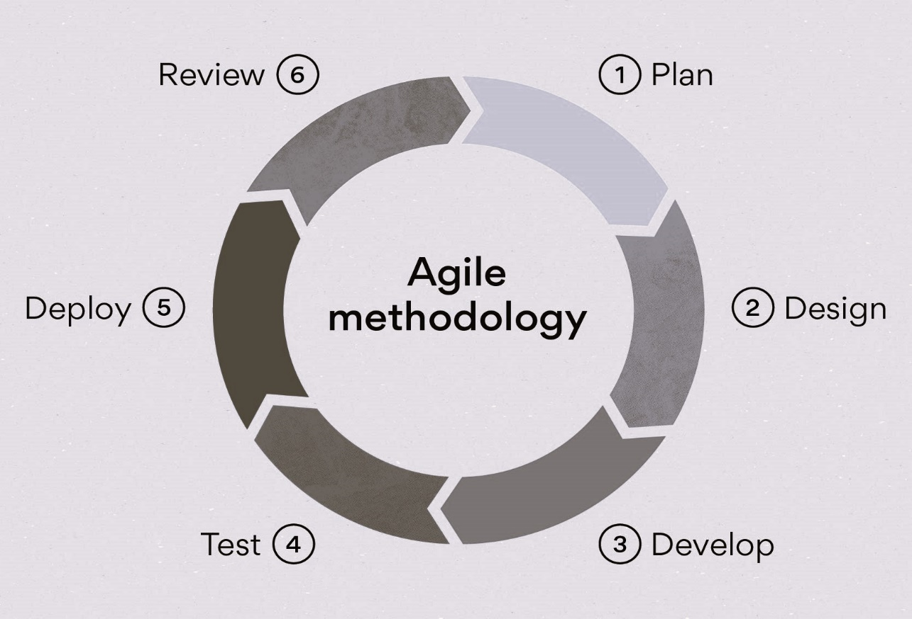

Figure 4.1: Agile Model

# Project Gantt Chart

The Gantt chart below shows the schedule planned for developing the “Hamro Booking Sewa”. It shows the time schedule description and tasks to be performed throughout the development of project. Thus, this project would be carried out in steps with proper planning in each step and best effort would be applied to finish this project before deadline.

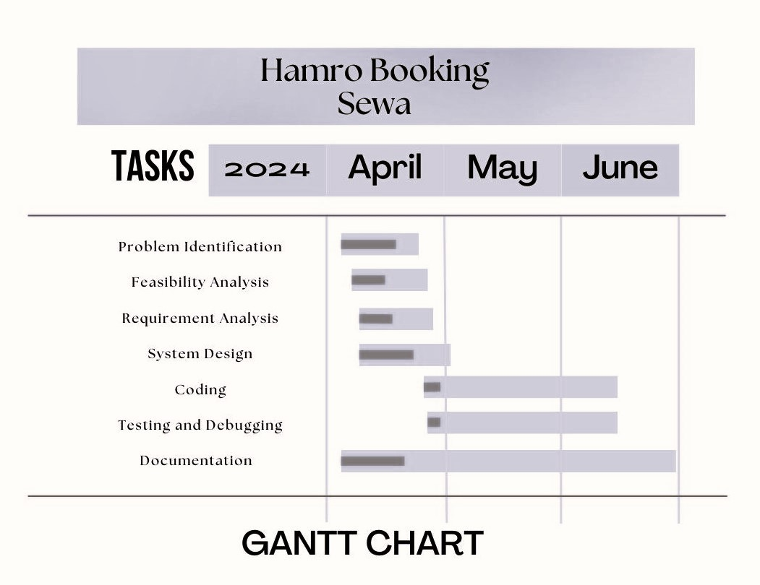

Figure 5.1: Gantt Chart

# DELIVERABLES

* Find hotels based on price range, and amenities, streamlining the booking process.
* Access to a wide range of hotels, from budget to luxury, catering to diverse preferences and budgets.
* Comprehensive details about each hotel, including photos, amenities, and room types empowering users to make informed decisions.
* Access to reviews and ratings from other guests, offering insights into the quality of service, cleanliness, and overall experience, aiding in decision-making.
* Access to reliable customer support for assistance with bookings, and queries, ensuring a positive user experience and support throughout the process.

# REFERENCES

* Colcol, S. (2024, January 31). *Hotel reservation system: Everything you need to know*. SiteMinder. https://www.siteminder.com/r/hotel-reservation-system/
* *About the Booking.com connectivity APIs*. (n.d.). https://developers.booking.com/connectivity/docs/
* *Hoodoo klub masáže*. (n.d.). https://wall.hoodooclub.cz/16041332153336017061/what-is-the-agile-methodology-in-software-development-skywell-software/