

**LA GRANDEE INTERNATIONAL COLLEGE**

**Simalchaur, Pokhara Nepal**

Final Project Report

On

**“JobNexus”**

(Online Job Portal)

**Submitted to:**

Bachelor of Computer Application (BCA) Program

In partial fulfilment of the requirements for the degree of BCA under

Pokhara University

**Submitted by:**

|  |  |  |  |
| --- | --- | --- | --- |
| **Name:** | **Course** | **Semester** | **P.U. Registration Number** |
| Akriti Chapagain | BCA | 8th | 2019-01-53-0104 |
| Binaya Koirala | BCA | 8th | 2019-01-53-0111 |

**Date:29/04/2024**

**DECLARATION FOR**

**“JobNexus”**

**STUDENT’S DECLARATION**

We hereby declare that we are the only authors of this work and that no sources other than the mentioned here have been used in this. We assure you that the work we present here is unique to ourselves and resemblances to another similar project are purely coincidental.

Akriti Chapagai (PU Exam Roll no): 20530162

Binaya Koirala (PU Exam Roll no): 20530169

Program: BCA, 8th Semester

Date: 29/04/2024

# ABSTRACT

“Job Nexus” is being developing for creating an interactive job vacancy form for candidates the app effectively gathers client and candidate information, categorizing them based on job requirements and vacancies. Its unique development methodology helps in acquiring the client and candidate information and separating them according to the job requirements and vacancies. This application would provide details of the job. An employer being registered in the application has the facility to use the services. Being an authorized user he can .Publish vacancy details and can search no of Employees on portal and also he can search candidates on basis of the key skill which employee provides on registration.

.

**TABLE OF CONTENTS**

1. INTRODUCTION 1

2. PROBLEM STATEMENT 2

3. OBJECTIVES 3

4. METHODOLOGY 4

5. GANTT CHART 5

6. DELIVARBLES 6

**TABLE OF FIGURES**

Figure 1: Agile Methodology for Development of JobNexus 4

Figure 2 Gantt Chart of JobNexus 5

# INTRODUCTION

Job Nexus, an upcoming mobile application set to revolutionize the job search process in Nepal. Job Nexus will establish partnerships with local organizations to facilitate the provision of vacancies for semi-skilled manpower, as well as opportunities for individuals seeking entry-level positions. This strategic collaboration will ensure that Job Nexus offers to a diverse range of job seekers, including those with varying levels of skills and experience. Above these Job Nexus will leverage these partnerships to broaden job access and provide opportunities for individuals in rural regions and local communities.

By offering a platform that connects job seekers with a wide array of job opportunities, including roles that require minimal skills, Job Nexus will play a crucial role in promoting inclusivity and economic empowerment. Job Nexus will simplifies job search process for both candidates and employers. Job seekers will have the ability to easily upload their resumes and explore job openings matched to their profiles, while employers will benefit from simplified job posting and application management. Furthermore, Job Nexus will be committed to strenghten skill development and professional growth. By creating a unified platform for training programs and volunteer opportunities, Job Nexus will empower individuals to enhance their skills and access new career opportunities.

This application will be developed using technologies such as React Native for frontend development and Laravel for backend along with various tools and utilities which will ensure easy and flawless navigation to the platform. Enabling it to serve as a beacon to the candidates searching for job opportunities and asset for those who will be beneficial through this application.

.

# PROBLEM STATEMENT

Following were the problems we found in job portal applications:

* Current job portals in Nepal lack collaborations with local businesses, hindering job access, particularly in rural regions.
* Job seekers encounter difficulties finding appropriate roles because of insufficient skill-based matching on existing platforms.
* Semiskilled workers, like plumbers and construction workers, confront a scarcity of job listings as portals primarily prioritize skilled positions.
* In the absence of dedicated platforms, there's a notable gap for registering volunteers during events, leaving organizers without efficient means to manage manpower.
* There aren't many apps that bring together different training and workshop programs, making it hard for people to find skill-building opportunities.

# OBJECTIVES

* To establish collaborations with local businesses to broaden job access and ensure rural inclusion and semi-skilled job potentials.
* To implement advance filter to better match job seekers with suitable roles based on their skills.
* To create a unified platform for users to easily find and enroll in diverse training programs, volunteers, fostering skill development.

# METHODOLOGY

The Agile methodology is being used to develop the Job Nexus. Agile is a flexible and iterative approach that allows for rapid development and testing. The Agile methodology is well-suited to projects with evolving requirements, such as Job Nexus, where there may be changes in the features and functionalities that the platform requires. The Agile methodology will be implemented using the Scrum framework, which is a popular Agile methodology that involves working in small, cross-functional teams. Here we are of two members handling frontend and backend each and we will meet regularly to discuss progress, plan for the next iteration, and address any issues that arise.

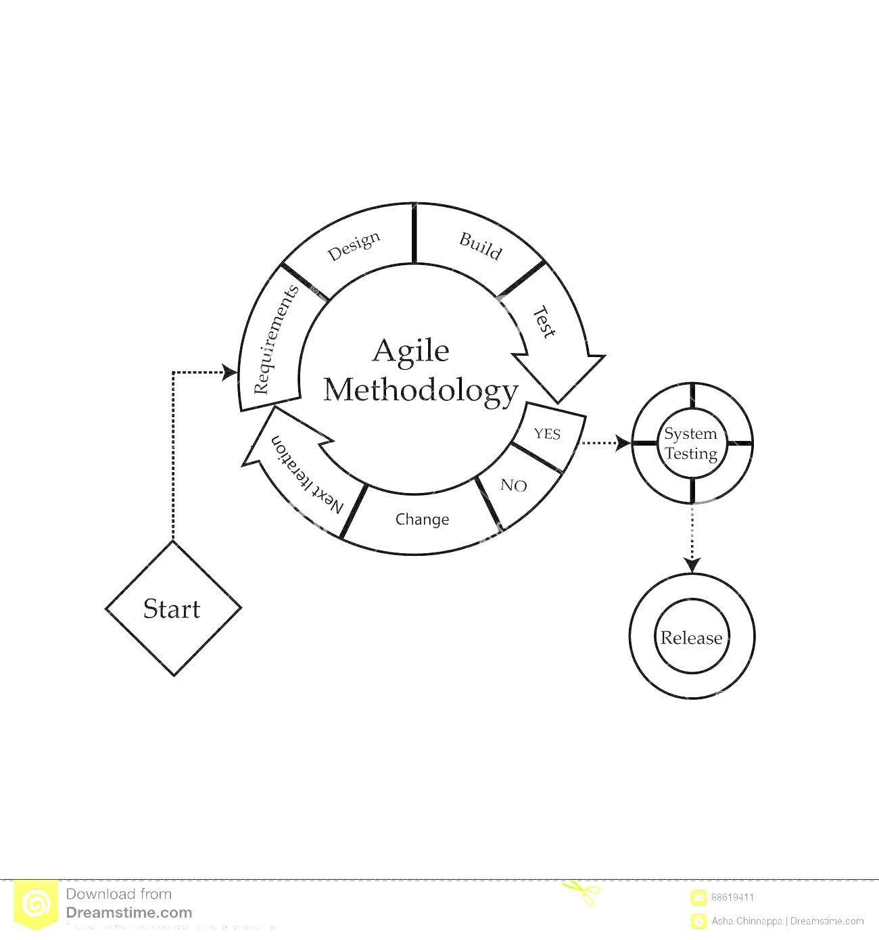

Figure 1: Agile Methodology for Development of JobNexus

# GANTT CHART

A Gantt chart is a visual representation of a project's schedule, displaying tasks as horizontal bars along a timeline. It provides an overview of project progress, task dependencies, and helps in tracking project milestones and deadlines.

Since we are using Agile methodology we will be working with continuous iterations or sprints where we communicate and address issues. As shown in the diagram below we have already started problem identifications and done partial feasibility study as well as requirement analysis and started to make some design of the system and work of coding, testing and debugging will be done continuously and documentation of every work is kept along.

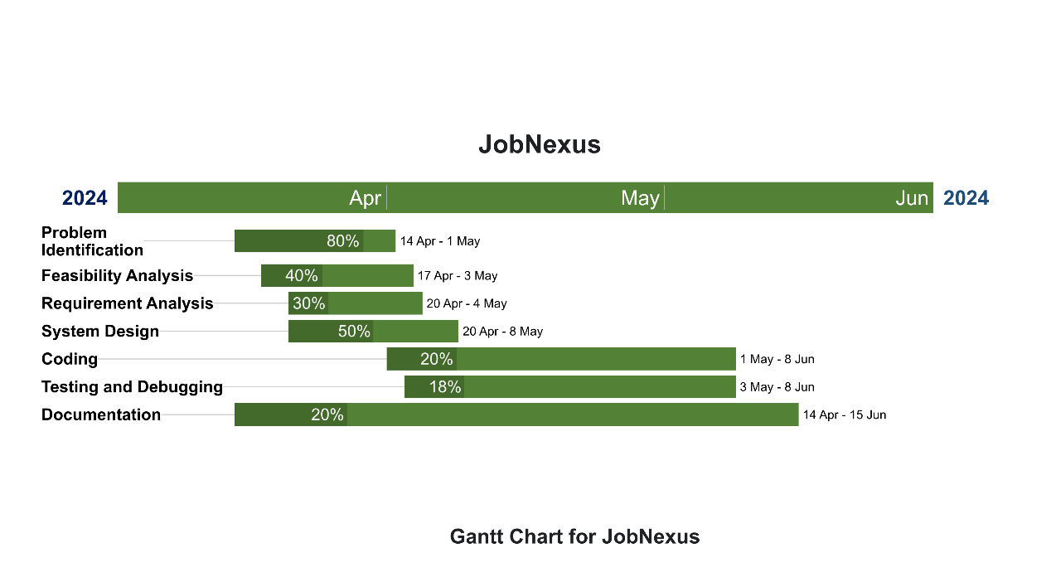

Figure 2 Gantt Chart of JobNexus

# DELIVARBLES

* Form partnerships with local organizations to source job vacancies for semi-skilled manpower and entry-level positions.
* Offers a wide range of job opportunities to cater to individuals with varying skills and experience levels, including those in rural regions and local communities.
* Provide a platform that promotes inclusivity and economic empowerment by connecting job seekers with roles that require minimal skills.
* Develop a user-friendly interface that simplifies the job search process for both candidates and employers.
* Allow job seekers to easily upload their resumes and match them with relevant job openings.
* Enable employers to post job listings easily and manage applications efficiently.
* Integrate training programs and volunteer opportunities into the platform to empower individuals to enhance their skills and access new career opportunities.