

**LA GRANDEE INTERNATIONAL COLLEGE**

**Simalchaur, Pokhara Nepal**

Final Project Report

On

**“JobNexus”**

(Online Job Portal)

**Submitted to:**

Bachelor of Computer Application (BCA) Program

In partial fulfilment of the requirements for the degree of BCA under

Pokhara University

**Submitted by:**

|  |  |  |  |
| --- | --- | --- | --- |
| **Name:** | **Course** | **Semester** | **P.U. Registration Number** |
| Akriti Chapagain | BCA | 8th | 2019-01-53-0104 |
| Binaya Koirala | BCA | 8th | 2019-01-53-0111 |

**Date:14/05/2024**

i

**ACKNOWLEDGEMENT**

We would like to express our gratitude to Pokhara University for developing a highly valuable curriculum and enabling us to undertake this project. Furthermore, we extend our sincere appreciation to La Grandee International College, whose assistance has been instrumental in making our project a reality. Without their support, our project would have been unattainable. We express our sincere regard to our project supervisor Sunil Sapkota, for his valuable time, guidance, encouragement, support, and cooperation throughout the duration of our project. We would sincerely like to thank BCA Department for giving us the opportunity to work on enhancing our technical skills while undergoing this project. This project helped us understand the various parameters involved in the development of a mobile application and the working and integration of frontend along with the backend to create a fully functional mobile application. We would like to express our gratitude to Pokhara University for developing a highly valuable curriculum and enabling us to undertake this project. Furthermore, we extend our sincere appreciation to La Grandee International College, whose assistance has been instrumental in making our project a reality. Without their support, our project would have been unattainable.

With Regards,

Akriti Chapgain (Registration No: 2019-1-53-0104)

Binaya koirala (Registration No: 2019-1-53-0111)

ii

**DECLARATION FOR**

**“JobNexus”**

**STUDENT’S DECLARATION**

We hereby declare that we are the only authors of this work and that no sources other than the mentioned here have been used in this. We assure you that the work we present here is unique to ourselves and resemblances to another similar project are purely coincidental.

Akriti Chapagai (PU Exam Roll no): 20530162

Binaya Koirala (PU Exam Roll no): 20530169

Program: BCA, 8th Semester

Date: 14/05/2024

Name: Binaya Koirala

Exam Roll No: 20530169

Semester: BCA 8h SEM

P.U Registration No: 2019-1-53-0169

Signature:



iii

**Supervisor’s Declaration**

I hereby recommend that this project entitled "JobNexus " is done under my supervision by Akriti Chapagain, Binaya Koirala during 8th semester in partial fulfillment of the requirement for the degree of Bachelor of Computer Application (BCA) under Pokhara University is completed to my satisfaction and be processed for final evaluation.

Sunil Sapkota



iv

**Letter of Approval**

We certify that we have examined this report JobNexus ", and are satisfied with the proposal defense. In our opinion it is satisfactory in the scope and qualify as project in partial fulfillment of the requirements for the degree of BCA under Pokhara University.

**Project Supervisor**

**External Invigilator**

**Principal**

**Er. Sunil Sapkota**

**Er. Kiran K.C**

v

**Abstract**

This report is submitted to the Department of Computer Application at LA Grandee International College as part of the BCA 8th Semester Project. The project, titled "JobNexus”, it serves as an introductory overview of the Job Portal App project, showcasing its potential to revolutionize the event planning and venue selection process. “Job Nexus” is being developing for creating an interactive job vacancy form for candidates the app effectively gathers client and candidate information, categorizing them based on job requirements and vacancies. Its unique development methodology helps in acquiring the client and candidate information and separating them according to the job requirements and vacancies. This application would provide details of the job. An employer being registered in the application has the facility to use the services. Being an authorized user he can .Publish vacancy details and can search no of Employees on portal and also he can search candidates on basis of the key skill which employee provides on registration.

.

vi

|  |  |  |  |
| --- | --- | --- | --- |
|  |  | **Contents** |  |
| 1. | Introduction ............................................................................................................ | | 1 |
| 2. | Problem Statement ..................................................................................................... | | 2 |
| 3. | Objectives .................................................................................................................. | | 3 |
| 4.Background Study ...................................................................................................... | | | 4 |
| 5. | Methodology .............................................................................................................. | | 6 |
|  | 5.1 | Requirement Analysis .......................................................................................... | 7 |
|  | 5.2. Problem Analysis: ............................................................................................... | | 7 |
|  | 5.3 Verification and Validation: .................................................................................. | | 8 |
|  | 5.4 | Development Plan: ............................................................................................... | 8 |
|  | 5.5 | Testing: ................................................................................................................ | 8 |
|  | 5.6 | Documentation: ................................................................................................... | 8 |
| 6. | Requirement document ............................................................................................ | | 10 |
|  | 6.1. Tools and software requirements ...................................................................... | | 10 |
|  | 6.2. Functional Requirements .................................................................................. | | 10 |
|  | 6.3 | Requirement Matrix: .......................................................................................... | 11 |
| 7. | System Analysis and Design: .................................................................................. | | 12 |
|  | 7.1 | ER-Diagram ....................................................................................................... | 12 |
|  | 7.2 | Class-Diagram .................................................................................................... | 13 |
|  | 7.3 | DFD (Data Flow Diagram) ................................................................................ | 14 |
| 8. | Development ............................................................................................................ | | 16 |
| 9. TESTING ................................................................................................................. | | | 19 |
|  | 9.1. Test cases ........................................................................................................... | | 19 |
| 10. Time schedule ........................................................................................................ | | | 32 |
| 11. Project Results: ..................................................................................................... | | | 33 |
| 12.Future Enhancement ............................................................................................... | | | 35 |
| 13.Conclusion .............................................................................................................. | | | 36 |
| 14. References ............................................................................................................. | | | 37 |
| Annexure ..................................................................................................................... | | | 39 |

vii

**List of Figures**

FIGURE 1: ITERATION MODEL 6

FIGURE 2:ER-DIAGRAM 12

FIGURE 3 CLASS-DIAGRAM 13

FIGURE 4: DFD LEVEL-0 14

FIGURE 5: DFD LEVEL 1 14

FIGURE 6: DFD LEVEL 2 15

FIGURE 7: DATABASE SCHEME 17

FIGURE 8 GANTT CHART 32

viii

**List of Tables**

Table 1: Requirement Matrix 11

Table 2: Task Division 18

Table 3: Test case for verification of user login 21

Table 4 : Test case for verification of admin login 24

Table 5: Test case for verification of venue owner login 26

Table 6: Test case for verification of registration 29

Table 7: Test case for booking venue 30

Table 8: Test case for payment 31

ix

**List of abbreviation**

DFD- Data Flow Diagram

MySQL- My Structured Query Language

ER- Entity Relationship

x

# INTRODUCTION

Job Nexus, an upcoming mobile application set to revolutionize the job search process in Nepal. Job Nexus will establish partnerships with local organizations to facilitate the provision of vacancies for semi-skilled manpower, as well as opportunities for individuals seeking entry-level positions. This strategic collaboration will ensure that Job Nexus offers to a diverse range of job seekers, including those with varying levels of skills and experience. Above these Job Nexus will leverage these partnerships to broaden job access and provide opportunities for individuals in rural regions and local communities.

By offering a platform that connects job seekers with a wide array of job opportunities, including roles that require minimal skills, Job Nexus will play a crucial role in promoting inclusivity and economic empowerment. Job Nexus will simplifies job search process for both candidates and employers. Job seekers will have the ability to easily upload their resumes and explore job openings matched to their profiles, while employers will benefit from simplified job posting and application management. Furthermore, Job Nexus will be committed to strenghten skill development and professional growth. By creating a unified platform for training programs and volunteer opportunities, Job Nexus will empower individuals to enhance their skills and access new career opportunities.

This application will be developed using technologies such as React Native for frontend development and Laravel for backend along with various tools and utilities which will ensure easy and flawless navigation to the platform. Enabling it to serve as a beacon to the candidates searching for job opportunities and asset for those who will be beneficial through this application.

1

**2. Problem Statement**

Following were the problems we found in job portal applications:

* Current job portals in Nepal lack collaborations with local businesses, hindering job access, particularly in rural regions.
* Job seekers encounter difficulties finding appropriate roles because of insufficient skill-based matching on existing platforms.
* Semiskilled workers, like plumbers and construction workers, confront a scarcity of job listings as portals primarily prioritize skilled positions.
* In the absence of dedicated platforms, there's a notable gap for registering volunteers during events, leaving organizers without efficient means to manage manpower.
* There aren't many apps that bring together different training and workshop programs, making it hard for people to find skill-building opportunities.

2

# OBJECTIVES

* To establish collaborations with local businesses to broaden job access and ensure rural inclusion and semi-skilled job potentials.
* To implement advance filter to better match job seekers with suitable roles based on their skills.
* To create a unified platform for users to easily find and enroll in diverse training programs, volunteers, fostering skill development.

3

**4.Background Study**

Background study is an essential step in understanding the market, user needs, and potential competitors. Here's a structured approach that we conducted a study for:

1. Market Research:

o Market Size and Growth: Determine the size and growth potential of the venue management industry. Look for statistics and trends that highlight the demand for such apps and websites.

o Target Audience: Identified our target audience within the venue management sector. This include event planners, venue owners, or even individual users looking to book venues.

o Competitor Analysis: Research existing venue management apps. Analyze their features, user reviews, pricing models, and market share. Identify gaps in their offerings that your app can fill.

o Regulations and Compliance: Understand any legal or regulatory requirements related to venue management, such as permits, safety standards, or licensing.

1. User Research:

o User personality: Create detailed user personality representing different segments of your target audience. Understand their pain points, needs, and preferences.

o Surveys and Interviews: Conducted surveys or interviews with potential users to gather insights into their challenges and expectations when it comes to venue management.

o User Journeys: Mapped out the typical user journeys involved in venue management, from searching for a venue to booking and managing events.

1. Technology and Infrastructure:

o App Platforms: Decide whether our app will be available on iOS, Android, or both. Consider whether it will also have a web version.

4

* 1. Technical Feasibility: Assess the technical feasibility of building the app, including the required infrastructure, development tools, and potential integrations with other systems.

1. Feature Set:
   1. Core Features: Defined the essential features our app must have, such as venue search, booking, scheduling, payment processing, and event management.
   2. Differentiators: Identified unique features or innovations that will set your app apart from competitors. This could include AI-driven recommendations, real-time availability updates, or seamless communication tools.
2. Monetization Strategy:
   1. Revenue Models: Explored different revenue models
   2. Pricing Strategy: Determine the pricing structure that aligns with your target audience's willingness to pay and the value your app provides.
3. Timeline and Milestones:
4. Project Timeline: Created a timeline that outlined key development milestones.
   1. Development Phases: Divide the app development process into phases, such as design, development, testing, and deployment.
5. Risk Assessment:

o Identify Risks: Listed potential risks and challenges that could affect the development and success of our app. Develop mitigation strategies for each.

1. Feedback and Iteration:

o Planned for collecting user feedback and incorporating it into future updates to continuously improve the app.

By conducting a comprehensive background study, we are prepared to develop a venue management app that meets the needs of your target audience and stands out in the market.

5

**5. Methodology**

The Agile methodology is being used to develop the Job Nexus. Agile is a flexible and iterative approach that allows for rapid development and testing. The Agile methodology is well-suited to projects with evolving requirements, such as Job Nexus, where there may be changes in the features and functionalities that the platform requires. The Agile methodology will be implemented using the Scrum framework, which is a popular Agile methodology that involves working in small, cross-functional teams. Here we are of two members handling frontend and backend each and we will meet regularly to discuss progress, plan for the next iteration, and address any issues that arise.

.

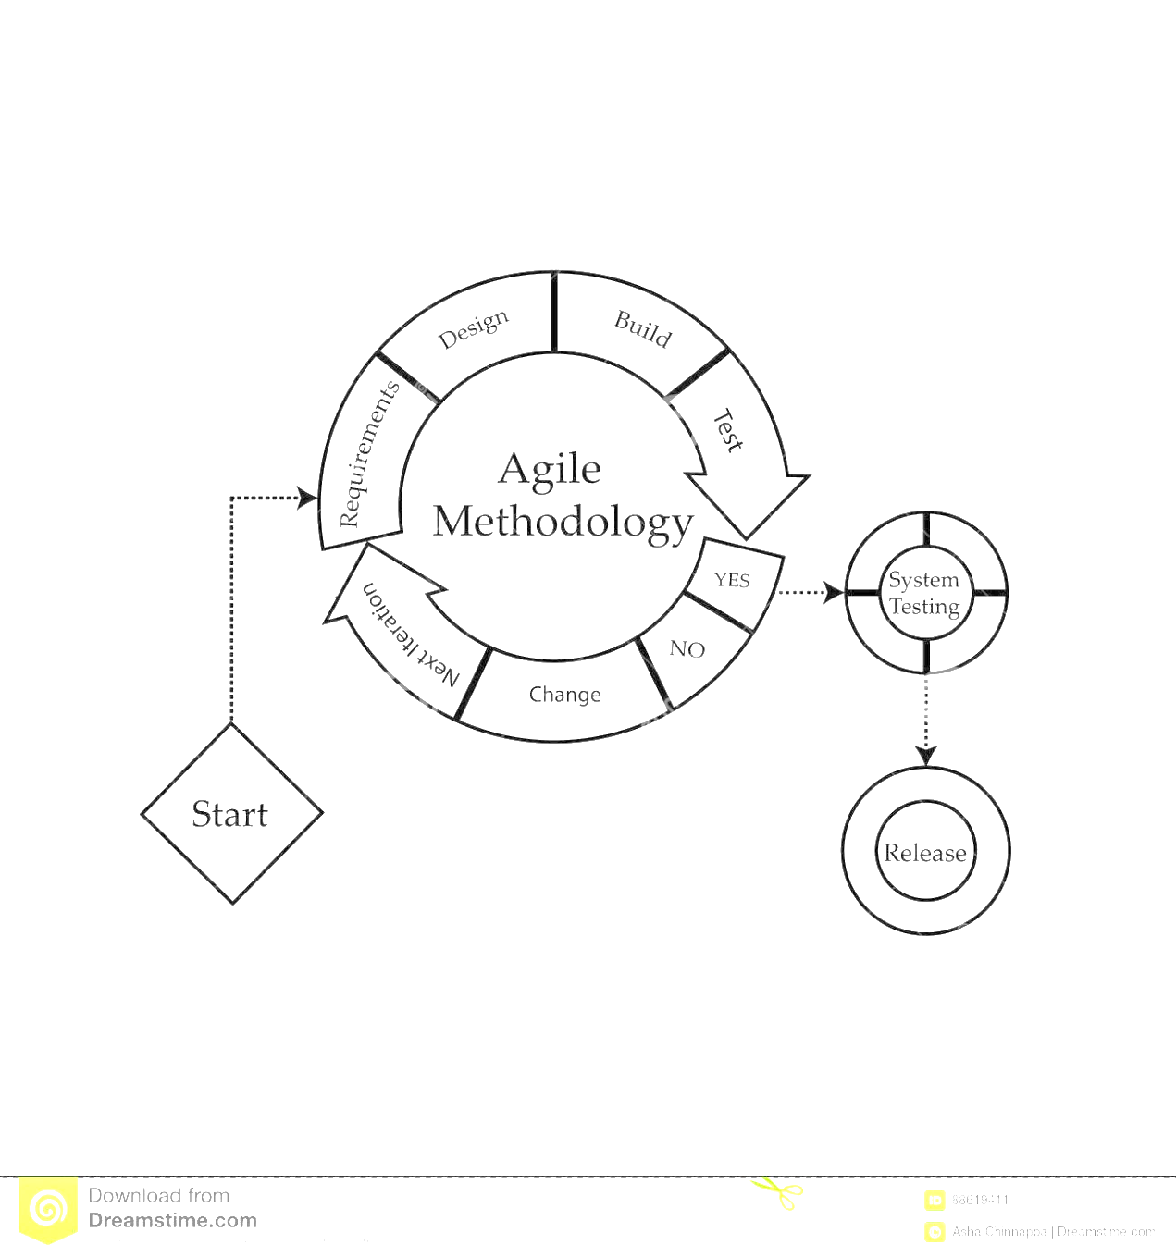



*FIGURE 1: ITERATION MODEL*

6

**5.1 Requirement Analysis**

To successfully develop a venue match app, conducting a comprehensive requirement analysis is paramount for understanding the needs and expectations of our target audience. We have gathered valuable insights from various operating venues in Pokhara, such as Pokhara Grandee, who emphasized the significance of customer satisfaction. Their recommendations underscored the importance of implementing a user-friendly interface to quickly engage users. Effective requirements analysis is pivotal in determining the success or failure of a software project. These requirements must be documented, actionable, measurable, testable, traceable, and directly aligned with identified business needs or opportunities, detailing them to a level suitable for system design. In every project, gathering essential requirements from diverse sources is crucial to align our efforts with project objectives. Our research has led us to the conclusion that developing a venue match app necessitates identifying core functionalities and features. These encompass defining user roles, implementing robust user authentication and authorization mechanisms, integrating location-based services for venue search, ensuring an intuitive interface for venue comparison, enabling real-time communication and booking capabilities, ensuring robust data security and privacy measures, and incorporating feedback mechanisms for user reviews and ratings.

**5.2. Problem Analysis:**

The problem analysis for a venue match application reveals several key areas of concern. These include limited venue options, inaccurate or outdated information, insufficient filtering and search options, a lack of user reviews and ratings, complex booking processes, limited integration with other services, and technical glitches and performance issues. Understanding and addressing these challenges will be crucial in developing a successful and user-friendly app that provides a seamless experience for users looking to find the perfect venue for their events or occasions. We also analyzed them and found that, while choosing venues many people prefer to use manual way of booking venues because they are not familiar with the advanced system of VENUE MATCH system.

7

**5.3 Verification and Validation:**

In the development of the Venue Match App, verification and validation were pivotal processes to ensure that the software system met its specifications and fulfilled its intended purpose. As part of our validation process, we implemented measures to verify the authenticity of users and validate the data entered into the system. This meticulous verification and validation process were crucial in maintaining the integrity of our database, ensuring that only genuine users interacted with the platform and that the data remained accurate and reliable.

**5.4 Development Plan:**

The development plan for the Venue Match App was a collaborative effort within our team. We addressed critical questions, such as designing the project to be user-friendly and accommodating to a wide range of users. We also considered time constraints, recognizing the importance of delivering the project within specified timelines. Our development plan encompassed every aspect of the project, ensuring that we could provide users with a seamless, efficient, and timely venue selection experience.

**5.5 Testing:**

Testing played a crucial role in the development of the Venue Match App, following the principles of the spiral model. Throughout the development cycle, we conducted multiple rounds of manual testing to identify and rectify errors. Online communities such as Stack Overflow and Quora served as valuable resources for troubleshooting and resolving issues promptly. Our commitment to software testing was grounded in the goal of delivering a defect-free application that consistently met users' expectations. We utilized various testing methodologies, tailoring our approach to the specific requirements of the project.

**5.6 Documentation:**

Documentation emerged as a vital aspect of the Venue Match App project. Every aspect of our development process was meticulously recorded in softcopy format. This comprehensive documentation not only served as a reference point but also facilitated a better understanding of the program's flow. It will prove invaluable for future enhancements and additional feature integrations. In cases where unforeseen problems

8

arise during further development, this documentation will serve as a valuable resource, enabling us to maintain and improve the application's interactivity effectively.

9

**6. Requirement document**

**6.1. Tools and software requirements**

Flutter SDK: This open-source framework, developed by Google, is essential for building cross-platform mobile apps. Install the Flutter SDK, which includes the Flutter framework, Dart programming language, and command-line tools.

Integrated Development Environment (IDE): Several IDE options are available for Flutter app development. Popular choices include: Visual Studio Code (VS Code): A lightweight and free IDE with excellent Flutter support through extensions. Android Studio: A full-featured IDE developed by Google, which includes built-in support for Flutter.

Dart programming language: Flutter apps are built using the Dart programming language.

State management: Effective state management is vital for a smooth ecommerce experience. Flutter offers various options like Provider, River pod, Redux, or Mob for handling app state.

UI/UX design tools: You can design your app's user interface (UI) and user experience (UX) using tools like Figma, which allows collaborative design work among team members.

Version control: Employing version control is a good practice for tracking code changes and collaborating with other developers. GitHub, GitLab, or Bitbucket are platforms that can host your code repositories.

Third-party packages: Flutter boasts a vast ecosystem of third-party packages that provide ready-made solutions for various app functionalities.

**6.2. Functional Requirements**

1. User Registration and Authentication: - Enable users to register and create accounts. - Implement secure authentication methods like email/password, social media login, or OAuth. - Provide password reset and account recovery options.

10

1. Venue Catalog - Display a list of products with details such as title, description, price, and images. - Implement categories and filters to help users browse and search for specific products. - Allow users to view product details and read reviews.
2. Booking Management: - Provide users with booking history. - Allow users to view and manage their booking, including cancellation.
3. User Profile and Settings:- Enable users to view and update their profile information.
4. Backend Integration: - Connect the app with a backend system to handle data storage, product management, order processing, and other business logic.

**6.3 Requirement Matrix:**

|  |  |  |  |
| --- | --- | --- | --- |
| SN | requirement, modules, | Description for the | Priority (high, |
|  | system and features | modules | medium, low) |
|  |  |  |  |
| 1. | Login and security system | Login can be done on the | high |
|  |  | basis of their levels |  |
|  |  |  |  |
| 2. | Data entry | Data entry of the major | high |
|  |  | details of the users |  |
|  |  |  |  |
| 3. | Venue Detail | The venue owner and | high |
|  |  | admin can place the |  |
|  |  | venue details |  |
|  |  |  |  |
| 4. | Checking of Booked and un | User must procced | high |
|  | booked venues | during testing of system |  |
|  |  |  |  |
| 5. | Performance Checkout | System must be able to | high |
|  |  | satisfy the customer in |  |
|  |  | user friendly manner |  |
|  |  |  |  |
| 6. | Booked venue | User must be simple able | high |
|  |  | to retrieve the booked |  |
|  |  | venue |  |
|  |  |  |  |
|  | *Table 1: Requirement Matrix* | |  |

11

**7. System Analysis and Design:**

**7.1 ER-Diagram**

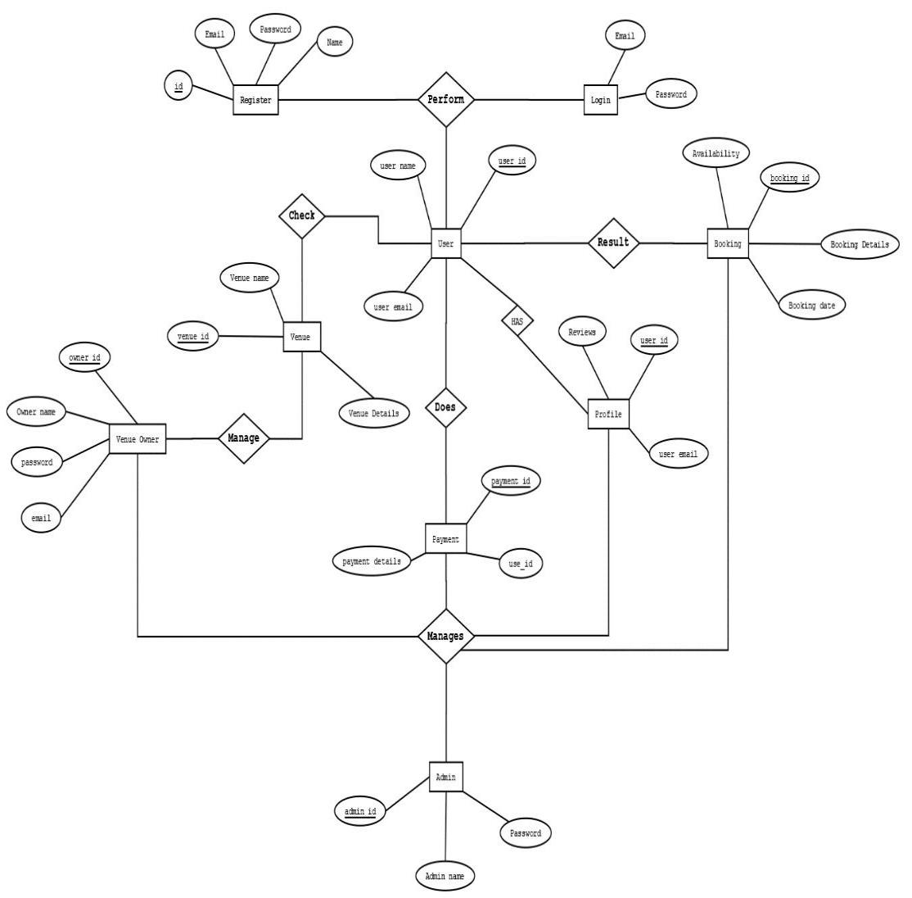

*FIGURE 2:ER-DIAGRAM*

12

**7.2 Class-Diagram**

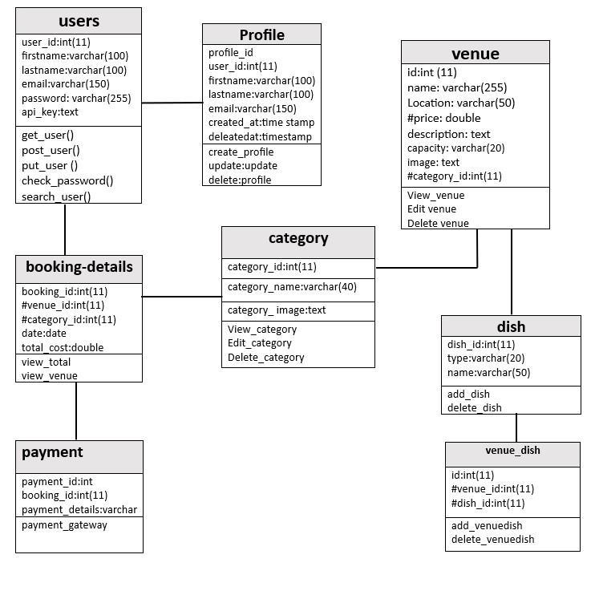

*FIGURE 3 CLASS-DIAGRAM*

13

**7.3 DFD (Data Flow Diagram)**

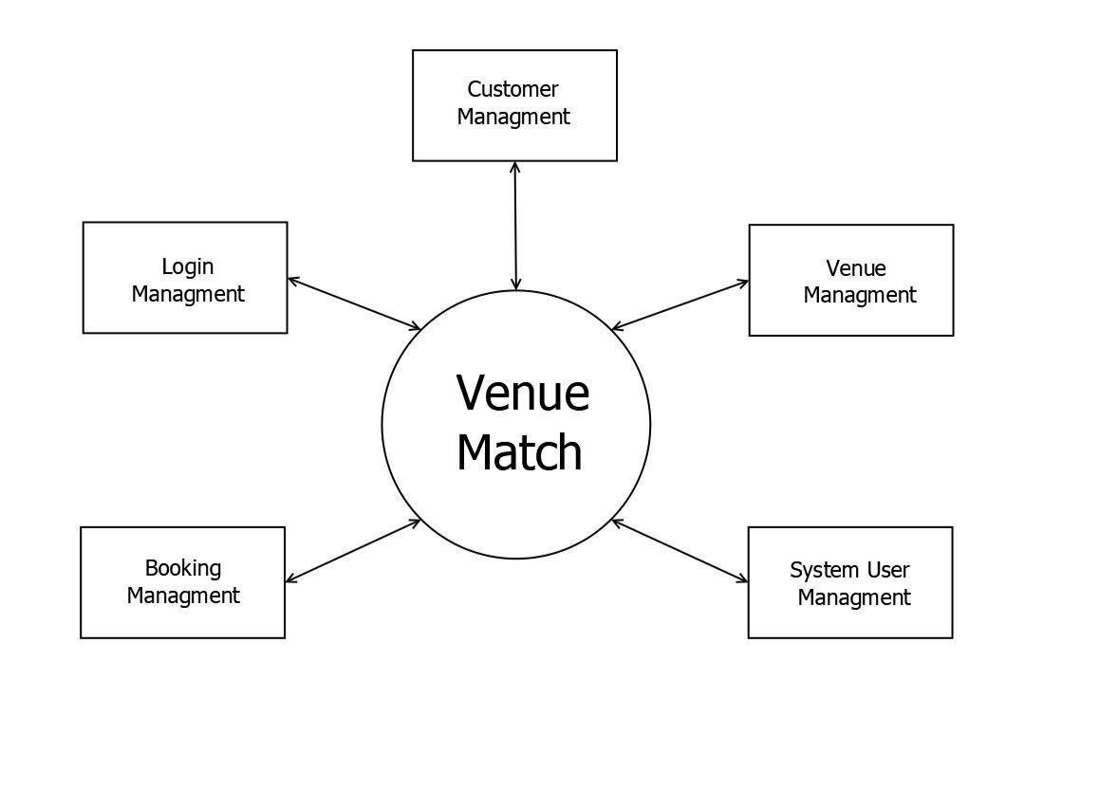

*FIGURE 4: DFD LEVEL-0*

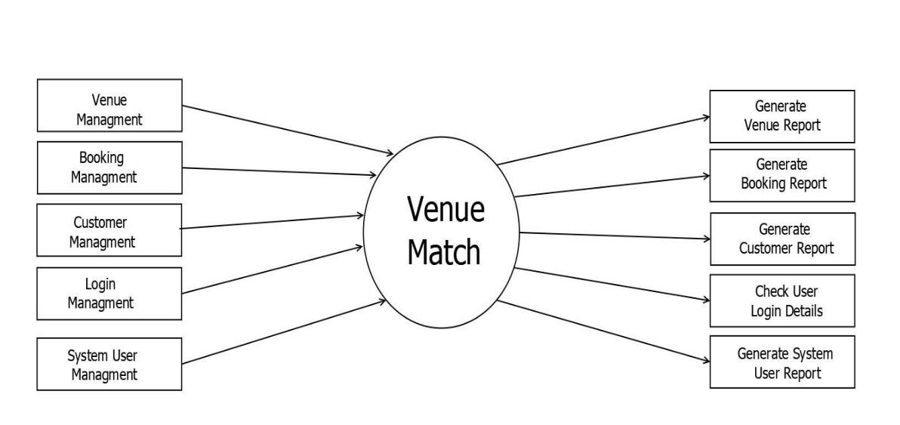

*FIGURE 5: DFD LEVEL 1*

14

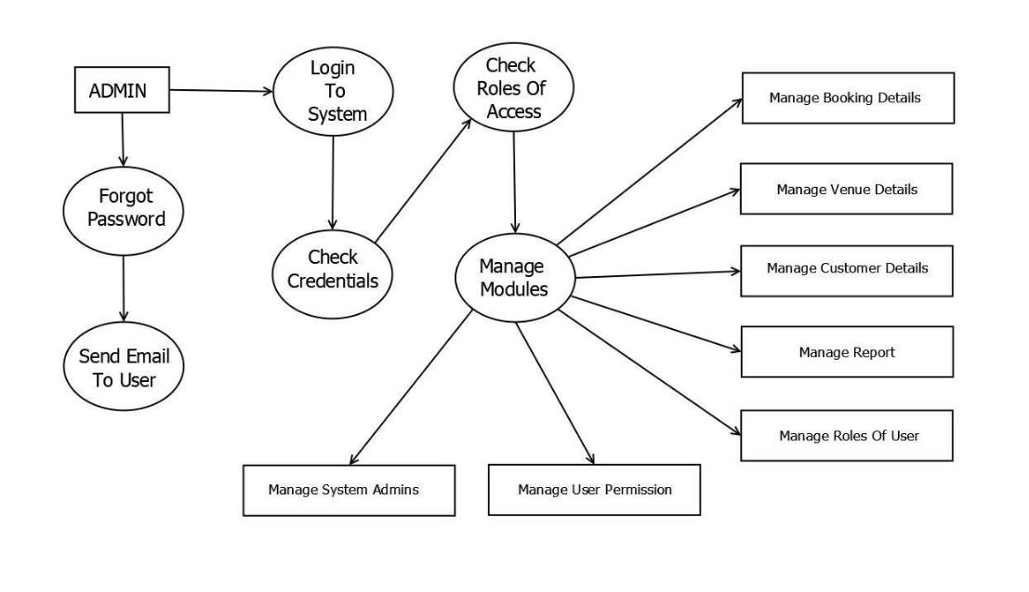

*FIGURE 6: DFD LEVEL 2*

15

**8. Development**

The Venue Match App development commenced with the adoption of the "Iterative Model". The Iterative Model is a software development approach that focuses on incremental and iterative progress throughout a project's lifecycle. In this model, the development process is divided into small cycles or iterations, each of which involves a subset of the project's requirements. The model begins with an initial planning phase where the project's objectives, requirements, and scope are defined. Following this, the first iteration is executed, typically involving design, development, and testing activities.

What sets the Iterative Model apart is that it doesn't attempt to define all project requirements upfront. Instead, it allows for flexibility, enabling developers and stakeholders to adapt and refine requirements as the project progresses. Each iteration results in a partially completed version of the software, and feedback from users and stakeholders is gathered and incorporated into the subsequent iterations.

This iterative process continues until the software reaches a state where it meets the desired level of functionality, quality, and user satisfaction. The advantage of the Iterative Model lies in its ability to accommodate changing requirements, respond to user feedback, and reduce the risk of late-stage project failures by addressing issues early in the development process.

As we know the process of planning, organizing, coordinating, and controlling resources to achieve specific goals is also referred to as development. Software engineers have created more sophisticated tools known as IDE (Integrated Development Environment) to accommodate the evolution of software development. We have used Visual studio IDE which has features that integrate flawlessly with flutter frameworks. Likewise, for effective and worthwhile documentation, many inhouse office products like Ms-excel, MS-word, and PowerPoint were used. For the charts and diagrams, DIA tool is used. PHP is a backend tools used in the system. We have used Discord, Git and Microsoft Teams for our collaborative platform to discuss with the problems and task division among the members with our project supervision among the team members in teamwork manner. Our system must store information about the

16

booking, venue details, Reservations, and so on. As a result, we've identified the major tables that will be implemented on the chosen RDBMS. So here is the database schema for our project "Venue Match".

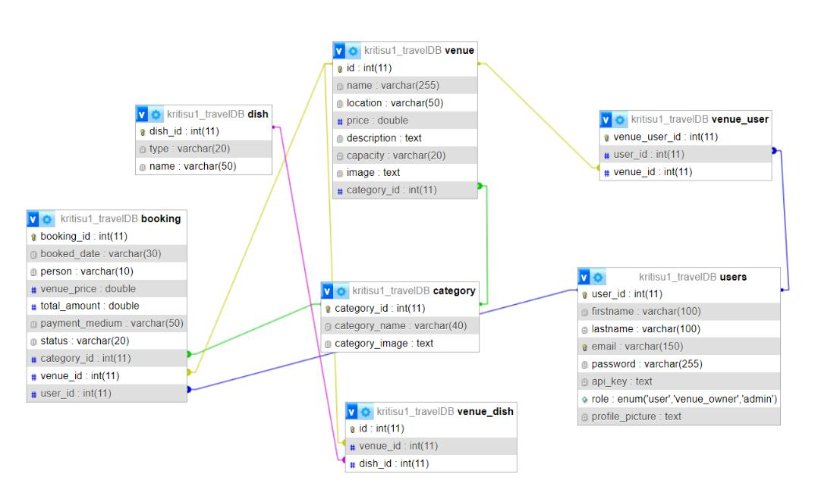

*FIGURE 7: DATABASE SCHEME*

The illustrated database visually represents the organization and relationships among the tables within the Venue Match database. This database schema serves as the structured, language-supported description of the database's architecture within a Database Management System (DBMS). The figure above provides a comprehensive list of tables and their associated entities involved in the development of Venue Match.

Specifically, the depicted database schema outlines the organization and interconnections of tables within a database named "kritisu1_travelDB." Notable tables within the Venue Match database include "kritisu1_travelDB_user," "kritisu1_travelDB_booking," "kritisu1_travelDB_venue_user," among others. These tables are integral components of the system.

To establish relationships and maintain data integrity, numerous foreign keys are employed throughout the database. A foreign key is a pivotal database constraint that establishes a connection between two tables within a relational database. This constraint

17

actively enforces referential integrity by guaranteeing that the values within a column of one table correspond to the values within a column of another table.

In essence, foreign keys play a vital role in ensuring the coherence and reliability of data across different tables, thus facilitating robust relationships and enabling efficient data retrieval within the Venue Match database.

|  |  |  |  |
| --- | --- | --- | --- |
| S. N | Name of student |  | Work Assigned |
|  |  |  |  |
| 1. | Narvasha Adhikari | o | Documentation |
|  |  | o | Proposal Planning |
|  |  | o | Problem Identification |
|  |  | o | Design (system design) |
|  |  | o Coding (mostly website and some | |
|  |  |  | parts of mobile app) |
|  |  | o | Testing |
|  |  |  |  |
| 2. | Samjhana Poudel | o | Documentation |
|  |  | o | Requirement Analysis |
|  |  | o Design (support in system design) | |
|  |  | o Coding (mostly mobile app and some | |
|  |  |  | parts of website) |
|  |  | o | Backend |
|  |  | o | Testing |
|  |  |  |  |

*Table 2: Task Division*

18

**9. TESTING**

A test case comprises a set of conditions or variables employed by a tester to ascertain if a system being evaluated fulfills prescribed requirements or functions correctly. The process of creating test cases can also aid in revealing potential shortcomings within an application's requirements or design. The Software Testing Life Cycle (STLC) serves as a testing methodology that contributes to the attainment of software quality standards with greater efficiency.

Throughout the entirety of the design and development stages, we have executed unit tests on each individual component, confirming their proper functionality before their integration into the larger system.

Given that we adopted the iterative model for our project's development. The iterative model testing process is an integral component of the iterative development methodology, where software is built and refined incrementally through a series of repetitive cycles. These cycles involve designing, developing, and testing small portions of the software in each iteration. The testing process within the iterative model is dynamic and evolves over the course of multiple iterations.

**9.1. Test cases**

**Test Case -No.1**

**Test Case Id:** TC001, TC002, TC003, TC004, TC005, TC006

**Test priority (low/medium/high):** med

**Module name**: Login module of Venue Match

**Test title:** verification of user login

**Description**: test the login page for valid entry

**Test executed by**: Narvasha Adhikari

**Test reviewed by**: Kreeti Subedi

**Pre-conditions**: user has valid username and password

19

**Test Steps**: Navigate to the login panel in the project's executable file. Enter random characters, zero or null values, capitalized strings, functions inside of functions, and then check to see if the page redirects to the appropriate section.

|  |  |  |  |  |  |  |  |  |  |  |  |  |  |  |  |
| --- | --- | --- | --- | --- | --- | --- | --- | --- | --- | --- | --- | --- | --- | --- | --- |
| Ste | Test | Test | | Test | Expected |  | Test data | | | |  | Actual | | Status |  |
| p | case | cases | | steps | results |  |  |  |  |  |  | result |  | (Pass/F |  |
|  | id |  |  |  |  |  |  |  |  |  |  |  |  | ail) |  |
|  |  |  | |  |  |  |  |  | |  |  |  |  |  |  |
| 1 | TC0 | verificat | | Navigat | System |  | User= | | | |  | User | is | pass |  |
|  | 01 | ion | | e | displays |  | [narvasha@gmai](mailto:narvasha@gmail.com) | | | |  | navigat | |  |  |
|  |  |  |  | to login | homepag |  | [l.com](mailto:narvasha@gmail.com) | |  |  |  | ed | to |  |  |
|  |  |  |  |  |  |  |  |
|  |  |  |  | page | e |  | Password= | | | |  | dashbo | |  |  |
|  |  |  |  |  |  |  | narvasha@123 | | | |  | ard |  |  |  |
|  |  |  |  |  |  |  |  |  |  |  |  | with |  |  |  |
|  |  |  |  |  |  |  |  |  |  |  |  | success | |  |  |
|  |  |  |  |  |  |  |  |  |  |  |  | ful |  |  |  |
|  |  |  |  |  |  |  |  |  |  |  |  | login |  |  |  |
|  |  |  | |  |  |  |  | | | |  |  | |  |  |
| 2 | TC0 | Valid | | Click | Displays |  | User= | | | |  | Error in | | pass |  |
|  | 02 | usernam | | on login | error |  | [user@gmail.co](mailto:user@gmail.com) | | | |  | success | |  |  |
|  |  | e | wrong | button | message |  | [m](mailto:user@gmail.com) | | |  |  | ful |  |  |  |
|  |  | passwor | | enter | login |  |  |  | | |  | login |  |  |  |
|  |  |  | Password= | | | |  |  |  |  |
|  |  | d |  | valid | failed |  | user@123 | | | |  |  |  |  |  |
|  |  |  |  | userna |  |  |  |  |  |  |  |  |  |  |  |
|  |  |  |  | me and |  |  |  |  |  |  |  |  |  |  |  |
|  |  |  |  | passwor |  |  |  |  |  |  |  |  |  |  |  |
|  |  |  |  | d |  |  |  |  |  |  |  |  |  |  |  |
|  |  |  | |  |  |  |  | | | |  |  | |  |  |
| 3 | TC0 | Wrong | | Click | Displays |  | User= | | | |  | Error in | | pass |  |
|  | 03 | usernam | | on login | error |  | [user@gmail.co](mailto:user@gmail.com) | | | |  | success | |  |  |
|  |  | e | valid | button | message |  | [m](mailto:user@gmail.com) | | |  |  | ful |  |  |  |
|  |  | passwor | | enter | login |  |  |  | | |  | login |  |  |  |
|  |  |  | Password= | | | |  |  |  |  |
|  |  | d |  | valid | failed |  | user@123 | | | |  |  |  |  |  |
|  |  |  |  | userna |  |  |  |  |  |  |  |  |  |  |  |
|  |  |  |  |  |  |  |  |  |  |  |  |  |  |  |  |

20

|  |  |  |  |  |  |  |  |  |  |  |  |
| --- | --- | --- | --- | --- | --- | --- | --- | --- | --- | --- | --- |
|  |  |  | me | and |  |  |  |  |  |  |  |
|  |  |  | passwor | |  |  |  |  |  |  |  |
|  |  |  | d |  |  |  |  |  |  |  |  |
|  |  |  |  | |  | |  |  |  | |  |
| 4 | TC0 | Button | Click | | Successf | | Navigated | to | success | | pass |
|  | 04 | click test | on login | | ul | click | welcome screen | |  |  |  |
|  |  |  | button | | and |  |  |  |  |  |  |
|  |  |  |  |  | further | |  |  |  |  |  |
|  |  |  |  |  | result | |  |  |  |  |  |
|  |  |  |  |  |  |  |  |  |  |  |  |
| 4 | TC0 | Verify | Try | to | error |  | Click on login |  | error |  | pass |
|  | 05 | login | login | |  |  |  |  |  |  |  |
|  |  | without | without | |  |  |  |  |  |  |  |
|  |  | registrat | providi | |  |  |  |  |  |  |  |
|  |  | ion test | ng |  |  |  |  |  |  |  |  |
|  |  |  | necessa | |  |  |  |  |  |  |  |
|  |  |  | ry |  |  |  |  |  |  |  |  |
|  |  |  | credenti | |  |  |  |  |  |  |  |
|  |  |  | als |  |  |  |  |  |  |  |  |
|  |  |  |  | |  | |  |  |  | |  |
| 4 | TC0 | Forgot | Provide | | Authenti | | User=empty |  | Retriev | | pass |
|  | 06 | passwor | valid | | cate | the | Password=empt | | e | for |  |
|  |  | d test | user |  | user | and | y |  | user |  |  |
|  |  |  | name | | change | |  |  | account | |  |
|  |  |  | and |  | the | new |  |  | s |  |  |
|  |  |  | passwor | | password | |  |  |  |  |  |
|  |  |  | d before | |  |  |  |  |  |  |  |
|  |  |  | clicking | |  |  |  |  |  |  |  |
|  |  |  | forgot | |  |  |  |  |  |  |  |
|  |  |  | passwor | |  |  |  |  |  |  |  |
|  |  |  | d |  |  |  |  |  |  |  |  |
|  |  |  |  |  |  | |  | |  | |  |
|  |  |  |  | *Table 3: Test case for verification of user login* | | | | | | | |

21

**Test Case -No.2**

**Test Case Id:** TC001, TC002, TC003, TC004, TC005, TC006

**Test priority (low/medium/high):** med

**Module name**: Login module of Venue Match

**Test title:** verification of admin login on website

**Description**: test the login page for valid entry

**Test executed by**: Narvasha Adhikari

**Test reviewed by**: Kreeti Subedi

**Pre-conditions**: user has valid username and password

**Test Steps**: Navigate to the login panel in the project's executable file. Enter random characters, zero or null values, capitalized strings, functions inside of functions, and then check to see if the page redirects to the appropriate section.

|  |  |  |  |  |  |  |  |  |  |  |  |  |
| --- | --- | --- | --- | --- | --- | --- | --- | --- | --- | --- | --- | --- |
| Ste | Test | Test | Test | Expected |  | Test data | |  | Actual | | Status |  |
| p | case | cases | steps | results |  |  |  |  | result |  | (Pass/F |  |
|  | id |  |  |  |  |  |  |  |  |  | ail) |  |
|  |  |  |  |  |  |  | |  |  |  |  |  |
| 1 | TC0 | verificati | Navigat | System |  | User= | |  | User | is | pass |  |
|  | 01 | on | e | displays |  | [admin@gmail.](mailto:admin@gmail.com) | |  | navigat | |  |  |
|  |  |  | to login | homepag |  | [com](mailto:admin@gmail.com) |  |  | ed | to |  |  |
|  |  |  |  |  |  |
|  |  |  | page | e |  | Password= | |  | dashbo | |  |  |
|  |  |  |  |  |  | admin@123 | |  | ard with | |  |  |
|  |  |  |  |  |  |  |  |  | success | |  |  |
|  |  |  |  |  |  |  |  |  | ful |  |  |  |
|  |  |  |  |  |  |  |  |  | login |  |  |  |
|  |  |  |  |  |  |  | |  |  | |  |  |
| 2 | TC0 | Valid | Click on | Displays |  | User= | |  | Error in | | pass |  |
|  | 02 | usernam | login | error |  | [admin@gmail.](mailto:admin@gmail.com) | |  | success | |  |  |
|  |  | e wrong | button | message |  | [com](mailto:admin@gmail.com) |  |  | ful |  |  |  |
|  |  | passwor | enter | login |  | Password= | |  | login |  |  |  |
|  |  | d | valid | failed |  | admin@123 | |  |  |  |  |  |
|  |  |  |  |  |  |  |  |  |  |  |  |  |

22

|  |  |  |  |  |  |  |  |  |  |  |  |  |  |
| --- | --- | --- | --- | --- | --- | --- | --- | --- | --- | --- | --- | --- | --- |
|  |  |  | usernam | |  |  |  |  |  |  |  |  |  |
|  |  |  | e | and |  |  |  |  |  |  |  |  |  |
|  |  |  | passwor | |  |  |  |  |  |  |  |  |  |
|  |  |  | d |  |  |  |  |  |  |  |  |  |  |
|  |  |  |  | |  | |  |  | | |  | |  |
| 3 | TC0 | Wrong | Click on | | Displays | |  | User= | | | Error in | | pass |
|  | 03 | usernam | login | | error |  |  | [admin@gmail.](mailto:admin@gmail.com) | | | success | |  |
|  |  | e valid | button | | message | |  | [com](mailto:admin@gmail.com) |  |  | ful |  |  |
|  |  | passwor | enter | | login |  |  | Password= | | | login |  |  |
|  |  | d | valid | | failed | |  | admin@123 | | |  |  |  |
|  |  |  | usernam | |  |  |  |  |  |  |  |  |  |
|  |  |  | e | and |  |  |  |  |  |  |  |  |  |
|  |  |  | passwor | |  |  |  |  |  |  |  |  |  |
|  |  |  | d |  |  |  |  |  |  |  |  |  |  |
|  |  |  |  | |  | |  |  | | |  | |  |
| 4 | TC0 | Button | Click on | | Successfu | |  | Navigated to | | | success | | pass |
|  | 04 | click test | login | | l | click |  | dashboard | | |  |  |  |
|  |  |  | button | | and |  |  |  |  |  |  |  |  |
|  |  |  |  |  | further | |  |  |  |  |  |  |  |
|  |  |  |  |  | result | |  |  |  |  |  |  |  |
|  |  |  |  |  |  |  |  |  | | |  |  |  |
| 4 | TC0 | Verify | Try | to | error |  |  | Click on login | | | error |  | pass |
|  | 05 | login | login | |  |  |  |  |  |  |  |  |  |
|  |  | without | without | |  |  |  |  |  |  |  |  |  |
|  |  | registrati | providin | |  |  |  |  |  |  |  |  |  |
|  |  | on test | g |  |  |  |  |  |  |  |  |  |  |
|  |  |  | necessar | |  |  |  |  |  |  |  |  |  |
|  |  |  | y |  |  |  |  |  |  |  |  |  |  |
|  |  |  | credenti | |  |  |  |  |  |  |  |  |  |
|  |  |  | als |  |  |  |  |  |  |  |  |  |  |
|  |  |  |  | |  | |  |  | | |  | |  |
| 4 | TC0 | Forgot | Provide | | Authentic | |  | User=empty | | | Retriev | | pass |
|  | 06 | passwor | valid | | ate | the |  | Password=em | | | e | for |  |
|  |  | d test | user |  | user | and |  | pty | | | user |  |  |
|  |  |  | name | | change | |  |  |  |  |  |  |  |
|  |  |  |  |  |  |  |  |  |  |  |  |  |  |

23

|  |  |  |  |  |  |  |  |
| --- | --- | --- | --- | --- | --- | --- | --- |
|  |  |  | and | the new |  | account |  |
|  |  |  | passwor | password |  | s |  |
|  |  |  | d before |  |  |  |  |
|  |  |  | clicking |  |  |  |  |
|  |  |  | forgot |  |  |  |  |
|  |  |  | passwor |  |  |  |  |
|  |  |  | d |  |  |  |  |
|  |  |  |  |  |  |  |  |

*Table 4 : Test case for verification of admin login*

**Test Case -No.3**

**Test Case Id:** TC001, TC002, TC003, TC004, TC005, TC006

**Test priority (low/medium/high):** med

**Module name**: Login module of Venue Match

**Test title:** verification of venue owner login on website

**Description**: test the login page for valid entry

**Test executed by**: Narvasha Adhikari

**Test reviewed by**: Kreeti Subedi

**Pre-conditions**: user has valid username and password

**Test Steps**: Navigate to the login panel in the project's executable file. Enter random characters, zero or null values, capitalized strings, functions inside of functions, and then check to see if the page redirects to the appropriate section.

|  |  |  |  |  |  |  |  |
| --- | --- | --- | --- | --- | --- | --- | --- |
| Ste | Test | Test | Test | Expected | Test data | Actual | Status |
| p | case | cases | steps | results |  | result | (Pass/F |
|  | id |  |  |  |  |  | ail) |
|  |  |  |  |  |  |  |  |

24

|  |  |  |  |  |  |  |  |  |  |  |  |  |  |  |  |
| --- | --- | --- | --- | --- | --- | --- | --- | --- | --- | --- | --- | --- | --- | --- | --- |
| 1 | TC0 | verificati | | Navigat | | System | |  | User= | | | User | is | pass |  |
|  | 01 | on |  | e |  | displays | |  | [owner@gmail.](mailto:owner@gmail.com) | | | navigat | |  |  |
|  |  |  |  | to | login | dashboar | |  | [com](mailto:owner@gmail.com) |  |  | ed | to |  |  |
|  |  |  |  |  |  |  |
|  |  |  |  | page | | d |  |  | Password= | | | dashbo | |  |  |
|  |  |  |  |  |  |  |  |  | owner@123 | | | ard with | |  |  |
|  |  |  |  |  |  |  |  |  |  |  |  | success | |  |  |
|  |  |  |  |  |  |  |  |  |  |  |  | ful |  |  |  |
|  |  |  |  |  |  |  |  |  |  |  |  | login |  |  |  |
|  |  |  | |  | |  | |  |  | | |  | |  |  |
| 2 | TC0 | Valid | | Click on | | Displays | |  | User= | | | Error in | | pass |  |
|  | 02 | usernam | | login | | error |  |  | [owner@gmail.](mailto:owner@gmail.com) | | | success | |  |  |
|  |  | e | wrong | button | | message | |  | [com](mailto:owner@gmail.com) |  |  | ful |  |  |  |
|  |  | passwor | | enter | | login |  |  | Password= | | | login |  |  |  |
|  |  | d |  | valid | | failed | |  | owner@123 | | |  |  |  |  |
|  |  |  |  | usernam | |  |  |  |  |  |  |  |  |  |  |
|  |  |  |  | e | and |  |  |  |  |  |  |  |  |  |  |
|  |  |  |  | passwor | |  |  |  |  |  |  |  |  |  |  |
|  |  |  |  | d |  |  |  |  |  |  |  |  |  |  |  |
|  |  |  | |  | |  | |  |  | | |  | |  |  |
| 3 | TC0 | Wrong | | Click on | | Displays | |  | User= | | | Error in | | pass |  |
|  | 03 | usernam | | login | | error |  |  | [owner@gmail.](mailto:owner@gmail.com) | | | success | |  |  |
|  |  | e | valid | button | | message | |  | [com](mailto:owner@gmail.com) |  |  | ful |  |  |  |
|  |  | passwor | | enter | | login |  |  | Password= | | | login |  |  |  |
|  |  | d |  | valid | | failed | |  | owner@123 | | |  |  |  |  |
|  |  |  |  | usernam | |  |  |  |  |  |  |  |  |  |  |
|  |  |  |  | e | and |  |  |  |  |  |  |  |  |  |  |
|  |  |  |  | passwor | |  |  |  |  |  |  |  |  |  |  |
|  |  |  |  | d |  |  |  |  |  |  |  |  |  |  |  |
|  |  |  | |  | |  | |  |  | | |  | |  |  |
| 4 | TC0 | Button | | Click on | | Successfu | |  | Navigated to | | | success | | pass |  |
|  | 04 | click test | | login | | l | click |  | dashboard | | |  |  |  |  |
|  |  |  |  | button | | and |  |  |  |  |  |  |  |  |  |
|  |  |  |  |  |  | further | |  |  |  |  |  |  |  |  |
|  |  |  |  |  |  | result | |  |  |  |  |  |  |  |  |
|  |  |  |  |  |  |  |  |  |  |  |  |  |  |  |  |

25

|  |  |  |  |  |  |  |  |  |  |
| --- | --- | --- | --- | --- | --- | --- | --- | --- | --- |
| 4 | TC0 | Verify | Try to | error |  | Click on login | error |  | pass |
|  | 05 | login | login |  |  |  |  |  |  |
|  |  | without | without |  |  |  |  |  |  |
|  |  | registrati | providin |  |  |  |  |  |  |
|  |  | on test | g |  |  |  |  |  |  |
|  |  |  | necessar |  |  |  |  |  |  |
|  |  |  | y |  |  |  |  |  |  |
|  |  |  | credenti |  |  |  |  |  |  |
|  |  |  | als |  |  |  |  |  |  |
|  |  |  |  |  | |  |  | |  |
| 4 | TC0 | Forgot | Provide | Authentic | | User=empty | Retriev | | pass |
|  | 06 | passwor | valid | ate | the | Password=em | e | for |  |
|  |  | d test | user | user | and | pty | user |  |  |
|  |  |  | name | change | |  | account | |  |
|  |  |  | and | the | new |  | s |  |  |
|  |  |  | passwor | password | |  |  |  |  |
|  |  |  | d before |  |  |  |  |  |  |
|  |  |  | clicking |  |  |  |  |  |  |
|  |  |  | forgot |  |  |  |  |  |  |
|  |  |  | passwor |  |  |  |  |  |  |
|  |  |  | d |  |  |  |  |  |  |
|  |  |  |  |  | |  |  |  |  |
|  |  | *Table 5: Test case for verification of venue owner login* | | | | | |  |  |

**Test Case -No.4**

**Test Case Id:** TC001, TC002, TC003, TC004, TC005, TC006

**Test priority (low/medium/high):** med

**Module name**: Registration

**Test title:** test of registration

**Description**: registration of new user

**Test executed by**: Narvasha Adhikari

26

**Test reviewed by**: Kreeti Subedi

**Pre-conditions**: user has valid username and password; email id must not be used before registration to the system i.e., is unique email id for each user

**Test Steps**: click on register button and fill with correct data

|  |  |  |  |  |  |  |  |  |  |  |  |  |  |
| --- | --- | --- | --- | --- | --- | --- | --- | --- | --- | --- | --- | --- | --- |
| Ste | Test | Test |  | Test | Expected | |  | Test data | |  | Actual | Status |  |
| p | case | cases |  | steps | results |  |  |  |  |  | result | (Pass/F |  |
|  | id |  |  |  |  |  |  |  |  |  |  | ail) |  |
|  |  |  | |  |  |  |  |  | |  |  |  |  |
| 1 | TC0 | Registrat | | Click | All | the |  | email= | |  | As | pass |  |
|  | 01 | ion | of | on | required | |  | [narvasha@gmai](mailto:narvasha@gmail.com) | |  | expecte |  |  |
|  |  | new user | | register | fields are | |  | [l.com](mailto:narvasha@gmail.com) | |  | d, |  |  |
|  |  |  |  | button | filled and | |  |  |  |  |  |  |  |
|  |  |  |  |  | Password= | |  |  |  |  |
|  |  |  |  | and fill | processe | |  | narvasha@123 | |  |  |  |  |
|  |  |  |  | fields of | d | to |  | Contact: | |  |  |  |  |
|  |  |  |  |  |  |  |  |  |  |  |  |
|  |  |  |  | forms | verificati | |  | 9806669990 | |  |  |  |  |
|  |  |  |  | i.e. | on | of |  |  |  |  |  |
|  |  |  |  |  | Address: | |  |  |  |  |
|  |  |  |  | email id | details |  |  |  |  |  |  |
|  |  |  |  |  |  |  |  |  |  |  |  |
|  |  |  |  | contact |  |  |  | Lakeside, | |  |  |  |  |
|  |  |  |  |  |  |  |  |  |  |  |  |  |
|  |  |  |  | number, |  |  |  | Pokhara | |  |  |  |  |
|  |  |  |  |  |  |  |  |  |  |  |  |  |
|  |  |  |  | address |  |  |  |  |  |  |  |  |  |
|  |  |  |  |  |  | |  |  | |  |  |  |  |
| 2 | TC0 | Valid |  | Click | Displays | |  | email= | |  | Error in | pass |  |
|  | 02 | usernam | | on login | error |  |  | [narvasha@gmai](mailto:narvasha@gmail.com) | |  | success |  |  |
|  |  | e wrong | | button | message | |  | [l.com](mailto:narvasha@gmail.com) | |  | ful |  |  |
|  |  | passwor | | enter | login |  |  |  |  |  | login |  |  |
|  |  |  |  | Password= | |  |  |  |
|  |  | d |  | valid | failed |  |  | narvasha@123 | |  |  |  |  |
|  |  |  |  | userna |  |  |  | Contact: | |  |  |  |  |
|  |  |  |  |  |  |  |  |  |  |  |  |
|  |  |  |  | me and |  |  |  | 9806669990 | |  |  |  |  |
|  |  |  |  | passwor |  |  |  |  |  |  |  |
|  |  |  |  |  |  |  | Address: | |  |  |  |  |
|  |  |  |  | d |  |  |  |  |  |  |  |
|  |  |  |  |  |  |  |  |  |  |  |  |  |
|  |  |  |  |  |  |  |  |  |  |  |  |  |  |

27

|  |  |  |  |  |  |  |  |  |  |  |  |  |  |  |  |
| --- | --- | --- | --- | --- | --- | --- | --- | --- | --- | --- | --- | --- | --- | --- | --- |
|  |  |  |  |  |  |  |  | Lakeside, | |  |  |  |  |  |  |
|  |  |  |  |  |  |  |  | Pokhara | |  |  |  |  |  |  |
|  |  |  |  | |  | |  |  | |  |  |  | |  |  |
| 3 | TC0 | Wrong | Click | | Displays | |  | User= | |  |  | Error in | | pass |  |
|  | 03 | usernam | on login | | error |  |  | [owner@gmail.c](mailto:owner@gmail.com) | | | | success | |  |  |
|  |  | e valid | button | | message | |  | [om](mailto:owner@gmail.com) | |  |  | ful |  |  |  |
|  |  | passwor | enter | | login | |  |  |  |  |  | login | |  |  |
|  |  |  | Password= | |  |  |  |  |
|  |  | d | valid | | failed | |  | owner@123 | |  |  |  |  |  |  |
|  |  |  | userna | |  |  |  |  |  |  |  |  |  |  |  |
|  |  |  | me | and |  |  |  |  |  |  |  |  |  |  |  |
|  |  |  | passwor | |  |  |  |  |  |  |  |  |  |  |  |
|  |  |  | d |  |  |  |  |  |  |  |  |  |  |  |  |
|  |  |  |  | |  | |  |  | |  | |  | |  |  |
| 4 | TC0 | Button | Click | | Successf | |  | Navigated | | to | | success | | pass |  |
|  | 04 | click test | on login | | ul | click |  | dashboard | |  |  |  |  |  |  |
|  |  |  | button | | and |  |  |  |  |  |  |  |  |  |  |
|  |  |  |  |  | further | |  |  |  |  |  |  |  |  |  |
|  |  |  |  |  | result | |  |  |  |  |  |  |  |  |  |
|  |  |  |  |  |  |  |  |  | |  |  |  |  |  |  |
| 4 | TC0 | Verify | Try | to | error |  |  | Click on login | |  |  | error |  | pass |  |
|  | 05 | login | login | |  |  |  |  |  |  |  |  |  |  |  |
|  |  | without | without | |  |  |  |  |  |  |  |  |  |  |  |
|  |  | registrati | providi | |  |  |  |  |  |  |  |  |  |  |  |
|  |  | on test | ng |  |  |  |  |  |  |  |  |  |  |  |  |
|  |  |  | necessa | |  |  |  |  |  |  |  |  |  |  |  |
|  |  |  | ry |  |  |  |  |  |  |  |  |  |  |  |  |
|  |  |  | credenti | |  |  |  |  |  |  |  |  |  |  |  |
|  |  |  | als |  |  |  |  |  |  |  |  |  |  |  |  |
|  |  |  |  | |  | |  |  | |  |  |  | |  |  |
| 4 | TC0 | Forgot | Provide | | Authenti | |  | User=empty | |  |  | Retriev | | pass |  |
|  | 06 | passwor | valid | | cate | the |  | Password=empt | | | | e | for |  |  |
|  |  | d test | user |  | user | and |  | y | |  |  | user |  |  |  |
|  |  |  | name | | change | |  |  |  |  |  |  |  |  |  |
|  |  |  | and |  |  |  |  |  |  |  |  |  |  |  |  |
|  |  |  |  |  |  |  |  |  |  |  |  |  |  |  |  |

28

|  |  |  |  |  |  |  |  |
| --- | --- | --- | --- | --- | --- | --- | --- |
|  |  |  | passwor | the new |  | account |  |
|  |  |  | d before | password |  | s |  |
|  |  |  | clicking |  |  |  |  |
|  |  |  | forgot |  |  |  |  |
|  |  |  | passwor |  |  |  |  |
|  |  |  | d |  |  |  |  |
|  |  |  |  |  |  |  |  |

*Table 6: Test case for verification of registration*

Test case No-5

Test case ID – TC001, TC002

Test Priority (Low/Medium/High): Medium

Module Name: Booking venue

Test Title: Booking testing

Description: User successfully books Venue A, is able to select their preferred date and time for the test, reviews the booking details, confirms the booking, and ensures that the confirmation is accurate.

Test Executed by: Samjhana Poudel

Test Reviewed by : Suman Poudel

Pre-condition: User must be logged in.

Test Steps : Select the desired venue and navigate to booking screen and select date, total guests

|  |  |  |  |  |  |  |  |  |
| --- | --- | --- | --- | --- | --- | --- | --- | --- |
| Step 1 | Test Case | Test Cases | Test | Expected | Test | Actual | Status |  |
|  | Id |  | Steps | Results | Data | Results | (Pass/Fail) |  |
|  |  |  |  |  |  |  |
|  |  |  |  |  |  |  |  |  |
| 1 | TC001 | User | Select | Navigate | Venue id | As | Pass |  |
|  |  | Should be | the | to | Category | expected |  |  |
|  |  | logged in | desired | booking | id |  |  |  |
|  |  |  | venue | screen |  |  |  |  |
|  |  |  |  |  |  |  |  |  |

29

|  |  |  |  |  |  |  |  |
| --- | --- | --- | --- | --- | --- | --- | --- |
|  |  |  | Click on |  |  |  |  |
|  |  |  | book |  |  |  |  |
|  |  |  | now |  |  |  |  |
|  |  |  |  |  |  |  |  |
| 2 | TC002 | User | User | Display | Total | As | Pass |
|  |  | should | should | the total | Amount | expected |  |
|  |  | navigate | select | details |  |  |  |
|  |  | to the | the date | and total |  |  |  |
|  |  | booking | and total | amount |  |  |  |
|  |  | screen | guests | for |  |  |  |
|  |  |  |  | booking |  |  |  |
|  |  |  |  | venue |  |  |  |
|  |  |  |  |  |  |  |  |
| 3 | TC003 | User | Click on | Navigate |  | As | Pass |
|  |  | should | book | to |  | expected |  |
|  |  | navigate | now | payment |  |  |  |
|  |  | to |  | screen |  |  |  |
|  |  | payment |  |  |  |  |  |
|  |  | screen |  |  |  |  |  |
|  |  |  |  |  |  |  |  |

*Table 7: Test case for booking venue*

Test case No-6

Test case ID – TC001

Test Priority (Low/Medium/High): Medium

Module Name: Payment integration

Test Title: Payment testing

Description: A user should have the capability to successfully initiate a payment and successfully finalize the booking procedure.

Test Executed by: Samjhana Poudel

Test Reviewed by: Suman Poudel

Pre-condition: The user needs to have an active login session, choose their preferred venue, and complete all the necessary information on the booking screen.

30

|  |  |  |  |  |  |  |  |  |
| --- | --- | --- | --- | --- | --- | --- | --- | --- |
| Step | Test | Test | Test | Expected | Test Data | Actual | Status |  |
| 1 | Case Id | Cases | Steps | Results |  | Results | (Pass/Fail) |  |
|  |  |  |  |  |  |  |
|  |  |  |  |  |  |  |  |  |
| 1 | TC001 | Payment | Navigate to | Venue | Phone no | As | Pass |  |
|  |  | process | payment | booked | and | expected |  |  |
|  |  |  | page. Enter |  | password |  |  |  |
|  |  |  | user's |  |  |  |  |  |
|  |  |  | payment |  |  |  |  |  |
|  |  |  | information. |  |  |  |  |  |
|  |  |  | Click on |  |  |  |  |  |
|  |  |  | "Pay Now" |  |  |  |  |  |
|  |  |  | button. |  |  |  |  |  |
|  |  |  |  |  |  |  |  |  |

*Table 8: Test case for payment*

31

**10. Time schedule**

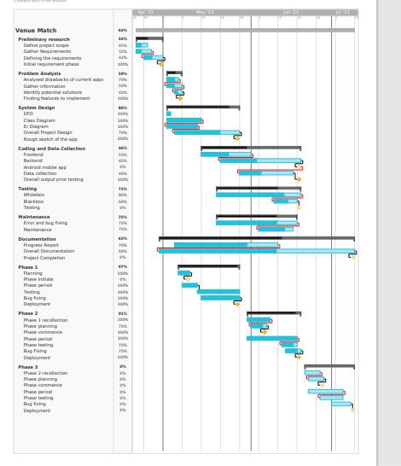

*FIGURE 8 GANTT CHART*

32

**11. Project Results:**

Venue Match App the Venue Match App was developed with the objective of providing users with a convenient platform to find suitable venues for their events and gatherings. After thorough development and testing, the app achieved the following results:

User-Friendly Interface: The Venue Match App boasts an intuitive and user-friendly interface, allowing users to easily navigate through the app's features and functionalities. The design incorporates a clean layout, making it simple for users to search, filter, and view venue options.

Accurate Venue Recommendations: The venue matching algorithm implemented in the app delivers accurate and relevant recommendations based on user preferences, such as location, capacity, amenities, and event type. Users can quickly find venues that align with their specific requirements.

Efficient Search and Filtering: The search and filtering mechanisms are efficient and responsive, enabling users to explore various venues and narrow down options quickly. Filters for price range, event type, and available dates enhance the search experience.

Seamless Booking Process: The app provides a seamless booking process, allowing users to reserve their chosen venues directly within the app. This streamlined process eliminates the need for manual bookings and reduces potential user frustrations.

Real-time Availability Tracking: Venue owners can update venue availability in real-time, ensuring that users receive up-to-date information about available dates and times.

Reliable and Secure Authentication: Robust authentication and authorization mechanisms ensure the security of user accounts and personal information. Users can confidently create accounts and log in using secure methods like email/password, social media login, or OAuth.

33

Scalable Architecture: The app was built using a scalable architecture, allowing it to handle increasing user traffic and growing venue listings without compromising performance.

Responsive Design: The Venue Match App's responsive design guarantees a consistent user experience across various devices and screen sizes, including smartphones, tablets, and web browsers.

Error Handling and Feedback: The app incorporates comprehensive error handling and provides meaningful feedback to users in case of errors or unsuccessful operations, enhancing the overall user experience. Extensibility and Maintainability: The project was developed with a focus on extensibility and maintainability. The codebase follows best practices and design patterns, making it easier to add new features and conduct future updates.

34

**12.Future Enhancement**

As the Venue Match App evolves and aims to provide an even better experience for its users, several future enhancements can be considered:

* Offer real-time availability updates and instant booking confirmation for users to access the latest information and secure reservations quickly.
* Enhance the app with event planning features: guest lists, and customization for seamless event management.
* Add venue comparison with user reviews and ratings for easy evaluation of different venues based on specific criteria.
* Implement social media integration to enable users to easily share their booked venues and event details, fostering social engagement by spreading the word among friends and family.
* Email verification and validation to ensure that an email address is both deliverable and genuine.
* Venue owner verification through documentation review (Proof of Identity**)**, Legal Agreements, Background Checks, Site visit.
* Introduce virtual 360-degree venue tours for immersive exploration, enhancing user understanding of venue spaces.
* Creating a smooth integration between the two platforms ( app and website) so that users can transition between them effortlessly with just a single action, typically a button or link.

35

**13.Conclusion**

The Venue Management System serves as a comprehensive and efficient solution, streamlining various facets of venue management. Notably, it enhances venue operations by simplifying event scheduling, bookings, resource allocation, and communication between stakeholders, markedly improving operational efficiency. Additionally, it fosters an improved customer experience, offering user-friendly interfaces for seamless venue browsing, availability checks, and reservations. This optimizes resource allocation by managing event calendars, bookings, and staff/equipment assignments, providing real-time visibility into resource availability, boosting productivity, and reducing costs. Effective communication is facilitated through various channels, minimizing misunderstandings and enhancing overall efficiency. Moreover, the system generates comprehensive reports and analytics, offering valuable insights into venue utilization, revenue generation, and customer preferences, empowering informed decision-making. Designed for scalability and customization, it adapts to diverse venue requirements, ensuring adaptability and easy expansion. In summary, the Venue Management System is a robust tool that significantly enhances venue management, resulting in increased efficiency, customer satisfaction, and business success upon implementation.

36

1. **References**
   1. Adler, T. (2007, March ). *Scribd*. Retrieved from Event Management System: https://www.scribd.com
   2. Alejandro and Pablo Blanes, J. C. (2010). *FLATICON*. Retrieved from Icons: https://www.flaticon.com/
   3. *Code Projects*. (2017). Retrieved from Event management

Project : https://code-projects.org

1. Flutter. (n.d.). *flutter* . Retrieved from https://flutter.dev/
2. *FreeProjectz*. (2014, November 7). Retrieved from event managment: https://www.freeprojectz.com
3. Jain, S. (n.d.). *GeeksforGeeks*. Retrieved from Flutter – Row and Column Widgets: https://www.geeksforgeeks.org
4. Maxim Melamedov, L. G. (n.d.). *Techopedia*. Retrieved from Tech: https://www.techopedia.com/

8. OpenAI. (2022, November

30).

*ChatGPT*.

Retrieved

from https://chat.openai.com/

1. Prosus. (2008, September 15 ). *StackOverflow*. Retrieved from SafeArea in Flutter: https://stackoverflow.com

10. shoutem. (n.d.). *shoutem*. Retrieved https://shoutem.com/blog/app-ideas-for-beginners/?

from app-ideas:

11. wiki. (n.d.). *wikipedia*.

Retrieved

from wikipedia.org:

https://en.wikipedia.org/wiki/

37

1. wikijsegfug. (n.d.). *flutterhuiewgf*. Retrieved from wiki fulutter: www.wiki.com
2. Zack Onisko, D. C. (2009, July 9). *Dribbble*. Retrieved from design: https://dribbble.com/

38

**Annexure**

During the development of our project we have faced unfamiliar errors while developing various services and we have come across to solve the problem within the given time period of time. So we are finally able to deliver the website and mobile application that will satisfy the customers. Here are some screenshots of our system

39

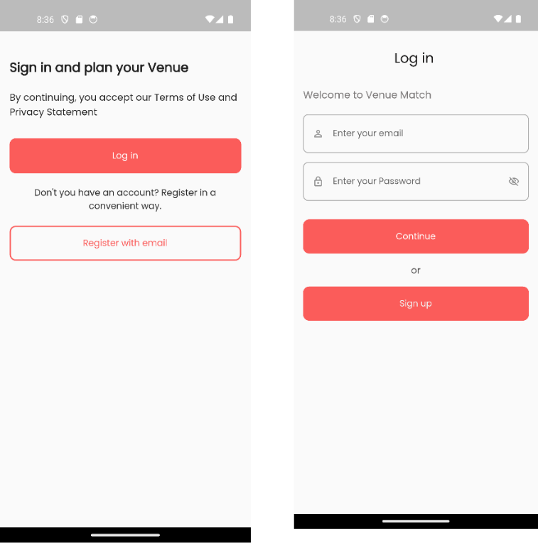

|  |  |  |
| --- | --- | --- |
|  | **WELCOME SCREEN** |  |
| **FIG: WELCOME SCREEN** | **FIG: LOGIN SCREEN** |  |
|  |  |

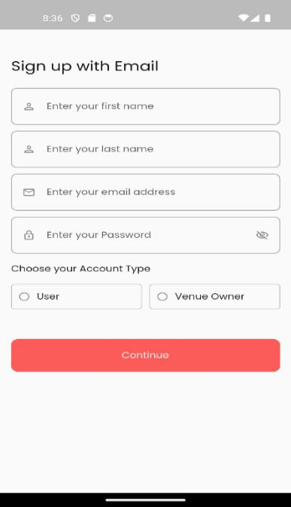

**FIG: SIGNUP SCREEN**

40

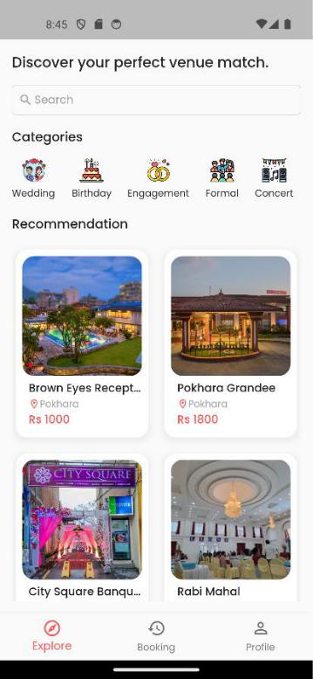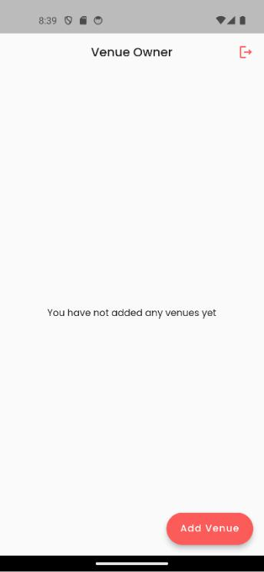

**FIG: VENUE OWNER PAGE** **FIG: EXPLORE SCREEN**

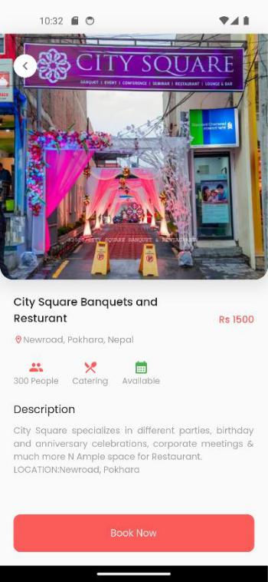

**FIG: DETAIL SCREEN**

41

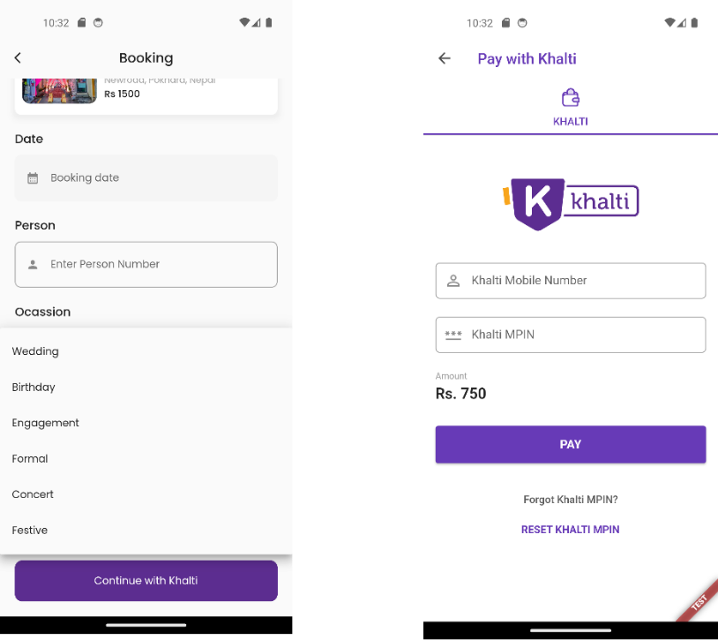

**FIG: BOOKING AND PAYMENT SCREEN**

42

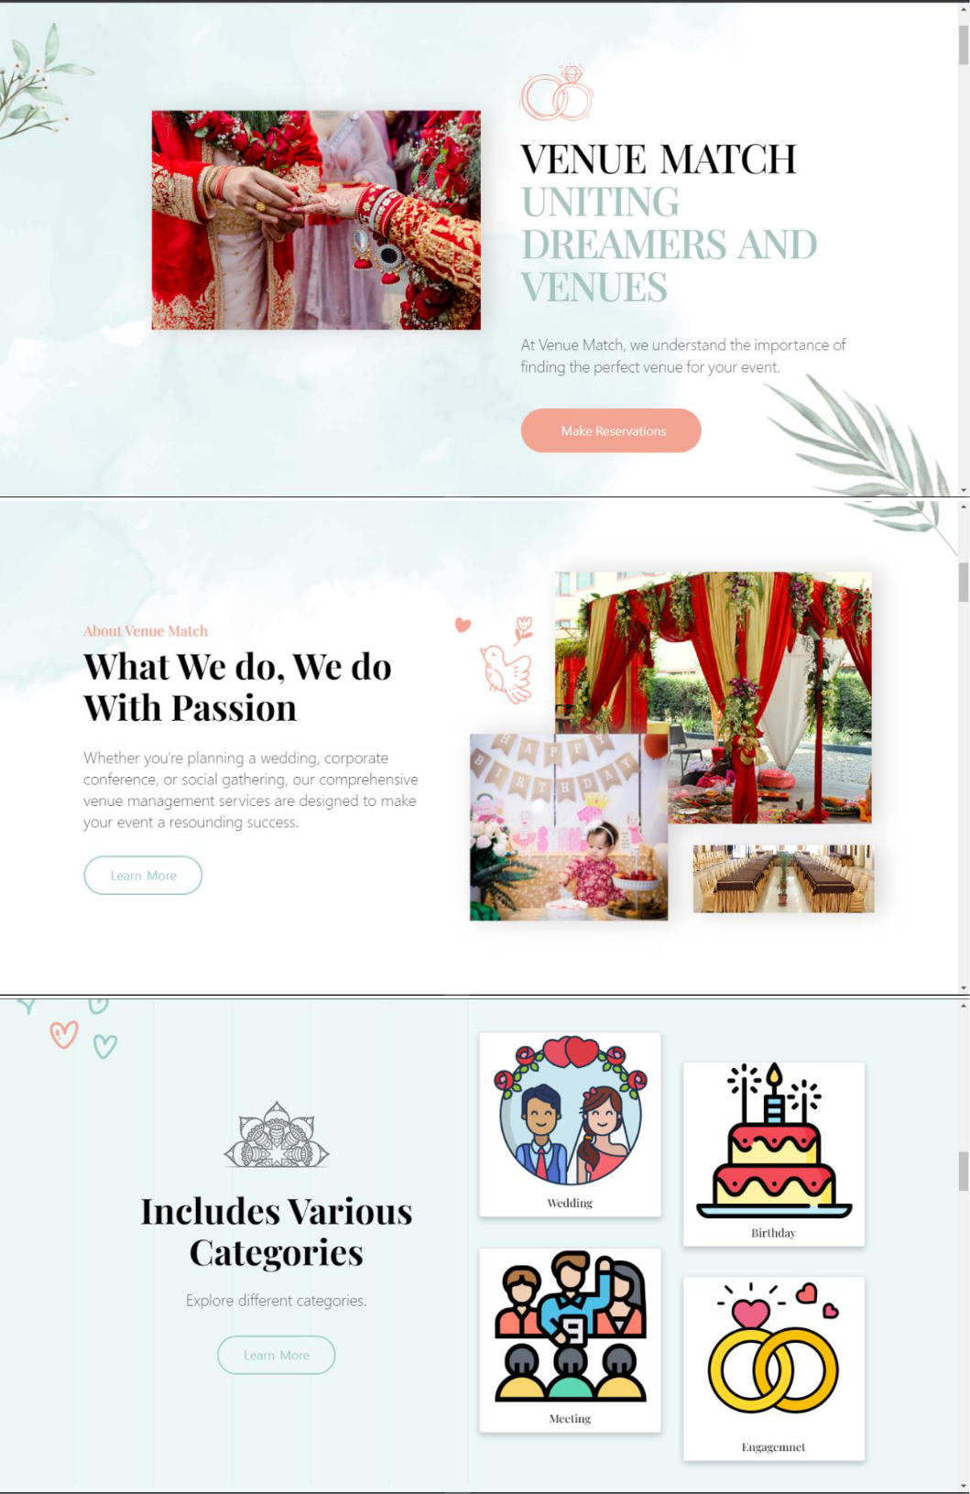

**FIG: WEBSITE LANDING PAGE**

43

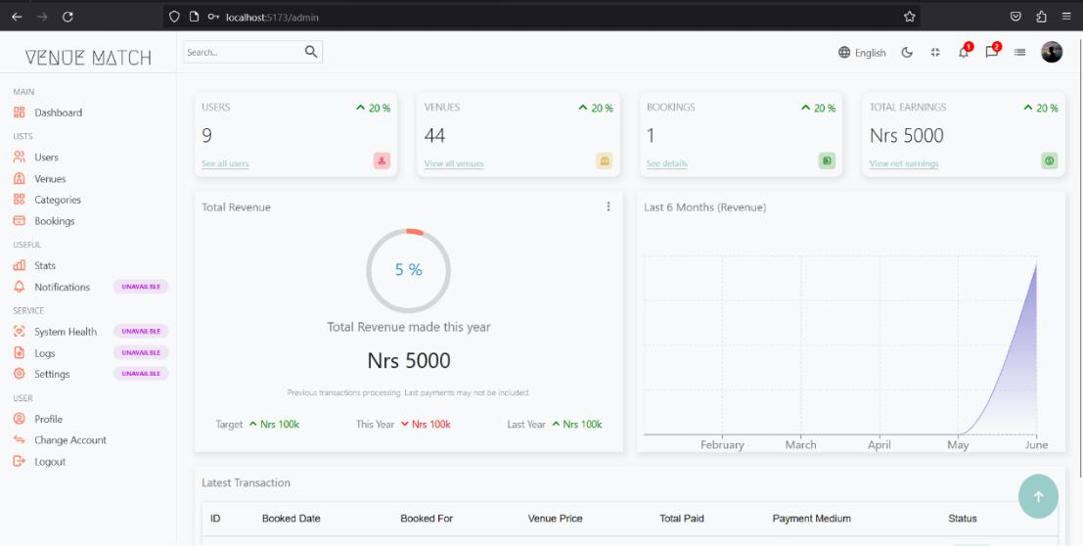

**FIG: ADMIN DASHBOARD**

44