

**LA GRANDEE INTERNATIONAL COLLEGE**

**Simalchaur, Pokhara Nepal**

Proposal

On

**“Job Nexus”**

(Online Job Portal)

**Submitted to:**

Bachelor of Computer Application (BCA) Program

In partial fulfilment of the requirements for the degree of BCA under

|  |  |  |  |
| --- | --- | --- | --- |
|  |  | Pokhara University |  |
| **Submitted by:** |  |  |  |
| **Name:** | **Course** | **Semester** | **P.U. Registration Number** |
| Akriti Chapagain | BCA | 8th | 2019-01-53-0104 |
| Binaya Koirala | BCA | 8th | 2019-01-53-0111 |
|  |  |  |  |
|  |  |  |  |

**Date: 4/28/2024**

**DECLARATION FOR**

**“Job Nexus”**

**STUDENT’S DECLARATION**

We hereby declare that we are the only authors of this work and that no sources other than the mentioned here have been used in this. We assure you that the work we present here is unique to ourselves and resemblances to another similar project are purely coincidental.

Akriti Chapagai (PU Exam Roll no): 2019-01-53-0104

Binaya Koirala (PU Exam Roll no): 2019-01-53-0111

Program: BCA, 8th Semester

**Date: 4/28/2024**

**ABSTRACT**

“Job Nexus” is being developing for creating an interactive job vacancy form for

Candidates the app effectively gathers client and candidate information, categorizing them based on job requirements and vacancies. Its unique development methodology helps in acquiring the client and candidate information and separating them according to the job requirements

and vacancies. This application would provide details of the job. An employer being registered in the application has the facility to use the services. Being an authorized user he can .Publish vacancy details and can search no of Employees on portal and also he can

search candidates on basis of the key skill which employee provides on registration.

**TABLE OF CONTENTS**

STUDENT’S DECLARATION ii

1. INTRODUCTION 1

2. PROBLEM STATEMENT 2

3. OBJECTIVES 3

4. METHODOLOGY 6

5.. GANTT CHART 14

7. Deliverables 15

12. REFRENCES 16

**TABLE OF FIGURES**

Figure 1: Gantt Chart for FundFusion 14

**LIST OF ABBREVIATIONS:**

|  |  |
| --- | --- |
| API | Application programming interface |
|  |  |
| BCA | Bachelor of computer Applications |
|  |  |
| CSS | Cascading style sheet |
|  |  |
| DFD | Data flow Diagram |
|  |  |
| ER | Entity Relationship |
|  |  |
| GUI | Graphics User Interface |
|  |  |
| HTML | Hypertext markup Language |
|  |  |
| NAP | Name, Address, Phone Number |
|  |  |
| PHP | Preprocessor Hypertext |
|  |  |
| SDLC | Software Development Life Cycle |
|  |  |
| SQL | Structure Query Language |
|  |  |
| WAF | Web Architecture Framework |
|  |  |
| EG | EXAMPLE |
|  |  |
| No. | Number |
|  |  |
| SSL | Secure Sockets Layer |
|  |  |
| API | Application Programming Interface |
|  |  |
| QA | Quality Assurance |
|  |  |
| NGO | Non government |
|  |  |

**1. INTRODUCTION**

In today's competitive job market, finding employment in specialized fields can be a daunting task. That's why we will develop a user-friendly job portal aimed at simplifying the job search process and connecting job seekers with suitable opportunities. Through our platform Job seekers can easily upload their resumes and explore a wide range of job openings matched to their profiles.

Our upcoming Job Portal Mobile Application, to be built using React Native, will offer a excellent experience for both job seekers and employers. With features like categorized job listings including popular and nearby options, as well as job types ranging from part-time to full-time, we will ensure a panoramic job search experience.

Employers, too, will benefit from our platform by being able to register, post job vacancies, and efficiently manage incoming applications. Our application will boast robust functionalities, including the ability to create, retrieve, update, and delete information, empowering employers to simplified their hiring process effectively.

"Job Nexus" will serve as a beacon for candidates seeking employment opportunities, providing a convenient platform to register, search, and apply for jobs. Likewise, it will offer a seamless avenue for employers to showcase their job vacancies, ultimately fostering meaningful connections between talent and opportunity.

The employers can also register, post jobs, and receive applications for the job they posted. The application had the functionality to create, retrieve, update, and delete information

**1**

**2. PROBLEM STATEMENT**

Following were the problems we found in Job Portal applications:

* Job seekers and employers encounter challenges in efficiently connecting with each other.
* Job seekers often struggle to find job opportunities that match their skills and preferences.
* Employers face difficulties in attracting qualified candidates for their job vacancies

2

**3. OBJECTIVES**

* Provide job seekers with an intuitive platform to register, search, and apply for suitable job opportunities.
* Enable employers to register and post job vacancies, including options for managing application

3

**4. METHODOLOGY**

The Agile methodology is being used to develop the Job Nexus. Agile is a flexible and iterative approach that allows for rapid development and testing. The Agile methodology is well-suited to projects with evolving requirements, such as Job Nexus, where there may be changes in the features and functionalities that the platform requires. The Agile methodology will be implemented using the Scrum framework, which is a popular Agile methodology that involves working in small, cross-functional teams. The team will consist of two members who will each work on a specific part of the Job Nexus platform. The team will meet regularly to discuss progress, plan for the next iteration, and address any issues that arise.

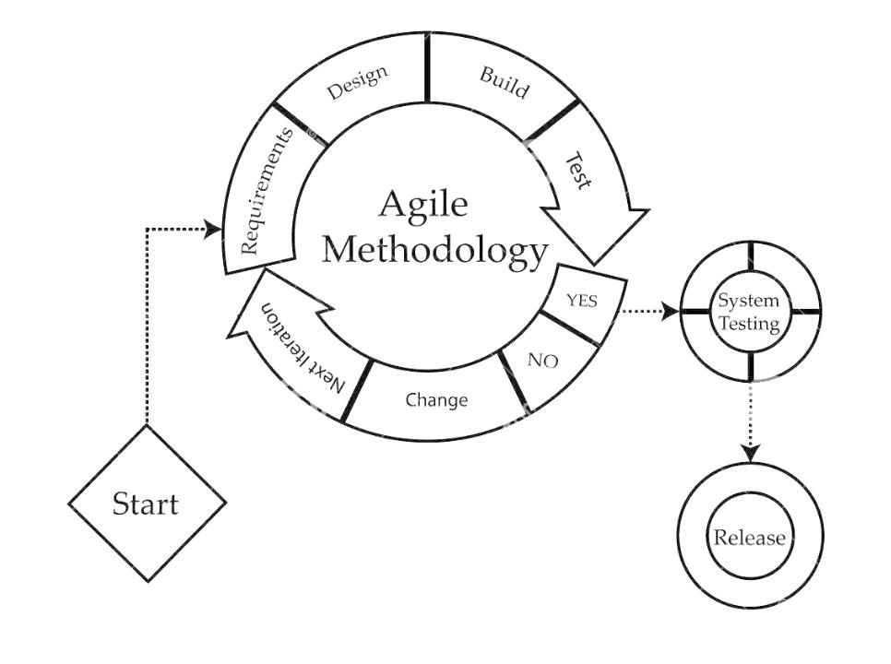

Figure 1: Agile Methodology for Development of Job Nexus

4

**5. GANTT CHART**

A Gantt chart is a visual representation of a project's schedule, displaying tasks as horizontal bars along a timeline. It provides an overview of project progress, task dependencies, and helps in tracking project milestones and deadlines.

The given below is the Gantt chart of our project Job Nexus:

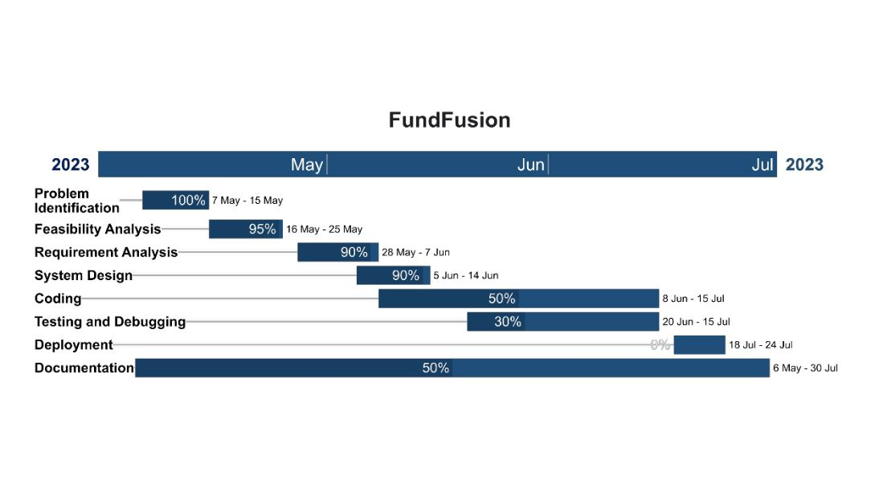

Figure 2: Gantt chart for Job Nexus

**6. DELIVERABLES**

* User registration system allowing job seekers to create accounts and employers to register their companies.
* Job search functionality enabling job seekers to browse and search for job listings based on various criteria such as job type, location, and industry.
* Resume submission feature allowing job seekers to upload their resumes and apply for job listings directly through the app.
* Job posting system allowing employers to create and publish job listings, including options for specifying job details, requirements, and application deadlines.
* Application management tools for employers to review and manage job applications received from job seekers.
* Categorized job listings showcasing popular and nearby job opportunities, as well as job types (e.g., part-time, full-time).