

**LA GRANDEE INTERNATIONAL COLLEGE**

**Simalchaur, Pokhara Nepal**

Proposal

On

**“KinMel”**

**Submitted to:**

Bachelor of Computer Application (BCA) Program

In partial fulfilment of the requirements for the degree of BCA under

Pokhara University

**Submitted by:**

|  |  |  |  |  |
| --- | --- | --- | --- | --- |
| **Name:** | **Course** | **Semester** | **P.U. Registration Number** | |
| Suman Devkota | BCA | 8th | 2019-1-53-0136 | |
| Arpan Pokhrel | BCA | 8th | 2019-1-53-0108 | |
| Navina Budhathoki | BCA | 8th | 2019-1-53-0123 | |
|  |  |  |  | |
|  | **Date: 21/04/2024** |  | |

# ACKNOWLEDGEMENT

We would like to express our heartfelt gratitude to everyone who has contributed to the development of the project “MyMed”. The satisfaction that accompanies after the successful completion of any task will be incomplete without mentioning the people whose ceaseless and relentless cooperation, constant guidance and encouragement made this project proposal report possible.

We are grateful to our project supervisor, faculty teacher **Mr. Sunil Sapkota** and BCA coordinator **Mr. Ramesh Chalise** for the guidance, inspiration and constructive suggestions that helped us in the preparation of this project. Their valuable insights and feedback have been instrumental in shaping the direction of this project.

We are also appreciative among each other and have understood that teamwork, the designation of the task per the skillset one portrays, constant synchronisation and monitoring of progress and installing new knowledge and skill is imperative for the success of any given work.

Sincerely,

Arpan Pokhrel

Suman Devkota

Navina Budhathoki

# STUDENT’S DECLARATION

We hereby declare that we are the only authors of this work and that no sources other than the mentioned here have been used in this. We assure you that the work we present here is unique to ourselves and resemblances to another similar project are purely coincidental.

Arpan Pokhrel (PU Exam Roll no): 2019-1-53-0108

Suman Devkota (PU Exam Roll no): 2019-1-53-0136

Navina Budhathoki (PU Exam Roll no): 2019-1-53-0123

Program: BCA, 8th Semester

Date: 4/21/24

# SUPERVISOR’S DECLARATION

I hereby declare that the project entitled **“**KinMel**”** has been carried out under my direct supervision by Arpan Pokhrel (2019-1-53-0108), Suman Devkota (2019-1-53-0136), Navina Budhathoki (2019-1-53-0123), Anish Thapa (2019-1-53-0105) during my sixth semester for the partial fulfilment of the requirements for the degree of **BCA (Bachelors of Computer Application)** program under **Pokhara University**.

_______________

Mr Sunil Sapkota

(Project Supervisor)

Date: 21 April 2024

# ABSTRACT

This project aims to computerize the management of hospitals, creating software which is user friendly, simple, fast, and cost-effective. It will cover the collection of patient information, diagnosis details, and other data traditionally done manually. The software will be designed to make the process easier and quicker, while remaining cost effective and easy to use. The system will also be secure to ensure the safety of patient data.

The main function of this project is to register and store patient details, doctor details and retrieve these details as and when required. Additionally, it is designed to manipulate these details meaningfully. Inputs into the system include patient details, diagnosis details, while the output of the system is to display this information on the screen. To gain access to the system, users must enter a username and password. This system is essential for providing a streamlined, secure, and efficient way to manage hospital details.

The database is a secure and efficient way to store data. It is easily accessible from any internet-enabled device by either an administrator or receptionist, and only they can add data the database. Furthermore, the data are will protected for personal use and make data processing very fast. This ensures that the data remains secure and accessible to only those with the proper authorization. Additionally, the data can be retrieved quickly and easily, providing the users with the information they need in a timely manner.

**TABLE OF CONTENTS**

ACKNOWLEDGEMENT ii

STUDENT’S DECLARATION iii

SUPERVISOR’S DECLARATION iv

ABSTRACT: v

1. INTRODUCTION 1

2. PROBLEM STATEMENT 2

3. OBJECTIVES 3

4. METHODOLOGY 4

5. DATA FLOW DIAGRAM 5

6. FLOWCHART 6

7. PROJECT GANTT CHART/ TIMELINE CHART 7

8. DELIVERABLES 8

9. CONCLUSION 9

## TABLE OF FIGURES

Figure 1: Iterative Model 4

Figure 2: DFD 5

Figure 3: FLOWCHART 6

Figure 4: Gantt Chart 7

# INTRODUCTION

We are developing digitalized software called **“MyMed”** by using HTML, CSS and PHP in VS Code. “MyMed” is a healthcare technology platform that provides personalized medical solutions and services to patients. Our platform is designed to be user-friendly and accessible to anyone with an internet connection. At MyMed, we understand that healthcare can be complex and overwhelming, which is why we offer a range of services to help patients navigate their health journey.

Our platform provides features such as consultations with medical professionals and access to medical records. Additionally, we offer wellness and lifestyle resources to help patients maintain a healthy and balanced lifestyle. Our goal is to empower patients to take control of their health and receive the care they need in a convenient and efficient manner.

We are committed to providing high-quality, affordable healthcare solutions to individuals and families around the world. It is a revolutionary software that provides a comprehensive solution for keeping track of patients. With its user-friendly interface and intuitive features, it will enable medical professionals to efficiently manage patients records and treatment plans. This innovative software will streamline the workflow and improves patient care by ensuring accurate and up-to-date records of their medical history. It will offer a secure and reliable which is a game-changer in the healthcare industry.

It will have streamlined the process of maintaining patient records, eliminating disorganization and time-consuming paperwork. MyMed will provide medical professionals with a handy tool to monitor patients, allowing them to access essential information such as medical histories and test results, all in one central location. In this fast-paced world where times is of the essence, it will make managing patient records accurate, efficient and convenient. With a focus on improving patient outcomes, MyMed is the answer to the increasing demands of the healthcare industry, ensuring that no patient’s record is lost, misplaced of forgotten.

# PROBLEM STATEMENT

Patients often struggle to keep track of their medications & health conditions leading to missed doses, incorrect doses & potential health complications. Moreover, they may forget to refill their prescriptions on time, leading to interruptions in treatment. Therefore, there is a need for an application or website that can help patients manage their medications & health condition more efficiently.

* There is a lack of a centralized system of maintaining patient records, which makes it difficult for healthcare professionals to access patient information from different sources.
* Another problem is the difficulty in managing patient health records. Many doctors still rely on paper-based records, which can be lost or difficult to share with other healthcare providers. This can lead to incomplete medical histories, duplicate tests and procedures, and potential medical errors.
* Patients are often required to fill out the same information repeatedly at different healthcare facilities, leading to a frustrating experience and potentially incomplete or inaccurate records.
* With the increasing number of patients and healthcare providers, it becomes increasingly challenging to track patient records and ensure that they are up to date.
* Improper categorization of patient records can lead to difficulties in retrieving the necessary information, leading to potential delays in diagnosis and treatment.
* The high cost of implementing and maintaining a patient record-keeping system is a significant challenge, particularly for smaller healthcare providers who have limited budgets.
* Patients need to have control over their medical records and be able to access them easily at any time, through a digital or printed format, without any restrictions or barriers.

# OBJECTIVES

The main objectives of this project are to provide better facilities to the patients. They are as follows:

* Customize and deploy an integrated system.
* To show and help to collect most of the information about both patient and doctor.

# METHODOLOGY

For this project, the Software Development Life Cycle (SDLC) Methodology that we have decided on using “Iterative Model” to develop the “MyMed” Software as a digitalized software based on the fact that our requirements aren't certain and will change with time.

Iterative development is a way of breaking down the software development of a large application into smaller chunks. In iterative development, feature code is designed, developed and tested in repeated cycles. With each iteration, additional feature can be designed, developed and tested until there is a fully functional software application ready to be deployed to customers.

The image below shows the process involved in Iterative Model Methodology:

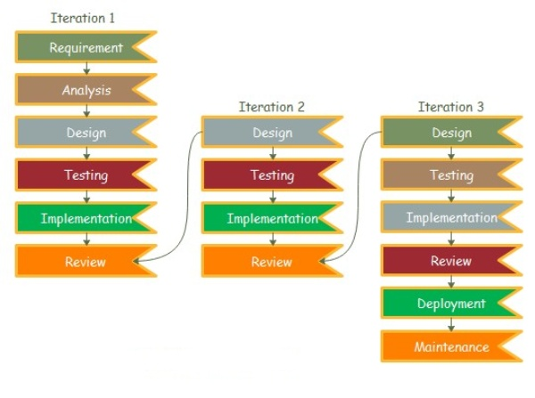

**Figure 1: Iterative Model**

# DATA FLOW DIAGRAM

A Data Flow Diagram (DFD) is a diagrammatic representation of the flow of data through a system. It illustrates show data is input, processed stored and output by as system or a process. DFDs are commonly used in software engineering and information systems design to help illustrate and describe the flow of information through a system, as well as the different processes, entities, and data stores involved, and output by a system or process.

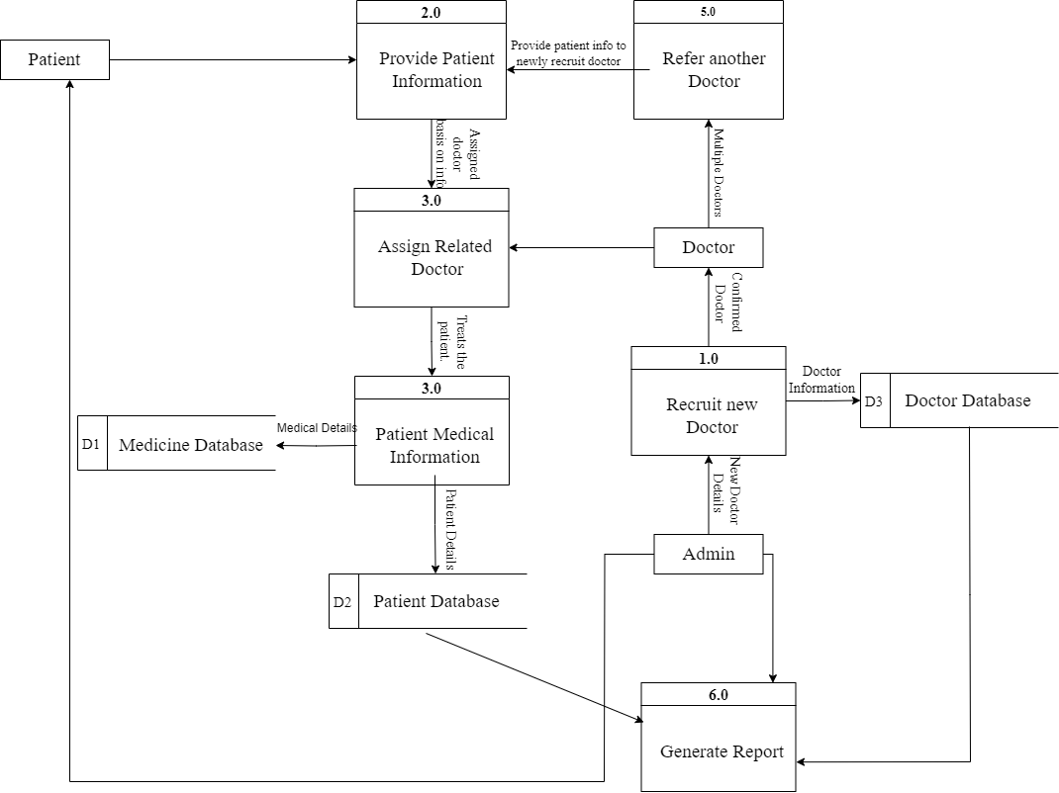

**Figure 2: DFD**

# FLOWCHART

A flowchart is a formalized graphic representation of a logic sequence, work or manufacturing process, organization chart, or similar formalized structure.

The purpose of a flow chart is to provide people with a common language or reference point when dealing with a project or process. Flowcharts use simple geometric symbols and arrows to define relationships. In programming, for instance, the beginning or end of a program is represented by an oval. A process is represented by a rectangle, a decision is represented by a diamond and an I/O process is represented by a parallelogram.

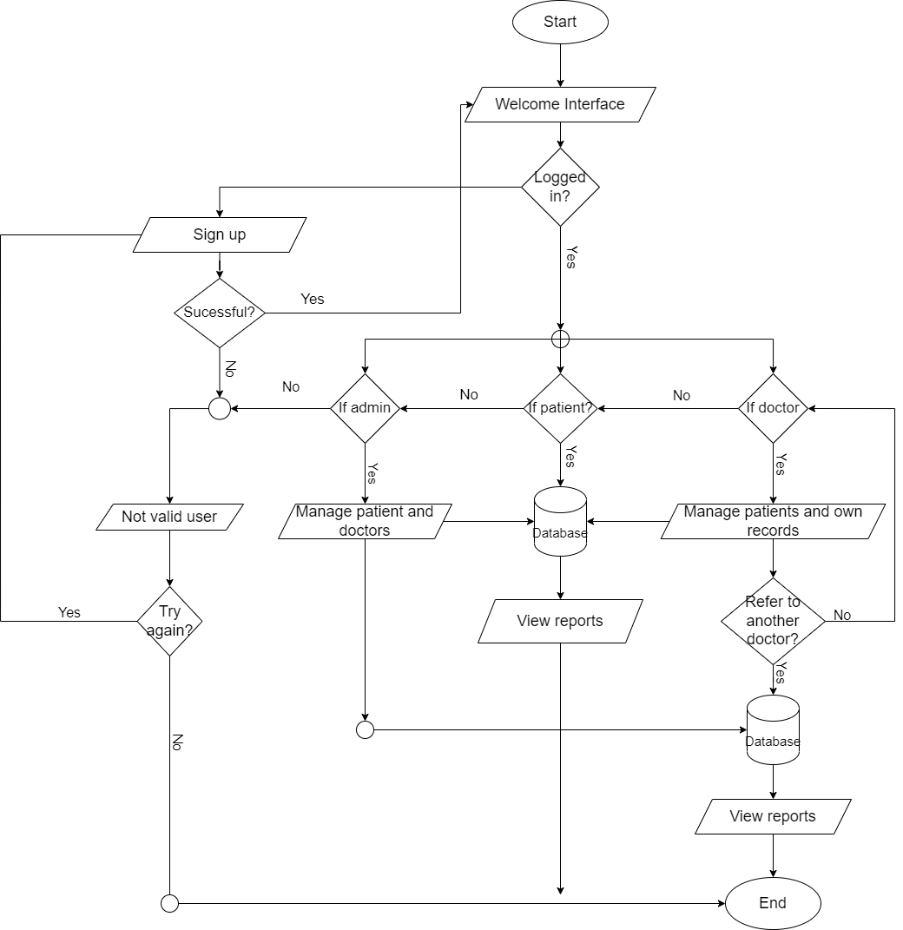

**Figure 3: FLOWCHART**

# PROJECT GANTT CHART/ TIMELINE CHART

The Gantt chart below shows the schedule planned for developing the “MYMED SOFTWARE” following Iterative Model Methodology. Thus, this project would be carried out in steps with proper planning in each step, best effort would be applied to finish this project before deadline.

It also shows the time schedule description and tasks performed throughout the completion of project from the day of starting the project until it will be finished in the horizontal bar below:

**Figure 4: Gantt Chart**

# DELIVERABLES

Here are some potential deliverables for the “My Med” project:

* It will provide friendly relationship between patients and doctors.
* This software will provide health information to the patients.
* It will help to facilitate communication between patients and doctors.
* Creating a dashboard for doctors to access the medical records of their patients and view trends of changes in their health over time.
* Developing an easy-to-use interface for patients to input and track their medical records.
* Continuously improve and update the software based on feedback from patients and healthcare providers.
* It will ensure that the software is secure and maintains patient confidentiality.

# CONCLUSION

As the Project is being made, there are many things that can be learned from it. In this module i.e., Web Technologies, we were given a project task to perform in a group work. The artefact of the project is a digitalized system called “MyMed” by using HTML, CSS, JS and PHP in VS-Code.

This project will require a lot of research and hard work for successful completion of our proposal, every step will be done by full effort. This project will help us to share and present our ideas in the Group, as well as will help us to share and present our ideas in the Group.

MyMed is an essential tool for keeping accurate records on doctors, patients, and medical personnel. Using MyMed will make the process of data collection much more efficient and streamlined, allowing hospital administrators to gain better control over their operations. The time saved by using My Med will be invaluable, as it not only reduces the amount of manual labour required but also increases accuracy and organization.

With “MyMed”, hospital staff can easily access the data they need to make informed decisions and ensure all aspects of the organization are running smoothly. In existing system there are several drawbacks. So, to sort out all the existing problems this project is being developed. The product will automate the process of collecting and receiving patient information, which will greatly improve response time in providing patient care.

This will free up the time of medical staff from dealing with administrative, allowing them to focus on what matters most – providing the best care for their patients. By eliminating these complexities, the product will make it easier for medical staff to provide the best care possible to their patients, without having to worry about administrative matters.