

**LA GRANDEE INTERNATIONAL COLLEGE**

**Simalchaur - 8, Pokhara, Nepal**

A Project Report on

“Gadget App”

**Submitted to**

Bachelor of Computer Application (BCA) Program

*In partial fulfillment of the requirement for the degree of BCA affiliate to*

*Pokhara University*

**Submitted by:**

|  |  |  |
| --- | --- | --- |
| **Name** | **Program, Semester** | **P.U. Registration Number** |
| Ganesh Tiwari | BCA, 8th Sem | 2021-1-53-0055 |
| Kapil Tiwari | BCA, 8th Sem | 2021-1-53-0059 |
| Prabhat Poudel | BCA, 8th Sem | 2021-1-53-0066 |

Date: 2082/01/18

Table of Contents

List of Figures……….……………………………………………….……………………………………………………………. iii

1. Introduction 1

2. Problem Statement 2

3. Objective 3

4. Background Study 4

5. Methodology 5

6. Gantt Chart 8

7. Deliverables 9

8. Conclusion 10

9. Reference 11

**List of Figures**

Fig 5.1: Block Diagram ……………………………………………………………………………….……… 5

Fig 5.2: Iterative model ………………………………………………………………………………………. 6

Fig 7.1: Gantt Chart ……………………………………………………………………………………………. 8

# Introduction

The (Electromart) Gadget App E-Commerce project is a comprehensive solution for businesses selling electronic gadgets, designed to automate and streamline the online shopping experience. It provides a user-friendly interface with functionalities like managing product inventory, processing orders, handling secure payments, and generating sales and activity reports. The goal is to boost efficiency and profitability for businesses while ensuring a convenient and seamless customer experience. By eliminating manual processes, businesses can focus on growth and enhanced customer service.

The proposed application will offer a wide range of gadgets, including smartphones, tablets, laptops, smartwatches, and accessories, to meet diverse user needs. Advanced features such as real-time stock availability, user-friendly navigation, flexible order and return systems, and secure payment gateways will ensure a smooth shopping experience. This project aims to enhance business efficiency and profitability by automating and streamlining the e-commerce process. With this system in place, businesses can expand their digital sales and serve their customers more effectively.

# Problem Statement

* Small to mid-sized gadget retailers struggle with managing e-commerce operations due to the absence of a comprehensive and user-friendly mobile application.
* Many rely on manual processes and disconnected tools, causing inefficiencies, errors, and confusion in inventory, order, and customer management—highlighting the need for an efficient and integrated management system.

# Objective

* To provide a user-friendly and efficient system that enables sellers to manage gadget products and e-commerce operations effectively and efficiently.
* To collect, store, organize, retrieve, and present product information and customer data for a seamless shopping and management experience.

# Background Study

The (Electromart) Gadget App E-Commerce project is a cross-platform mobile application built using React Native, designed to provide seamless interaction for both buyers and sellers on Android and iOS devices. Its backend is powered by Node.js and Next.js, developed in TypeScript—offering a scalable, high-performance, and maintainable architecture. The system efficiently handles product management, order processing, and customer data storage in real time, enabling users to manage their business operations from anywhere.

To better understand the current landscape of gadget retail operations in our country, we studied existing local platforms such as ITTI Pvt. Ltd. and Nagmani International (ITTI Pvt. Ltd., n.d.; Nagmani International, n.d.).:

* ITTI Pvt. Ltd. offers a mobile application and web interface that showcases a wide range of electronic gadgets such as laptops, smartphones, and accessories. Their platform provides product listings with technical specifications, promotional offers, and customer support. However, the mobile experience still lacks full seller-side management tools like inventory tracking, real-time updates, and advanced analytics.
* Nagmani International primarily operates through a website, offering renowned brands like ASUS, MSI, and Acer. While the site supports bulk product listings and handles direct customer inquiries, it lacks a dedicated mobile application and offers limited features for real-time inventory and order management, especially for small vendors who want to use the platform for distribution.

In addition to these platforms, we visited a local gadget store to observe how small retailers manage their sales and inventory in real time. The store used a mix of an offline POS system and basic online listings. We noticed several challenges:

* The use of manual and disconnected tools made it difficult to sync inventory and order records efficiently.
* Staff struggled with frequent errors and confusion while tracking stock and customer orders.
* The absence of centralized systems meant that data entry was repetitive and time-consuming.

From these insights, we identified a clear opportunity to develop a **comprehensive and customizable solution** for gadget retailers. Our application is intended to address these gaps by providing:

* A mobile-first system where sellers can easily **add, edit, or remove products**, manage inventory, and process orders.
* A structured database for **real-time storage and retrieval** of customer and product data.
* Advanced features like **search filters by brand, price, or specs**, and **reporting tools** to track sales and performance.
* An intuitive user interface designed to reduce complexity for store staff and improve the shopping experience for customers.

Ultimately, the Gadget App is designed to empower small and mid-sized electronics businesses by improving operational efficiency, reducing human error, and offering a more modern, digital approach to retail management in the growing e-commerce landscape of our country.

# Methodology

The Iterative Model is a software development approach that involves repeating a sequence of steps—such as planning, designing, implementing, and testing—until the desired level of quality is achieved. This model is used for the development of this Android-based e-commerce application, as it ensures that each iteration is thoroughly tested, reviewed, and improved. By incorporating feedback in each cycle, the development team can continuously enhance the app’s performance, usability, and functionality, leading to a more reliable and user-friendly final product.

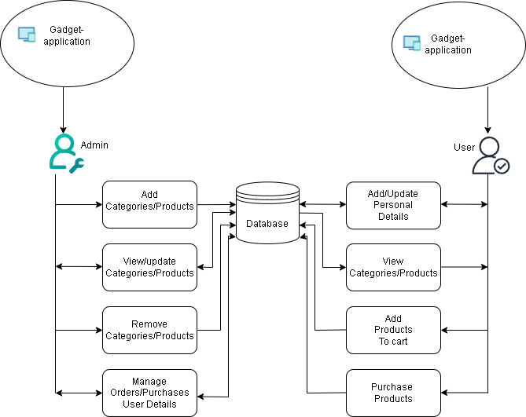

### Fig 5.1: Block Diagram

Iteration 1

Requirement

### Fig 5.2: Iterative model

Iteration 3

Iteration 2

Design

Deployment

Maintenance

Design

Coding

Testing

Implementation

Review

Coding

Testing

Implementation

Review

Review

Analysis

Design

Coding

Testing

Implementation

The Iterative Model for the development of the Android-based Gadget E-Commerce application typically consists of the following phases:

1. **Requirement Gathering:** In this phase, we gather the project objectives, scope, and requirements. We also define the features for the mobile application, such as product catalog management, order processing, and secure payment systems, and identify the resources required for the project.
2. **Analysis:** During this phase, we analyze the gathered requirements in detail. Any potential issues or gaps are identified, and we develop diagrams (such as flowcharts or wireframes) to help clarify the system's functionality and user interactions.
3. **Design:** In this phase, we create detailed designs for the system. This includes designing the user interface (UI) for the Android app, database schema using MongoDB, and defining the software architecture for the backend using Node.js/Next.js and TypeScript.
4. **Coding:** This phase involves writing the actual code for the mobile application and backend system. The Android app is developed using typescript and react native, while the backend is implemented using Node.js and Next.js, with MongoDB for data storage.
5. **Testing:** In this phase, we rigorously test the Android app and backend to ensure they meet the defined requirements. We perform functional testing, performance testing, and security testing to verify the system works as expected.
6. **Implementation:** Ran the app on test devices, verified its features, and demonstrated it by deploying the backend to a cloud service, making the app ready for use.
7. **Review:** After deployment, we continue to maintain and support the system. This includes fixing bugs, enhancing features based on user feedback, and ensuring the app stays updated with new technology and security patches.

# Gantt Chart

|  |  |  |  |  |  |
| --- | --- | --- | --- | --- | --- |
| **Task Name** | May 1 | May 15 | June 1 | June 15 | July 1 |
| Planning |  |  |  |  |  |
| Research |  |  |  |  |  |
| Design |  |  |  |  |  |
| Coding |  |  |  |  |  |
| Debugging |  |  |  |  |  |
| Implementation |  |  |  |  |  |
| Documentation |  |  |  |  |  |

### Fig 7.1: Gantt Chart

# Deliverables

The deliverables of this project are as follows:

* Development of a fully functional mobile application that is user-friendly, flexible, and easy to manage.
* Preparation of a comprehensive user manual to guide end-users through the application's features and functionalities.
* Compilation and submission of a detailed final report documenting the entire development process, methodologies used, and outcomes achieved.

# Conclusion

The Gadget E-Commerce Application project is an efficient and scalable solution for businesses looking to automate and streamline their online sales and inventory management. With its wide range of customizable features and functionalities, this project can be tailored to meet the unique needs of different e-commerce retailers. The user-friendly mobile interface, along with real-time inventory management and secure payment processing, ensures a seamless shopping experience for both customers and sellers. Overall, it is a valuable tool for businesses aiming to enhance their operations and drive growth in the competitive e-commerce market.

# Reference

Rouse, M. (2017). *Mobile application development (mobile app development)*. TechTarget. <https://www.techtarget.com/searchsoftwarequality/definition/mobile-application-development>

ITTI Pvt. Ltd. (n.d.). *ITTI Computers - Your Trusted IT Training Institute in Nepal*. Retrieved May 7, 2025, from <https://www.itti.com.np>

Nagmani International. (n.d.). *Official distributor of ASUS and other tech brands in Nepal*. Retrieved May 7, 2025, from <https://www.nagmani.com.np>