**Pokhara University Affiliate**

**LA GRANDEE INTERNATIONAL COLLEGE**

**Simalchaur, Pokhara**

A Proposal Report on

**“Hospify”**

**Bachelor of Computer Application (BCA)**

**Submitted By:**

|  |  |  |  |
| --- | --- | --- | --- |
| **Name** | **Course** | **Semester** | **Pu Regd. Num.** |
| **Safal Koirala** | **BCA** | **th** | **2019-1-53-0128** |
| **Darshan Ghale** | **BCA** | **6th** | **2019-1-53-0113** |
| **Kiran Sunar** | **BCA** | **6th** | **2019-1-53-0116** |

**Submitted to:**

**Bachelor of Computer Application (BCA) Program**

**In partial fulfilment of the requirements for the degree of BCA**

**Under Pokhara University**

**Date: 04/29/2024**

**“Hospify”**

**Student’s Declaration**

This **“Hospify”** will be developed by the following members. So we hereby declare that we are the only authors of this project and that no sources other than the listed here have been used in this project.

**Safal Koirala Darshan Ghale Kiran Sunar**

BCA, 6th semester BCA, 6th semester BCA, 6th semester

Date: 29/04/2024

**Abstract**

Hospify is a mobile application designed to revolutionize hospital management. In today's digital world, efficient healthcare requires innovative solutions.Hospify empowers hospitals with a user-friendly app accessible on smartphones and tablets.

This comprehensive application caters to all aspects of hospital operations. Administrators can manage staff, appointments, billing, and inventory with greater ease. Doctors gain instant access to patient medical records, streamlining appointment scheduling and treatment plan updates. Patients experience a new level of convenience by booking appointments, viewing medical history, managing prescriptions, and receiving updates - all from their mobile device.

Hospify goes beyond basic functionalities. By automating tasks, reducing paperwork, and facilitating secure data access, the app fosters improved operational efficiency. This translates to faster wait times, enhanced communication between patients and doctors, and ultimately, better healthcare outcomes for everyone.

**Table of content**

**1. Introduction 5**

**2. Problem Statement 6**

**3. Objectives 7**

**4. Methodology 8**

**5. Gantt Chart 9**

**6. Deliverables 10**

# 

# 1. Introduction

In today's fast-paced world, navigating the healthcare system can often feel overwhelming. Lengthy wait times, cumbersome paperwork, and limited access to medical information are just a few of the challenges patients face. For hospitals, managing complex workflows and ensuring seamless communication between staff can be a constant struggle. Hospifyemerges as a beacon of innovation, aiming to bridge this gap and revolutionise the way hospitals operate and patients manage their health.

This groundbreaking mobile application represents a paradigm shift in hospital management.Hospify transcends geographical limitations, offering a user-friendly platform accessible from the convenience of smartphones and tablets. By leveraging the power of mobile technology, the app fosters a more streamlined and collaborative healthcare experience, benefiting both patients and medical staff alike.

# 2. Problem Statement

1. Traditional hospital management is often plagued by inefficiencies: lengthy appointment scheduling, cumbersome paperwork, and limited access to medical history.
2. Communication gaps between patients, doctors, and nurses.
3. When a patient visits the hospital, they receive a large amount of paperwork containing medical data, which can be difficult to maintain.

# 3. Objectives

1. **Enhance Efficiency:** Automate tasks, streamline workflows, and improve data accessibility for all hospital staff.
2. **Improve Communication:** Foster seamless communication between patients, doctors, and nurses for better coordination.
3. **Empower Patients:** Provide patients with a convenient platform to manage appointments, access medical history, and receive updates.

# 4. Methodology

Hospify will be built upon a foundation of collaboration and user-centric design. We will employ an iterative methodology, where the initial prototype focuses on core functionalities. This prototype will then be rigorously tested. And in each iteration new features and functions are added. Ensuring the app is tailored to address the specific needs and workflows of each user role. This iterative process will continue until a comprehensive and user-friendly application is achieved.

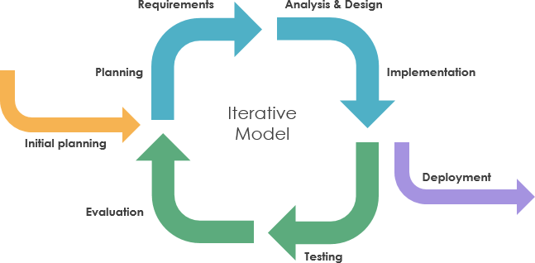

# 5. Gantt Chart

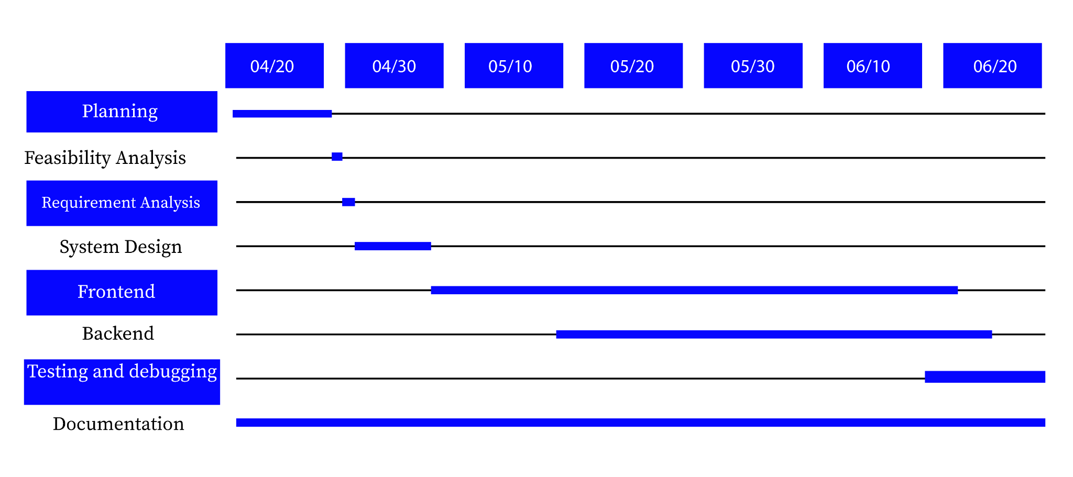

Fig: Gantt Chart of Hospify

# 6. Deliverables

1. A functional mobile application for Android.
2. User-friendly interfaces for each user role (receptionist, doctor, nurse, patient, admin).
3. Secure sensitive data storage to ensure patient privacy.
4. Integration of features like appointment booking, prescription management, and medical history access.
5. A comprehensive report outlining the app's functionalities and future development plans.

# 7. References

https://deltatechnepal.com/business-apps/hospital-management-system

https://www.emedicaresoft.com/news-and-blog/view/an-overview-of-hospital-management-system