

**LA GRANDEE INTERNATIONAL COLLEGE**

**Simalchaur, Pokhara Nepal**

A Proposal

On

**“**Thrift-Store**”**

**Submitted to:**

Bachelor of Computer Application (BCA) Program

In partial fulfilment of the requirements for the degree of BCA under

Pokhara University

**Submitted by:**

|  |  |  |  |
| --- | --- | --- | --- |
| **Name:** | **Course** | **Semester** | **P.U. Registration Number** |
| Anish Thapa | BCA | 8th | 2019-1-53-0105 |
| Rakesh Chhetri | BCA | 8 th | 2018-1-53-0123 |

**Date: 30/04/2024**

# ACKNOWLEDGEMENT

The satisfaction that accompanies after the successful completion of any task will be incomplete without mentioning the people whose ceaseless and relentless cooperation, constant guidance and encouragement made this project proposal report possible.

We are grateful to our project supervisor, faculty teacher **Mr Sunil Sapakota** and BCA coordinator **Mr Ramesh Chalise** for the guidance, inspiration and constructive suggestions that helped us in the preparation of this project.

We are also appreciative among each other and have understood that teamwork, the designation of the task per the skillset one portrays, constant synchronisation and monitoring of progress and instilling new knowledge and skill is imperative for the success of any given work.

Sincerely,

Anish Thapa

Rakesh Chhetri

**DECLARATION FOR**

**“**Thrift-Store**”**

# STUDENT’S DECLARATION

We hereby declare that we are the only authors of this work and that no sources other than the mentioned here have been used in this. We assure you that the work we present here is unique to ourselves and resemblances to another similar project are purely coincidental.

Anish Thapa (PU Exam Roll no): 2019-1-53-0105

Rakesh Chhetri (PU Exam Roll no): 2018-1-53-0123

Program: BCA, 8th Semester

Date: 4/30/24

# SUPERVISOR’S DECLARATION

I hereby declare that the project entitled **“**Thrift-Store**”** has been carried out under my direct supervision by Anish Thapa (2019-1-53-0105), and Rakesh Chhetri (2018-1-53-0123) during their fourth semester for the partial fulfilment of the requirements for the degree of **BCA (Bachelors of Computer Application)** program under **Pokhara University**.

**_______________**

**Mr Sunil Sapakota**

(Project Supervisor)

Date: 30 April 2024

Table of Contents

ACKNOWLEDGEMENT ii

STUDENT’S DECLARATION ii

SUPERVISOR’S DECLARATION iii

**1.** **Introduction** 1

**2.** **Objectives** 2

**3.** **Problem Statement** 3

**4.** **METHODOLOGY** 4

**5.** **Project Gantt Chart** 5

**6.** **Deliverables** 6

# **Introduction**

Thrifting is simply buying from stores that sell pre-loved, second-hand clothes, accessories, and lifestyle products. This concept of reusing gently- used items is decades old. Traditionally Thrift shops were referred to as Charity shops and as the name suggests these shops were set up as non-profit organizations to raise money for various causes.

The first thrifting experience can be seen dated back to 1897 when Salvation Army’s ‘Salvage Brigade’ was launched out of a basement where residents would go in search of used clothes and receive food and lodgings in return. A thrift store, also known as a second-hand store or charity shop, is a retail establishment that sells gently used or pre-owned goods at discounted prices. These goods typically include clothing, shoes, accessories, household items, furniture, books, and sometimes even electronics.

Thrift stores operate on the principle of reusing and recycling items, which aligns with the concept of sustainability and reducing waste. People often donate items they no longer need or want to thrift stores, and these items are then resold to new owners at affordable prices. Thrift stores are not only popular for their budget-friendly shopping options but also for the treasure-hunting experience they offer. Customers often enjoy browsing through the eclectic mix of items, never knowing what unique or unexpected find they might discover.

Moreover, many thrift stores are run by charitable organizations or non-profits, with proceeds often going towards supporting various social causes or community programs. This aspect adds a layer of social responsibility to the act of shopping at thrift stores, as customers contribute indirectly to charitable efforts through their purchases.

Overall, thrift stores serve as more than just retail outlets; they are hubs of community engagement, sustainability, and philanthropy, offering both shoppers and donors a way to participate in a cycle of giving and reusing.

# **Objectives**

The main objectives of this project are as follows:

* Thrift stores encourage recycling and reusing items, reducing waste and environmental impacted.
* Thrift stores offer affordable options for shoppers, including low-income individuals and families helping them access necessities at lower prices.
* To facilitates the data storage and data maintenance and privileges to access any records services.

# **Problem Statement**

These days everything gets easier and smarter. Many people want safe and computerized working which saves a lot of time. Today’s world is all about on the business. So, for this reason different system has been born. They made the life of people very effective. But there are different features that haven’t been created till now for the users.

* 1. Due to lack of sustainable shopping options.
  2. Due to limited access to affordable goods.
  3. Due to lack of education and awareness of purchasing goods.
  4. Due to E-advertising and viral selling products of goods.
  5. Due to Promoting Conscious Consumerism

# **METHODOLOGY**

For this project, the Software Development Life Cycle (SDLC) Methodology that we have decided on using “Waterfall Model” to develop the Thrift-Store as a digitalized college software based on the fact that our requirements are certain and will not change with time.

The waterfall model is a classical model used in system development life cycle to create a system with a linear and sequential approach. It is termed as waterfall because the model develops systematically from one phase to another in a downward fashion. This model is divided into different phases and the output of one phase is used as the input of the next phase. Every phase has to be completed before the next phase starts and there is no overlapping of the phases.

The image below shows the process involved in Waterfall Model Methodology:

Figure 1: Waterfall Model (Used Methodology)

# **Project Gantt Chart**

The Gantt chart below shows the schedule planned for developing the “THRIFT-STORE” following Waterfall Model Methodology. Thus, this project would be carried out in steps with proper planning in each step, best effort would be applied to complete this project before deadline.

It also shows the time schedule description and tasks performed throughout the completion of project from the day of starting the project until it was finished in the horizontal bar below:

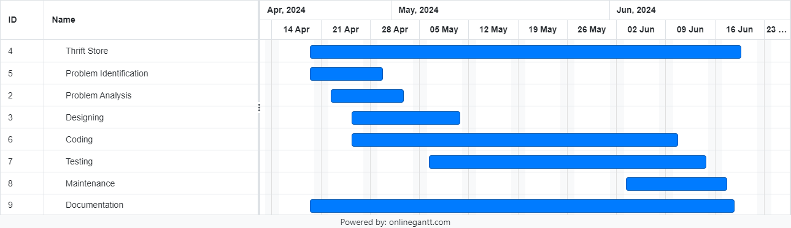

Figure 2: Figure of Gantt chart

# **Deliverables**

On the completion of the project we would get the following expected outcomes:

* 1. To collection of second-hand items including clothing and books.
  2. To sustainable income generated through the sale of thrifted goods.
  3. To creates the contribution to social or environmental causes, such as promoting sustainability or supporting local charities.
  4. To established collaborations with local organizations, businesses, and charities to enhance impact and reach.
  5. To increased awareness and positive perception of the thrift store within the community.
  6. To increases shopping experience resulting in high customer satisfaction and potential repeat business.
  7. To increases the sales of local product on the lower prices.