

**LA GRANDEE INTERNATIONAL COLLEGE**

**Simalchaur,Pokhara-8**

Project Report on

**“Venue Match”**

In partial fulfillment of the requirements for the degree of Program Name under

Pokhara University

**Bachelor of Computer Application (BCA)**

**Submitted by:**

|  |  |
| --- | --- |
| **Name** | **Pu Reg No** |
| 1. **Narvasha Adhikari** | **2018-01-53-0117** |
| 1. **Samjhana Poudel** | **2018-01-53-0126** |

BCA Semester: VII

**Submitted to :**

Department of Bachelor of Computer Application

Date :12th May,2023

**Table of Contents**

1 Introduction 1

2 Objectives 3

3 Problem Statement 4

4 Methodology 5

4.1 Requirement analysis 6

4.2 Risk analysis 7

5 Gantt Chart 8

6 Deliverables 9

7 References 10

# Introduction

In the fast-paced world of event planning, finding the perfect venue can be a daunting task. Event organizers often struggle with limited options, lack of information, and time-consuming coordination. To address these challenges and revolutionize the way venues are discovered and booked, we present our innovative Venue Match App.

The Venue Match App is a comprehensive platform designed to simplify the process of finding, comparing, and booking venues for various events. It provides event organizers with a user-friendly interface and a vast database of venues, complete with detailed information on availability, capacity, amenities, pricing, and location.

Our app aims to enhance the user experience by offering a personalized journey. With features such as recommendations, saved searches, and customized notifications, users can easily discover venues that align with their specific needs and preferences. Whether it's a corporate conference, wedding reception, or social gathering, the Venue Planner App streamlines the entire venue selection process.

Not only does the app benefit event organizers, but it also empowers venue managers. Our platform includes tools for efficient venue management, such as automated booking confirmation, availability calendars, and online payment processing. This enables venue managers to streamline operations, optimize bookings, and provide a seamless experience for event planners.

Furthermore, the Venue Match App boosts venue exposure by integrating social media platforms, implementing search engine optimization techniques, and offering targeted advertising options. The app provides analytics and insights on venue performance, allowing venues to make data-driven decisions and optimize their listings for maximum exposure.

We understand the importance of fostering positive relationships between event planners and venues. Our app facilitates communication channels, rating and review systems, and feedback mechanisms to ensure transparency, trust, and collaboration.

In conclusion, the Venue Planner App revolutionizes the venue selection process by offering a comprehensive platform for event organizers and venue managers. With its user-friendly interface, personalized recommendations, efficient venue management tools, increased exposure opportunities, and emphasis on positive relationships, our app is set to become the go-to resource for seamless and successful event planning.

# Objectives

Venue match app can vary depending on the specific goals of the project and the target audience. However, here are some common objectives that we are focusing while developing a venue match app:

1. Simplify venue booking with detailed venue information and availability.
2. Enhance user experience with easy venue searching and booking.
3. Improve venue management with efficient tools for booking, calendars, and payments.
4. Provide value to event planners with tools for budget, guest, and vendor management.
5. Foster positive relationships with rating systems and communication channels.
6. Provide detailed venue information and overviews to help users make informed decisions.

# Problem Statement

The current state of venue applications presents several challenges and limitations

* Venue match is a complex and time-consuming process.
* Tracking guest lists and managing budgets can be difficult.
* Coordinating with vendors and ensuring seamless communication is a challenge.
* Venues may struggle to reach a wider audience and efficiently manage bookings.
* There is a need for a comprehensive and user-friendly event planner app.
* The app should simplify the planning process and enhance the user experience.
* There is a need for a platform that fosters positive relationships between event planners and venues.

# Methodology

For the development of Venue Match application, we use the iterative model. Iterative model is one of the popular models for development of projects. Iterative model starts with a simple implementation of a subset of the software requirements and iteratively enhances the evolving versions until the full system in implemented

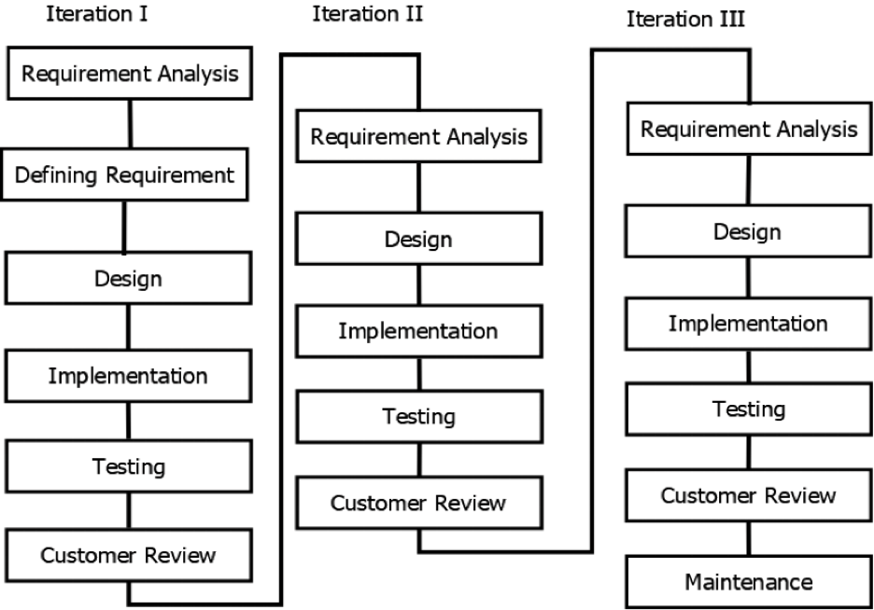

Fig: Iterative Model

## Requirement analysis

In order to develop a successful venue match app, it is important to conduct a thorough requirement analysis to identify the needs and expectations of our target audience. The following requirements have been identified:

User-friendly Interface: The app should have an intuitive and user-friendly interface that enables users to easily navigate and quickly find the information they need. This will enhance user satisfaction and engagement.

Advanced Search Options: The app should provide advanced search options that allow users to filter results based on various criteria such as location, venue type, price range, availability, and other relevant factors. This will help users find the perfect venue that meets their specific requirements.

User Profiles and Preferences: The app should allow users to create profiles and set preferences based on their interests, budget, location, and other factors. This will enable the app to provide personalized recommendations that are tailored to each user's needs.

Venue Listings and Reviews: The app should have a comprehensive database of venues that users can browse and review. This will help users make informed decisions based on the experiences of others.

Booking and Reservation System: The app should provide a seamless booking and reservation system that enables users to easily make reservations and bookings directly through the app. This will save users time and hassle in making bookings through other channels.

Feedback and Rating System: The app should have a feedback and rating system that allows users to provide feedback and rate venues based on their experiences. This will help improve the quality of services provided by venues and enhance the overall user experience

In conclusion, these requirements are critical to the success of the venue match app. They should be documented, actionable, measurable, testable, traceable, and defined to a level of detail sufficient for system design. Our team will work towards meeting these requirements in order to develop a user-friendly, reliable, and efficient venue match app that meets the needs and expectations of our target audience.

## Risk analysis

The development and launch of a mobile app involve several risks, such as technical issues, competition, user adoption, legal compliance, financial costs, reputation, and operational challenges. Technical risks include compatibility issues, server failures, and security vulnerabilities. Competition risks may arise due to the presence of established competitors. User adoption risks may result from poor user experience or insufficient marketing efforts. Legal risks may relate to privacy regulations, data protection laws, and intellectual property rights. Financial risks include cost overruns, low return on investment, and inability to secure funding. Reputation risks arise from negative reviews, poor user experience, and other issues. Operational risks include technical glitches, server downtime, and insufficient support resources. Mitigating these risks requires a comprehensive risk analysis and management plan that includes proactive measures, such as regular security audits, excellent user support, marketing and user acquisition efforts, compliance with legal and regulatory requirements, and continuous monitoring and review of the app's performance.

# Gantt Chart

|  |  |  |  |  |  |  |  |  |  |  |  |  |
| --- | --- | --- | --- | --- | --- | --- | --- | --- | --- | --- | --- | --- |
| **Weeks**  **Works** | **1** | **2** | **3** | **4** | **5** | **6** | **7** | **8** | **9** | **10** | **11** | **12** |
| **Pre-Analysis phase** |  |  |  |  |  |  |  |  |  |  |  |  |
| **Feasibility Study** |  |  |  |  |  |  |  |  |  |  |  |  |
| **Project Proposal** |  |  |  |  |  |  |  |  |  |  |  |  |
| **Detailed Study and Analysis** |  |  |  |  |  |  |  |  |  |  |  |  |
| **Initial Prototype** |  |  |  |  |  |  |  |  |  |  |  |  |
| **Mid Term Defense** |  |  |  |  |  |  |  |  |  |  |  |  |
| **Implementing of System** |  |  |  |  |  |  |  |  |  |  |  |  |
| **Testing** |  |  |  |  |  |  |  |  |  |  |  |  |
| **Documentation of project Work** |  |  |  |  |  |  |  |  |  |  |  |  |
| **Final Defense** |  |  |  |  |  |  |  |  |  |  |  |  |

Table 1: Working Schedule of the Project

# Deliverables

User interface design: The app should be easy to use and navigate. Database of venues: The app should have a comprehensive list of venues.

Search and filtering options: The app should allow users to search for venues based on different criteria.

Booking and payment system: The app should allow users to book and pay for venues directly.

Reviews and ratings: The app should allow users to rate and review venues to help other users make informed decisions.

# References

* Flutter. (n.d.). *flutter* . Retrieved from https://flutter.dev/
* shoutem. (n.d.). *shoutem*. Retrieved from app-ideas: https://shoutem.com/blog/app-ideas-for-beginners/?
* wiki. (n.d.). *wikipedia*. Retrieved from wikipedia.org: https://en.wikipedia.org/wiki/