The truck battery cables
 | Photo | Size | Description | 人民币含税价 | OE
1 | 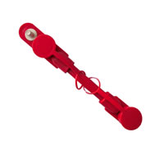 | 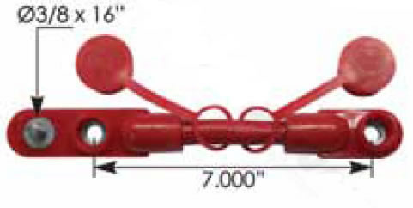 | Fits 2 Battery Setups  Made With 2/0 PVC Starter Cable  Fits up to 3/8" Stud  Protective Caps  100% Copper Assembly  105 degrees of heat-resistant  Voltage is 600 v | 56元/根 | Part Number: 178.2020RD
2 | 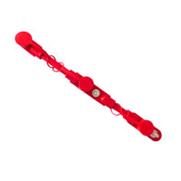 | 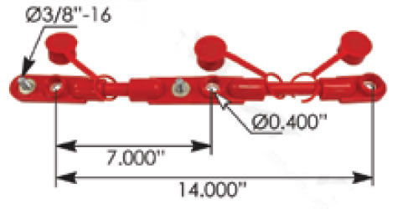 | Fits 3 Battery Setups  Made With 2/0 PVC Starter Cable  Fits up to 3/8" Stud  Protective Caps  100% Copper Assembly  105 degrees of heat-resistant  Voltage is 600 v | 95元/根 | Part Number: 178.2021RD
3 | 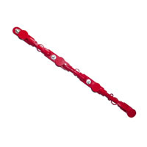 | 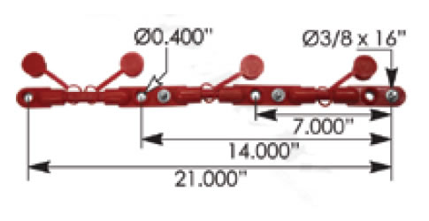 | Fits 4 Battery Setups  Made With 2/0 PVC Starter Cable  Fits up to 3/8" Stud  Protective Caps  100% Copper Assembly  105 degrees of heat-resistant  Voltage is 600 v | 155元/根 | Part Number: 178.2022RD
 | 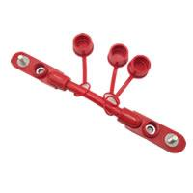 | / | Fits 2 Battery Setups  Made With 2/0 PVC Starter Cable  Fits up to 3/8" Stud  Protective Caps  100% Copper Assembly  105 degrees of heat-resistant  Voltage is 600 v | 68元/根
4 | 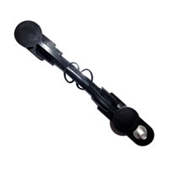 | 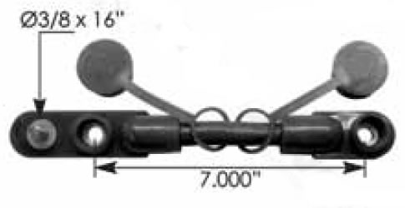 | · Fits 2 Battery Setups  Made With 2/0 PVC Starter Cable  Fits up to 3/8" Stud  Protective Caps  100% Copper Assembly  105 degrees of heat-resistant  Voltage is 600 v | 56元/根 | Part Number: 178.2020BK
5 | 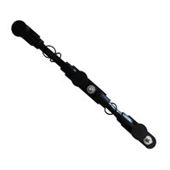 | 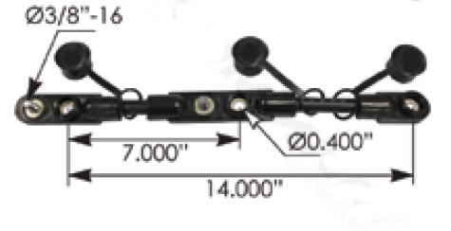 | Fits 3 Battery Setups  Made With 2/0 PVC Starter Cable  Fits up to 3/8" Stud  Protective Caps  100% Copper Assembly  105 degrees of heat-resistant  Voltage is 600 v | 95元/根 | Part Number: 178.2021BK
6 | 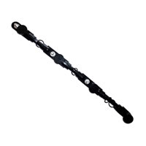 | 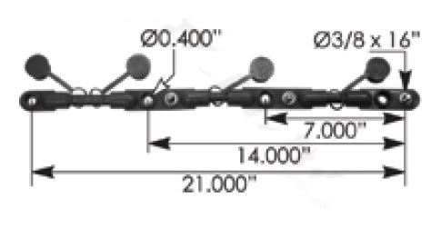 | Fits 4 Battery Setups  Made With 2/0 PVC Starter Cable  Fits up to 3/8" Stud  Protective Caps  100% Copper Assembly  105 degrees of heat-resistant  Voltage is 600 v | 155元/根 | Part Number: 178.2022BK
 | 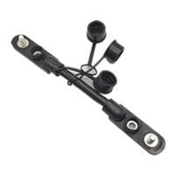 | \ | Fits 2 Battery Setups  Made With 2/0 PVC Starter Cable  Fits up to 3/8" Stud  Protective Caps  100% Copper Assembly  105 degrees of heat-resistant  Voltage is 600 v | 68元/根
7 | 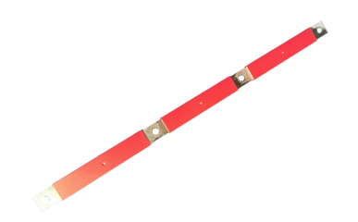 |  | 242-5529P POSITIVE TERMINAL BATTERY BUS BAR | 4 HOLES  Voltage: 12V  Application for Use: 2004-2015 Vn,Vnl,Vnm Volvo  Type: Flat Bar  Positive or Negative: Positive  Color: Red  Number of Holes: 4 Holes - 3/8" | 76元/根 | Style: Oe#21107828  Dorman：2425529P  Volvo：21107828  Automann：178.2024RD
8 | 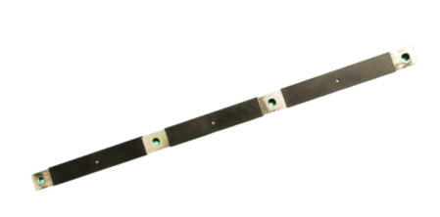 |  | 242-5529N NEGATIVE TERMINAL BATTERY BUS BAR 4 HOLES  Voltage: 12V  Application for Use: 2004-2015 Vn,Vnl,Vnm Volvo  Type: Flat Bar  Positive or Negative: Negative  Color: Black  Number of Holes: 4 Holes - 3/8" | 76元/根 | Style: Oe#21107829  Dorman： 2425529N  Volvo：21107829  Automann：178.2024BK
9 | 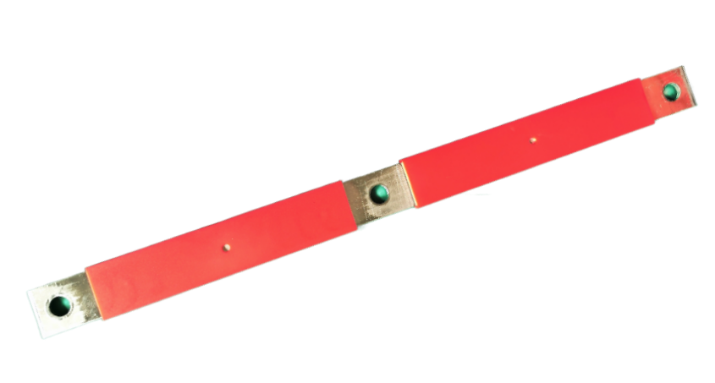 |  | 242-5530P POSITIVE TERMINAL BATTERY BUS BAR 3 HOLES  Voltage: 12V  Application for Use: 2004-2015 Vn,Vnl,Vnm Volvo  Type: Flat Bar  Positive or Negative: Positive  Color: Red  Number of Holes: 3 Holes - 3/8" | 55元/根 | Style: Oe#21107822  Dorman： 2425530P  Volvo：21107822  Automann：178.2025RD
10 | 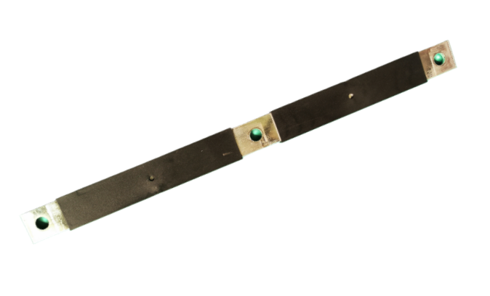 |  | 242-5530N NEGATIVE TERMINAL BATTERY BUS BAR 3 HOLES  Voltage: 12V  Application for Use: 2004-2015 Vn,Vnl,Vnm Volvo  Type: Flat Bar  Positive or Negative: Negative  Color: Black  Number of Holes: 3 Holes - 3/8" | 55元/根 | Style: Oe#21107826  Dorman：2425530N  Volvo：21107826  Automann：178.2025BK

