300A Specification Sheet for Starting Battery Connector

Juheng technologies co. Ltd | Lithium battery module connector
Ⅰ、Product appearance
Positive pole:JH-QD-300-W-02R  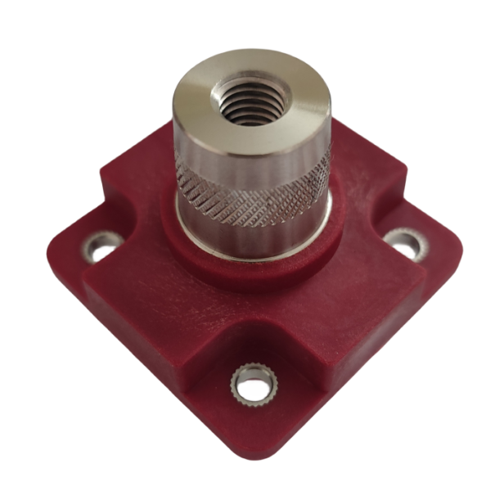  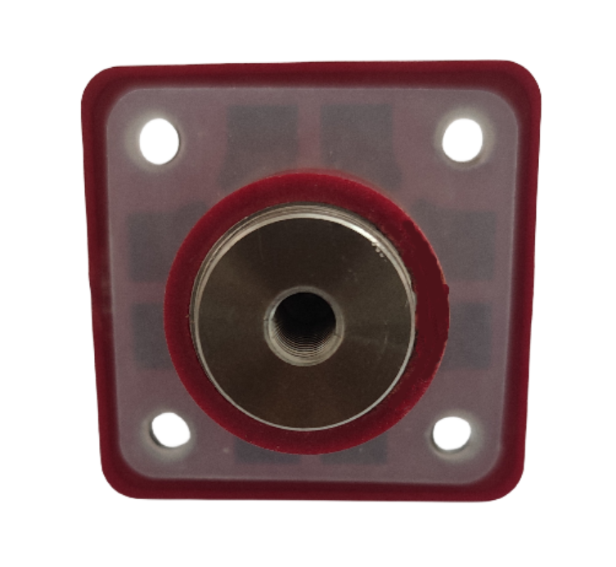 | Negative pole:JH-QD-300-W-02BK  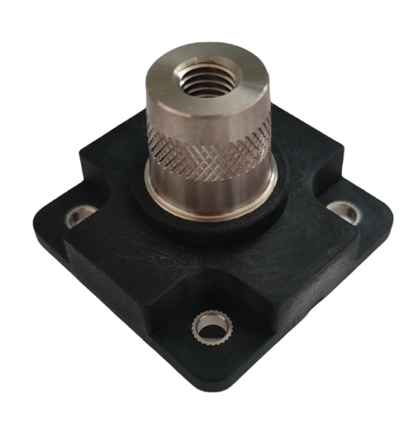  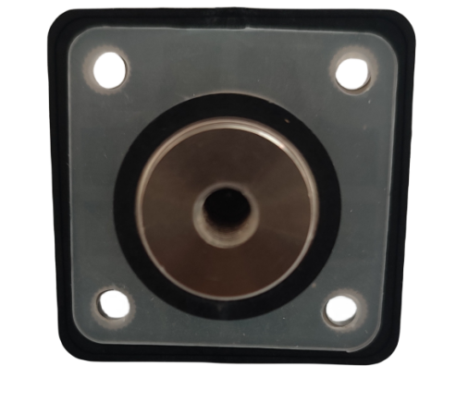
Ⅱ、Performance parameter：
1、Electrical parameters
■ Rated Voltage：1500V DC
■ Rated current：300AMP
■Instantaneous current：2500A
■Withstand voltage：：4200V DC
■Insulation Resistance：≥500MΩ

2、Mechanical parameter
■Contact surface diameter18mm
■ Aperture of external screw：M8
■ Internal screw aperture：M6
■Tightening torque: M6 Threaded hole (Coarse thread)：9N.m MAX,M8-12N.m MAX

3、Materials composition
■ Conductor: brass, nickel plated
■ Insulating material：PA66 Flame retardant V0 Level
■ Insulation parts thermal deformation temperature：205℃
■ Color：Positive pole orange color / Negative pole black color
■ Sealing ring: silicone

Ⅲ、External dimension
Units：mm

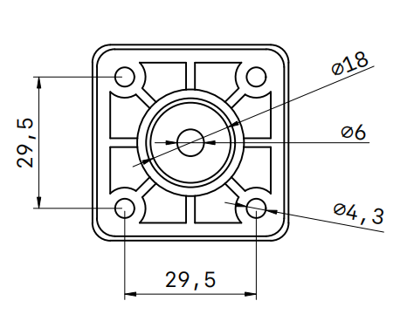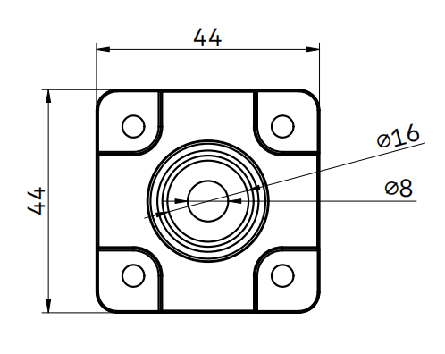

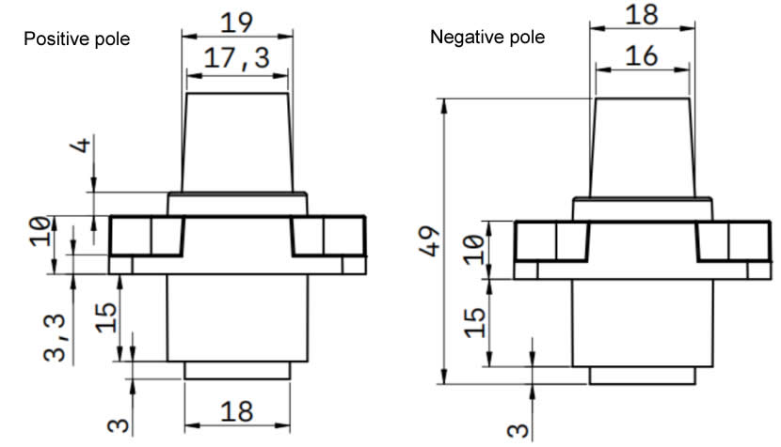

S Ⅳ、Installation trepanning
- Units:mm

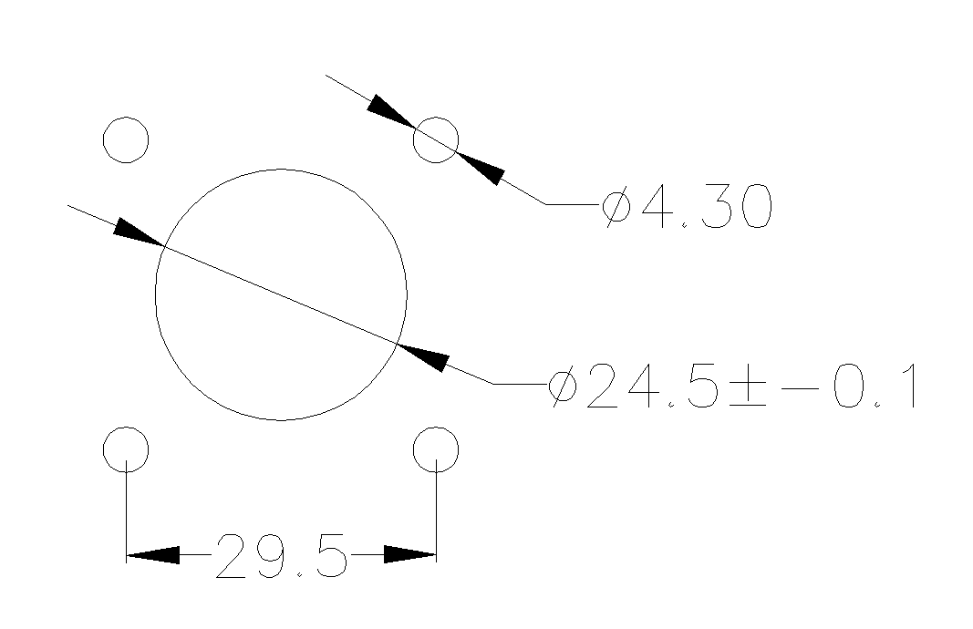

Juheng technologies co. Ltd
2024-03-12

