## Entry Name: Laxman Sai Karthik Mahidhar Gopalabhatla

## Student ID: 800936333

## ITCS 6162 Summer 2016 Final Project Deliverable 1

### Tools Used:

*Tableau, Excel, D3.js*

**Approximately how many hours were spent working on this submission in total?**

*30 Hours*

**What are data mining techniques you used and why did you choose them?**

*I have used a variety of visualization techniques like Bar Charts, Gantt Charts with combination of different parameters, Time-series charts etc. I have used linear trend lines for finding the overall trend of the parameters. I have extensively used VLOOKUP for understanding and for generating new temporary parameters.*

*I have developed a 3 small web applications with D3.js and their description is as follows*

1. *Time-series charts of all the 415 parameters in the building data.*

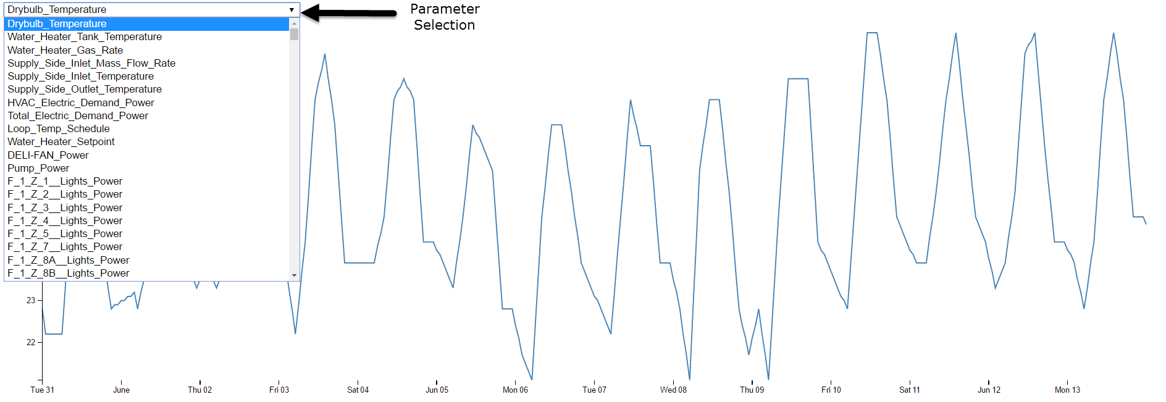

1. Activity of all the 415 parameters during the hour of the day for all days.

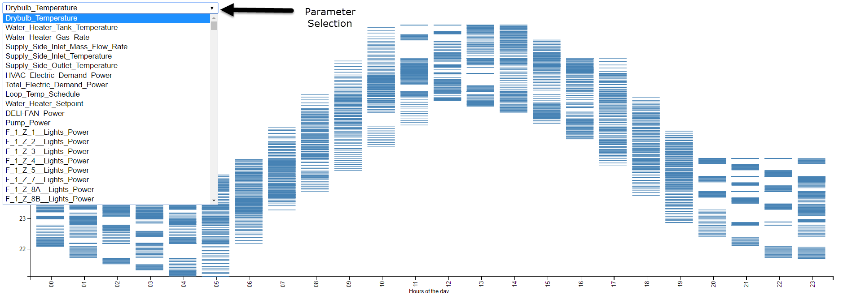

1. A Master Gantt chart using proximity data (Dimensions 10000x500)

(Note: Save the file and view for better clarity)

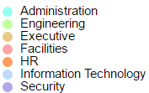

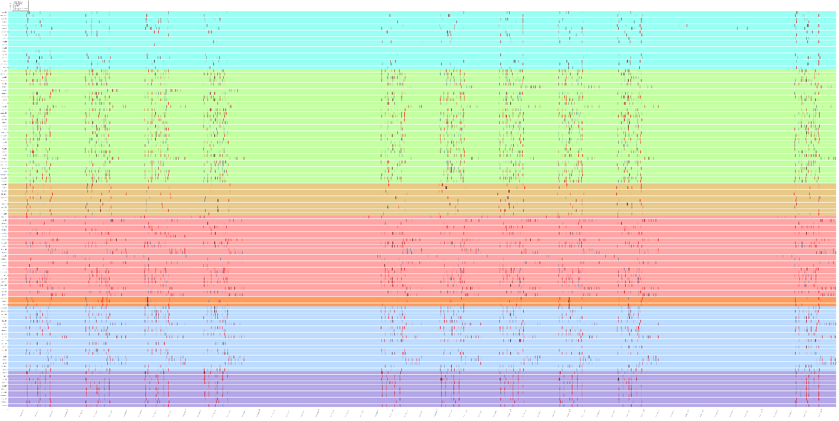

**What are the limitations of your approach?**

*As the timestamp data in the proximity data is a point it is hard to understand the duration of an employee at a particular location. Even though we try to create a time range using the co-occurrences of timestamps, it cannot be said with absolute confidence about the employees’ location.*

**Questions**

**1.a** – What are the typical patterns visible in the prox card data? What does a typical day look like for GAStech employees?

I have used the master gantt chart to observe the patters of employee prox card data and have come to the following conclusions

1. Engineering department people have the most movement in the office.

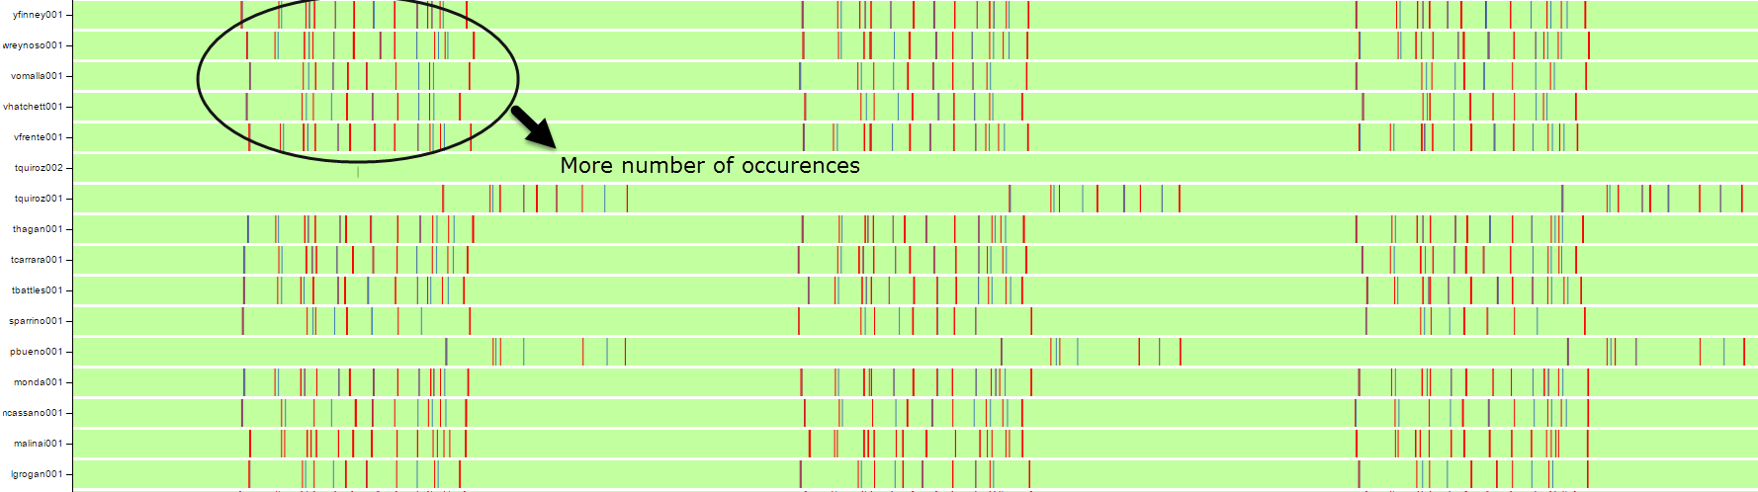

1. Security Department employees have the most consistent patterns in their occurrences which might be the result of their continuous and timely surveillance of the entire office.

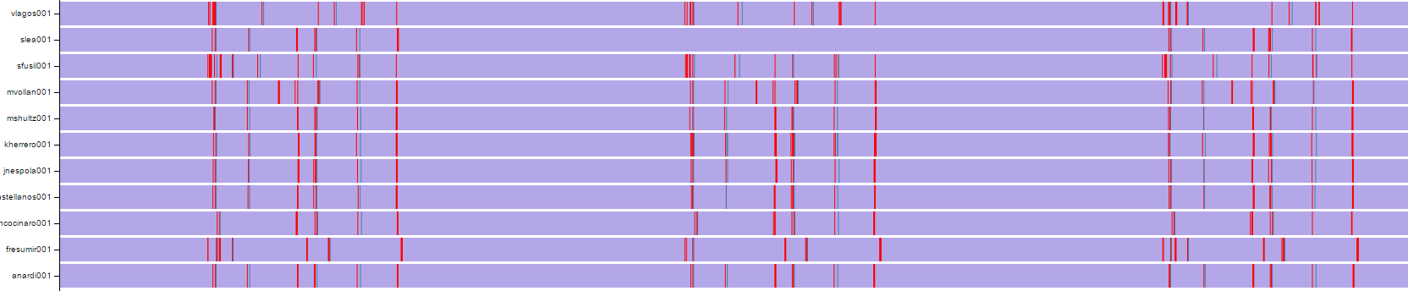

1. Security Department People are the least likely to be seen in their office.

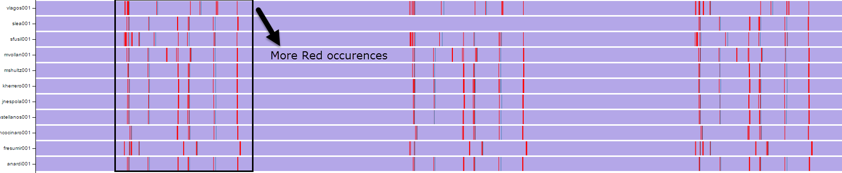

1. From the Chart it can be clearly said that the IT employees work in two shifts i.e 7:30 AM to 5:00PM and 4:00 PM to 12:00 AM

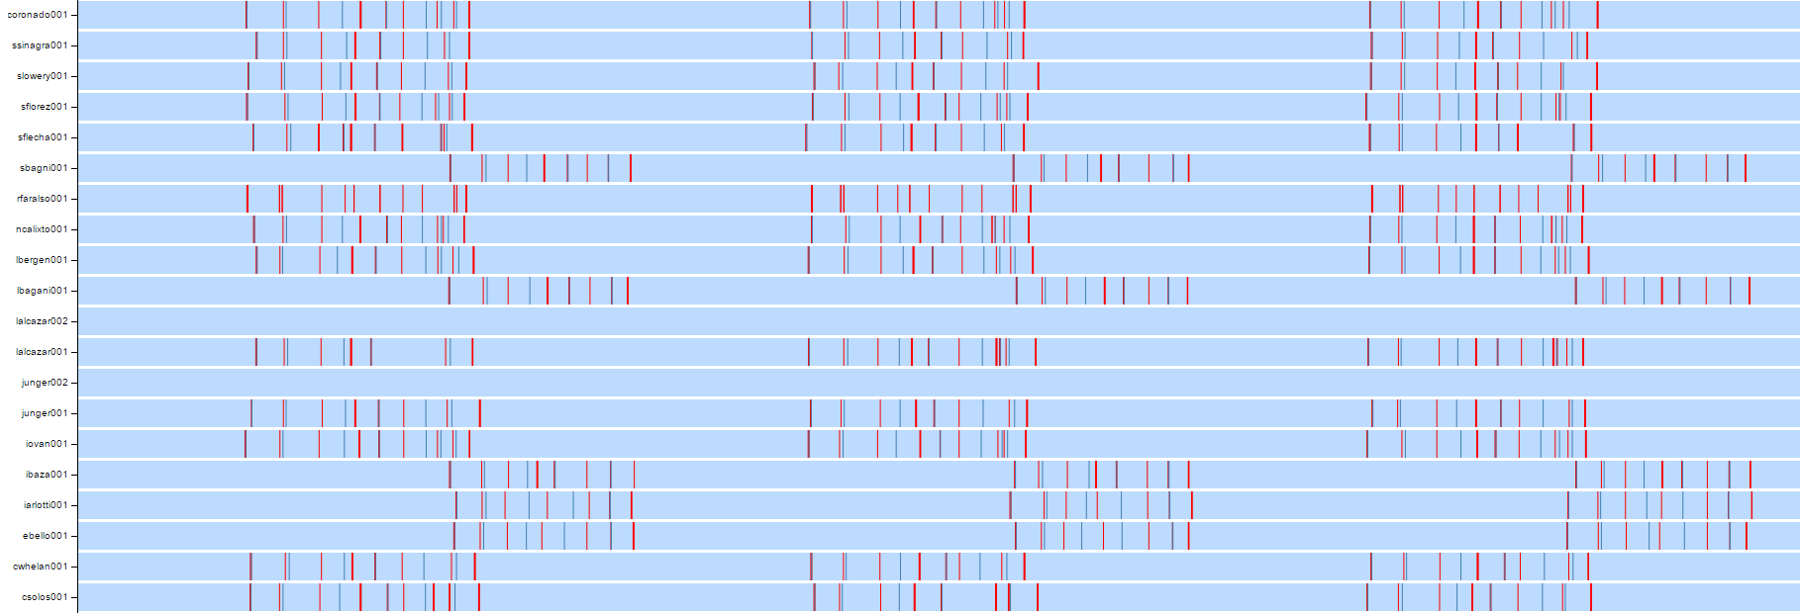

1. Facilities department employees have Three shifts i.e 7:30 AM to 5:00PM, 4:00 PM to 12:00 AM and 12:00 AM to 7:30AM

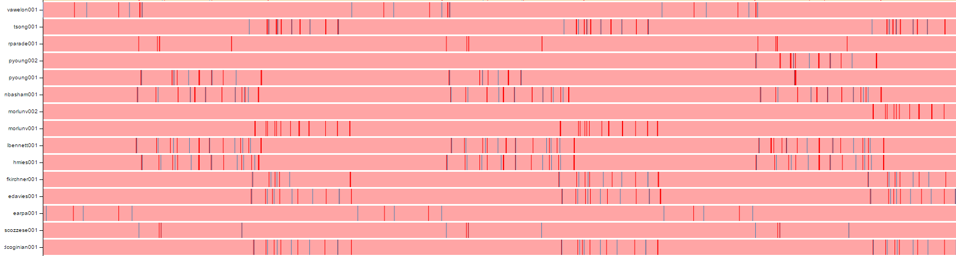

1. HR department employees have the least occurrences thus can be considered to have least movement in the office.



1. Most of the IT employees working in shift i.e. from 7:30 AM to 5:00 PM go to Deli between the 12:00 PM and 12:30 PM (Black likes in the Master gantt represent Deli)

**1.b** – Describe up to ten of the most interesting patterns you observe in the building data. Describe what is notable about the pattern and explain what you can about the significance of the pattern.

I have observed some interesting patterns with the 2nd D3 module I developed and some of the interesting patterns are as follows.

1. The Dry Bulb temperature gradually increases during the day and reaches its maximum between 12:00 PM and 2:00 PM

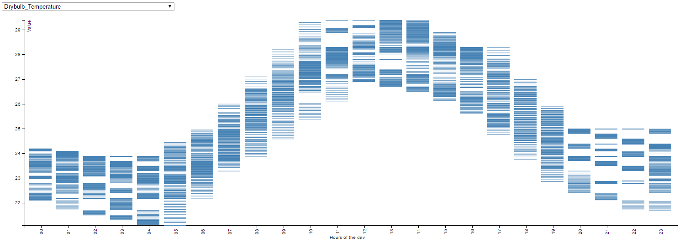

1. The power consumption of HVAC fan of Floor 1 is usually more 05:00 hours to 11:00 Hours

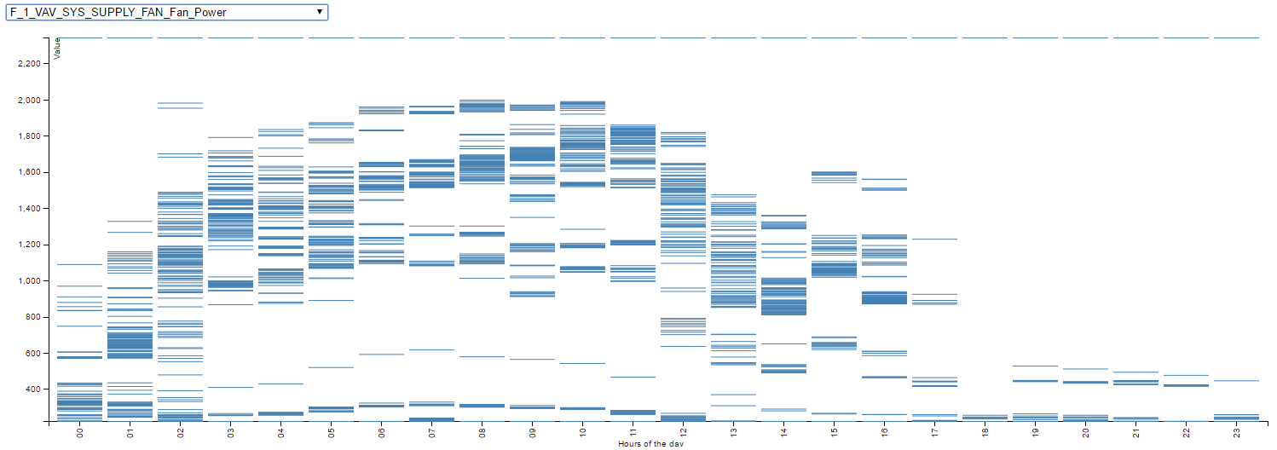

1. The power consumption of HVAC fan of Floor 2 is usually uses very low power during the time 23:00 hours to 04:00 Hours

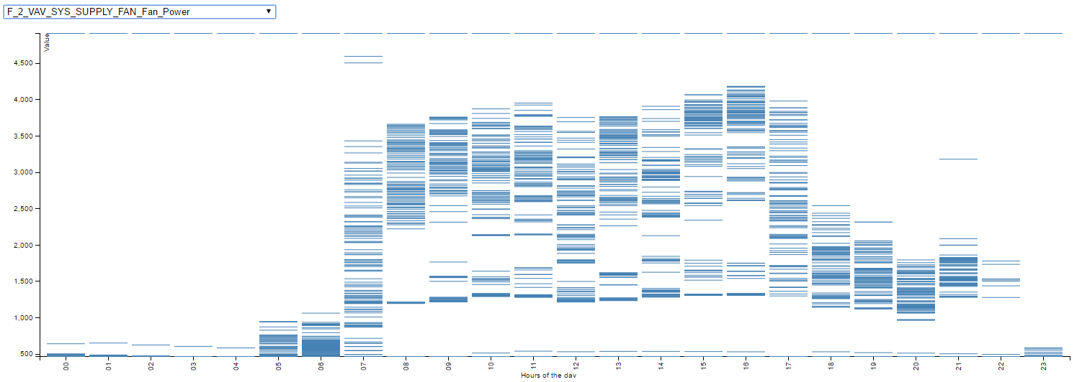

1. The power consumption of HVAC fan of Floor 2 is usually uses very low power during the time of regular office hours

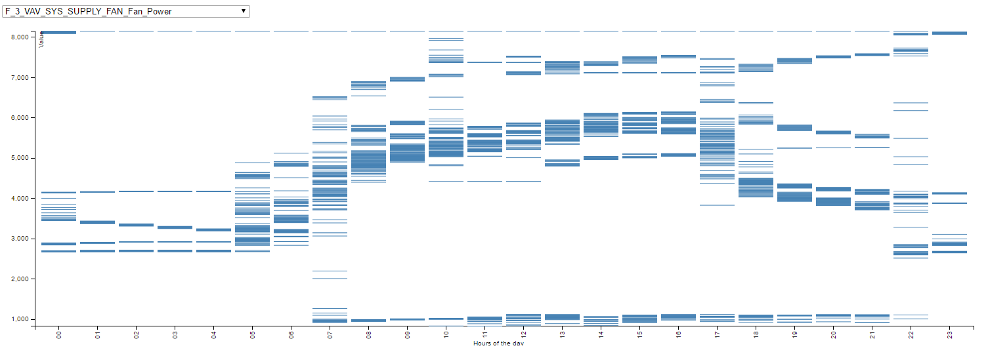

1. Concentration of C02 measured at the zone's return air grille i.e RETURN OUTLET CO2 Concentration gradually increases and decreases during the time of 08:00 to 23:00. This is due to the presence of employees that increases the CO2 content all the zones.
2. Temperature of the air entering the zone from its air supply box gradually decreases during the time of 08:00 to 23:00. This can be understood in reference to the increase of CO2 at the same time which in turn increases the temperature of the zone. Thus the air supply box pumps air with lower temperature to maintain the temperature.
3. Flow rate of the air entering the zone from its air supply box has never been set to 0 in any of the zone which indicates that there is always minimum airflow in all the zones.
4. The patterns of Water Heater Tank Temperature and Supply Side Outlet Temperature during the hour of the day look strikingly similar as the heated water from the tank leaves the through supply side outlet and hence it is almost equal to the temperature of water in the tank.

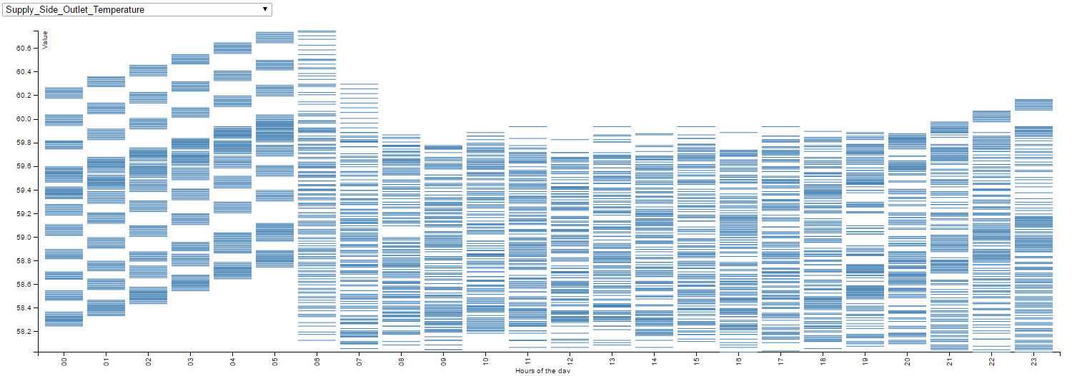

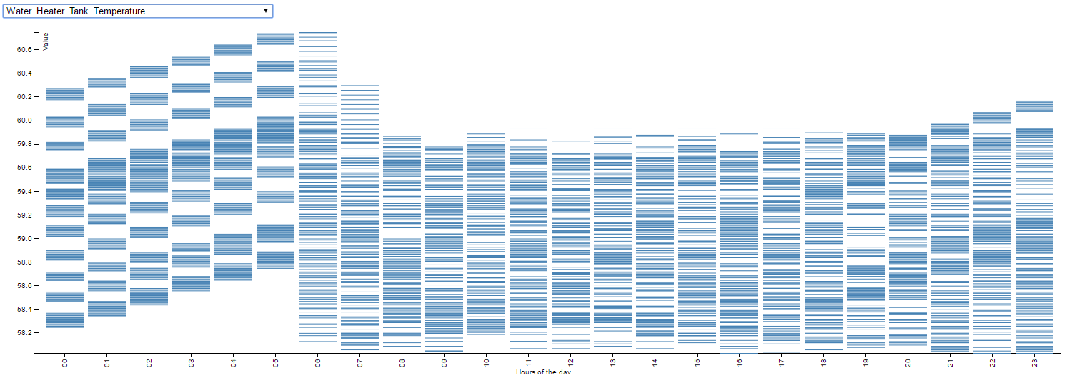

1. Total power used by the building is usually high during 07:00 to 17:00.

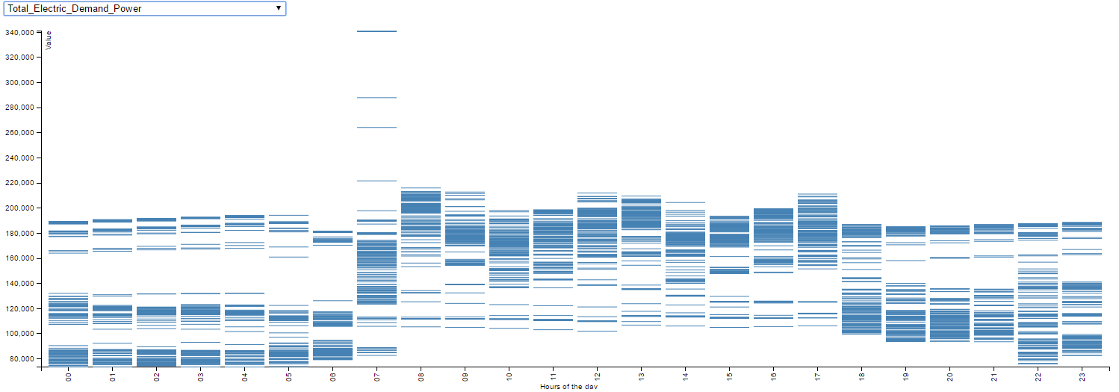

1. Concentration of CO2 measured at the all the zone's return air grille is maximum during 7th and 8th of June.

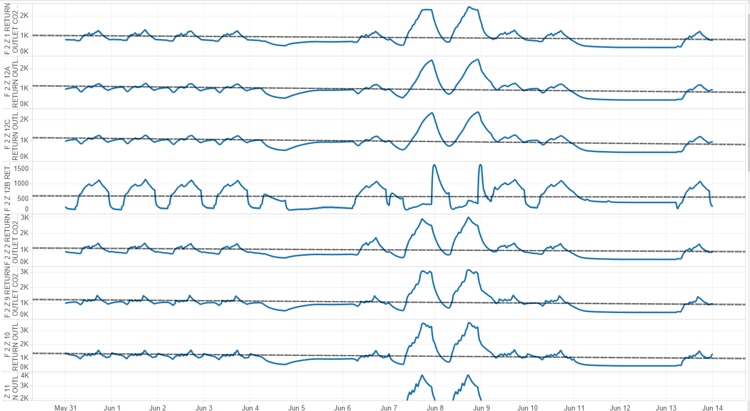

1. Even the Thermostat temperature of all the zone in the building maxed during 7th and 8th of June. (e.g. Temperature readings of Floor 1 Zone 7 Thermostat)

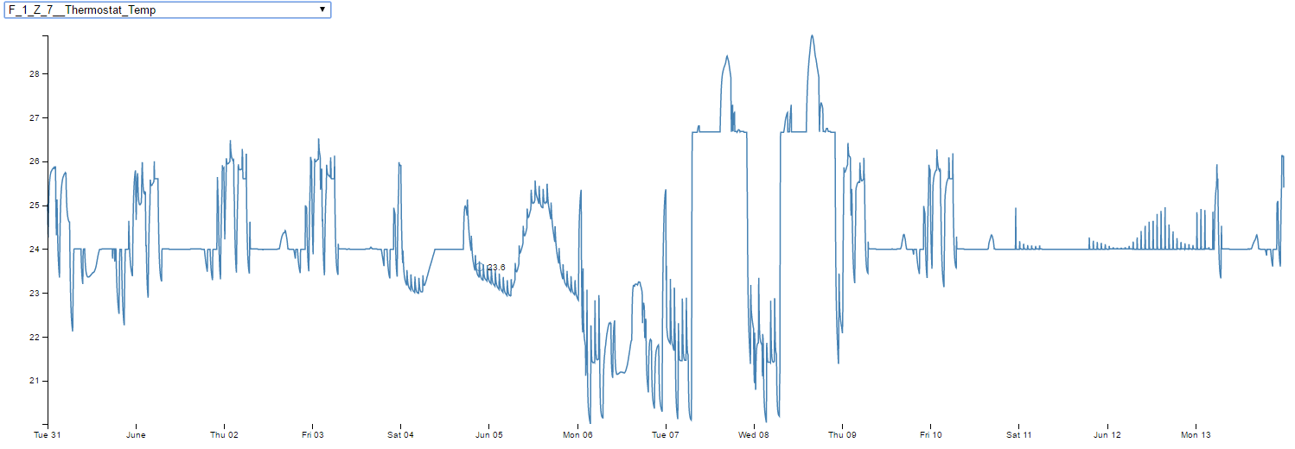

1. HVAC system fan of floor 1 was running at full power from 11th of June to 13th of June as the Damper position was set to 1 indicating maximum air flow. It is the same case with other two floors as well.

