**Lab Application Container Cloud Service  
ACCS**

This lab covers the Application Container Cloud Service.

# Introduction

In this lab, you will:

* Develop a REST web service in NodeJS
* Build the REST web service for the Oracle Application Container Cloud Service
* Run the REST web service on the Oracle Application Container Cloud Service

The lab will be made on a VirtualBox image that will be distributed.

Note that Oracle has a good Learning path on this topic: <https://apexapps.oracle.com/pls/apex/f?p=44785:50:111037163849128:::50:P50_COURSE_ID,P50_EVENT_ID:201,5794>

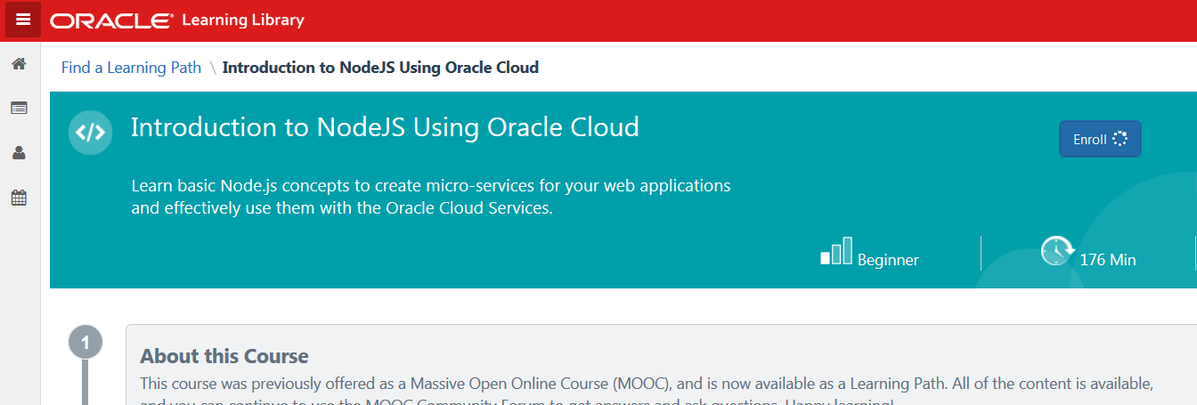

# Login

Log in into Application Container Cloud Service, using the following information:

* Identity domain: a516817
* Username: [lucas.jellema@amis.nl](mailto:lucas.jellema@amis.nl)
* Password: <to be provided>

Console for ACCS:

<https://apaas.us.oraclecloud.com/apaas/faces/aPaaSRunner.jspx>

Via:



To

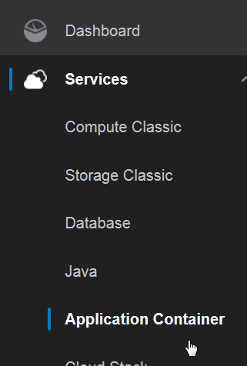

Result:

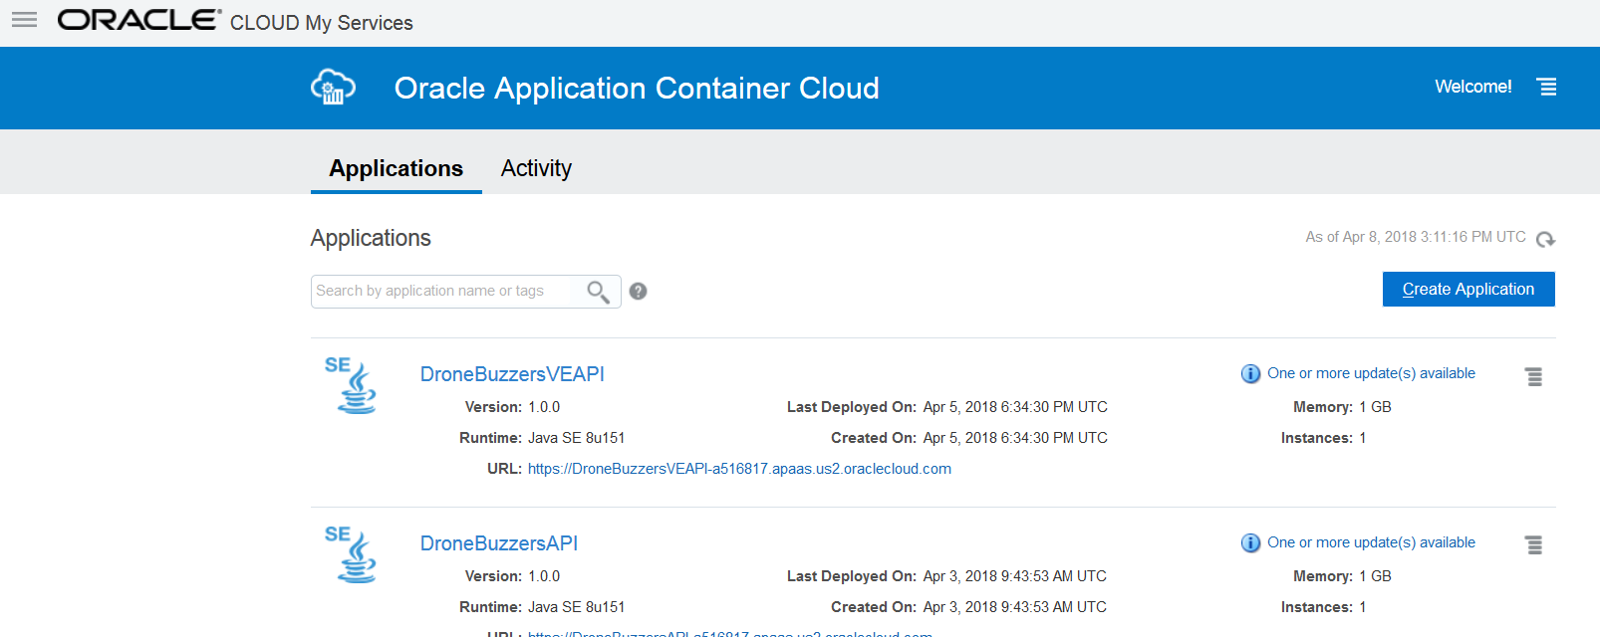

# Develop the REST web service in NodeJS

The following steps will be done for building the web service:

* Create the project – package.json file
* Install express – the node web framework
* Install body-parser – the parser for incoming request bodies
* Copy the web service JS code file
* Run and test the service

**Create the project:**

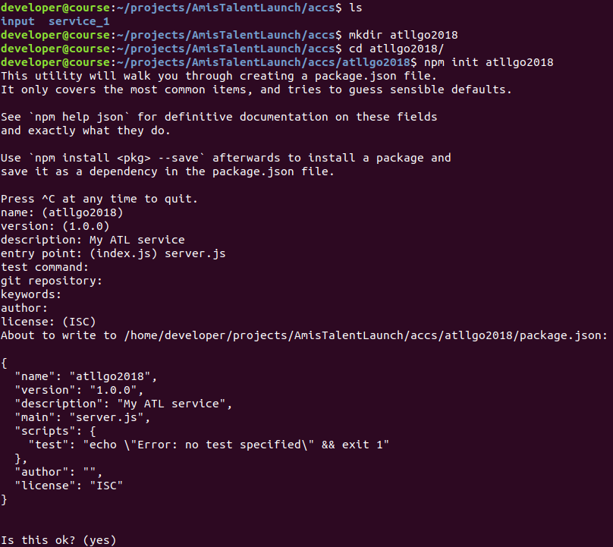

**Install express – the node web framework**

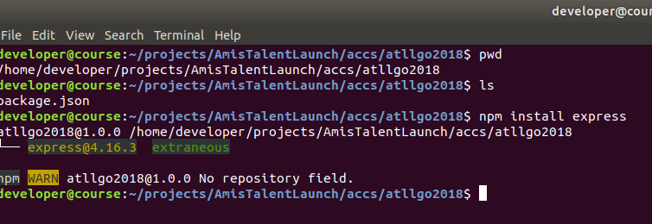

**Install body-parser – the parser for incoming request bodies**

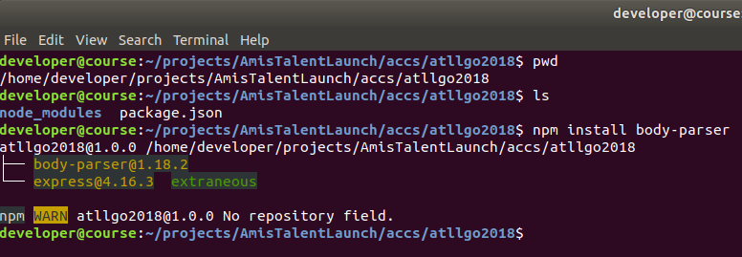

**Copy the web service JS code file**

The service code is available in the input directory:

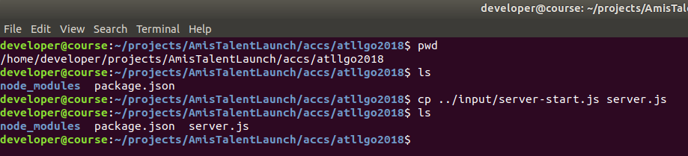

This is a good moment to have a look at the service code:

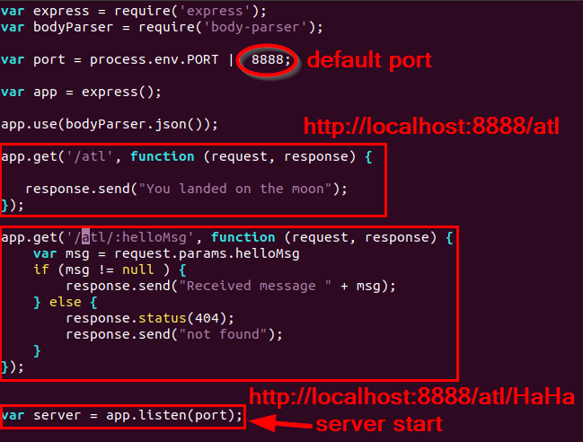

**Run and test the service**

Running the service – locally – is quite simple:

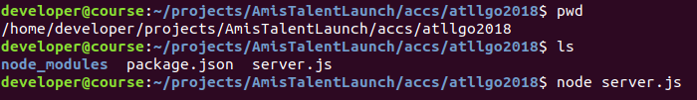

Testing can be done by pointing the local browser to:

* <http://localhost:8888/atl>
* <http://localhost:8888/atl/HiHo>

# Build the REST web service for the Oracle Application Container Cloud Service

We now want to run this REST web service that we built in NodeJS in the Oracle Application Container Cloud Service. In order to do so, we need to:

* Add a manifest.json
* Zip the complete service

**Add a manifest.json:**

The manifest.json file describes what ACCS has to do with the contents of the zip file. In our case, we will indicate that the nodejs runtime is of version 6, and what the command is that ACCS has to run on start of the service:

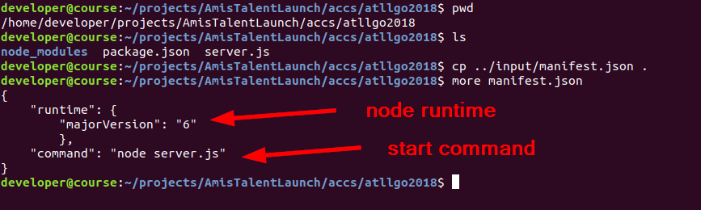

**Zip the complete service**

For deploying a service to ACCS, it has to be wrapped in a zip archive, with the manifest.json in the root of the zip file:

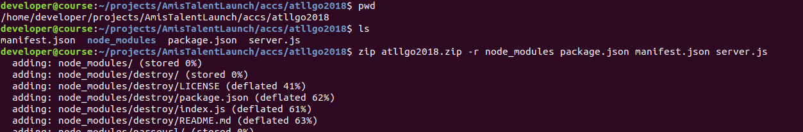

Resulting in a zip file:

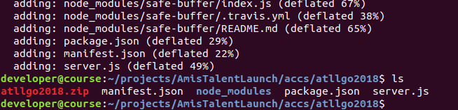

# Run the REST web service on the Oracle Application Container Cloud Service

It is assumed that you are logged in into the Oracle ACCS (shown at the start of this Lab):

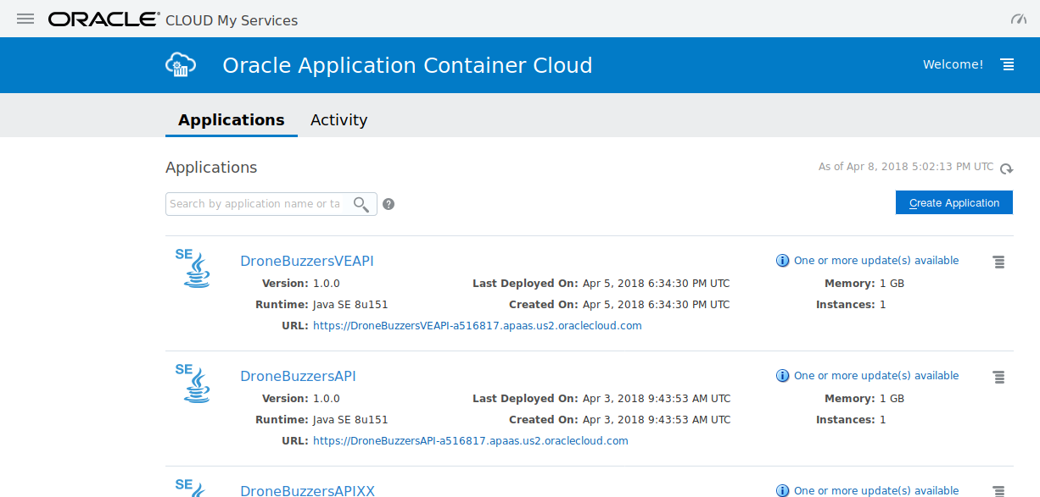

Now, click ‘Create Application’:

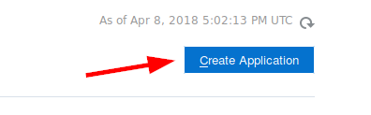

The resulting pop-up shows what different kinds of applications you can deploy on Oracle ACCS:

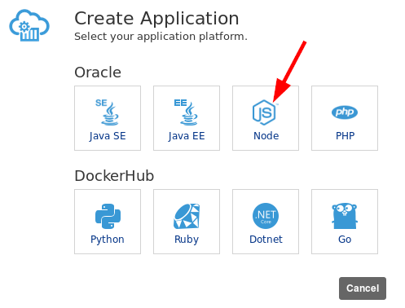

Click the NodeJS option. This results in a dialogue where you can give the details on your node application:

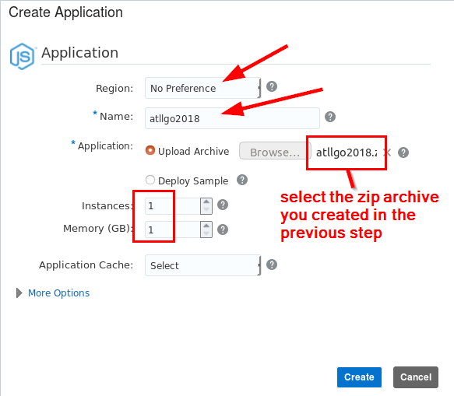

Click Create and exercise some patience… and then it shows:

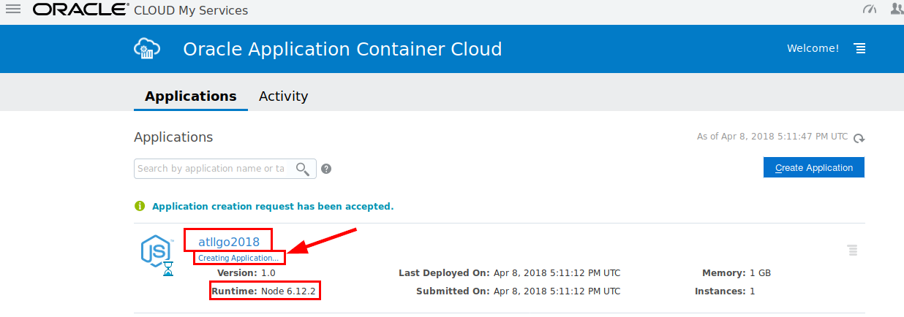

Click the application to go to the details:

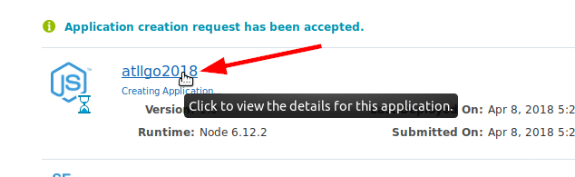

This will show:

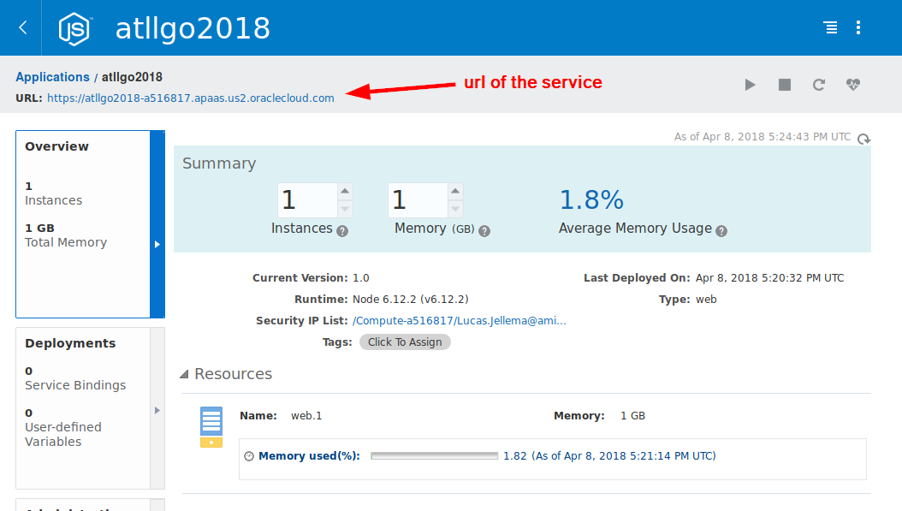

Now, the service can be tested:

* <https://atllgo2018-a516817.apaas.us2.oraclecloud.com/atl>
* <https://atllgo2018-a516817.apaas.us2.oraclecloud.com/atl/HoHo>