**Lab Event Hub Cloud Service - EHCS**

This lab covers the Event Hub Cloud Service.

# Introduction

In this lab, you will:

* Create a (kafka) Topic in the Event Hub Cloud Service
* Create a message producer and consumer in NodeJS
* Update the producer and consumer code
* Run the producer and consumer

The clients will be made on a VirtualBox image that will be distributed.

Note that there are a lot of articles on <https://technology.amis.nl> on this topic, e.g.: Input: <https://technology.amis.nl/2017/02/09/nodejs-publish-messages-to-apache-kafka-topic-with-random-delays-to-generate-sample-events-based-on-records-in-csv-file/>

# Login

Log in into Event Hub Cloud Service, using the following information:

* Identity domain: a516817
* Username: [lucas.jellema@amis.nl](mailto:lucas.jellema@amis.nl)
* Password: <to be provided>

Console for managing Kafka Topics:

<https://psm.us.oraclecloud.com/psmui/faces/paasRunner.jspx?serviceType=OEHCS>

# Create a Topic

After logging in the screen will look like:

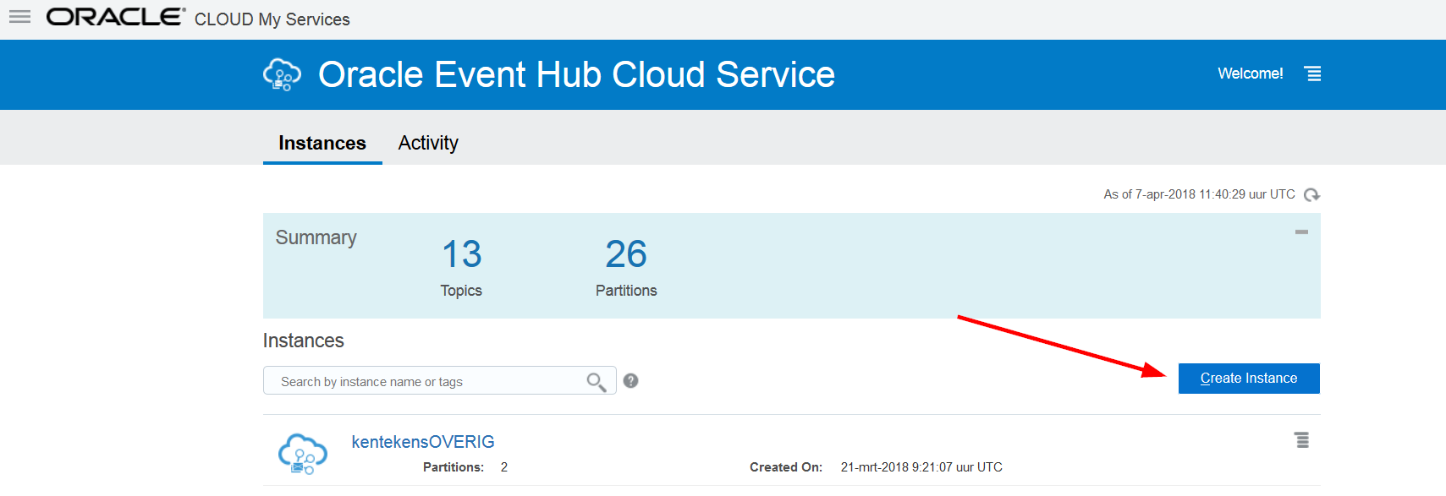

You are now in the Oracle Event Hub instance console.

Click ‘Create Instance’ to start creating a Kafka Topic:

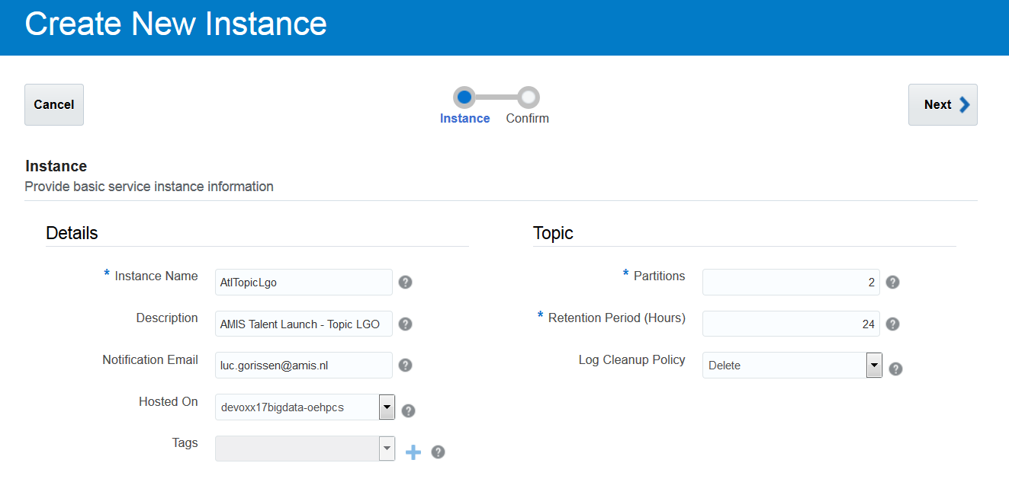

Click Next:

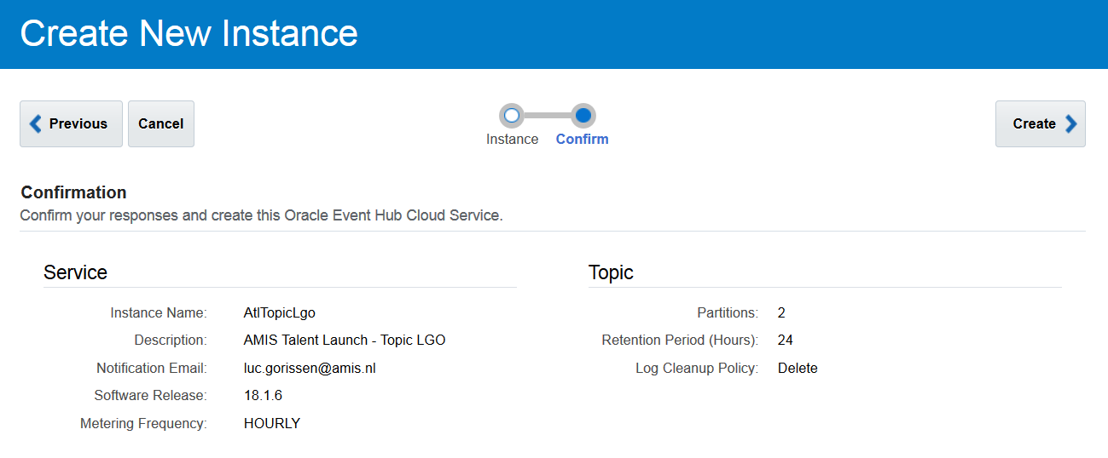

And click Create

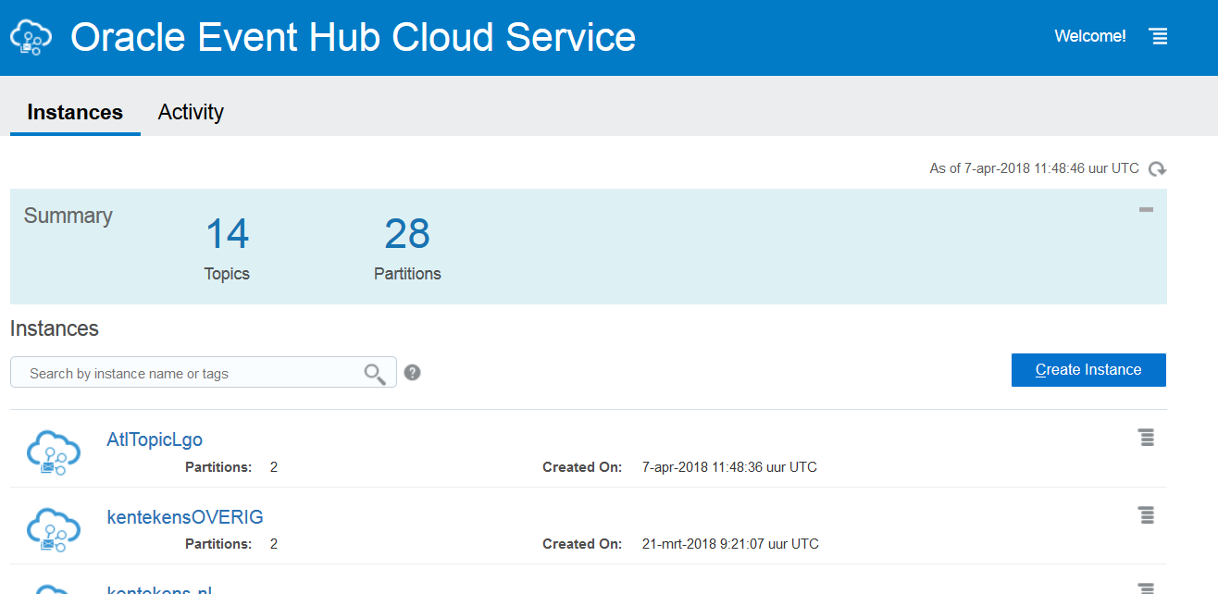

The Topic is there …

# Create a message producer and consumer in NodeJS

The message producer and consumer are both NodeJS applications. We will first:

* Create the Node project directory
* Add Kafka support for the Node project
* Include the producer and consumer js source files

**Create the appropriate Node project**

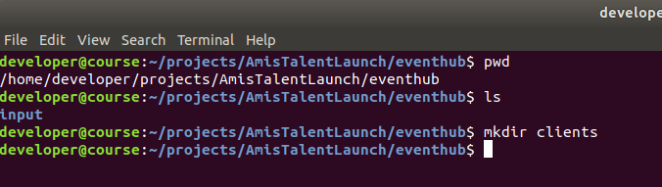

**Add Kafka support for the Node project**

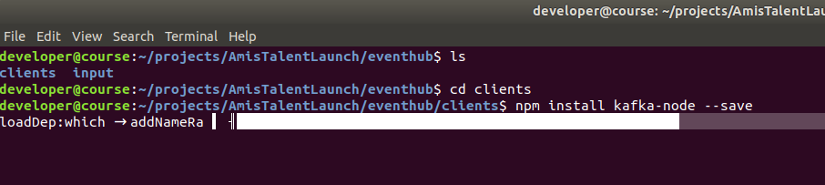

… ending with:

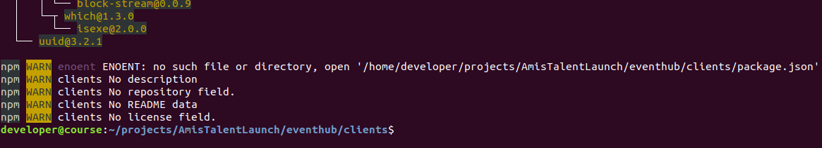

**Include the producer and consumer js source files**

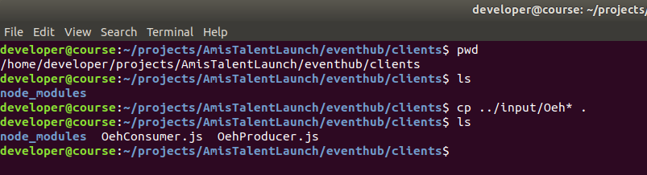

# Update the producer code

Examine the producer code to understand:

**Oracle Event Hub configuration settings**



**The initialization mechanism for the Kafka Producer**

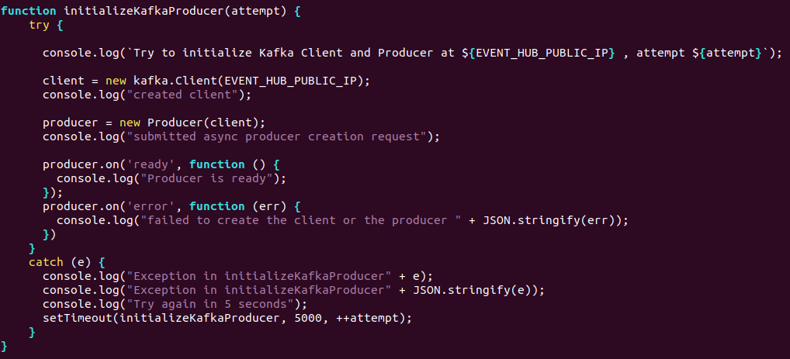

**The Event publisher**

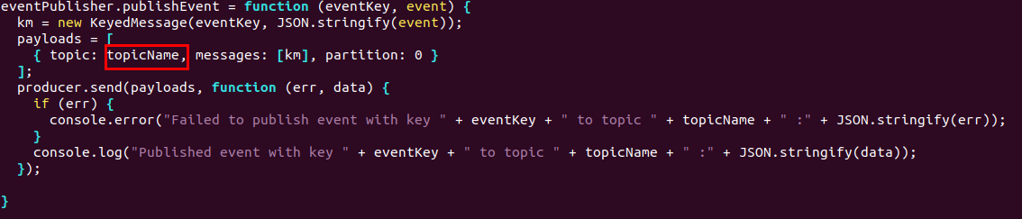

**The main code**

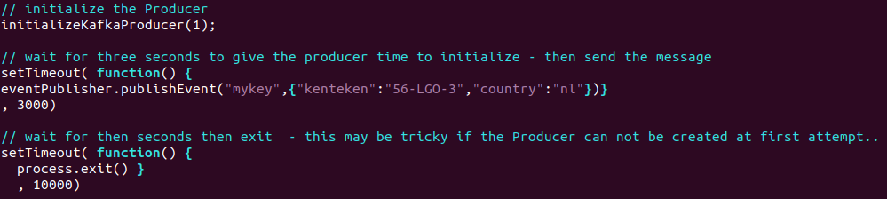

# Update the consumer code

Examine the consumer code to understand:

**Oracle Event Hub configuration settings**



**The eventListenerAPI**

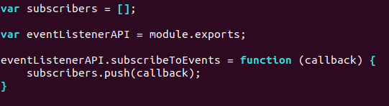

**Add a subcriber**

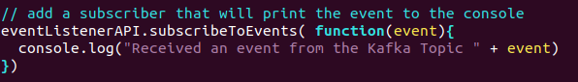

**The consumer options**

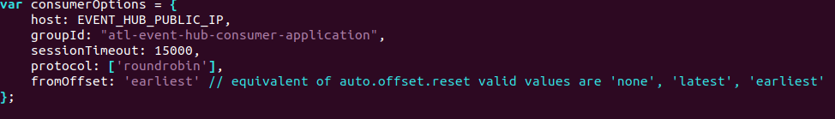

**The Kafka consumer group – esp the onMessage**

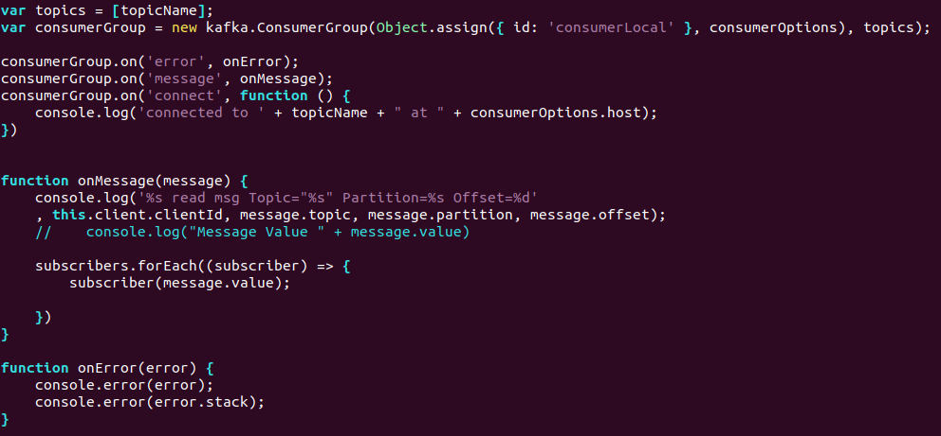

**How to handle a message**

**Closing the application**

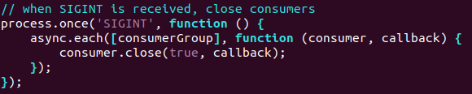

# Run the producer and consumer

The producer:

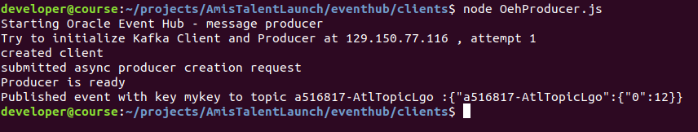

The consumer:

