User Interface – Only the parent nodes are displayed by default
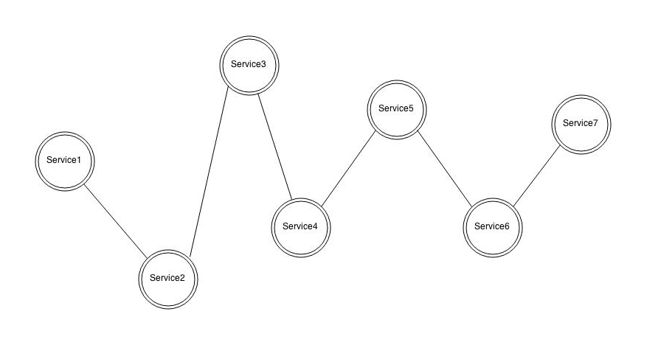
User Interface (On Hover) – Children nodes of Service hovered over with mouse are displayed
(a click can select one or more nodes so users can request more information about that service or services)
