Services – From the Database To The Screen

The display of services and their data is the linchpin for our whole website. They are used to populate the graph of nodes that is the focus of the site and primary point of intrigue for users. Services contain information that is used to drive the behavior of the graph, to be displayed to the user, and to be adjusted by the site administrator whenever they see fit.

Services on the Service Side

As far as a user is concerned, a service consists of a name, description, and an icon. Under the hood, a service also includes a list of its connected services, an option to determine its select-ability, and others. A class, called the service model, is used to contain this information. This service model is translated using Entity Framework into a relational model to save data to the database.

The C# service model is shown below.

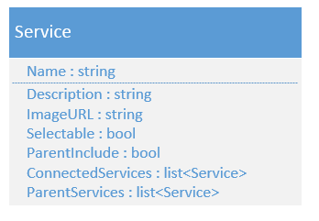
ParentInclude and ParentServices are not currently used. ParentInclude exists for scenarios where when in node form and a service is selected by user, it optionally would select its parent nodes automatically. ParentServices would contain all of the service's parents. This is different than ConnectedServices in that it only lists the nodes that are higher in the node hierarchy. ConnectedServices lists any and all services connected.

Services on the Client Side

When passed from the server to the client, services take on a slightly different form. A few extra properties are added to each service, such as selected, color, and shape and label. The id of the service, which is an auto-generated key created by the database, is passed as the name. The original human readable name is passed as the label. Selected determines whether or not the user has selected that service. The label (human readable name) is what is displayed on the node and wherever the name is needed. Color and shape are used to style the nodes on-screen.

The Javascript service object is shown below.

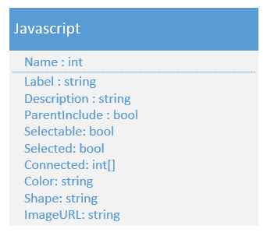

A collection of these objects is stored for use in both arbor to populate the nodes, and the javascript that drives the sidebars. These nodes are not persistent. Based on various conditions, the node graph is algorithmically constructed and services from the list are inserted as nodes in the graph. These nodes are also removed when they are not needed. This is why the list of services is needed.

The service nodes contain the same information as the services stored in the list, aside from special data that is needed to drive the behavior of the graph. Their structure is a little different to accommodate the graph's functionality, so a slight conversion is needed. Aside from the name, the graph stores the rest of the properties in a data object within the node. Accessing node x's selected property would be done by x.data.name, whereas service y in the list would have the selected property accessed by y.name.

The graph system also stores other data in nodes, but they are specific to arbor and will not be described here.

