Software Requirement Specification

for

JCNEx
Java Contract Number Extractor

Version 1.0

Prepared by team “Bration”

15-08-2015

Revision History

Name | Date | Reason for Changes | Version
First release | 15-08-2015 | Initial release | 1.00
First release | 19-08-2015 | Added mockups and description of Login screen functionality | 1.01

Table of Contents
Revision History 1
Introduction 3
Purpose 3
Document Conventions 3
Project Scope 3
References 3
Overall Description 4
Product Perspective 4
Product Features 4
User Classes and Characteristics 4
Operating Environment 4
Specific Requirements 5
Input file requirements 5
Output file requirements 5
User interface requirements 6
Start process screen 6
Prompt messages requirements 6
Functional Requirements 7
Use case related to select an input file: 7

Introduction

Purpose
In this document are specified the software requirements for JCNEx, Java based system that extract contract number from XML file. This documents includes functional, non-functional requirements and use cases for all features.

Document Conventions
This document was created when the JCNEx was in development process, so all requirements described in the document are already satisfied. However, it is important to update this document with every future requirement to stay informed. This document is intended for both the stakeholders and the developers of the system

Project Scope

JCNEx is a JAVA based application for parsing, analyzing and extract Contract number form each company invoice received using XML file format. The JCNEx read the XML input file (invoice.xml), and to process it to look for specific tags POnumber which contain specific Contract number which need to be extracted in a new tag, for better used. This approach gives an output file with POnumber and Contract number, which can be used to create the report document with full information about clients and companies.

References
IEEE 830-1998 standard for writing SRS document.

Overall Description

Product Perspective
JCNEx is specifically designed for to use from company or institutions which use digital document exchange.
The JCNEx application is composed of user friendly interface which consist a login screen and executing element which process the input file and present a result in a file structure.
User interface

Input Files
Analyzing, parsing and extracting
Output Files

Product Features
The following list offers a brief outline and description of the main features and functionalities of the JCNEx.
Main Features:
- Extract Contract number from PO number of invoice xml file
- Analyze xml document for data which are not meet the specification
- Create an input file with splitted Convert and PO numbers in different tags.

User Classes and Characteristics
JCNEx can be used from developers that want to incorporate it to their applications or to used it as a base to build an application. The simplicity of using JCNEX makes it easy to use to anyone that wants to take advantage of the XML file parser or extractor.
It can be used also from companies and institutions which already have a digital document exchange process using XML files.

Operating Environment
JCNEx has written in Java so is compatible with all the operating systems i.e. is OS platform independent. It only need jvm. (java virtual machine).

Specific Requirements

Input file requirements
For input file, JCNEx will use a single XML file, invoices.xml. This file consists of many similar XML trees. It has a document root, <invoices>, which can contain one or more instances of the <invoice> element. One of the internel elemnt need to be PO number <PONumber> which contain a Contract number which is mark with “-” and can be extract.
Sample input XML file structure is:
<Invoice>
<InvoiceNumber>INV001</InvoiceNumber>
<Date>2015/08/08</Date>
<PONumber>123456-CT123</PONumber>
<TotalNet>100.00</TotalNet>
<TotalVAT>20.00</TotalVAT>
<TotalGross>120.00</TotalGross>
</Invoice>
If some of these requirements are not exist in input file it should be rejected.

Output file requirements
The Output file should be contain the same structure of Input file with additional Contract number which extract from PONumber and add into tag Contract (<Contract>).
Samle output XML file structure is:
<Invoice>
<InvoiceNumber>INV001</InvoiceNumber>
<Date>2015/08/08</Date>
<PONumber>123456</PONumber>
<Contract>CT123</Contract><TotalNet>100.00</TotalNet>
<TotalVAT>20.00</TotalVAT>
<TotalGross>120.00</TotalGross>
</Invoice>

User interface requirements

Login screen
Login screen is the first screen, which is resent when the JCNEx is started. On this screen user should be enter its username and password to identify itself into the system. The login screen looks:

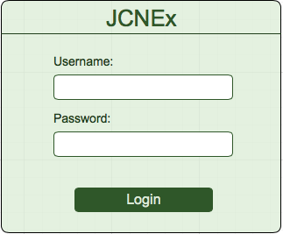

Start process screen
JCNEx have a sample graphical interface, which help user to select the input file and folder where output file should be saved.
It contains:
Input file field and browse button to choose the file.
Output file field and browse button to choose the location folder of output file.
Submit button to start processing.
In next screen is present a mockups of the interface:
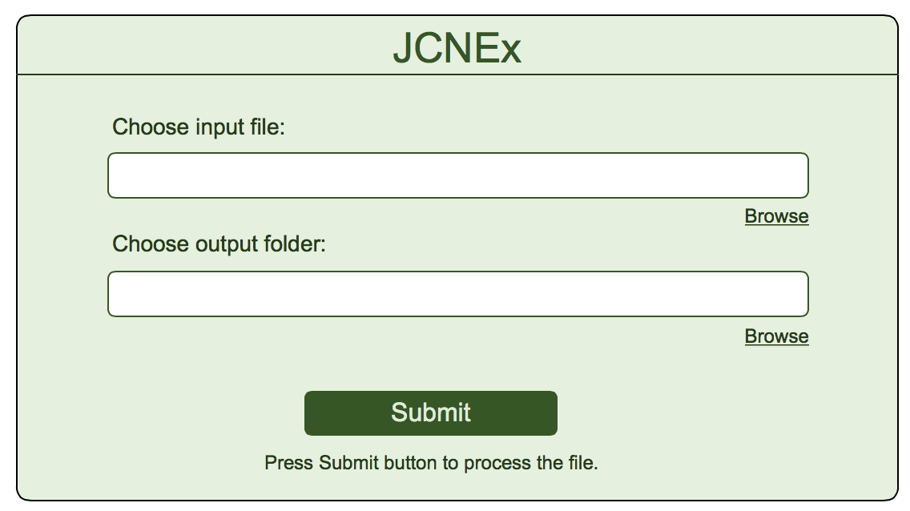

Prompt messages requirements
Ever process of selected file complete with the promt message which present if the process is complete successfully or the file is incorrect and hava some Error.
The prompt messages are:
- Complete process successfully:
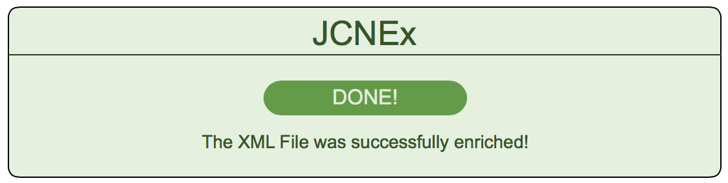

- Input file is incorrect:
  - If the PONumber tag is not exist in input file.
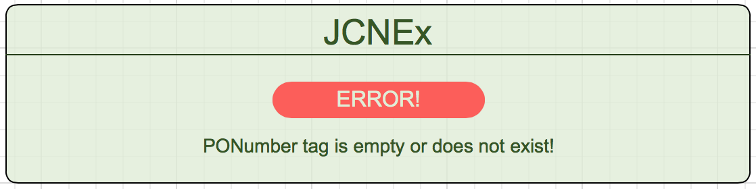

  - If the “-” is not exits in POnumber
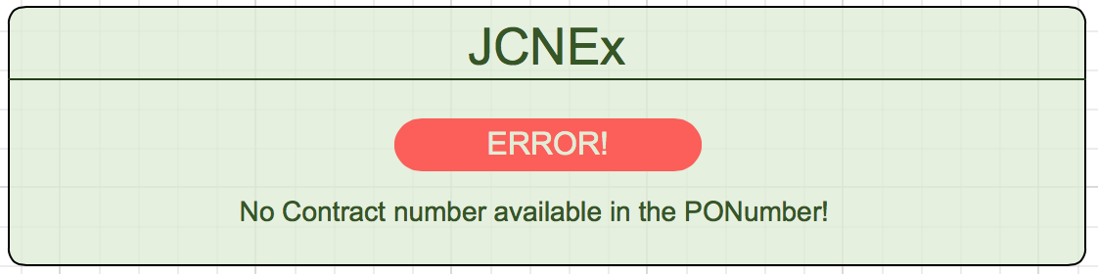

Functional Requirements
We describe the functional requirements by giving various use cases.

Use case related to select an input file:
Use Case 1: Select an input file
Primary Actor: User
Pre Condition: Application is start and prompt window to choose file is released
Main Scenario:
- Press the Browse button.
- Standard Open screen is displayed.
- User choose the input file with is in .xml format
- Press OK
Result: The name and location path is displayed in input file field on Choose file application screen.

Alternative Scenario:
3a) Choose the input file which is not .xml file
3a) 1. Press OK
Result: Prompt message displayed that file format is invalid.

Use Case 2: Select a correct input file
Primary Actor: User
Pre Condition: Application is start and prompt window to choose file is released
Main Scenario:
- Press the Browse button.
- Standard Open screen is displayed.
- User choose the input file with correct .xml structure
- Press Submit button
Result: The process is complete successfully the Prompt message appeared and display “The XML file is successfully enriched.”

Use Case 3: Select an incorrect input file
Primary Actor: User
Pre Condition: Application is start and prompt window to choose file is released
Main Scenario:
- Press the Browse button.
- Standard Open screen is displayed.
- User choose the input file which PONumber tag is missing;
- Press Submit button
Result: The process is complete and Prompt message appeared with Error message “PONumber tag is empty or not exist”

Use Case 4: Select an incorrect input file
Primary Actor: User
Pre Condition: Application is start and prompt window to choose file is released
Main Scenario:
- Press the Browse button.
- Standard Open screen is displayed.
- User choose the input file which PONumber not include a “-” delimiter;
- Press Submit button
Result: The process is complete and Prompt message appeared with Error message “No Contract number available in PONumber”

