Software Requirement Specification

for

JCNEx
Java Contract Number Extractor

Version 1.0

Prepared by team “Bration”

15-08-2015

Revision History

Name | Date | Reason for Changes | Version
First release | 08-08-2015 | Initial version | 1.00
Update | 10-08-2015 | Mockups and description of Login screen functionality were added | 1.01
Update | 12-08-2015 | Use cases were added | 1.03
Update | 14-08-2015 | Use cases were added | 1.04
Final release | 16-08-2015 | Final release of the document | 1.05

Table of Contents
Revision History 2
Introduction 4
Purpose 4
Document Conventions 4
Project Scope 4
Definitions, acronyms and abbreviations 5
References 5
Product Perspective 6
Product Functions 7
User Classes and Characteristics 7
Operating Environment 8
Technologies Overview 8
Specific Requirements 9
Input file requirements 9
Output file requirements 9
User interface requirements 10
Functional Requirements (Use cases) 13
Performance Requirements: 17
Design Constraints: 17

Introduction

Purpose
In this document the software requirements for JCNEx (Java Contract Number extractor) are specified - Java based system that extracts contract number from XML file. This document includes functional, non-functional requirements and use cases for all features.

Document Conventions
This document was created before the process of developing the JCNEx, therefore all the requirements, described in the document, have to be verified with test plan. However, it is important to update this document with every future requirement in order to be up to date. This document is intended for both the stakeholders and the developers of the system.

Project Scope
JCNEx is a Web application based on JAVA which helps people to do analysis, parse or extract data form XML documents. In the initial version of the application a Contract number must be extracted from Invoices which are save in xml.
Users can choose and put their invoices into JCNex and take the processed files immediately. For more usability the JCBNEx provides the simple user Web interface which helps users to choose their files and locate where the result must be stored.
In addition, the application has a registration form which can be used if the user wants to put an additional information for themselves in the processed file.
In general, the JCNEx gets the XML input file (source.xml) selected form user, and process it. The processing of extract is to look for specific tags <POnumber> and extract a Contract number from it. This approach gives an output file with POnumber and Contract number, which can be used to create the report document with full information about clients and companies. Moreover, the output file can contain information about the user who process the file if it is registered in the system.

Definitions, acronyms and abbreviations

Term | Definitions
User | Someone who interacts with the applications
Client | Someone who registers in the system. It could be a company or an individual person.
Web-Portal | An web application which presented in web browser with user interface
JCNEx | Java Contract Number Extractor
POnumber | Purchase order number
CT number | Contract number
Stakeholder | Any person who has interaction with the system who is not a developer
TAG | A unique, persistent identifier contained in a PLanguage statement using in XML documents
XML | EXtensible Markup Language

References
IEEE 830-1998 standard for writing SRS document.
JCNEx_test_plan

Product Perspective
This system consists of two parts: one web portal which presents user interface and JAVA based part which is processing the input files, also there is a data base where the data of registered users are stored.
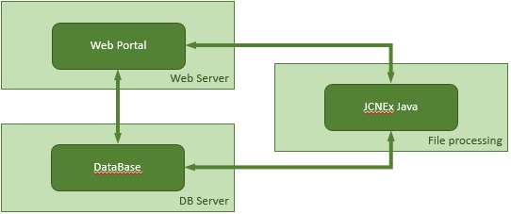

JCNEx Web portal helps the user to select their files which must be processed and send to JCNEx Java processing. The processed file is stored directly on user machine into specified location.
Since the JCNEx web portal have a registration and login functionality, it will need a place to store the data. For this purpose, a database will be used. Both the JCNEx Web and JCNEx Java communicate with the database. The Web portal will use the database to add and modify data. JCNEx Java uses the Database to add the user information into the processed file. All of the database communication will go over the Internet.
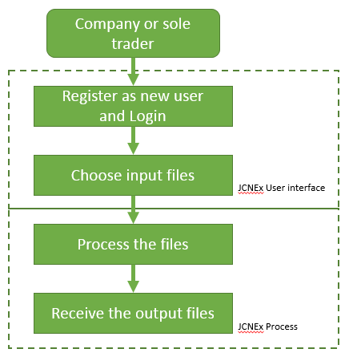
The general perspective is to help clients to use this system to extract a Contract number from their invoices. Every client can create an account in the system and use extractor mechanism.
The JCNEx application is composed of user friendly interface which consist of a login screen and executing element which processes the input files and present a result in the files structure.

Product Functions
With JCNEx the clients will be able to extract the Contract number from their files. The result will be stored directly on the client’s machine.
The application provides a functionality to extract the Contract number from existing PONumber of the invoices which have been created in specific XML Structure.
Main Features:
- Extract Contract number from PO number of invoice xml file
- Analyze xml document for data which does not meet the specification
- Create an input file with split Convert and PO numbers in different tags.
- Add client’s information into processed file.
Invoices – source.xml
PONumber CTN1256-BR0001

JCNEx

Output file
PONumber: CTN1256
Contract: BR0001

User Classes and Characteristics
JCNEx can be used from clients who want to modify their invoices or other XML documents with ease. The simplicity of using the JCNEX makes it easy for usage by anyone who wants to take the advantage of the XML file parser or extractor.
There are two login possibilities. Login as a registered user or as a guest. The registered user can receive their files with additional own info which is included in the output file, while the guest user does not have such rights.

Operating Environment
JCNEx is web and Java based application therefore is compatible with all the operating systems i.e. is OS platform independent. It only needs Internet Browser and Java.
Recommended Java 6 or higher
Web browser:
Internet Explorer 9 or higher
Google Chrome 5.0 or higher
Firefox 5.0 or higher
Safari 5.0 or higher

Technologies Overview
Application server : JBoss 4.2.1.GA
Java : JRE 1.6_03
JBOSS: AOP 1.5.5.GA
Persistence: JPA / hibernate 3, Javax Persistence 1.0, Oracle ojdbc 1.4
J2EE/JavaEE: EJB2.1, EJB3.0, Java Mail, Transactions, Xml Beans? 2.3, Javax Mail 1.4
View: JSP 2.1, Servlet 2.5, JSF 1.3, Rich Faces 3, Jquery 1.3.2, Seam 1.2
Imaging: Java Advanced Imaging 1.1.2, Java Advanced Imaging Codecs 1.1, tiffRenderer 0.9, Barcode4J 1.0

Specific Requirements
This section contains all of the functional and quality requirements of the system. It gives a detailed description of the system and all its features.

Input file requirements
For the input file, JCNEx will use a single XML file, invoices.xml. This file consists of many similar XML trees. It has a document root, <invoices>, which can contain one or more instances of the <invoice> element. One of the internal element should be PO number <PONumber> which contains a Contract number which is marked with “-” before it and must be extracted.
Sample input XML file structure is:
<Invoice>
<InvoiceNumber>INV001</InvoiceNumber>
<Date>2015/08/08</Date>
<PONumber>CTN1256-BR0001</PONumber>
<TotalNet>100.00</TotalNet>
<TotalVAT>20.00</TotalVAT>
<TotalGross>120.00</TotalGross>
</Invoice>
If some of these requirements does not exist, the input file must be rejected.

Output file requirements
The Output file must contain structure similar to the Input file but with the additional Contract number which extracts from PONumber and adds into tag Contract (<Contract>).
Samle output XML file structure is:
<Invoice>
<InvoiceNumber>INV001</InvoiceNumber>
<Date>2015/08/08</Date>
<PONumber>CTN1256</PONumber>
<Contract>BR0001</Contract>
<TotalNet>100.00</TotalNet>
<TotalVAT>20.00</TotalVAT>
<TotalGross>120.00</TotalGross>
</Invoice>

User interface requirements

Login screen
The Login screen is the first screen, which is presented when the JCNEx is started. On this screen, in order the clients to login they must enter their username and password to identify themselves into the system.
The user can login as a guest or as a registered user. If he/she does not have an account, he/she should register a new one.

The view of the login screen is:

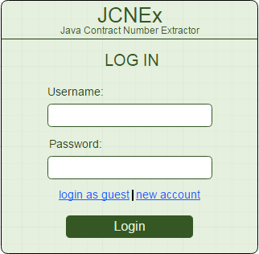

New user registration screen

If the client wants to add and additional information for themselves into the processed file he/she has to login as a registered user until the system gets their information and puts it into the output file.

The view of the registration form screen is:

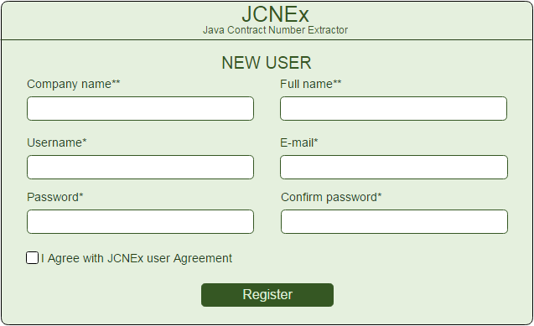

“Choose file” - screen
JCNEx has a sample graphical interface, which helps user to select the input file or files and folder where the output file should be stored.
The view of the screen is:
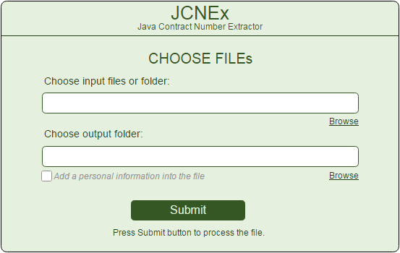

Registered users can set if the personal info is added into the output file or not with marking the option “Add personal information into the file”.

Processing
If the user chooses more files, the extract process may take a lot of time, therefore the interface needs to present a processing screen which view is:

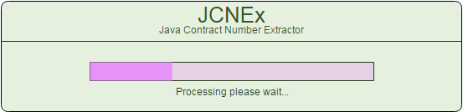

Prompt messages requirements
Every process of selected file finishes with a prompt message, which presents if the process is complete successfully or the file is incorrect and have some error.
The prompt messages are:
- Complete process successfully:
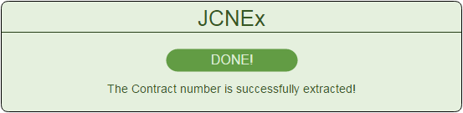

- Input file is incorrect:
  - If the PONumber tag does not exist in the input file.
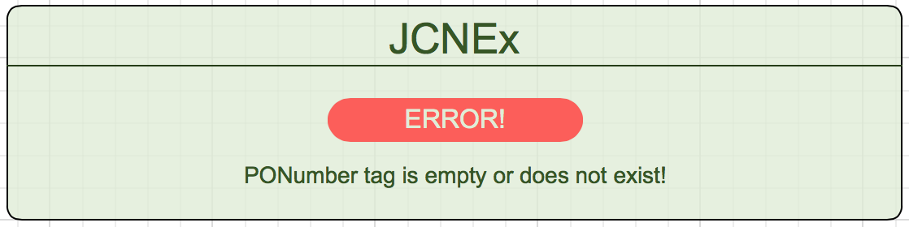

  - If the “-” does not exist in the POnumber
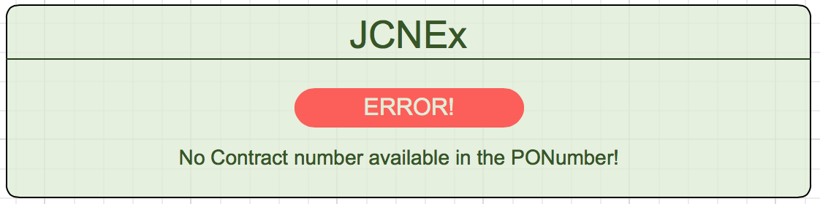

Functional Requirements (Use cases)
Functional requirements capture the intended behavior of the system. This behavior may be expressed as services, tasks or functions the system is required to perform

We describe the functional requirements by giving various use cases.

Use cases related to login the system.

ID: FR-1.001
Title: Register a new account
Primary Actor: User
Precondition: user is not register in the system
Main scenario:
1. Go to www.jcnex.com
2. Press the “New account” button
3. User fills all mandatory fields with correct information
4. Press the Register button
Result. The User is registered successfully
Alternative Scenario-01: The user chooses already registered user name
Alternative Result-01: The system displays an error message that the username is already registered.
Alternative Scenario-02: The user chooses already registered e-mail
Alternative Result-02: The system displays an error message that the e-mail is already registered.
Alternative Scenario-03: The user enters not allowed symbols in the user name or password
Alternative Result-03: The system displays an error message that symbols into username and password are not allowed.

ID: FR-1.002
Title: Login as guest
Primary Actor: User
Precondition: user is not register in the system
Main scenario:
1. Go to www.jcnex.com
2. Press the “Login as guest” button
Result. The User is redirected to “Choose file” screen

ID: FR-1.003
Title: Login as registered user
Primary Actor: User
Precondition: User needs to register in the system (see FR-001)
Main scenario:
1. Go to www.jcnex.com
2. Enter a correct user name
3. Enter a correct password
4. Press “Login” button
Result. The user has access to the system and is able to choose files to be processing.
Alternative Scenario - 001: The user enters a wrong username
Alternative Scenario Result – 001: The system displays an error message that the username or password is wrong.
Alternative Scenario - 002: The user enters a wrong password
Alternative Scenario Result – 002: The system displays an error message that the username or password is wrong.

Use case related to select an input file and output folder:
ID: FR-2.001
Title: Choose a correct input file
Primary Actor: User
Pre-Condition: User has logged in with their own account or as a guest
Main Scenario:
- Press the Browse button on input field.
- Standard Open window is displayed.
- User chooses the file which he/she wants to be processed
- Press OK
Result. The name and location path of the file is displayed in input field. The output field is filled with the path of the folder of the selected file.
Alternative Scenario: The user chooses an unsupported file format
Alternative Scenario Result: The system displays an error message that selected file is not supported.

ID: FR-2.002
Title: Choose an input folder
Primary Actor: User
Pre-Condition: User has logged in with their own account or as a guest
Main Scenario:
- Press the Browse button on input field.
- Standard Open window is displayed.
- User chooses the folder where the files, which wants to be processed, are stored
- Press OK
Result. The name and location path of the folder is displayed into the field. The output field is filled with the same path.
Alternative Scenario - 001: The user select an empty folder
Alternative Scenario Result - 001: The system displays an error message that selected folder is empty.
Alternative Scenario - 002: The user selects a folder which contains unsupported file formats
Alternative Scenario Result - 002: The system displays an error message that selected folder contains unsupported file formats.

ID: FR-2.003
Title: Choose a multiple files
Primary Actor: User
Pre-Condition: User has logged in with their own account or as a guest
Main Scenario:
- Press the Browse button on input field.
- Standard Open window is displayed.
- User chooses more than one file using Ctrl+ select or Shift+ select button
- Press OK
Result: The names of selected files are displayed into the field with “;” delimiter. The output field is filled with the path of the folder of the selected files.
Alternative Scenario - 001: The user selects some files which are not supported
Alternative Scenario Result - 001: The system displays an error message that selected files are not supported.

ID: FR-2.004
Title: Choose a output folder
Primary Actor: User
Pre-Condition: User has logged in with their own account or as a guest
Main Scenario:
- Press the Browse button on input field.
- Standard Open window is displayed.
- Choose one or more files
- Press OK
- Press the Browse button on output field
- Standard Open window is displayed.
- Choose the folder where the processed files will be saved.
- Press OK
Result: The path of the selected folder is filled into output field

Use case related to processing the selected files:
ID: FR-3.001
Title: Process the correct input file as a guest
Primary Actor: User
Pre-Condition: User has logged in as a guest
Main Scenario:
- Select the correct input file.
- Select the folder where the file should be saved.
- Press Submit button
Result:. The process is complete successfully, the Prompt message appears and displays “The Contract number is successfully extracted!”
Alternative Scenario: The user chooses a folder which is with read-only permissions
Alternative Scenario Result: The system displays an error that the file cannot be saved.

ID: FR-3.002
Title: Process the incorrect input file as guest
Primary Actor: User
Pre-Condition: User has logged in as a guest
Main Scenario:
- Select the incorrect input file. File which PONumber not include a “-” delimiter
- Select the folder where the file should be saved
- Press Submit button
Result: The process is complete and Prompt message appears with error message. “No Contract number available in PONumber”

ID: FR-3.003
Title: Process the incorrect input file as a guest
Primary Actor: User
Pre-Condition: User logins as a guest
Main Scenario:
- Select the incorrect input file. File which PONumber tag is missing
- Select the folder where the file should be saved.
- Press Submit button
Result: The process is complete and Prompt message appears with error message. “PONumber tag is empty or does not exist!”

ID: FR-3.004
Title: Process the multiple files as guest
Primary Actor: User
Pre-Condition: User has logged in as a guest
Main Scenario:
- Select the correct input files.
- Select the folder where the file should be saved.
- Press Submit button
Result: The process screen is displayed and shows the progress of processing.
Alternative Scenario: The user chooses less than 10 files
Alternative Scenario Result: The system processes the files fast and does not display the progress screen.

ID: FR-3.005
Title: Process the file and add personal information into the file
Primary Actor: User
Pre-Condition: User has logged in as a registered user
Main Scenario:
- Select the correct input files.
- Select the folder where the file should be saved.
- Mark the option “Add personal information into the file”
- Press Submit button
Result:. The file has been processed successfully. The output file contains the information of the login user.

Performance Requirements:

Server Hardware Requirements
Minimum hardware requirements:
CPU: 2 x Intel Core 2 (2.66 Ghz, 128K cache)
RAM: 2GB
Minimum database space: 10GB

Process performance Requirements
90% of the responses should be within 2 sec.
The process of the files should be:
 | Concurrent users | Number of files | Processing time (ms)
1 | 5 users | 50 | 500
2 | 25 userrs | 100 | 1000
3 | >100 | 10000 | 5000

Design Constraints:

Security
The files in which the information regarding securities and portfolios should be secured against malicious deformations.

Fault Tolerance
Data should not become corrupted in case of system crash or power failure.

