Software Requirement Specification

for

JCNEx
Java Contract Number Extractor

Version 1.0

Prepared by team “Bration”

15-08-2015

Revision History

Name | Date | Reason for Changes | Version
First release | 15-08-2015 | Initial version | 1.00
First release | 19-08-2015 | Added mockups and description of Login screen functionality | 1.01

Table of Contents
Revision History 1
Introduction 3
Purpose 3
Document Conventions 3
Project Scope 3
References 3
Overall Description 4
Product Perspective 4
Product Features 4
User Classes and Characteristics 4
Operating Environment 4
Specific Requirements 5
Input file requirements 5
Output file requirements 5
User interface requirements 6
Start process screen 6
Prompt messages requirements 6
Functional Requirements 7
Use case related to select an input file: 7

Introduction

Purpose
In this document are specified the software requirements for JCNEx (Java Contract Number extractor) Java based system that extract contract number from XML file. This document includes functional, non-functional requirements and use cases for all features.

Document Conventions
This document was created before development process of the JCNEx, so all requirements described in the document need to be verified with test plan. However, it is important to update this document with every future requirement to stay informed. This document is intended for both the stakeholders and the developers of the system.

Project Scope

JCNEx is a Web application based on JAVA which helps people to do analyze, parse or extract data form XML documents. In initial version the application should be extract a Contract number from Invoices which are save in xml.
Users can choose and put yours invoices into JCNex and take the processed files immediately. For more usability the JCBNEx provide the simple user Web interface which helps user to choose yours files and locate where the result should be placed.
Also the application have a registration form which can use if the user want to put an additional information for itself in the processed file.
In general the JCNEx get the XML input file (source.xml) selected form user, and process it. The processing of extract is to look for specific tags <POnumber> and extract a Contract number from it. This approach gives an output file with POnumber and Contract number, which can be used to create the report document with full information about clients and companies. In additional the output file can contain information about the user who process the file if it is register in the system.

Definitions, acronyms and abbreviations

Term | Definitions
User | Someone who interact with the applications
Client | Someone who register in the system It may be the Company or individual person.
Web-Portal | An web application which presented in web browser with user interface
JCNEx | Java Contract Number Extractor
POnumber | Purchase order number
CT number | Contract number
Stakeholder | Any person who has interaction with the system who is not a developer
TAG | A unique, persistent identifier contained in a PLanguage statement using in XML documents
XML | EXtensible Markup Language

References
IEEE 830-1998 standard for writing SRS document.
JCNEx_test_plan

Overall Description

Product Perspective
This system will consist a two parts: one web portal which present user interface and JAVA based part which processing the input files, also there is a data base where store the data of registered users.
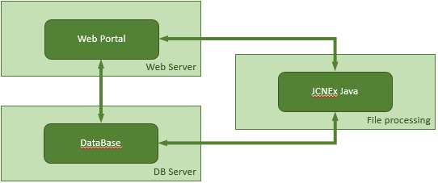

JCNEx Web portal helps to user to select yours filed wich should be processed and send to JCNEx Java processing. The processed file is saved directly on user machine into location which it specified.
Since the JCNEx web portal have a registration and login functionality it will need somewhere to store the data. For that, a database will be used. Both the JCNEx Web and JCNEx Java communicate with the database. The Web portal will use the database to add and modify data. JCNEx Java use the Databse to add a user information into the processed file. All of the database communication will go over the Internet.
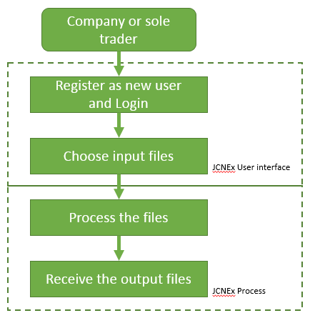
The general perspective is to help clients to use this system to extract a Contract number form your invoices. Every clients can create an account in the system and use extractor mechanism.
The JCNEx application is composed of user friendly interface which consist a login screen and executing element which process the input files and present a result in a files structure.

Product Functions

With JCNEx the clients will be able to extract the Contract number from its files. The result will saved directly on the client’s side.
The application provide functionality to Extract the Contract number form existing PONumber of the invoces wich are create in specific XML Structure.
Main Features:
- Extract Contract number from PO number of invoice xml file
- Analyze xml document for data which are not meet the specification
- Create an input file with splitted Convert and PO numbers in different tags.
- Add client information into proccessed file.
Invoices – source.xml
PONumber CTN1256-BR0001

JCNEx

Output file
PONumber: CTN1256
Contract: BR0001

User Classes and Characteristics
JCNEx can be used from clients wich want to easy modify its invoices or other XML documents. The simplicity of using JCNEX makes it easy to use to anyone that wants to take advantage of the XML file parser or extractor.
There are two login possibly. Login as register user or as guest. The register user can receive yours files with additional own info contain into the output file while the guest user is not.

Operating Environment
JCNEx is web and Java based application so is compatible with all the operating systems i.e. is OS platform independent. It only need Internet Browser and Java.
Recommended Java 6 or higher
Web browser:
Internet Explorer 9 or higher
Google Chrome 5.0 or higher
Firefox 5.0 or higher
Safari 5.0 or higher

Technologies Overview
Application server : JBoss 4.2.1.GA
Java : JRE 1.6_03
JBOSS: AOP 1.5.5.GA
Persistence: JPA / hibernate 3, Javax Persistence 1.0, Oracle ojdbc 1.4
J2EE/JavaEE: EJB2.1, EJB3.0, Java Mail, Transactions, Xml Beans? 2.3, Javax Mail 1.4
View: JSP 2.1, Servlet 2.5, JSF 1.3, Rich Faces 3, Jquery 1.3.2, Seam 1.2
Imaging: Java Advanced Imaging 1.1.2, Java Advanced Imaging Codecs 1.1, tiffRenderer 0.9, Barcode4J 1.0

Specific Requirements

This section contains all of the functional and quality requirements of the system. It gives a detailed description of the system and all its features.

Input file requirements
For input file, JCNEx will use a single XML file, invoices.xml. This file consists of many similar XML trees. It has a document root, <invoices>, which can contain one or more instances of the <invoice> element. One of the internal element should be PO number <PONumber> which contain a Contract number which is mark with “-” before it and must be extracted.
Sample input XML file structure is:
<Invoice>
<InvoiceNumber>INV001</InvoiceNumber>
<Date>2015/08/08</Date>
<PONumber>CTN1256-BR0001</PONumber>
<TotalNet>100.00</TotalNet>
<TotalVAT>20.00</TotalVAT>
<TotalGross>120.00</TotalGross>
</Invoice>
If some of these requirements are not exist the input file should be rejected.

Output file requirements
The Output file should be contain the same structure of Input file with additional Contract number which extract from PONumber and add into tag Contract (<Contract>).
Samle output XML file structure is:
<Invoice>
<InvoiceNumber>INV001</InvoiceNumber>
<Date>2015/08/08</Date>
<PONumber>CTN1256</PONumber>
<Contract>BR0001</Contract>
<TotalNet>100.00</TotalNet>
<TotalVAT>20.00</TotalVAT>
<TotalGross>120.00</TotalGross>
</Invoice>

User interface requirements

Login screen
Login screen is the first screen, which is present when the JCNEx is started. On this screen the clients can be login should be enter its username and password to identify itself into the system.
The login screen looks:

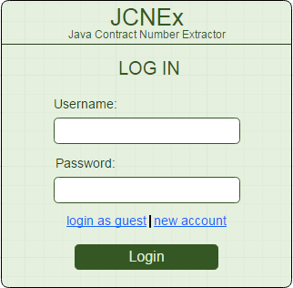

New user registration screen

If the client want to add and additional information for itself into the processed file it need to be login as register user, than the system get its information and put it into the output file.
The registration form screen looks:
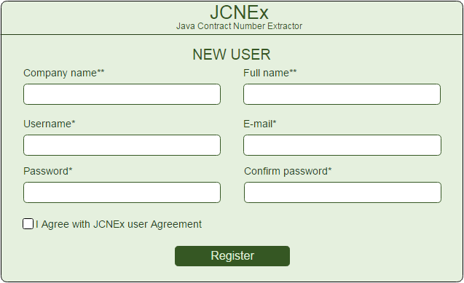

Start process screen
JCNEx have a sample graphical interface, which help user to select the input file and folder where output file should be saved.
It contains:
Input file field and browse button to choose the file.
Output file field and browse button to choose the location folder of output file.
Submit button to start processing.
In next screen is present a mockups of the interface:

Prompt messages requirements
Ever process of selected file complete with the promt message which present if the process is complete successfully or the file is incorrect and hava some Error.
The prompt messages are:
- Complete process successfully:
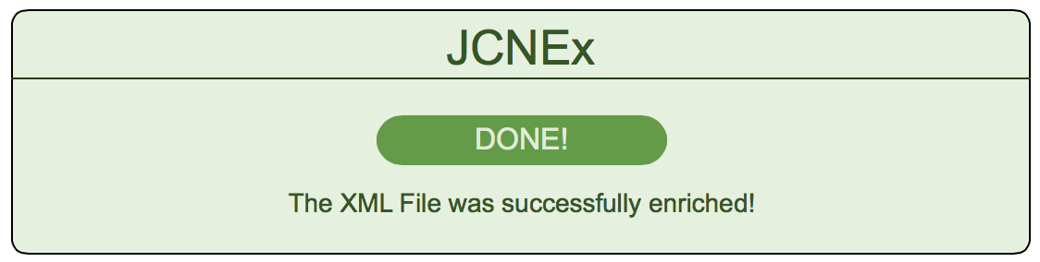

- Input file is incorrect:
  - If the PONumber tag is not exist in input file.
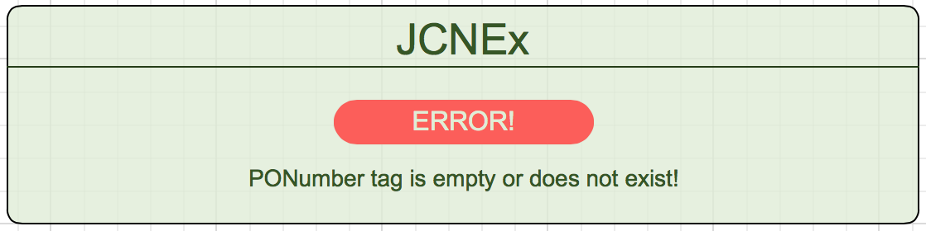

  - If the “-” is not exits in POnumber
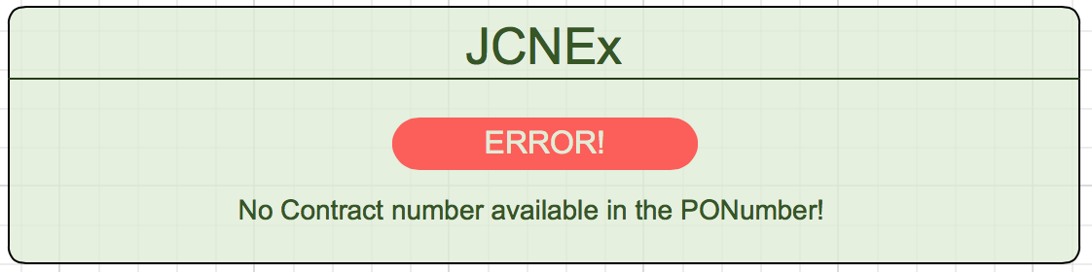

Functional Requirements
We describe the functional requirements by giving various use cases.

Use case related to select an input file:
Use Case 1: Select an input file
Primary Actor: User
Pre Condition: Application is start and prompt window to choose file is released
Main Scenario:
- Press the Browse button.
- Standard Open screen is displayed.
- User choose the input file with is in .xml format
- Press OK
Result: The name and location path is displayed in input file field on Choose file application screen.

Alternative Scenario:
3a) Choose the input file which is not .xml file
3a) 1. Press OK
Result: Prompt message displayed that file format is invalid.

Use Case 2: Select a correct input file
Primary Actor: User
Pre Condition: Application is start and prompt window to choose file is released
Main Scenario:
- Press the Browse button.
- Standard Open screen is displayed.
- User choose the input file with correct .xml structure
- Press Submit button
Result: The process is complete successfully the Prompt message appeared and display “The XML file is successfully enriched.”

Use Case 3: Select an incorrect input file
Primary Actor: User
Pre Condition: Application is start and prompt window to choose file is released
Main Scenario:
- Press the Browse button.
- Standard Open screen is displayed.
- User choose the input file which PONumber tag is missing;
- Press Submit button
Result: The process is complete and Prompt message appeared with Error message “PONumber tag is empty or not exist”

Use Case 4: Select an incorrect input file
Primary Actor: User
Pre Condition: Application is start and prompt window to choose file is released
Main Scenario:
- Press the Browse button.
- Standard Open screen is displayed.
- User choose the input file which PONumber not include a “-” delimiter;
- Press Submit button
Result: The process is complete and Prompt message appeared with Error message “No Contract number available in PONumber”

