Finalised AI Sentiment Scores
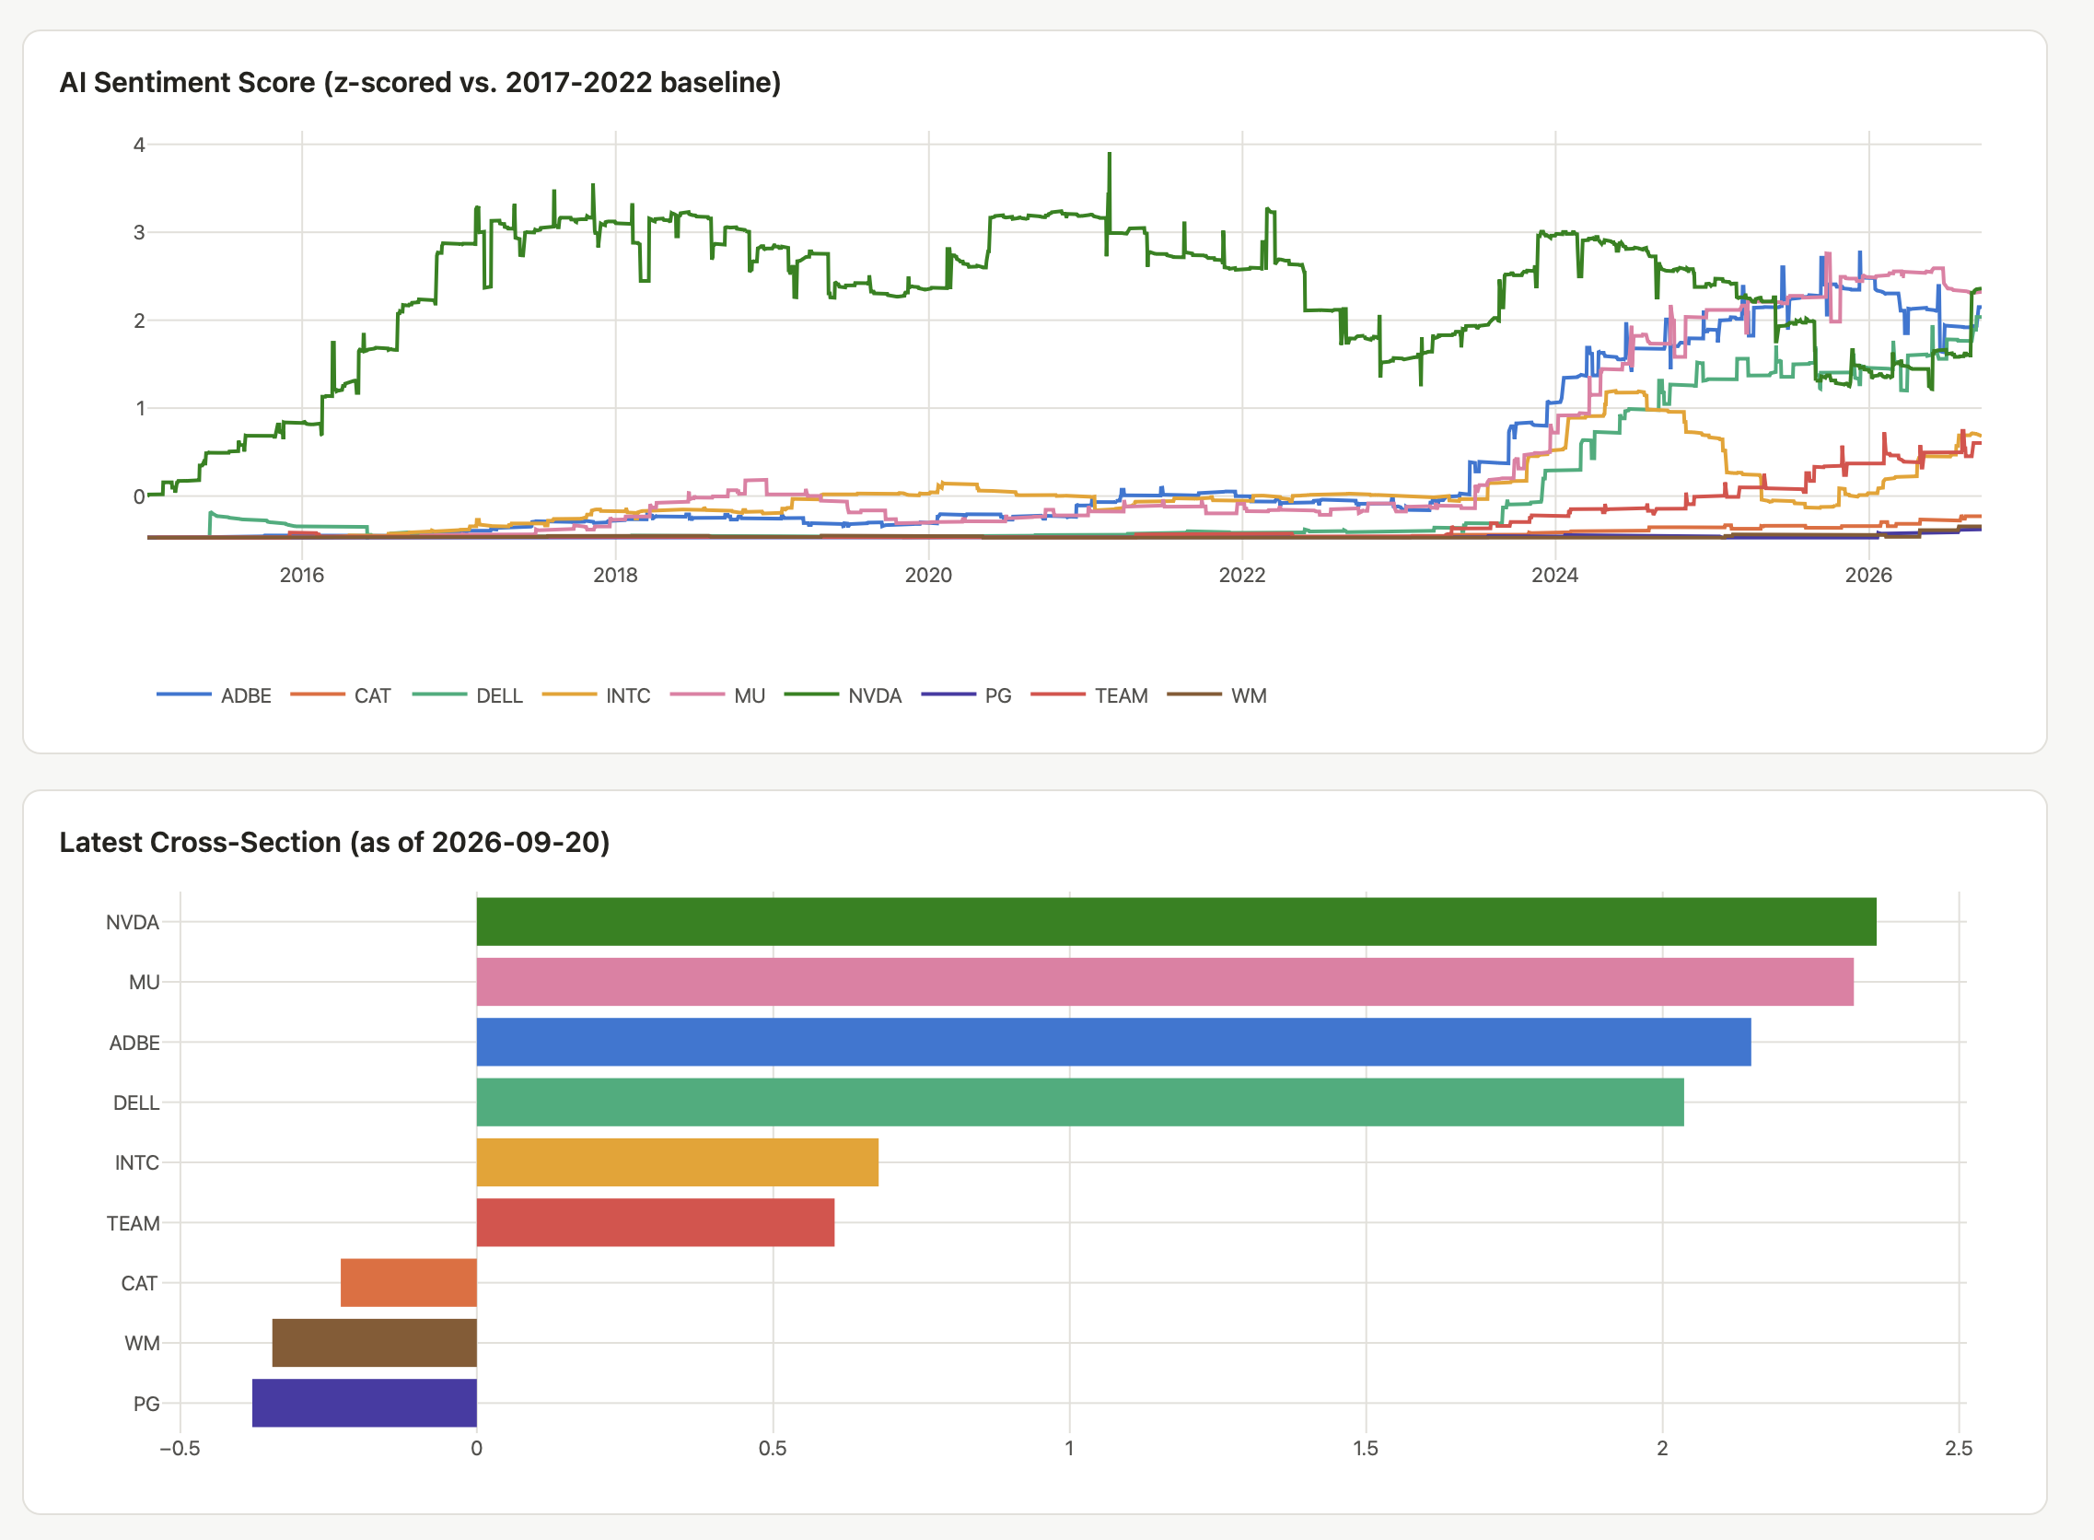
Finalised AI Factor betas Vs AI Sentiment Scores
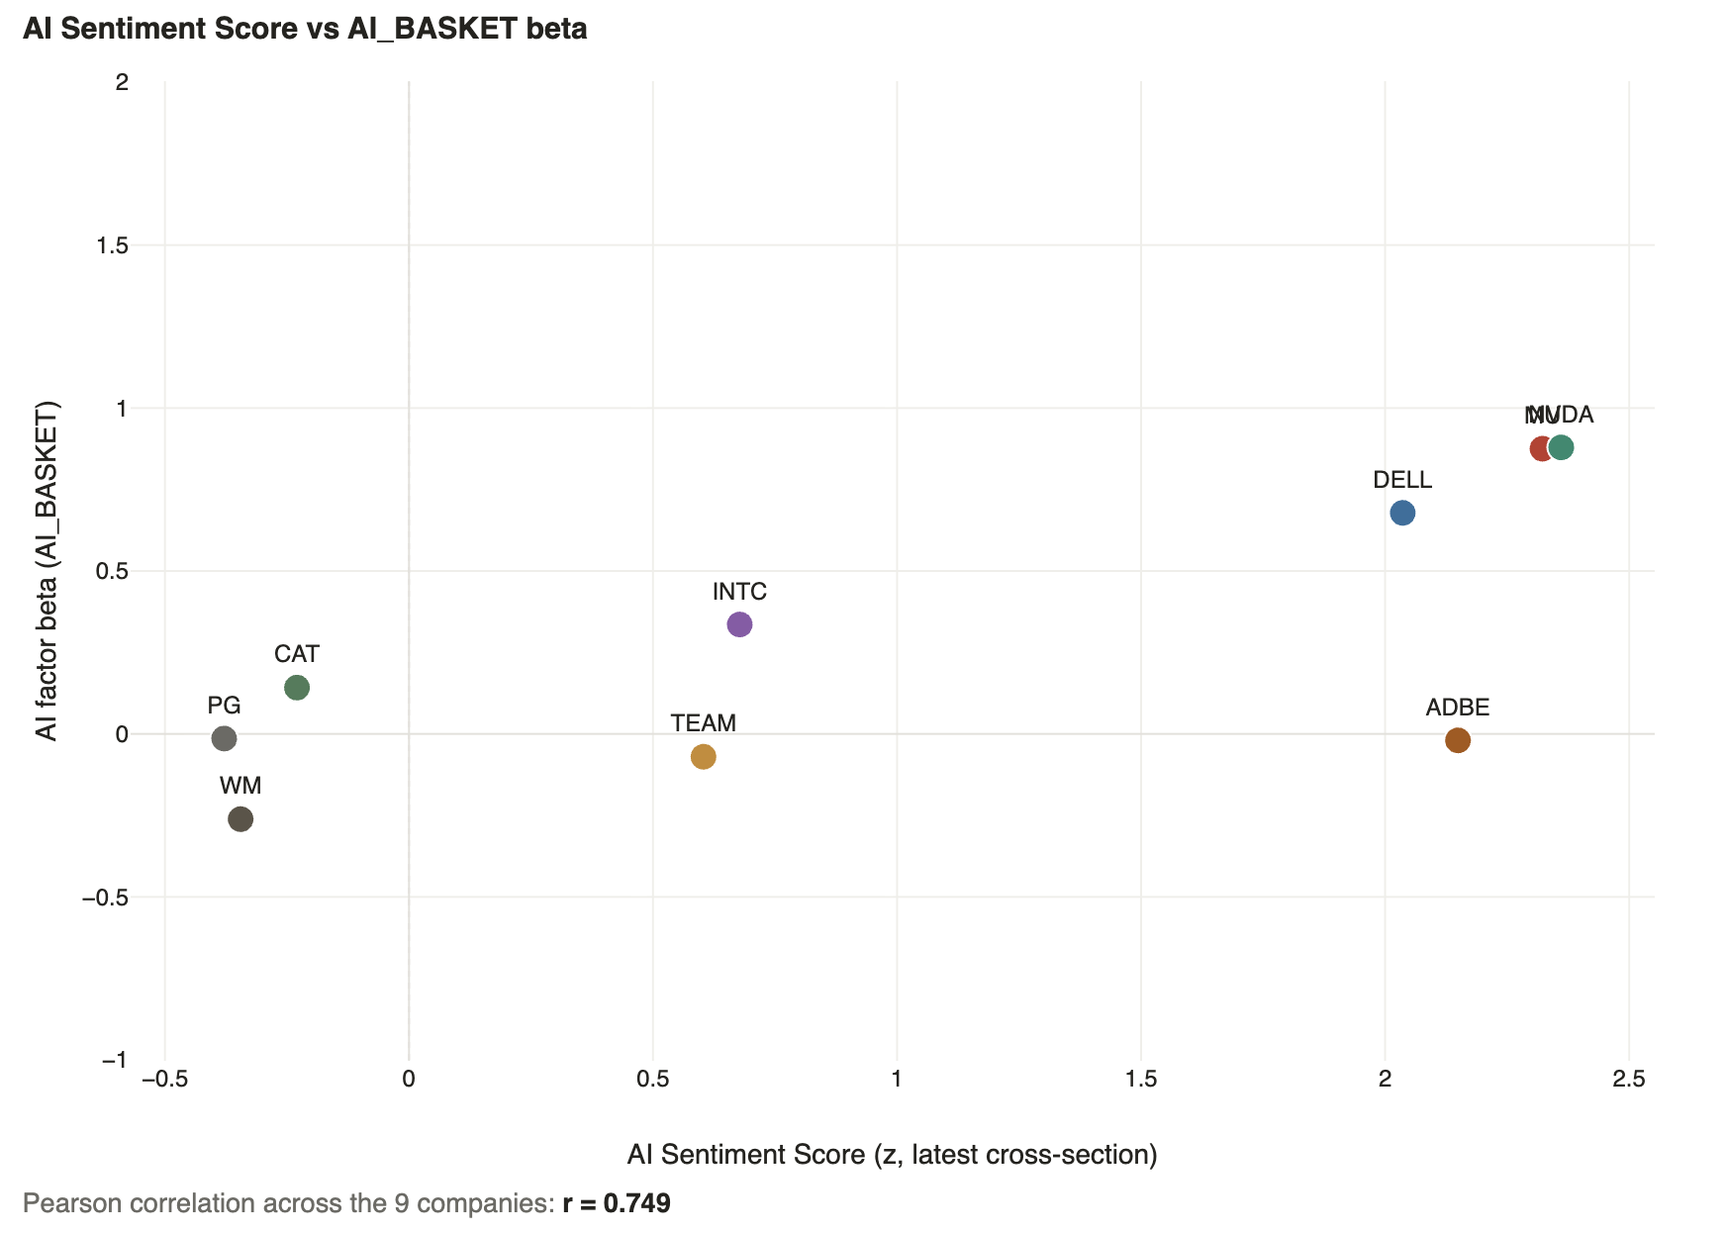

(For an overview of the Data Sources, Classification Methodology, Text Sentiment Signal and AI Factor construction, please consult the numbered html reports in the *appendix)
Key Findings

- Adobe (Strong internal AI narrative, weak market belief)

Since mid-2023, in its own published filings, earnings call transcripts and sourced from news articles, Adobe has increasingly discussed itself as an AI beneficiary.

The intensity of this positioning is such that it’s AI Sentiment score is currently on par with Nvidia and Micron. As an example, here is an excerpt from the most material and positively valenced AI chunk detected across 1346 Adobe documents:

2026 Earnings Call:
" we just look at what's happening with the AI opportunity for creativity as this incredible opportunity that is upon us right now… No other company is as well-positioned, given what we have across our models, across our products…”

Whilst there have been prior mentions of AI, almost all surrounding Adobe’s AI Product Roadmap, we have seen a huge spike since 2024, lagged by weaker AI related sentiment regarding actual business performance. Compare this to Nvidia’s historic mix of extremely high sentiment on real AI related financial performance, underpinned by stable product sentiment and consistent +ve AI partnership sentiment.
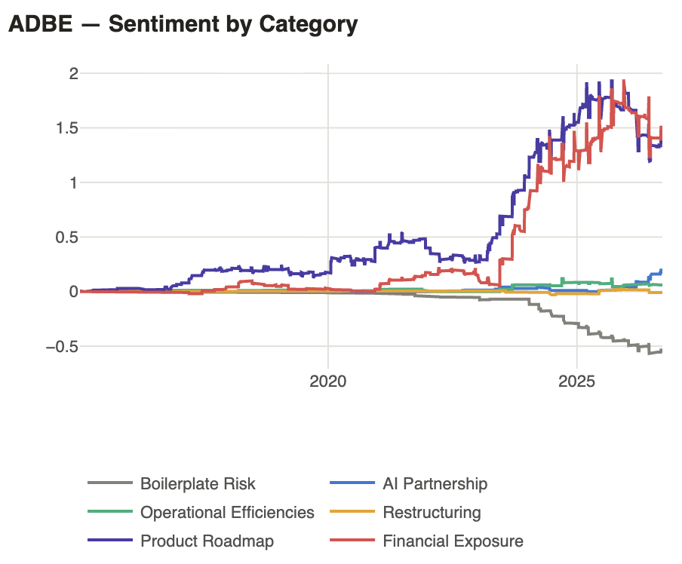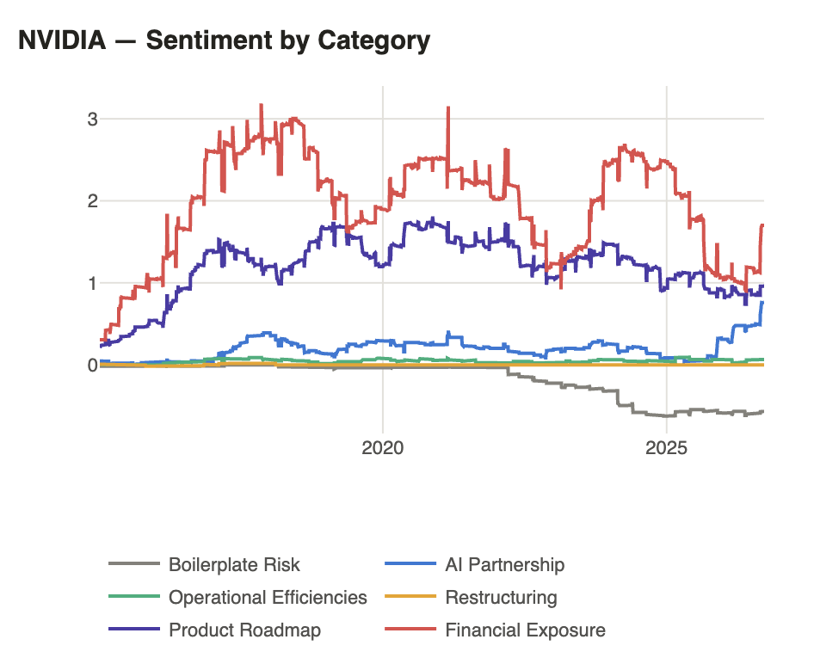

Adobe is down -25.1% YTD, and as indicated by its low AI factor beta, the market does not perceive it as an AI winner. The recommendation here is to monitor for signs of a reversal in AI Product and AI Financial sentiment levels and track the recent uptick in AI Partnership sentiment.

- Nvidia (Sentiment worsening)
On a raw AI materiality scoring basis, Nvidia was effectively the only AI relevant theme for the pre-boom period. 34.5% of its stored content was adjacently relative to AI, compared with 0.3% for Waste Management.

Whilst its AI materiality increased post-boom, the valence of these AI related news stories and publications flipped, even after accounting for increasingly lengthy SEC filing risk factor disclosures.
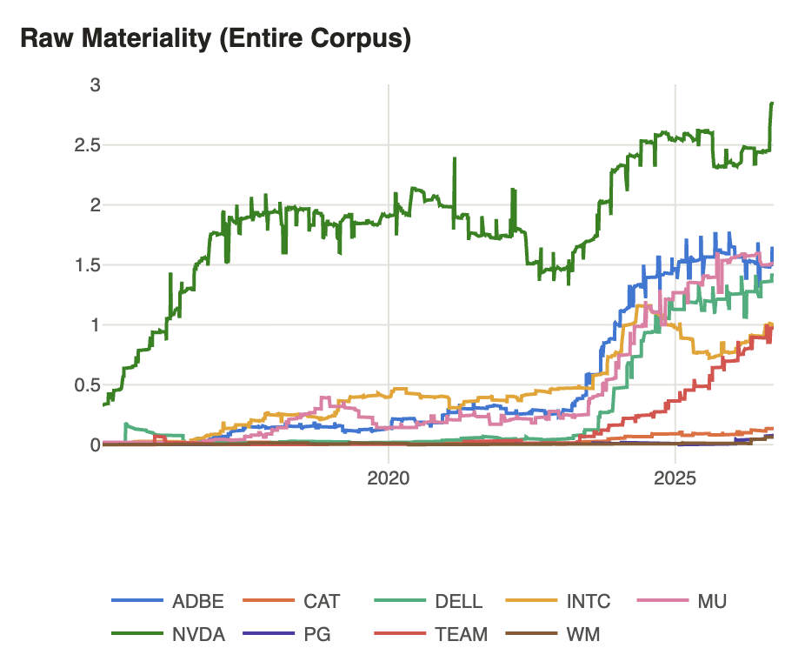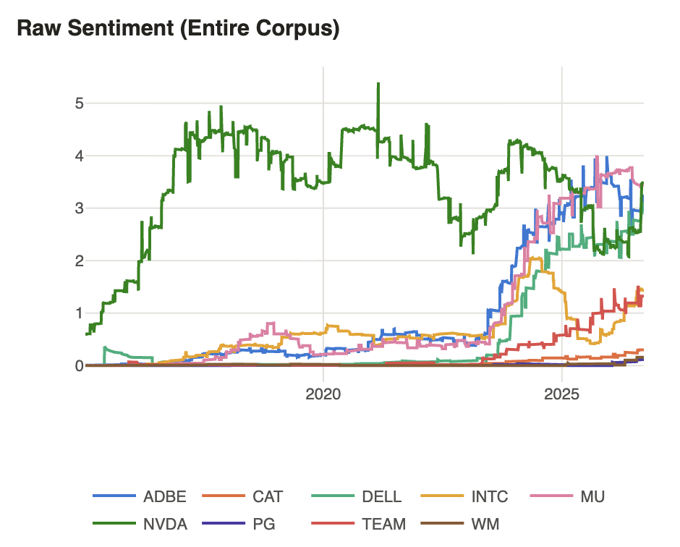

Why?:

*Following examples pulled using custom AI content search UI:

- “As of the end of fiscal year 2026, we were effectively foreclosed from competing in China's data center computing/compute market, and our effective foreclosure from the China”

- “We're going to do our best to compete in that marketplace and succeed in that marketplace within the specifications of the restriction.”
- “This last quarter, our business significantly declined as we paused in the marketplace.”
- “Growth was strong across all regions except for China, where our data center revenue declined significantly following the U.S. government export control regulations imposed in October.”
- “How "Hardwired" AI Will Destroy Nvidia's Empire and Change the World” - News
- “DOJ subpoenas Nvidia in deepening AI antitrust probe, report says” - News
- “Google says its AI supercomputer is faster, greener than Nvidia” – News
Effectively, Nvidia has been consistently raising issues with export controls to China, and news is surfacing new regulatory issues, emergent competitive threats.
My recommendation here is to categorise the mix-shift in these drags on Nvidia’s AI sentiment over the last 1-2 yeas and monitor closely for signs of acceleration in volume or materiality.

