Top quality plot of parental early life TL vs offspring TL. Based on parental juvenile TL, n = 7 points (!), h2 is 0.40. For parental adult TL, h2 is 0.75.

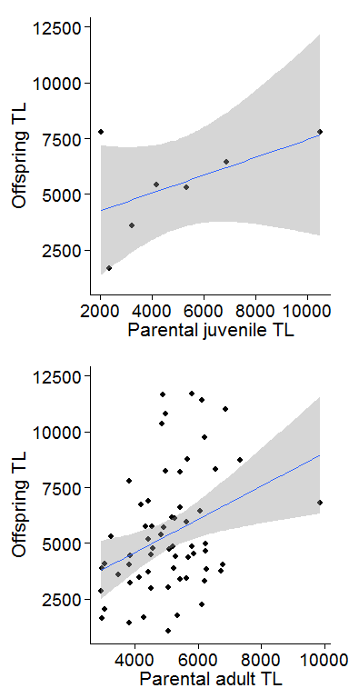

Look separately for each parent. Heritability estimates are < 0.01 for maternal juvenile TL, 0.59 for paternal juvenile TL, 0.58 for maternal adult TL, and 0.49 for paternal adult TL.

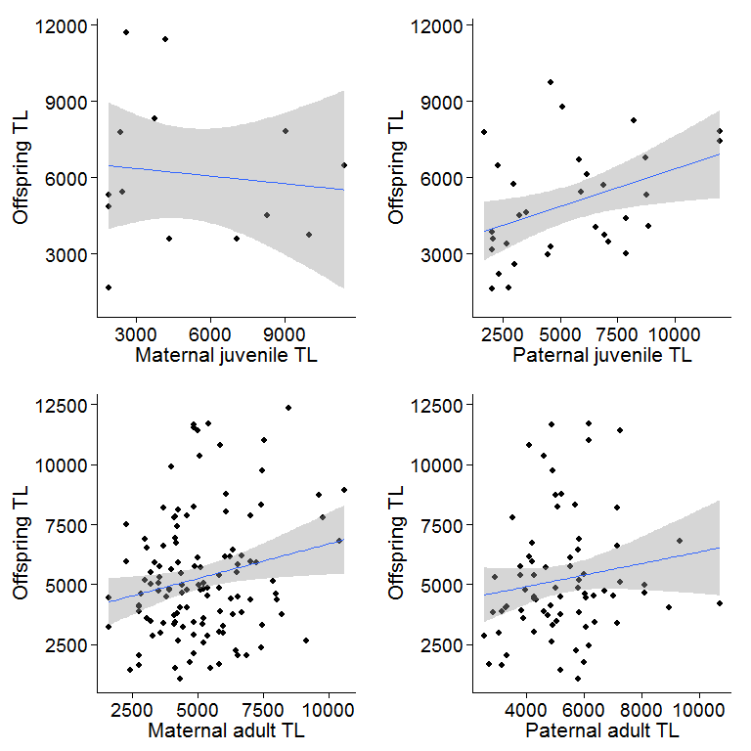

Paternal age and offspring TL - no effects of age or lifespan.

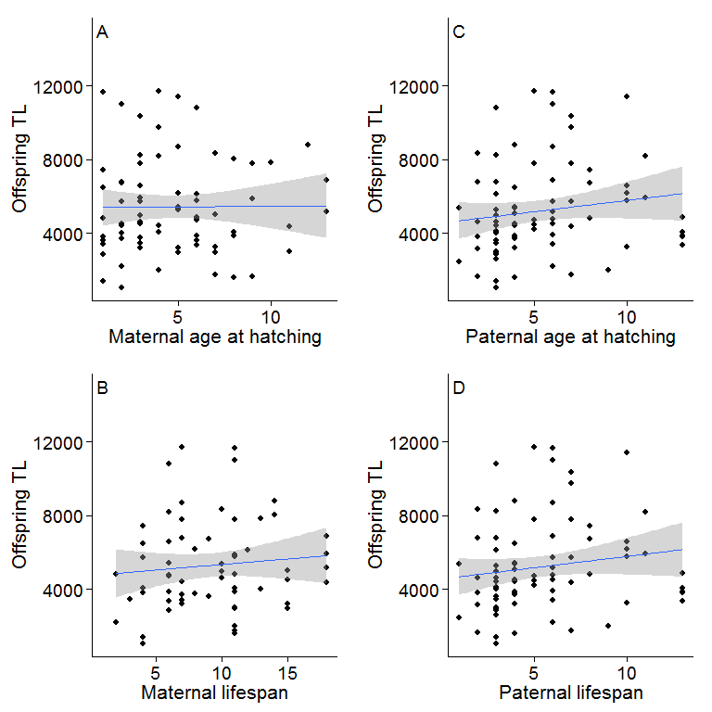

Parental TL and offspring Sex - big effect of maternal adult TL.

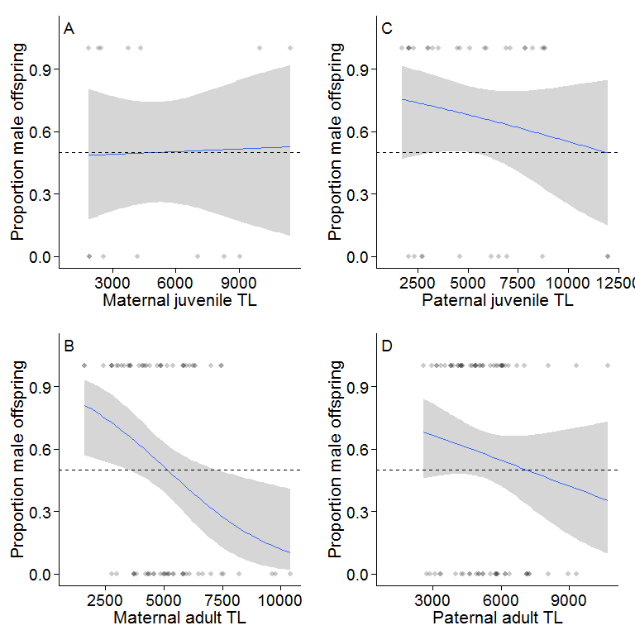

Parental age and offspring sex- significant effect of paternal age - note that this seems to be mainly driven by young fathers producing more males.

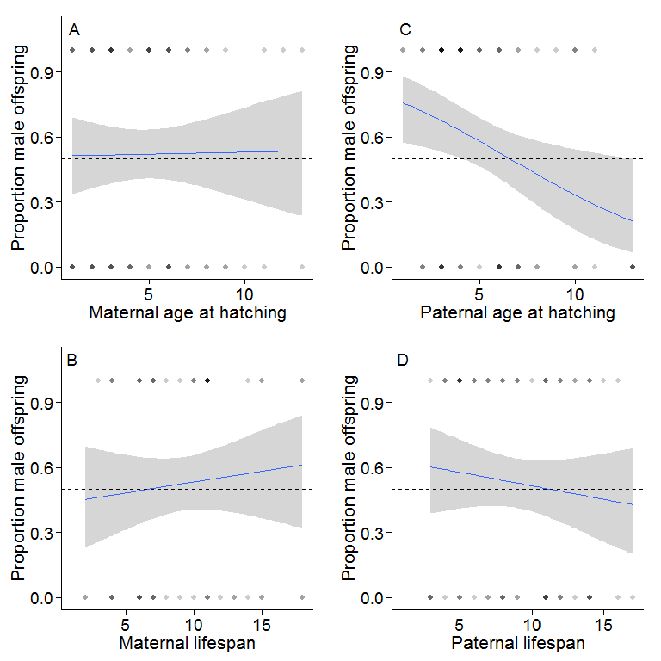

Telomere length and sex/age = female chicks have longer telomeres, but effect disappears by fledgling stage, and in face some evidence that male subadults have longer telomeres than females. Sex-specific survival?

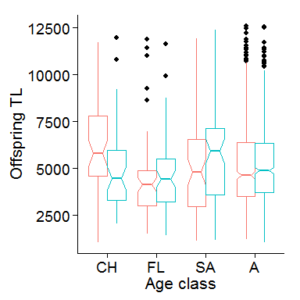

Maternal telomere length and male age effects on offspring sex ratio. Worth noting the shaded areas here, which are the confidence limits. Suggests young crap mums with young fathers produce more males, but not when they are with older fathers. Interaction isn't significant though.

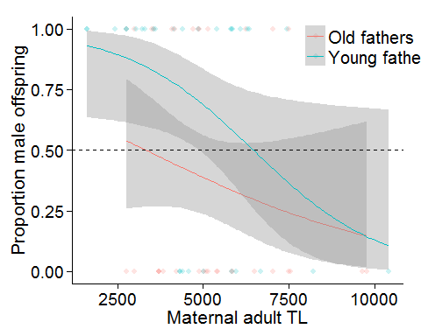

Another look at raw data - proportion males produced and male age. Weird quadratic effect. Sample sizes are limited as we're restricted to the telomere data, but we can look at this for all data with parentage.

