**Telomere inheritence in the Seychelles warbler**

Have a look at the relationship between Parental and offspring telomere length.

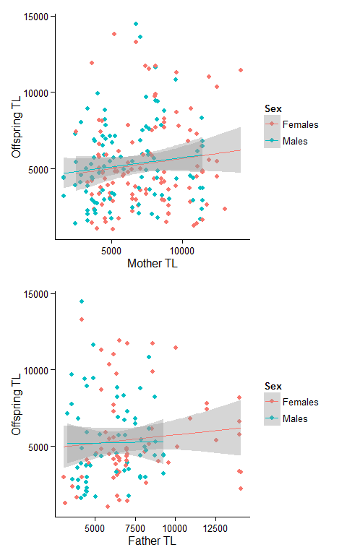

Run some models - In the first table, the same factors as before predict offspring telomere length, but so does maternal telomere length. In the second table nothing is significant. This could be collinearity, or it could be crappy sample size. Need to check.

## Estimate Std. Error t value Pr(>|t|)  
## (Intercept) 4929.7020776 688.67586422 7.1582327 1.483669e-11  
## mumTL 0.1405035 0.06877165 2.0430448 4.234664e-02  
## mumage 84.7749241 75.74934309 1.1191506 2.644049e-01  
## AgeclassFL -1907.4758242 495.47226993 -3.8498135 1.585875e-04  
## AgeclassSA -1210.1275622 472.35986766 -2.5618763 1.113956e-02  
## SexMales 246.2369683 391.13623598 0.6295427 5.297052e-01

## Estimate Std. Error t value Pr(>|t|)  
## (Intercept) 5.586485e+03 1113.4487892 5.01728096 1.819954e-06  
## dadTL 4.793121e-02 0.1078812 0.44429627 6.576220e-01  
## dadage 7.797608e+01 97.7075398 0.79805590 4.264015e-01  
## AgeclassFL -1.449924e+03 694.5626405 -2.08753485 3.893820e-02  
## AgeclassSA -1.291956e+03 658.3718066 -1.96235080 5.201696e-02  
## SexMales -4.525993e+01 551.0398385 -0.08213549 9.346747e-01

Second, telomere length in both male and female parents is negatively related to the proportion of male offspring. So, mums and dads with longer telomeres have more female chicks.

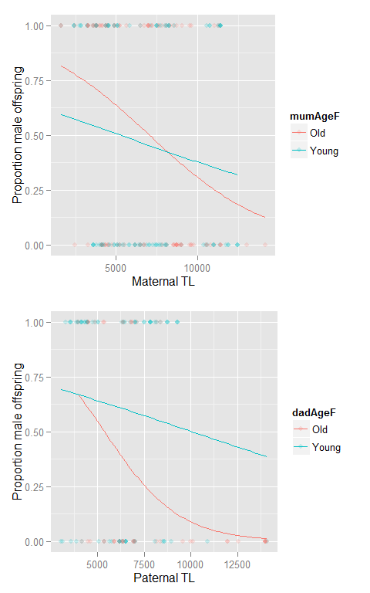

Run some models - we get significant effects for paternal age, paternal TL, and maternal TL, but not maternal age

## Generalized linear mixed model fit by maximum likelihood (Laplace  
## Approximation) [glmerMod]  
## Family: binomial ( logit )  
## Formula: SexBin ~ Ageclass + mumTL + mumage + (mother | TerritoryID)  
## Data: juv  
##   
## AIC BIC logLik deviance df.resid   
## 273.3 300.0 -128.6 257.3 200   
##   
## Scaled residuals:   
## Min 1Q Median 3Q Max   
## -1.8415 -0.6933 -0.3103 0.6525 2.2656   
##   
## Random effects:  
## Groups Name Variance Std.Dev. Corr   
## TerritoryID (Intercept) 5.162e-02 0.2272090   
## mother 4.741e-07 0.0006885 -1.00  
## Number of obs: 208, groups: TerritoryID, 84  
##   
## Fixed effects:  
## Estimate Std. Error z value Pr(>|z|)   
## (Intercept) 1.179e+00 6.410e-01 1.839 0.0659 .   
## AgeclassFL 7.576e-01 4.541e-01 1.668 0.0953 .   
## AgeclassSA 8.280e-01 4.384e-01 1.889 0.0589 .   
## mumTL -2.965e-04 6.962e-05 -4.259 2.05e-05 ***  
## mumage 5.787e-02 7.207e-02 0.803 0.4220   
## ---  
## Signif. codes: 0 '***' 0.001 '**' 0.01 '*' 0.05 '.' 0.1 ' ' 1  
##   
## Correlation of Fixed Effects:  
## (Intr) AgclFL AgclSA mumTL   
## AgeclassFL -0.227   
## AgeclassSA -0.206 0.574   
## mumTL -0.674 -0.071 -0.109   
## mumage -0.497 -0.162 -0.159 -0.032  
## fit warnings:  
## Some predictor variables are on very different scales: consider rescaling  
## convergence code: 0  
## Model failed to converge with max|grad| = 0.349016 (tol = 0.001, component 1)  
## Model is nearly unidentifiable: very large eigenvalue  
## - Rescale variables?  
## Model is nearly unidentifiable: large eigenvalue ratio  
## - Rescale variables?

## Generalized linear mixed model fit by maximum likelihood (Laplace  
## Approximation) [glmerMod]  
## Family: binomial ( logit )  
## Formula: SexBin ~ dadTL + dadage + Ageclass + (father | TerritoryID)  
## Data: juv  
##   
## AIC BIC logLik deviance df.resid   
## 158.5 181.2 -71.2 142.5 119   
##   
## Scaled residuals:   
## Min 1Q Median 3Q Max   
## -2.17861 -0.42782 -0.07226 0.51495 1.69981   
##   
## Random effects:  
## Groups Name Variance Std.Dev. Corr   
## TerritoryID (Intercept) 2.313e+00 1.521006   
## father 4.837e-06 0.002199 -0.99  
## Number of obs: 127, groups: TerritoryID, 58  
##   
## Fixed effects:  
## Estimate Std. Error z value Pr(>|z|)   
## (Intercept) 4.6121937 1.3989331 3.297 0.000977 ***  
## dadTL -0.0004773 0.0001669 -2.860 0.004234 **   
## dadage -0.2751080 0.1059087 -2.598 0.009388 **   
## AgeclassFL 0.4142313 0.7895601 0.525 0.599837   
## AgeclassSA 0.3381143 0.6738738 0.502 0.615845   
## ---  
## Signif. codes: 0 '***' 0.001 '**' 0.01 '*' 0.05 '.' 0.1 ' ' 1  
##   
## Correlation of Fixed Effects:  
## (Intr) dadTL dadage AgclFL  
## dadTL -0.829   
## dadage -0.482 0.123   
## AgeclassFL -0.153 -0.093 -0.148   
## AgeclassSA -0.156 0.011 -0.303 0.532  
## fit warnings:  
## Some predictor variables are on very different scales: consider rescaling  
## convergence code: 0  
## unable to evaluate scaled gradient  
## Model failed to converge: degenerate Hessian with 1 negative eigenvalues