A continental-scale analysis of genomic variation in a songbird
AUTHOR ORDER A SUGGESTION ONLY - PLEASE ADD/CHANGE IF REQUIRED
Lewis G. Spurgin^{1,2}*, Mirte Bosse^{3,4}*, Veronika N. Laine³, The Great Tit HapMap Consortium, Martien A.M. Groenen⁴, Kees van Oers³, Ben C. Sheldon¹, Marcel E. Visser³ and Jon Slate⁵**
1 School of Biological Sciences, University of East Anglia, Norwich Research Park, United Kingdom
2 Edward Grey Institute, University of Oxford, United Kingdom
3 Department of Animal Ecology, Netherlands Institute of Ecology (NIOO-KNAW), Wageningen, the Netherlands
4 Animal Breeding and Genomics Centre, Wageningen University, the Netherlands
5 Department of Animal and Plant Sciences, University of Sheffield, United Kingdom
* These authors contributed equally to this manuscript
** Correspondence: j.slate@sheffield.ac.uk

Abstract
A major aim of evolutionary biology is to understand why patterns of genetic variation vary within genomes, and among populations and species. Widespread continental species are interesting models for studying how evolution shapes patterns of genomic divergence, as they are associated with recent and rapid colonisations, large population sizes and high levels of gene flow. We studied patterns of genomic variation among 28 great tit (Parus major) populations in Europe. We found that genome-wide variation was consistent with a recent colonisation across Europe from a single refugium in the Balkans and/or Turkey. The highest levels of genome-wide structure were found between island populations in Crete, Sardinia and Corsica, most likely as a result of mild bottlenecks and reduced gene flow among these populations. We then found that the landscape of genomic differentiation was highly heterogeneous, with clear "islands of divergence", even among ostensibly panmictic great tit populations. Islands of divergence were consistently found in regions of low recombination, even among the most closely related populations, suggesting that background selection can rapidly promote population differentiation among large, recently colonised populations undergoing gene flow. Finally, we found that the relationship between recombination and the landscape of genomic differentiation mirrored the population history of great tits in Europe, with the strongest relationship between population divergence and recombination found among the most distantly related populations. Together, our findings suggest that studies of genomic divergence in the wild should consider population history, demography and genomic architecture, as well as likely patterns of natural selection.

Introduction
Since the first studies of allozyme variation in humans (Harris 1966) and Drosophila (Hubby & Lewontin 1966; Lewontin & Hubby 1966), there has been great interest in explaining how evolutionary and ecological processes shape the patterns of genetic variation observed within and among natural populations. One focus of research and debate in this area has been on quantifying the roles of adaptive and neutral processes in explaining observed levels of genetic variation (Nei 2005). However, adaptation does not occur in isolation, but against a background of recombination, gene flow, and genetic drift. More recently there has been increased effort in understanding how these fundamental evolutionary forces operate in concert to generate and maintain the levels of genetic diversity commonly observed in natural populations (e.g. Feder, Egan & Nosil 2012; Lanfear, Kokko & Eyre-Walker 2014).
The arrival of high-throughput sequencing and subsequent characterisation of genome-wide variation across large numbers of individuals has revealed that at the genetic level, patterns of variation and divergence among natural populations and species are highly heterogeneous (Turner et al. 2005). A feature of these "genomic landscapes" of differentiation that has received particular attention is the presence of so-called "islands of divergence"; outlier regions of the genome with high levels of divergence estimated from statistics such as $F_{ST}$ or $d_{xy}$ (e.g. Turner et al. 2005; Nadeau et al. 2011; Renaut et al. 2013; Poelstra et al. 2014). Initially these regions were termed "islands of speciation", and were thought to arise as a result of reduced gene flow in genomic regions associated with reproductive isolation (Turner et al. 2005). Subsequent modelling and analysis revealed that highly heterogeneous patterns of genomic divergence can occur in the complete absence of gene flow, as a result of linked selection on beneficial or deleterious mutations (Noor & Bennett 2009; Cruickshank & Hahn 2014).
Comparing patterns of genomic differentiation among sets of populations and/or species at different stages of the speciation continuum is a powerful way of disentangling the forces that shape variation among populations. Martin et al. (2013) showed that, across multiple Heliconius butterfly populations and species, patterns of genomic variation were shaped by a combination of gene flow and selection, particularly in genomic regions harbouring genes involved in wing patterning. In contrast, Renaut et al. (2013) showed that in Helianthus sunflowers, genomic architecture was the main driver of genomic differentiation across sets of populations. Similarly, recent research in birds has revealed that differentiation landscapes are conserved across populations, species and even across avian families (Burri et al. 2015; Van Doren et al. 2017; Vijay et al. 2017). This latter pattern appears to have arisen, at least in part, as a result of a highly conserved recombination landscape in birds.
It is now clear that the recombination landscape is a key driver of genomic variation, but we are only just beginning to understand how this recombination rate variation interacts with other evolutionary forces to shape patterns of differentiation across natural populations and species (Burri 2017; Ellegren & Wolf 2017; Jiggins & Martin 2017; Lohse 2017; Ravinet et al. 2017). A recent, large-scale analysis in sticklebacks showed that, like in many other studies, islands of differentiation were most likely to be found in regions of low recombination, but by looking at this relationship across many pairs of populations they showed that outlier genomic regions were more likely to arise in low recombination regions when gene flow occurred between populations (Samuk et al. 2017). There is also a significant impact of how recently separated populations are, and it is expected that in very recently separated populations the differentiation landscape is most likely to reflect selective sweeps, then as divergence accumulates, genomic architecture plays an increasingly important role (Burri 2017). More studies of genomic differentiation across very recently separated populations are now required to examine i) how rapidly divergence can accumulate in low recombining regions, and ii) how selection, gene flow and genomic architecture interact to shape genomic divergence in the early stages of the differentiation process.
The European great tit (Parus major major) is an excellent model for ecological and evolutionary study (Gosler 1993). Phyleogeographic research using mitochondrial and microsatellite loci suggests that this species has recently expanded across its European range, possible from a single refugium in the Balkans (Kvist et al. 1999). Contemporary populations are characterised by large effective population sizes and high levels of gene flow among populations, resulting in low levels of genetic differentiation (Kvist et al. 2003; Lemoine et al. 2016). The genome of the great tit has recently been sequenced (Laine et al. 2016), and a high density (650K) panel of SNP markers has been developed. A recent study of two European populations using this marker panel suggests that rapid adaptation has occurred at the genomic and phenotypic levels (Bosse et al. 2017). A wealth of ecological data also exists across multiple great tit populations (e.g. Visser et al. 1998; Charmantier et al. 2008; Dingemanse et al. 2012), enabling us to generate informed hypotheses about selection in this system.
In this study we examined how selection, gene flow and population history have shaped patterns of genomic variation across recently colonised European great tit populations. Using a large SNP panel typed across 28 populations, we first characterise variation within and among populations, in order to infer patterns of population history. We then examine how variation is partitioned across the genome, and test the hypothesis that highly divergent genomic regions have arisen as a result of variation in recombination rate across the genome. Finally, we examine how the relationship between genomic divergence and recombination varies according to geography, with the aim of inferring how gene flow and drift interact with selection to shape genomic landscapes in natural populations.

Methods

Sampling and molecular methods
Samples were collected from 28 populations from 22 countries across Europe (Fig. 1A; Table 1). Birds were trapped from nest boxes, or using mist nets, and ringed with a uniquely numbered aluminium ring. Blood was taken via brachial venipuncture, and stored in either 1 ml Cell Lysis Solution (Gentra Puregene Kit, Qiagen, USA) or Queen’s buffer. All samples were genotyped using a custom-made Affymetrix® great tit 650K SNP chip at Edinburgh Genomics (Edinburgh, United Kingdom). After filtering, a total of 647 samples typed at 483888 SNPs were retained for analysis (Table 1).

Analyses
Unless stated otherwise, all population genetic statistics were calculated in PLINK version 1.9 (Purcell et al. 2007), and downstream analysis and plotting was carried out in R version 3.3 (R Development Core Team 2011). In each population, we estimated linkage disequilibrium ($R^{2}$) for each pair of markers within 50kb on the same chromosome, and compared this to physical distance between marker pairs. For a simple comparison of short-range LD among populations, we also calculated, for each population, mean LD between all pairs of markers within 1kb. We calculated observed heterozygosity for each SNP and population using a reduced SNP dataset, which was pruned based on linkage disequilibrium to remove all markers with $R^{2}$ > 0.1, then thinned with a probability of retaining each variant of 0.25.
We calculated genome-wide (mean) $F_{ST}$ between each pair of populations using the pruned and thinned dataset described above. Pairwise $F_{ST}$ was compared to geographic distance between populations using Mantel tests, implemented in the Ecodist package in R (Goslee & Urban 2007). We tested whether genetic structure was related to distance from candidate refugial populations (in the Balkans, Turkey, Spain and Italy), using Pearson correlations. We also estimated population structure using Admixture version 1.3, with default settings (Alexander, Novembre & Lange 2009). We varied values of $K$ from one to ten; by which time increasing values of $K$ provided no informative information about population structure (see results). Model support for each value of $K$ was estimated by calculating 5-fold cross-validation error. Finally, we visualised the evolutionary history among European great populations by generating a maximum likelihood tree in TreeMix version 1.13 (Pickrell & Pritchard 2012). We rooted the tree using a sample of P. minor individuals sampled from Amur, Russia. We fitted models allowing for range of migration events (0-10), and used a window size of 500 SNPs (Pickrell & Pritchard 2012). To assess model fit, we calculated the proportion of variance in relatedness between populations explained by each model (equation 30 in Pickrell & Pritchard 2012).
We examined the genomic landscape of differentiation across European great tit populations by calculating $F_{ST}$ for all markers. For plotting and analysis, we calculated mean $F_{ST}$ values in 500kb bins, using custom R and python scripts. We also calculated standardised $F_{ST}$ (hereafter $ZF_{ST}$) by mean-centring windowed $F_{ST}$ values and dividing them by the standard deviation among windows. We calculated windowed $F_{ST}$ and $ZF_{ST}$ between the most structured populations, as defined by Admixture analysis (hereafter "marginal populations"), and between populations within a panmictic cluster in central Europe (hereafter "central European populations"). We tested whether the same regions of the genome were highly structured among these different sets of populations by comparing windowed $F_{ST}$ values, using Pearson correlations. We also specifically tested whether $F_{ST}$ outliers were more likely to occur in the same regions of the genome; we defined outlier regions as 500kb bins with mean $F_{ST}$ values greater than the 95th percentile (following Samuk et al. 2017), and tested whether outliers co-occurred among datasets using chi-squared tests.
We tested whether the landscape of genomic differentiation was related to recombination rate variation using a recombination map previously developed for the great tit using a 10K SNP chip (Oers et al. 2014), from which we estimated recombination rates in 500kb non-overlapping windows. We tested whether outlier presence/absence was related to 500kb averaged recombination rates using logistic regression.
Finally, we explored how the relationship between genomic differentiation and recombination rate variation was related to geography. We calculated genome-wide differentiation in 500kb bins for all 378 population pairs, and identified $F_{ST}$ outlier regions as above. Then for every pair of populations we performed logistic regressions and outlier presence/absence against recombination rate, and extracted the slope of these models. We tested whether variation in these slopes were related to pairwise geographic distance and pairwise genome-wide $F_{ST}$, using Mantel tests. We also tested whether the relationships between divergence and recombination varied according to distance from potential refugial populations, using Pearson correlation.

Results

Genetic diversity and population history
Sampling locations and sample sizes for each population are given in Table 1. Levels of genetic diversity were generally high and LD declined rapidly in all populations, but we observed substantial differences in genetic diversity among populations. Highest levels of LD were observed in the island populations of Crete (Greece), Sardinia (Italy), Corsica (France) and Vlieland (Netherlands) with lowest levels of LD in central Europe, Turkey and Spain (Fig. 1A; Fig. S1). Similarly, heterozygosity was highest in central Europe, and lowest in Crete, Sardinia and the Balkans (Fig. 1B).
Considering all European great tit populations, there was no significant pattern of isolation-by-distance (Mantel test; r = 0.14, p = 0.16). Instead, the highest levels of $F_{ST}$ were found in comparisons involving the island populations of Corsica, Sardinia and Crete (Fig. 2A Fig. 2B). Considering only comparisons involving mainland populations, pairwise $F_{ST}$ was still not related to related to geographic distance (r = 0.18, p = 0.13). We then examined genetic structure in relation to distance from potential refugial populations (only including mainland populations), and found that $F_{ST}$ was significantly related to distance from Turkey (r = 0.83, p < 0.001; Fig. 2C) and the Balkans (r = 0.67, p < 0.001), but not to distance from Spain (r = 0.09, p = 0.69), or from Italy (r = 0.16, p = 0.48).
Admixture analysis revealed patterns of genetic structure corresponding to geographical variation in European great tits (Fig. S2). The $K$ = 2 analysis assigned individuals in Sardinia and Corsica to one genetic cluster, and the remaining populations to the second. At $K$ = 3 (the model that best fitted the great tit data; Fig. S3), Spain was separated from the rest of mainland Europe. Increasing values of $K$ resulted of the separation of populations in Scotland ($K$ = 4), Sardinia (from Corsica; $K$ = 5), France ($K$ = 6), Crete ($K$ = 7) and England ($K$ = 8). The Admixture output at $K$ = 8 is displayed in Fig. 2C; further increases in $K$ did not generate patterns of structure that corresponded to geographical variation (Fig. S2), and were increasingly less well supported (Fig. S3).
Maximum likelihood analyses implemented in Treemix showed that a model with no migration explained 97.8% of variance in relatedness between populations; increasing the number of migration events substantially improved the percentage of relatedness explained, up to 99.7% when 10 migration events were fitted (Fig. S4). In Figure 3 we display the maximum likelihood tree with 2 migration events, after which the variance in relatedness explained plateaued when more migration events were added (Fig. S4). The tree was generally characterised by short branch lengths, with the exception of the island populations of Sardinia and Crete, which were grouped with the population from mainland Italy. The Spanish and Corsican populations were also grouped together, as were populations from Turkey and the Balkans, and populations from England and Scotland (Fig. 3). The two fitted migration edges both involved Sardinia, involving migration from eastern Europe, and to Corsica (Fig. 3).

Genomic landscapes of differentiation
We found that $F_{ST}$ varied markedly across the genome, regardless of whether we considered marginal populations across which structure was higher or across central European populations with very low structure (Fig. 4A). Mean windowed $F_{ST}$ values were correlated among the central and marginal populations ($r$ = 0.11; $P$ = 0.001; Fig. 4B), and outliers were likely to be found in the same regions across the two sets of populations (Chi-squared test, $P$ < 0.001; Fig. 4A,B). While $F_{ST}$ outliers were generally over five times higher in the marginal populations (mean $F_{ST}$ in outlier regions = 0.055) compared to the central populations (mean outlier $F_{ST}$ = 0.009), relative of standardised $F_{ST}$ in outlier regions were much more similar across the two sets of populations (marginal populations, $ZF_{ST}$ = 3.139; central populations, $ZF_{ST}$ = 2.315), suggesting that although genome-wide levels of $F_{ST}$ differ across the marginal and central populations, the landscape of genomic differentiation is highly heterogeneous across both sets of populations (Fig. 4A). $F_{ST}$ outliers were more likely to be found in regions of low recombination across both the marginal (GLM; $P$ < 0.001; Fig. 4C), and the central ($P$ = 0.003; Fig. 4D), populations.
We next quantified how the landscape of genomic differentiation was related to recombination rate for all 378 pairs of populations. The slope of the relationship between presence/absence of F_{ST} outliers and recombination rate was negative in the majority (81%) of pairwise comparisons (Fig. 5A). $F_{ST}$ outliers were most likely to be found in regions of low recombination in pairwise comparisons involving populations in the UK and Spain, as well as comparisons involving Corsica and Sardinia (Fig. 5A). Outliers were found in regions with higher recombination rates in pairwise comparisons involving eastern and central European populations, and Crete (Fig. 5A). The relationship between $F_{ST}$ outlier presence/absence and recombination rate did not vary according to the geographical distance between populations (r = -0.14, p = 0.21). However, we found a strong, negative relationship between the $F_{ST}$/recombination slope and genome-wide $F_{ST}$ ($r$ = -0.24, $P$ < 0.001). Considering only mainland populations, we found that the relationship between presence/absence of $F_{ST}$ outliers and recombination decreased with distance from Turkey ($r$ = -0.65, $P$ = 0.001; Fig. 5B), and with genetic structure with Turkey ($r$ = -0.63, $P$ = 0.002; Fig. 5C).

Discussion
UNFINISHED - I WANT TO FINALISE THE ANALYSES/RESULTS BEFORE GOING INTO DETAIL HERE. IGNORE FOR NOW OR ADD NOTES/THOUGHTS.
In this study we use a large panel of genetic markers to provide insight into the evolutionary history of the great tit in Europe. We found that, consistent with previous research in this species, levels of genomic variation were consistent with a large effective population and substantial levels of gene flow among populations (Kvist et al. 2003; Laine et al. 2016). We then examine how genomic landscapes of differentiation vary among different sets of populations, and find that i) islands of differentiation arise among extremely closely related populations, ii) these same islands of differentiation arise in more distantly related populations, iii) islands of differentiation arise in regions of low recombination, iv) the relationship between recombination rate and the genomic landscape of differentiation varies substantially among populations. These findings have several implications for how we interpret patterns of genomic variation among natural populations.
Our results suggest that great tits colonised Europe from a single refugium in the Balkans. This scenario has been suggested before (Kvist et al. 1999), and our observed pattern of increasing genome-wide divergence from the Turkish and Balkan populations lends this hypothesis empirical support. Genomic structure among mainland populations is, however, extremely low, and even with hundreds of thousands of markers Admixture was unable to separate the central European populations. Similarly, in the Treemix analysis the central European great tit populations formed a large group characterised by shallow branching, although much of the grouping that did occur (e.g. Finland and Estonia) made geographical sense. Interestingly, Treemix grouped the Spanish and Corsican populations, which is consistent with previous subspecies descriptions of European great tits (REF). More generally, the highest levels of differentiation were found between island populations, suggesting a reduced effective population size and reduced gene flow in these populations.
It is likely that the many, and perhaps the majority, of wild populations are characterised by highly heterogeneous patterns of differentiation across the genome (see REFS for a recent overview). What is not yet clear is how quickly "islands" of differentiation arise, nor how selection, gene flow and drift interact with genomic architecture to shape differentiation over shorter and longer evolutionary timescales (Burri 2017). Our results suggest that islands of differentiation arise in regions of low recombination even among populations that could be considered panmictic. The central European great tit populations have a mean $F_{ST}$ of 0.005, yet islands of divergence can clearly be seen, and occur almost exclusively in regions of low recombination, regardless of which populations were examined (Figs 4,5). Thus, our results suggest that linked selection in regions of low recombination plays a key role in driving patterns of genomic differentiation even in the very earliest stages of population separation. This is not necessarily what we would expect - in the very earliest stages of differentiation it is often assumed that peaks of high differentiation are the product of selective sweeps, and that only after time do correlated patterns of genomic divergence arise (Burri 2017). It is difficult to differentiate between positive and background selection in producing heterogeneous patterns of differentiation across the genome. Correlated patterns of genomic differentiation among sets of populations suggests that background selection likely plays a role (REFS), and that is what we find in great tits.
Patterns of increasing genetic differentiation with distance from In accordance with this, we find that the tendency for outlier regions to occur in regions of low recombination increases with geographical and genetic distance from the refugial population in Turkey (Fig. 5). Thus we suggest that in continental species, the increased genome-wide divergence that accumulates with distance from refugial populations is accelerated in regions of low recombination, resulting in highly heterogeneous landscapes of genomic differentiation.
Needs more. Perhaps a discussion on role of gene flow... also need to think about what additional analyses may be required to strenghtn/add novelty to the story. One thing we could do is look in more detail at how genomic differentiaiton builds up with distance from the refugial population? Thoughts?

Acknowledgements
PLEASE ADD. LGS was funded by fellowships from the Edward Grey Institute for Ornithology and the BBSRC.

References
Alexander, D.H., Novembre, J. & Lange, K. (2009) Fast model-based estimation of ancestry in unrelated individuals. Genome Research, 19, 1655–1664.
Burri, R. (2017) Dissecting differentiation landscapes: a linked selection’s perspective. Journal of Evolutionary Biology, 30, 1501–1505.
Burri, R., Nater, A., Kawakami, T., Mugal, C.F., Olason, P.I., Smeds, L., Suh, A., Dutoit, L., Bureš, S., Garamszegi, L.Z., Hogner, S., Moreno, J., Qvarnström, A., Ružić, M., Sæther, S.-A., Sætre, G.-P., Török, J. & Ellegren, H. (2015) Linked selection and recombination rate variation drive the evolution of the genomic landscape of differentiation across the speciation continuum of Ficedula flycatchers. Genome research, 25, 1656–65.
Charmantier, A., McCleery, R.H., Cole, L.R., Perrins, C., Kruuk, L.E.B. & Sheldon, B.C. (2008) Adaptive phenotypic plasticity in response to climate change in a wild bird population. Science (New York, N.Y.), 320, 800–3.
Cruickshank, T.E. & Hahn, M.W. (2014) Reanalysis suggests that genomic islands of speciation are due to reduced diversity, not reduced gene flow. Molecular Ecology, 23, 3133–3157.
Dingemanse, N.J., Bouwman, K.M., Pol, M. van de, Overveld, T. van, Patrick, S.C., Matthysen, E. & Quinn, J.L. (2012) Variation in personality and behavioural plasticity across four populations of the great tit Parus major. Journal of Animal Ecology, 81, 116–126.
Ellegren, H. & Wolf, J.B.W. (2017) Parallelism in genomic landscapes of differentiation, conserved genomic features and the role of linked selection. Journal of Evolutionary Biology, 30, 1516–1518.
Feder, J.L., Egan, S.P. & Nosil, P. (2012) The genomics of speciation-with-gene-flow. Trends in Genetics, 28, 342–350.
Goslee, S.C. & Urban, D.L. (2007) The ecodist package for dissimilarity-based analysis of ecological data. Journal Of Statistical Software, 22, 1–19.
Gosler, A. (1993) The great tit. Hamlyn Species Guides.
Harris, H. (1966) Enzyme Polymorphisms in Man. Proceedings of the Royal Society B: Biological Sciences, 164, 298–310.
Hubby, J.L. & Lewontin, R.C. (1966) A molecular approach to the study of genic heterozygosity in natural populations. I. The number of alleles at different loci in Drosophila pseudoobscura. Genetics, 54, 577–594.
Jiggins, C.D. & Martin, S.H. (2017) Glittering gold and the quest for Isla de Muerta. Journal of Evolutionary Biology, 30, 1509–1511.
Kvist, L., Martens, J., Higuchi, H., Nazarenko, A.A., Valchuk, O.P. & Orell, M. (2003) Evolution and genetic structure of the great tit (Parus major) complex. Proceedings. Biological sciences / The Royal Society, 270, 1447–54.
Kvist, L., Ruokonen, M., Lumme, J. & Orell, M. (1999) The colonization history and present-day population structure of the European great tit (Parus major major). Heredity, 82, 495–502.
Laine, V., Gossmann, T., Schachtschneider, K., Garroway, C., Madsen, O., Verhoeven, K., Jager, V. de, Megens, H.-J., Warren, W., Minx, P., Crooijmans, R., Corcoran, P., Consortium, The Great Tit Hapmap Sheldon, B., Slate, J., Zeng, K., Oers, K. van, Visser, M. & Groenen, M. (2016) Evolutionary signals of selection on cognition from the great tit genome and methylome. Nature Communications.
Lanfear, R., Kokko, H. & Eyre-Walker, A. (2014) Population size and the rate of evolution. Trends in Ecology & Evolution, 29, 33–41.
Lemoine, M., Lucek, K., Perrier, C., Saladin, V., Adriaensen, F., Barba, E., Belda, E.J., Charmantier, A., Cichoń, M., Eeva, T., Grégoire, A., Hinde, C.A., Johnsen, A., Komdeur, J., Mänd, R., Matthysen, E., Norte, A.C., Pitala, N., Sheldon, B.C., Slagsvold, T., Tinbergen, J.M., Török, J., Ubels, R., Oers, K. van, Visser, M.E., Doligez, B. & Richner, H. (2016) Low but contrasting neutral genetic differentiation shaped by winter temperature in European great tits. Biological Journal of the Linnean Society, 118, 668–685.
Lewontin, R.C. & Hubby, J.L. (1966) A molecular approach to the study of genic heterozygosity in natural populations. II. Amount of variation and degree of heterozygosity in natural populations of Drosophila pseudoobscura. Genetics, 54, 595–609.
Lohse, K. (2017) Come on feel the noise - from metaphors to null models. Journal of Evolutionary Biology, 30, 1506–1508.
Martin, S.H., Dasmahapatra, K.K., Nadeau, N.J., Salazar, C., Walters, J.R., Simpson, F., Blaxter, M., Manica, A., Mallet, J. & Jiggins, C.D. (2013) Genome-wide evidence for speciation with gene flow in Heliconius butterflies. Genome Research, 23, 1817–28.
Nadeau, N.J., Whibley, A., Jones, R.T., Davey, J.W., Dasmahapatra, K.K., Baxter, S.W., Quail, M.A., Joron, M., Ffrench-Constant, R.H., Blaxter, M.L., Mallet, J. & Jiggins, C.D. (2011) Genomic islands of divergence in hybridizing Heliconius butterflies identified by large-scale targeted sequencing. Philosophical Transactions of the Royal Society of London B: Biological Sciences, 367.
Nei, M. (2005) Selectionism and Neutralism in Molecular Evolution. Molecular Biology and Evolution, 22, 2318–2342.
Noor, M.A.F. & Bennett, S.M. (2009) Islands of speciation or mirages in the desert? Examining the role of restricted recombination in maintaining species. Heredity, 103, 439–444.
Oers, K. van, Santure, A.W., De Cauwer, I., Bers, N.E. van, Crooijmans, R.P., Sheldon, B.C., Visser, M.E., Slate, J. & Groenen, M.A. (2014) Replicated high-density genetic maps of two great tit populations reveal fine-scale genomic departures from sex-equal recombination rates. Heredity, 112, 307–316.
Pickrell, J.K. & Pritchard, J.K. (2012) Inference of Population Splits and Mixtures from Genome-Wide Allele Frequency Data. PLoS Genetics, 8.
Poelstra, J.W., Vijay, N., Bossu, C.M., Lantz, H., Ryll, B., Müller, I., Baglione, V., Unneberg, P., Wikelski, M., Grabherr, M.G. & Wolf, J.B.W. (2014) The genomic landscape underlying phenotypic integrity in the face of gene flow in crows. Science, 344.
Purcell, S., Neale, B., Todd-Brown, K., Thomas, L., Ferreira, M.A., Bender, D., Maller, J., Sklar, P., Bakker, P.I. de, Daly, M.J. & Sham, P.C. (2007) PLINK: A Tool Set for Whole-Genome Association and Population-Based Linkage Analyses. The American Journal of Human Genetics, 81, 559–575.
R Development Core Team. (2011) R: A Language and Environment for Statistical Computing (ed RDC Team).
Ravinet, M., Faria, R., Butlin, R.K., Galindo, J., Bierne, N., Rafajlović, M., Noor, M.A.F., Mehlig, B. & Westram, A.M. (2017) Interpreting the genomic landscape of speciation: a road map for finding barriers to gene flow. Journal of Evolutionary Biology, 30, 1450–1477.
Renaut, S., Grassa, C.J., Yeaman, S., Moyers, B.T., Lai, Z., Kane, N.C., Bowers, J.E., Burke, J.M. & Rieseberg, L.H. (2013) Genomic islands of divergence are not affected by geography of speciation in sunflowers. Nature Communications, 4, 1827.
Samuk, K., Owens, G.L., Delmore, K.E., Miller, S.E., Rennison, D.J. & Schluter, D. (2017) Gene flow and selection interact to promote adaptive divergence in regions of low recombination. Molecular Ecology, 26, 4378–4390.
Turner, T.L., Hahn, M.W., Nuzhdin, S.V., Mitchison, G. & Spencer, F. (2005) Genomic Islands of Speciation in Anopheles gambiae (ed N Barton). PLoS Biology, 3, e285.
Van Doren, B.M., Campagna, L., Helm, B., Illera, J.C., Lovette, I.J. & Liedvogel, M. (2017) Correlated patterns of genetic diversity and differentiation across an avian family. Molecular Ecology, 26, 3982–3997.
Vijay, N., Weissensteiner, M., Burri, R., Kawakami, T., Ellegren, H. & Wolf, J.B.W. (2017) Genomewide patterns of variation in genetic diversity are shared among populations, species and higher-order taxa. Molecular Ecology, 26, 4284–4295.
Visser, M.E., Noordwijk, A.J.v., Tinbergen, J.M. & Lessells, C.M. (1998) Warmer springs lead to mistimed reproduction in great tits (Parus major). Proceedings of the Royal Society B: Biological Sciences, 265, 1867–1870.

Tables and Figures
Table 1 Sampling details for the 28 European great tit populations.
Population | Region | N | Latitude | Longitude
Loch_Lomond_Scotland | Scotland | 21 | 56.108 | -4.562
Cambridge_UK | England | 28 | 52.198 | 0.152
Wytham_UK | England | 48 | 51.776 | -1.303
Font_Roja_Spain | Spain | 19 | 38.664 | -0.544
Mariola_Spain | Spain | 21 | 37.717 | -0.658
La_Rouviere_France | France | 19 | 43.930 | 4.235
Montpellier_France | France | 36 | 43.098 | 3.569
Antwerp_Belgium | Belgium | 15 | 51.226 | 4.390
Westerheide_Netherlands | Netherlands | 50 | 52.250 | 5.190
Vlieland_Netherlands | Netherlands (Vlieland) | 15 | 53.238 | 4.932
Zurich_Switzerland | Switzerland | 22 | 47.383 | 8.523
Radolfzell_Germany | Germany | 18 | 47.759 | 8.957
Seewisen_Germany | Germany | 30 | 47.978 | 11.233
Pirio_Muro_Corsica | Corsica | 27 | 42.110 | 9.104
Sardinia | Sardinia | 9 | 40.056 | 9.025
Italy | Italy | 13 | 42.386 | 13.354
Vienna_Austria | Austria | 27 | 48.239 | 16.347
Velky_Kosir_Czech_Republic | Czech Republic | 22 | 49.547 | 17.062
Pilis_Mountains_Hungary | Hungary | 28 | 47.733 | 18.917
Gotland_Sweden | Sweden | 32 | 57.504 | 18.466
Harjavalta_Finland | Finland | 44 | 61.314 | 22.139
Oulu_Finland | Finland | 29 | 65.013 | 25.468
Tartu_Estonia | Estonia | 32 | 58.375 | 26.739
Crete | Crete | 4 | 35.183 | 24.960
Bulgaria | Balkans | 3 | 42.852 | 24.986
Romania | Balkans | 7 | 46.497 | 24.582
Turkey | Turkey | 11 | 39.464 | 34.797
Zvenigorod_Russia | Russia | 17 | 55.738 | 36.857

Figure legends
Figure 1 A Sampling locations of great tit populations used in the present study. The size of the circles represents the extent of short term LD (markers within 1kb) within each population. B Notched boxplots of marker-based heterozygosity in each population.
Figure 2 Population structure in European Great tit populations. A Heatmap of pairwise $F_{ST}$ between all European populations. B Pairwise $F_{ST}$ in comparisons involving island (or island/mainland) and only mainland populations. C Pairwise $F_{ST}$ in relation to geographic distance from the Turkey, only including comparisons involving Turkey. D Output from admixture analysis at $K$ = 8.
Figure 3 Maximum likelihood tree inferred by Treemix, allowing ten migration events. Migrations events (arrows) are coloured according to their weight (red = higher migration), and horizontal branch lengths are proportional to the amount of genetic drift that has occurred along the branch.
Figure 4 Landscapes of genomic differentiation among European great tit populations. A Manhattan plot of $ZF_{ST}$ in 500kb windows across the central (top) and marginal (bottom) populations. B Relationship between windowed $ZF_{ST}$ values in the marginal and central populations. Dotted lines represent 95% quantiles, and outlier loci are coloured in navy. C,D Recombination rate at outlier and non-outlier windows in the central (C) and marginal (D) populations.
Figure 5 Genomic differentiation and recombination in European great tit populations. A Heatmap of the relationship (i.e. the slope from a logistic regression) between outlier presence/absence and recombination rate among all pairs of populations. B,C The slope of this relationship in relation to geographical (C) and genetic (D) distance to a proposed refugial population in Turkey.

Figure 1
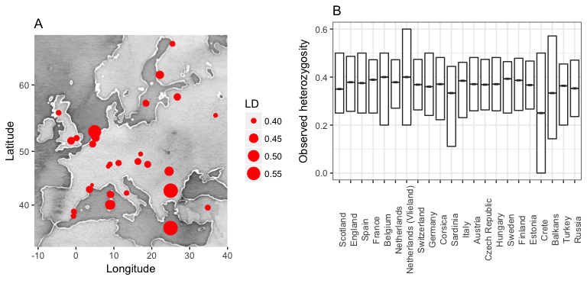

Figure 2
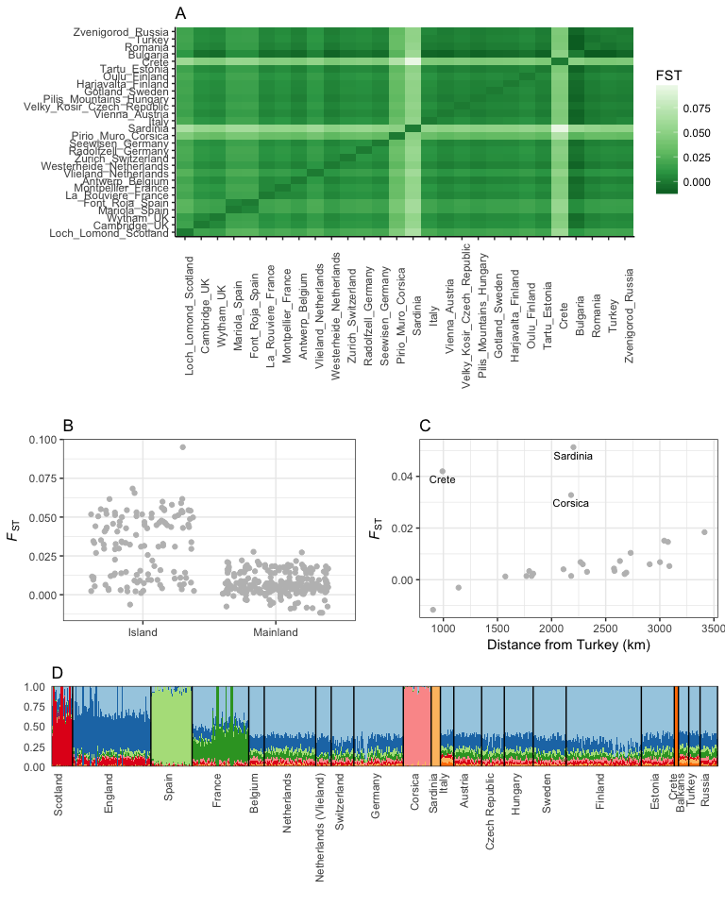
Figure 3
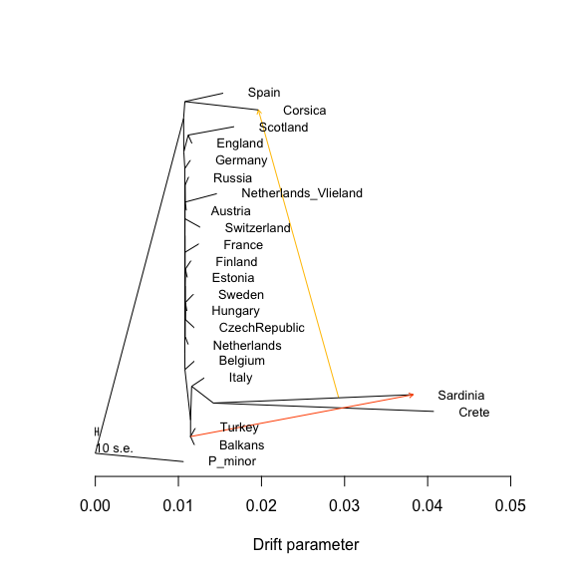
Figure 4 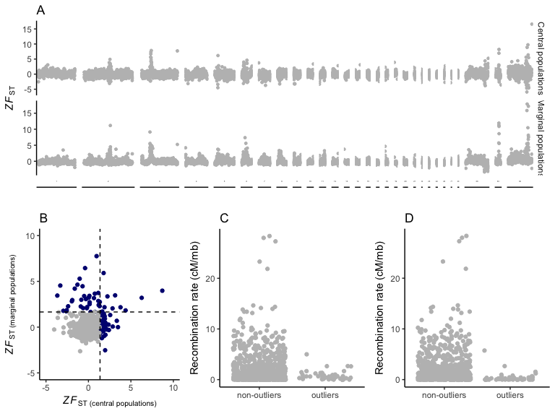
Figure 5 