Supplementary material for “The great tit HapMap project: a continental-scale analysis of genomic variation in a songbird”
Table S1 Sampling details for the 29 European great tit populations. “Code” corresponds to labels in Figure 1 of the main text.
Code | Population | Region | N | Latitude | Longitude
1 | Loch_Lomond_Scotland | Scotland | 21 | 56.108 | -4.562
2 | Cambridge_UK | England | 28 | 52.198 | 0.152
3 | Wytham_UK | England | 48 | 51.776 | -1.303
4 | Font_Roja_Spain | Spain | 19 | 38.664 | -0.544
5 | Mariola_Spain | Spain | 21 | 38.737 | -0.658
6 | La_Rouviere_France | France | 19 | 43.930 | 4.235
7 | Montpellier_France | France | 36 | 43.098 | 3.569
8 | Antwerp_Belgium | Belgium | 15 | 51.226 | 4.390
9 | Westerheide | Netherlands | 50 | 52.250 | 5.190
10 | Vlieland_NL | Netherlands (Vlieland) | 15 | 53.238 | 4.932
11 | Zurich_Switzerland | Switzerland | 22 | 47.383 | 8.523
12 | Radolfzell_Germany | Germany | 18 | 47.759 | 8.957
13 | Seewisen_Germany | Germany | 30 | 47.978 | 11.233
14 | Pirio_Muro_Corsica | Corsica | 27 | 42.110 | 9.104
15 | Sardinia | Sardinia | 9 | 40.056 | 9.025
16 | Matera_Italy | Italy | 5 | 40.601 | 16.514
17 | Po_Plain_Italy | Italy | 8 | 45.171 | 9.138
18 | Vienna_Austria | Austria | 27 | 48.239 | 16.347
19 | Velky_Kosir_Czech_Republic | Czech Republic | 22 | 49.547 | 17.062
20 | Pilis_Mountains_Hungary | Hungary | 28 | 47.733 | 18.917
21 | Gotland_Sweden | Sweden | 32 | 57.504 | 18.466
22 | Harjavalta_Finland | Finland | 44 | 61.314 | 22.139
23 | Oulu_Finland | Finland | 29 | 65.013 | 25.468
24 | Kilingi-Nõmme_Estonia | Estonia | 32 | 58.150 | 24.938
25 | Crete | Crete | 4 | 35.183 | 24.960
26 | Bulgaria | Balkans | 3 | 42.696 | 23.328
27 | Romania | Balkans | 7 | 46.497 | 24.582
28 | Turkey | Turkey | 11 | 39.464 | 34.797
29 | Zvenigorod_Russia | Russia | 17 | 55.738 | 36.857
Table S2 Details of outlier $F_{ST}$ regions in European great tit populations. For each region, $F_{ST}$ was calculated for each population versus Turkey. The “number of outliers” represents the number of populations in which each region was detected as an outlier. All genes found within 500kb outlier windows are displayed.
Chromosome | Position (MB) | Number of outliers | Outlier comparisons | Genes
2 | 81 5 | 12 | Austria, Belgium, Czech Republic, Estonia, Finland, France | PADP7, SRDSA1, NSUN2, UBE2QL, MED10
 |  |  | Germany, Hungary, Netherlands, Scotland, Sweden, Switzerland
6 | 18 | 10 | Belgium, Corsica, England, France, Germany, Hungary, Italy | RASGEF1A, RET, CSGALNACT2
 |  |  | Netherlands, Russia, Sweden
3 | 28 5 | 2 | England, Spain | PPP1CB, CALM2, TTC7A, MCFD2
1A | 70 5 | 2 | Czech Republic, Russia | CDKN1B
4A | 12 | 2 | England, Scotland | COL4A5
6 | 8 | 2 | Finland, Scotland | SLC18A3, RGR, LRI1, LRI2, CDHR1, GHITM
3 | 28 | 1 | Spain | MRPL33, RBKS, BRE, FOSL2
1A | 48 5 | 1 | Finland | CBX6, CBX7, DNAL4, SUN2, NPTXR, JOSD1, TOMM22, KDELR3, DMC1, GTPBP1, DDX17, CBY1
 |  |  |  | KCNJ4, THEM184B, CSNK1E, PLA2G6, MAFF, BAIAP2L2, SLC16A8, PICK1, SOX10, MICALL1
 |  |  |  | EIF3L, ANKRDS4, GCAT, POLR2F
6 | 7 5 | 1 | Scotland | BMPR1A, SNGC, MMRN2, GLUD1, FAM35A, GPRIN2, PARG, NCOA4, OGDHL, CHAT
8 | 7 5 | 1 | Vlieland | -
8 | 8 | 1 | Belgium | -
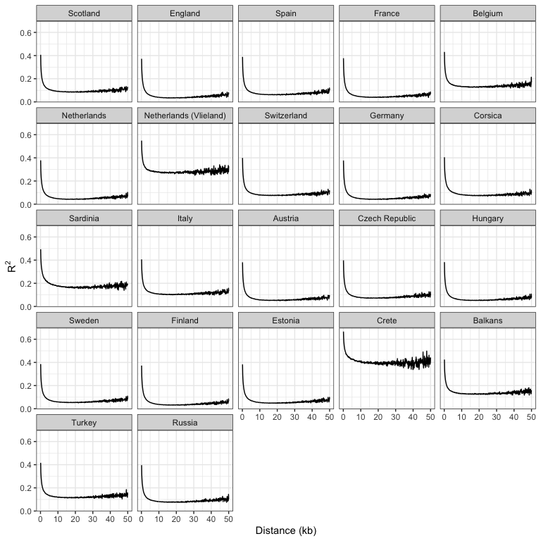
Figure S1 Linkage disequilibrium in European great tit populations. Lines are means of $R^{2}$ values for all pairs of markers within 100bp distance bins.

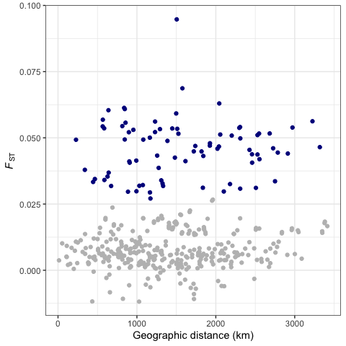
Figure S2 Pairwise $F_{ST}$ in relation to geographic distance among European great tit populations. Pairwise comparisons involving the island populations of Corsica, Sardinia and Crete are coloured in dark blue.

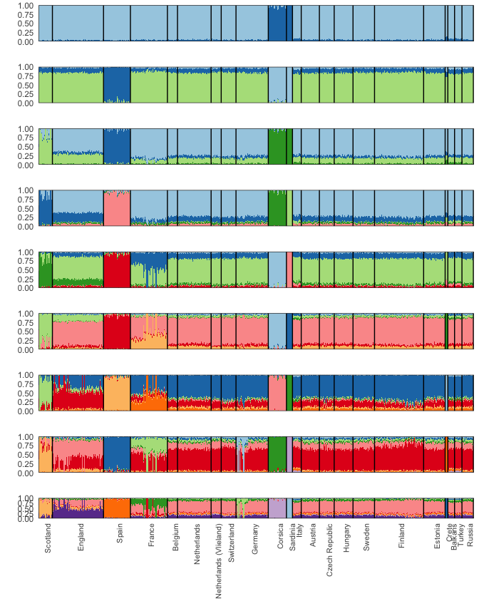
Figure S3 Admixture analyses at $K$ = 2 to 10 in European great tit populations.

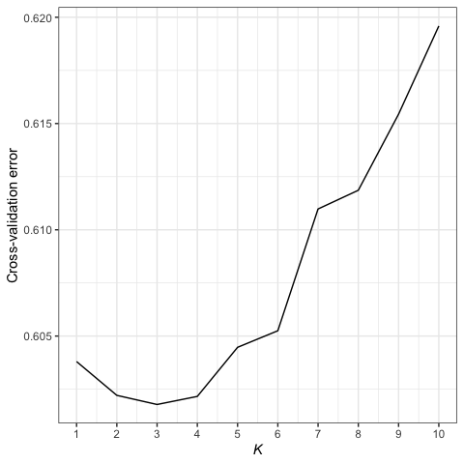
Figure S4 Cross-validation error from Admixture analyses at $K$ = 1 to 10.

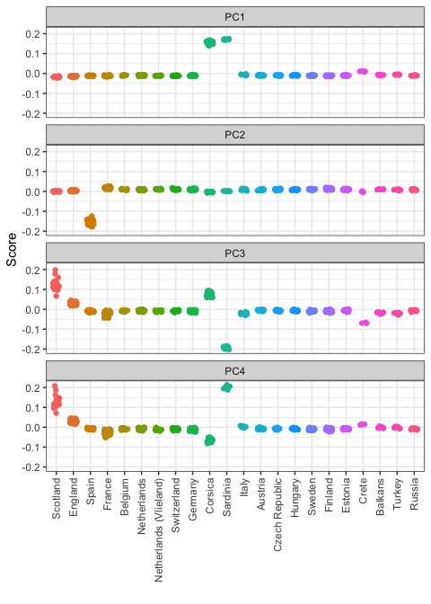
Figure S5 Results from PCA analysis of European great tit populations.

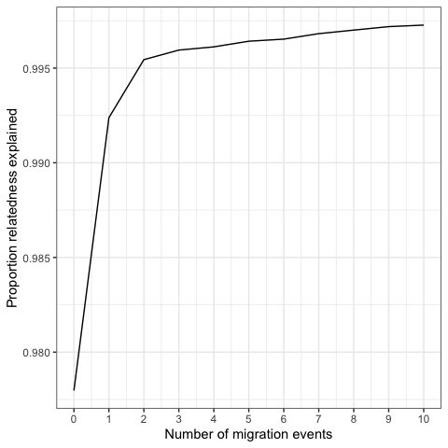
Figure S6 Proportion of relatedness explained among populations in relation to the number of migration events allowed in TreeMix analyses.

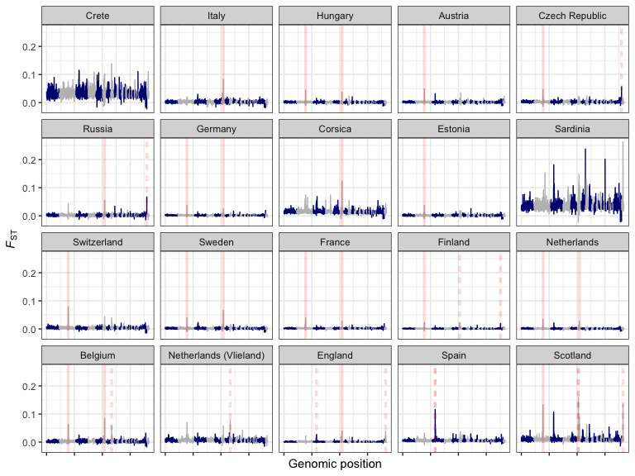
Figure S7 Landscapes of genomic differentiation in European great tit populations. $F_{ST}$ across the genome is averaged in 500kb windows, with each panel displaying a pairwise comparison with the proposed refugial population in Turkey. Red lines represent $F_{ST}$ outliers (windows with mean $zF_{ST}$ > 10) shared across more than two comparisons (solid red lines), or unique to one or two comparisons (dashed red lines).

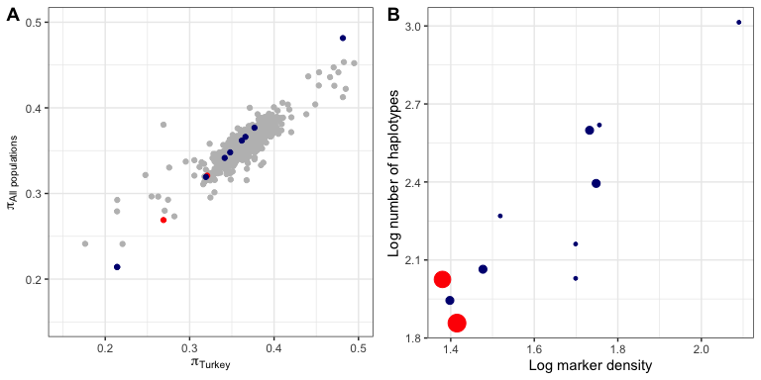
Figure S8 Genetic diversity in $F_{ST}$ outlier regions in European great tit populations. Each point is an outlier window, with point size scaled by the number of populations the outlier was found in - “shared” haplotypes are coloured red and “unique” haplotypes dark blue (see main text for details). In A, Nucleotide diversity for each window is calculated for the proposed refugial population in Turkey, and plotted against the mean for all other populations. In B, SNP marker density is plotted against haplotype richness for each region.

Figure S9 Haplotype structure underlying regions of high differentiation. A IBS clustering of all European haplotypes in the region containing a signal of high differentiation with Turkey specific to the Oulu population. The red arrow indicates the haplotype at highest frequency in Finland. Colour indicates IBS similarity (range 0: white - 1: dark blue). B IBS clustering of all European haplotypes in the region on chromosome 2 containing a signal of high differentiation with Turkey in multiple populations. C Frequency of all identified haplotypes within each population. The red arrow indicates the high-frequency haplotype within Finland. D Frequency of all identified haplotypes spanning the region on chromosome 2 within each population.

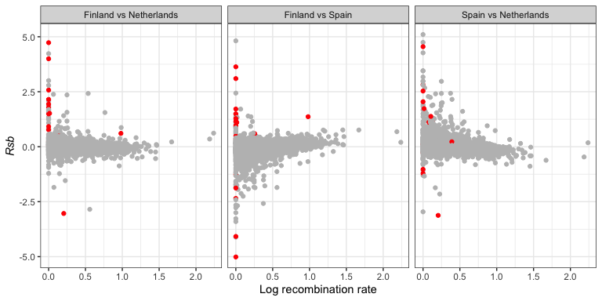
Figure S10 Rsb in relation to recombination in three pairwise comparisons, averaged across 500kb windows. Red points represent the top 1% of FST outliers.

