Faculty of Science
School of Biological Sciences

University of East Anglia
Norwich Research Park
Norwich NR4 7TJ
United Kingdom

Email:l.spurgin@uea.ac.uk
Tel: +44 (0) 1603 59 2947

Web:lewisspurgin.wordpress.com
25 February 2019

To the Editor,

We would like to enquire about out manuscript “The great tit HapMap project: a continental-scale analysis of genomic variation in a songbird”, which we hope you will consider for publication in Current Biology. In this study we address the fundamental and topical question of how natural selection shapes genetic variation in the wild. To address this, we perform one of the most geographically comprehensive screens of genomic variation of any wild organism to date, showing continental-scale signatures of adaptation across a widespread and familiar species. In doing so, we provide a new benchmark for studies of phylogeography and ecological adaptation in wild organisms.

The human HapMap studies of global genomic variation revolutionised our understanding of human evolutionary history, and of the relationship between genotype and phenotype. Based on this ambitious project, a limited number of HapMap studies have been carried out on model species and species of agricultural or economic interest. However, large-scale, genomic studies of wild organisms are still scarce, despite the fact that such studies could enormously enhance our understanding of ecology and evolution. We performed a HapMap study on European great tits – one of the best known and widely studied wild animals. Our recent genomic research using just two great tit populations has significantly enhanced our understanding of natural selection in the wild (Bosse et al. 2018, Science).

We provide, for the first time, clear evidence of the colonisation history of great tits, and identify genetic structure among populations previously thought to be homogeneous. We then examine variation along the genome, and identify “islands of divergence”, where genetic structure is unusually high. We show that many such islands of divergence occur in regions of low recombination due to background selection, are highly conserved, and arise much more rapidly than previous theory or empirical studies have suggested. Due to the large-scale nature of our study, we were able to identify signatures of positive selection in specific populations, and showed that this mainly occurred on the edges of the great tit range expansion, in genomic regions containing candidate genes for climate adaptation and morphology.

The large-scale dataset presented here will be made freely available, and represents an unprecedent resource. As well as being of use to the large and growing research community studying the biology of great tits, our data will be of excellent value for testing new theories of colonisation, adaptation, and range expansion. They will also be of great interest for testing new methods for detecting selection from genomic data, environmental association analyses, and modelling population history. Thus, we are confident that the research and data presented here will be highly cited and influential.

We hope you agree that our study is of high scientific importance, and suited to the readership of Current Biology.

We look forward to hearing from you.

Yours faithfully,

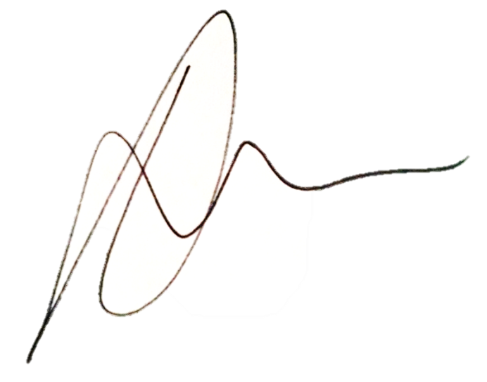

Lewis Spurgin and Jon Slate, on behalf of all authors

Author list: Lewis G. Spurgin, Mirte Bosse, Frank Adriaensen, Tamer Albayrak, Christos Barboutis, Eduardo Belda, Andrey Bushuev, Jacopo G. Cecere, Anne Charmantier, Mariusz Cichon, Niels J. Dingemanse, Blandine Doligez, Tapio Eeva, Kjell Einar Erikstad, Vyacheslav Fedorov, Matteo Griggio, Dieter Heylen, Sabine Hille, Camilla A. Hinde, Elena Ivankina, Veronika N. Laine, Bart Kempenaers, Anvar Kerimov, Milos Krist, Laura Kvist, Raivo Mänd, Erik Matthysen, Ruedi Nager, Boris P. Nikolov, A. Claudia Norte, Markku Orell, Jenny Ouyang, Gergana Petrova-Dinkova, Heinz Richner, Diego Rubolini, Tore Slagsvold, Vallo Tilgar, János Török, Barbara Tschirren, Csongor I. Vágási, Teru Yuta, Martien A.M. Groenen, Marcel E. Visser, Kees van Oers, Ben C. Sheldon and Jon Slate

Abstract: A major aim of evolutionary biology is to understand why patterns of genomic variation vary among populations and species. Large-scale genomic studies of widespread species are useful for studying how the environment and demographic history shape patterns of genomic divergence, and with the continually decreasing cost of sequencing, such studies are now becoming feasible. Here, we carry out one of the most comprehensive surveys of genomic variation in a wild vertebrate to date; the great tit (Parus major) HapMap project. We screened ca 500,000 SNP markers across 647 individuals from 29 populations, spanning almost the entire geographic range of the European great tit subspecies. We found that genome-wide variation was consistent with a recent colonisation across Europe from a single refugium in the Balkans and/or Turkey, with bottlenecks and reduced genetic diversity in island populations. Differentiation across the genome was highly heterogeneous, with clear "islands of differentiation" even among populations which are ostensibly panmictic. These islands of differentiation were consistently found in regions of low recombination, suggesting that background selection can rapidly promote population differentiation among even the most recently colonised populations. We also detected genomic outlier regions that were unique to peripheral great tit populations, most likely as a result of recent directional selection at the range edges of this species. These "unique" outlier regions contained candidate genes for morphology, thermal adaptation and colouration, supporting previous research in this species, and providing avenues for future investigation. Our study suggests that comprehensive screens of genomic variation in wild organisms can provide unique insights into evolution.

