To the Editor,

Please find enclosed our manuscript “The great tit HapMap project: a continental-scale analysis of genomic variation in a songbird”, which we hope you will consider for publication in PLoS Biology. In this study we perform one of the most comprehensive screens of genomic variation of any wild organism to date, providing new insights into how variation along the genome evolves in widespread continental species. In doing so, we provide a new benchmark for studies of phylogeography and ecological adaptation.

The human haplotype map – or HapMap – studies of genomic variation across the globe revolutionised our understanding of human evolutionary history, and of the relationship between genotype and phenotype. Based on this ambitious project, a number of HapMap-style studies have been carried out on model species and species of agricultural or economic interest. However, large-scale, genomic studies of wild organisms are still scarce, despite the fact that such studies could enormously enhance our understanding of ecology and evolution.

Great tits are excellently suited to a HapMap study – they are one of the best known and widely studied wild animals, and thanks to a rich history of research are considered an “ecological model species”. Authors of this paper have been instrumental in developing genomic resources for this the great tit (Laine et al. 2016, Nature Comms), which we have combined with ecological data to further our understanding of natural selection in the wild (Bosse et al. 2018, Science).

Utilising a recently developed panel of ~600,000 single nucleotide polymorphism markers, we screen genome-wide variation across 29 populations, covering almost the entirety of Europe (see map below).

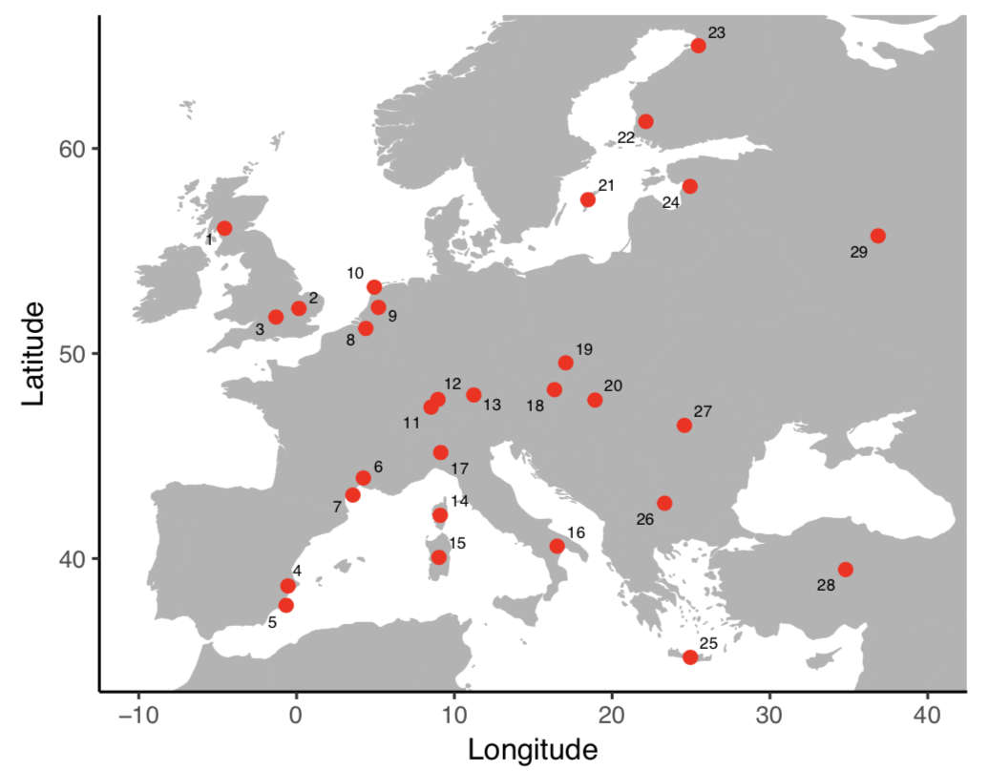

Using these data we provide, for the first time, clear evidence that great tits colonised Europe from a single refugium in the East, and identify clear patterns among of genetic structure among populations previously thought to be homogeneous. We then examine variation along the genome, and identify “islands of divergence”, where genetic structure is unusually high. Importantly, due to the large-scale nature of our study, we were where and why these genomic islands arise, showing that while some islands arise to features of the genome, others are the product of recent natural selection.

We hope you agree that our study is of high scientific importance, and suited to the readership of PLoS Biology. Should you choose to send our paper to review, we suggest the following reviewers, who are all experts in evolutionary biology and population genetics

Dr Sonya Clegg, University of Oxford - sonya.clegg@zoo.ox.ac.uk
Prof Chris Jiggins, University of Cambridge - c.jiggins@zoo.cam.ac.uk
Dr Kristin Reugg, Colorado State University - Kristen.Ruegg@colostate.edu
Dr Reto Burri, University of Jena - reto.burri@uni-jena.de
Dr Kathryn Elmer, University of Glasgow - Kathryn.Elmer@glasgow.ac.uk
Prof Sam Yeaman, University of Calgary - samuel.yeaman@ucalgary.ca

We look forward to hearing from you.

Yours faithfully,

Lewis Spurgin and Jon Slate, on behalf of all authors.

