# Polyandry enables successful colonisation in a challenging thermal environment

## Abstract

Polyandry, when females mate with multiple males, could play an important role in successful colonisation of challenging environments. In addition to potential benefits from sexual selection, polyandry could enable colonisation by protecting against the cost of mating with incompatible or infertile males, and by reducing levels of inbreeding in founder populations. Here, we measure the importance of polyandry for population persistence and fitness following experimental founder events in a challenging environment. Using colonisation experiments with the model beetle *Tribolium castaneum*, we founded replicate populations under hotter thermal regimes using either singly- or doubly-mated females, and then tracked their subsequent population dynamics. Following ten generations across more than 100 experimental colonisations, we found that extinction rates were significantly lower in populations founded by doubly-mated females (9%) compared to populations founded by singly-mated females (34%). In addition, populations founded by doubly-mated females showed consistently greater productivity following colonisation, compared to monogamous-founded populations. Importantly, we identified both short-term and longer-term benefits to post-colonisation populations from double-mating, with results suggesting that polyandry acts to both protect against mating with incompatible males through the founder event, and reduce inbreeding depression as the colonisation proceeds. Our results show that polyandry provides both reproductive and genetic benefits for depleted populations facing the challenges of colonising new thermal environments following climate change.

**Key words:** climate change, extinction, inbreeding depression, population dynamics, sexual selection, *Tribolium*

## Introduction

Global warming, when combined with other anthropogenic pressures, is placing a range of ecological and evolutionary stresses on wild populations (Hoffmann & Sgrò, 2011; Pecl *et al.*, 2017). In particular, a combination of habitat clearance and changing temperatures will result in populations simultaneously going through bottlenecks, while needing to cope with novel habitats and thermal regimes (Hill *et al.*, 2011). Understanding the behavioural, ecological, and genetic processes by which bottlenecked populations respond to challengin thermal environments is therefore of relevance to understanding - and ultimately predicting - organismal responses to a rapidly changing world (Hoelzel, 2010). Disentangling these processes requires a combination of laboratory and field research at a wide range of organisational levels (**???**).

One way that populations may be buffered against demographic and environmental change is through female multiple mating, or polyandry (Candolin & Heuschele, 2008; Parrett & Knell, 2018). In addition to the direct benefits that polyandry may provide to females and their offspring (e.g. increased resources from males) (Fedorka & Mousseau, 2002), multiple mating can provide genetic benefits (Zeh & Zeh, 2001). Polyandry facilitates sexual selection, in which females may encourage genetic benefits for their descendants by skewing paternity towards specific males (Andersson & Iwasa, 1996). Sexual selection can therefore improve population fitness through a range of mechanisms (reviewed in Yasui, 1998), including offspring inheriting “good” or “compatible” genes as a result of polyandry (Neff & Pitcher, 2005), or through selection for increased genetic diversity in offspring, which may increase adaptability to fluctuating environments (García‐González *et al.*, 2015).

Polyandry may also provide benefits to individuals and populations in the absence of sexual selection, with one recognised mechanism for this via bet-hedging (Watson, 1991). If mate-choice is unreliable or costly, multiple mating may be an effective strategy to protect against unsuitable males. It is still debated whether the fitness gains derived from bet-hedging are sufficient to drive the evolution of polyandry (Holman, 2016). However, bet-hedging may play an important role in the dynamics of small colonising populations, where the consequences of mating with a single male who happens to be of low quality are expected to be particularly severe (Yasui & Garcia-Gonzalez, 2016).

Finally, polyandry may play a key role in the colonisation of new environments through reductions in inbreeding. Cornell and Tregenza (2007) developed a model showing that, because offspring of polyandrous females contain half-sibs, inbreeding depression in future generations will be reduced, improving the probability of colonisation success. This theory received empirical support in a recent study of seed beetles (*Callosobruchus maculatus*) in which populations founded by polyandrous females had increased fitness after five generations, compared to monogamous females (Power & Holman, 2014). Interestingly, despite the benefits of polyandry for individual fitness, Power and Holman (2014) found no effect of mating treatment on extinction rates, which were low throughout the experiment. It is therefore not yet known how much of a benefit polyandry may provide in terms of establishment probability in new and harsher environments. Given that inbreeding depression is most severe in challenging environmental conditions (Armbruster & Reed, 2005), this is an important area for future investigation.

The red flour beetle *Tribolium castaneum* is an ideal model system to test experimentally how polyandry influences colonisation success in a new environment. A pest of stored products, the ecology of *T. castaneum* is characterised by continued colonisation of empty habitats (e.g. grain stores), presumably often by a small number of founders (Dawson, 1977). Experimental studies in this species have shown that founder effects have pronounced costs as a result of genetic and demographic effects, and that colonising populations are able to rapidly adapt to challengin environments (Szucs *et al.*, 2014, 2017). Further, this species is promiscuous and experimental evolution studies have shown that a history of sexual selection results in decreased risk of extinction under inbreeding, and improved invasion into competitor populations (Lumley *et al.*, 2015; Godwin *et al.*, 2018). Moreover, matings and fertility often appear to fail in this species (Tyler & Tregenza, 2013), and there is some evidence to suggest that these costs are reduced when females mate multiply (Pai *et al.*, 2005).

Using the *T. castaneum* system, we therefore test how polyandry impacts upon colonisation success when foundresses enter a challengin thermal environment. We placed singly- and doubly-mated females into an empty habitat at high temperature, and then tracked population dynamics and extinction rates across ten generations. We tested the hypotheses that populations founded from polyandrous females i) were less likely to go extinct, and ii) maintained larger sizes due to increased reproductive fitness, and then identified the behavioural, ecological and genetic drivers behind colonisation success. These findings provide important insight into how mating strategy and inbreeding interact to affect colonisation dynamics in challengin environments.

## Materials and Methods

#### Experimental protocols

All beetles used were from our outbred Krakow Super-strain (KSS), which are reared under standatd conditions of 30 $​^{∘}$ C and 60% humidity (Dickinson, 2018). Beetles were maintained both before and throughout the experiment on a fodder medium consisting of 90% organic strong white bread flour mixed with 10% brewer’s yeast, and topped with a layer of oats for traction.

The overall experimental design is outlined in Figure 1. Founding females and their mates were reared separately and mated under standard conditions as above. To allow matings to occur, pairs were placed into small (7ml) screw-top vials containing 1.5g of fodder. All females received two mating opportunities, each lasting 24 hours. In the first round of pairings, virgin females were randomly paired with virgin males (aged ~7 days post-eclosion). In the second round of pairings, half of the females were paired with a second male who had previously been paired with a different female for 24 hours (hereafter referred to as the ‘polyandrous’ treatment). The remaining females were assigned to a ‘monogamous’ treatment, in which they were re-paired with their same initial male for 24 hours who, for consistency between treatments, was briefly removed from the dish before being replaced. Thus, all females were paired with single males for two 24-hour mating periods, either with different males (N = 55, polyandry), or the same male twice (N = 53, monogamy).

Following the above mating treatments, we then allowed populations to become established in a challengin thermal environment for the remainder of the experiment (Figure 1). Specifically, after 48 hours of mating opportunities with either one or two males, individual females were transferred alone to a population container (100 ml PVC screw-cap containers, with the caps pierced for ventilation, containing 70 ml fodder) and allowed to oviposit for 7 days in a warmer thermal regime of 38 $​^{∘}$ C and 60% humidity, after which they were removed and offspring left to develop. This temperature is at the upper limit at which *T. castaneum* can reproduce, and presents a stressful and demanding environment for survival and reproduction (Howe, 1960). All population containers post-mating were marked only with a randomised ID number so that experimental treatment was unknown by researchers during subsequent handling and counting. Twenty-eight days after females were removed, the first generation of offspring were separated from the fodder by sieving, the fodder was discarded, and the container and sieve cleaned with ethanol between replicates. The number of live adults was counted and placed into fresh fodder to seed the next generation. If >100 adults were present in a population, 100 were allowed to reproduce the next generation, and the remainder discarded after counting (in order to minimise density-dependent effects). This next new generation of adults was then allowed to mate and oviposit in the fresh fodder for seven days, after which adults were removed by sieving and the offspring again left to develop into adults for 28 days. This process was repeated for 10 generations, all at 38 $​^{∘}$ C.

#### Statistical analyses

All analyses were carried out using R version 3.3.3 (Development Core Team, 2011). We separately modelled how the experimental mating treatment affected i) the probability of extinction over ten generations, and ii) changes in population size over the same period. For the extinction analysis, we used Cox proportional hazards models, implemented in the Survival package (Therneau, 2015) in R. Because some populations went extinct in the first generation, possibly as a result of failure to mate, fertilise or develop, we ran the survival models both with and without populations that went extinct in the first generation.

To model how population size changed over time, we used generalised linear mixed models, implemented using the glmmADMB package (Fournier *et al.*, 2012) in R. For this analysis we only included population counts above zero. Offspring number per generation was modelled as a response variable with a negative binomial error distribution, and generation and experimental treatment (monogamous vs polyandrous founder) were fitted as explanatory variables, alongside the interaction between treatment and generation. To account for potential non-linear changes in population size over time, we fitted changes in offspring numbers over generations as i) a continuous variable, and ii) a third-order polynomial. We fitted random slopes models, which allowed variation among individual populations over generations. Finally, we tested for a difference in population size between experimental treatments in the first and last generation, using two separate generalised linear models (as above but with no random effects), implemented using the MASS package (Venables & Ripley, 2002) in R.

## Results

We tracked the dynamics of 53 monogamy-founded and 55 polyandry-founded *T. castaneum* populations in a challengin thermal environmental until extinction, or for 10 generations, with overall dynamics shown in Figure 2. Though there was a general trend for increasing population size post-colonisation, there were substantial fluctuations over some generations, with decreases in population size between generations three and four, and generations six and seven, possibly due to density-dependent crashes (Fig. 2). Despite this variation, we observed a clear and consistent trend for larger adult population sizes in populations founded by polyandrous compared to monogamous females (Fig. 2). Across all generations, the median size of polyandry-founded populations founded was 162 (interquartile range = 58-308), compared to 85 (interquartile range = 2-216) for monogamy-founded populations.

For statistical comparison, we separately tested for differences in extinction rates between mating pattern treatments, and population size changes over time. In the first colonisation generation, six populations founded by monogamous females went extinct (11%), while no populations founded by polyandrous females went extinct. By generation ten, 18 monogamous populations (34%) had gone extinct, but only five polyandrous populations (9%) were no longer producing offspring (Fig. 3A). The effect of treatment on time to extinction was significant (Cox proportional hazards; hazard ratio = 0.276; 95% CIs = 0.110, 0.696; $P$ = 0.006). This effect remained significant after removal of populations that went extinct in the first generation (hazard ratio = 0.361; 95% CIs = 0.137, 0.950; $P$ = 0.039).

We next tested how founder mating regime affected subsequent population fitness and growth trajectories. Excluding extinctions, we found no significant difference in the number of offspring produced by monogamous or polyandrous females in the first generation (GLM, $P$ = 0.503), suggesting that mating pattern *per se* did not directly influence offspring production at the initial colonisation event. Considering all generations, however, we found that populations founded from polyandrous females had larger overall population sizes than populations founded by monogamous females (Fig. 3B, Table 1). When generation was modelled as a linear continuous variable, population size increased over time, but there was no interaction between treatment and generation (Fig. 3B, Table 1). The effect of experimental treatment was also significant when generation was modelled as a third-order polynomial ( $P$ = 0.019). Finally, considering only populations that survived all ten generations, population size in polyandrous-founded populations in generation ten was significantly larger than monogamous-founded populations (GLM, $P$ = 0.004).

## Discussion

Because of the widespread costs to females of mating with multiple males (when a single male can provide full fertility), the widespread evolution and maintenance of polyandry is an evolutionary puzzle (Simmons, 2005). Here, we reveal substantial fitness benefits from polyandry for populations colonising challengin thermal environments, even when the opportunity for pre-copulatory sexual selection is reduced.

Potential indirect benefits of polyandry include: i) enabling sexual selection, ii) protection via bet-hedging, and iii) reducing inbreeding load. Perhaps the best-studied way in which females can increase their fitness through polyandry is via bet-hedging (Yasui & Garcia-Gonzalez, 2016). By mating with multiple males, females may reduce the risk of mating failures or being fertilised by an unsuitable male, and therefore increase reproductive and/or offspring fitness. Bet-hedging is likely to be most beneficial when i) there is a substantial proportion of unsuitable (e.g. infertile) males in the population, and ii) the population is small (Yasui & Garcia-Gonzalez, 2016). In our study, populations were founded by a single female, and as such there is clear potential for polyandry to provide benefits. We found that 11% of monogamous females produced no offspring in the first colonisation generation, while all polyandrous females produced offspring. This is consistent with a situation in which a failure to produce offspring is the result of male infertility, from which we would have expected only 1.28% of random pairs of males in the double-mating treatment to both be infertile. Previous research in *T. castaneum* has found that a substantial proportion of matings fail to result in offspring production (Pai *et al.*, 2005; Tyler & Tregenza, 2013), and across insects, male infertility or reproductive failure has been observed in the wild (García‐González, 2004). It is therefore likely that multiple mating is one important mechanism for increasing short-term establishment probability in newly-colonised populations.

Another potential mechanism through which polyandry can benefit colonising populations is through reducing levels of inbreeding in subsequent generations (Cornell & Tregenza, 2007). Consistent with this hypothesis, we found significantly lower population sizes and higher extinction rates in monogamy-founded populations over the full duration of our experiment. Population sizes fluctuated substantially over the course of our experiment, likely a result of density-dependent processes which are well-documented in *T. castaneum* (Mertz, 1972). Though the higher population sizes in polyandry-founded populations were generally consistent over time, it is notable that the difference between treatments was highest when population sizes were high (i.e. in generations 2,3,8 and 9), and lowest when population sizes were reduced (i.e. generations 4 and 7). It is possible that scenario akin to bet-hedging could explain these longer-term benefits of polyandry if there was substantial variation in fitness among fertile males, as multiple-mating would increase the chances of mating with at least one suitable male (Yasui & Garcia-Gonzalez, 2016). However, this is unlikely to explain our results, as we found no difference in population size between mating pattern treatments in the first colonisation generation, but these became obvious when considering later generations. Similarly, if post-copulatory sexual selection explained some of the differences observed between our experimental treatments, we would expect to observe at least some differences in offspring fitness in the first generation. We therefore suggest that in *T. castaneum* and similar systems, polyandry benefits colonising populations through two main routes: i) insuring against male infertility and enabling initial establishment, and ii) reducing inbreeding and enabling longer-term population persistence.

Our results are broadly consistent with a recent study in *C. maculatus*, in which the increased fitness in polyandrous-founded populations was observed in F4 and F5 generations, but not F1-F3, generations (Power & Holman, 2014). However, and in contrast to our study, Power and Holman (2014) found no effect of mating treatment on extinction, likely because their experimental environment was relatively benign, or because there was insufficient time for extinctions to occur. Here, through a longer-term experiment on colonisation success into a challenging thermal environment, we demonstrate that the benefits of polyandry can persist for much longer periods of time, and show that they are likely to be important when populations enter challengin environments. Future climate change is expected to result in species shifting their ranges and undergoing changes in population size, and there is increasing realisation that evolutionary processes need to be incorporated into predictive models of population and species responses to climate change (Lavergne *et al.*, 2010). The multiple, interacting benefits of polyandry should certainly be incorporated into such models in order to improve predictive power.

## References

Andersson, M. & Iwasa, Y. 1996. Sexual selection. *Trends Ecol. Evol.* **11**: 53–58.

Armbruster, P. & Reed, D.H. 2005. Inbreeding depression in benign and stressful environments. *Heredity* **95**: 235–242.

Candolin, U. & Heuschele, J. 2008. Is sexual selection beneficial during adaptation to environmental change? *Trends Ecol. Evol.* **23**: 446–452.

Cornell, S.J. & Tregenza, T. 2007. A new theory for the evolution of polyandry as a means of inbreeding avoidance. *Proc. Biol. Sci.* **274**: 2873–2879.

Dawson, P.S. 1977. Life history strategy and evolutionary history of *Tribolium* flour beetles. *Evolution* **31**: 226–229.

Development Core Team, R. 2011. R: A language and environment for statistical computing. R foundation for statistical computing, Vienna, Austria. URL https://www.R-project.org/.

Dickinson, M. 2018. The impacts of heat-wave conditions on reproduction in a model insect, *Tribolium castaneum*. University of East Anglia; ueaeprints.uea.ac.uk.

Fedorka, K.M. & Mousseau, T.A. 2002. Material and genetic benefits of female multiple mating and polyandry. *Anim. Behav.* **64**: 361–367.

Fournier, D.A., Skaug, H.J., Ancheta, J., Ianelli, J., Magnusson, A. & Maunder, M. *et al.* 2012. AD Model Builder: Using automatic differentiation for statistical inference of highly parameterized complex nonlinear models. *Optim. Methods Softw.* **27**: 233–249.

García‐González, F. 2004. Infertile matings and sperm competition: The effect of “nonsperm representation” on intraspecific variation in sperm precedence patterns. *Am. Nat.* **164**: 457–472.

García‐González, F., Yasui, Y. & Evans, J.P. 2015. Mating portfolios: Bet-hedging, sexual selection and female multiple mating. *Proc. Biol. Sci.* **282**: 20141525.

Godwin, J.L., Spurgin, L.G., Michalczyk, Ł., Martin, O.Y., Lumley, A.J. & Chapman, T. *et al.* 2018. Lineages evolved under stronger sexual selection show superior ability to invade conspecific competitor populations. *Evol Lett* **2**: 511–523.

Hill, J.K., Griffiths, H.M. & Thomas, C.D. 2011. Climate change and evolutionary adaptations at species’ range margins. *Annu. Rev. Entomol.* **56**: 143–159.

Hoelzel, A.R. 2010. Looking backwards to look forwards: Conservation genetics in a changing world. *Conserv. Genet.* **11**: 655–660.

Hoffmann, A.A. & Sgrò, C.M. 2011. Climate change and evolutionary adaptation. *Nature* **470**: 479–485.

Holman, L. 2016. Bet hedging via multiple mating: A meta-analysis. *Evolution* **70**: 62–71.

Howe, R.W. 1960. The effects of temperature and humidity on the rate of development and the mortality of *Tribolium confusum* Duval (Coleoptera, Tenebrionidae). *Ann. Appl. Biol.* **48**: 363–376.

Lavergne, S., Mouquet, N., Thuiller, W. & Ronce, O. 2010. Biodiversity and climate change: Integrating evolutionary and ecological responses of species and communities. *Annu. Rev. Ecol. Evol. Syst.* **41**: 321–350.

Lumley, A.J., Michalczyk, Ł., Kitson, J.J.N., Spurgin, L.G., Morrison, C.A. & Godwin, J.L. *et al.* 2015. Sexual selection protects against extinction. *Nature* **522**: 470–473.

Mertz, D.B. 1972. The *Tribolium* model and the mathematics of population growth. *Annu. Rev. Ecol. Syst.* **3**: 51–78.

Neff, B.D. & Pitcher, T.E. 2005. Genetic quality and sexual selection: An integrated framework for good genes and compatible genes. *Mol. Ecol.* **14**: 19–38.

Pai, A., Bennett, L. & Yan, G. 2005. Female multiple mating for fertility assurance in red flour beetles (*Tribolium castaneum*). *Can. J. Zool.* **83**: 913–919.

Parrett, J.M. & Knell, R.J. 2018. The effect of sexual selection on adaptation and extinction under increasing temperatures. *Proc. Biol. Sci.* **285**.

Pecl, G.T., Araújo, M.B., Bell, J.D., Blanchard, J., Bonebrake, T.C. & Chen, I.-C. *et al.* 2017. Biodiversity redistribution under climate change: Impacts on ecosystems and human well-being. *Science* **355**.

Power, D.J. & Holman, L. 2014. Polyandrous females found fitter populations. *J. Evol. Biol.* **27**: 1948–1955.

Simmons, L.W. 2005. The evolution of polyandry: Sperm competition, sperm selection, and offspring viability. *Annu. Rev. Ecol. Evol. Syst.* **36**: 125–146.

Szucs, M., Melbourne, B.A., Tuff, T. & Hufbauer, R.A. 2014. The roles of demography and genetics in the early stages of colonization. *Proc. Biol. Sci.* **281**.

Szucs, M., Melbourne, B.A., Tuff, T., Weiss-Lehman, C. & Hufbauer, R.A. 2017. Genetic and demographic founder effects have long-term fitness consequences for colonising populations. *Ecol. Lett.* **20**: 436–444.

Therneau, T.M. 2015. *A package for survival analysis in s*.

Tyler, F. & Tregenza, T. 2013. Why do so many flour beetle copulations fail? *Entomol. Exp. Appl.* **146**: 199–206.

Venables, W.N. & Ripley, B.D. 2002. *Modern applied statistics with s*, Fourth. New York.

Watson, P.J. 1991. Multiple paternity as genetic bet-hedging in female sierra dome spiders, *Linyphia litigiosa* (Linyphiidae). *Anim. Behav.* **41**: 343–360.

Yasui, Y. 1998. The “genetic benefits” of female multiple mating reconsidered. *Trends Ecol. Evol.* **13**: 246–250.

Yasui, Y. & Garcia-Gonzalez, F. 2016. Bet-hedging as a mechanism for the evolution of polyandry, revisited. *Evolution* **70**: 385–397.

Zeh, J.A. & Zeh, D.W. 2001. Reproductive mode and the genetic benefits of polyandry. *Anim. Behav.* **61**: 1051–1063.

## Tables and Figures

**Table 1** Summary of results from a generalised linear mixed model of population dynamics of experimental *T. castaneum* populations founded from monogamous or polyandrous females. Here, the ‘treatment’ estimate refers to the effect of polyandrous relative to monogamous females, and generation was modelled as a linear effect. As random effects we modelled a random intercept of population ID (Var = 0.103, SD = 0.32) and a random slope of generation with population ID (Var = 0.0008, SD = 0.028).

|  |  |  |  |
| --- | --- | --- | --- |
|  | Estimate | SE | P |
| (Intercept) | 4.719 | 0.083 | < 0.001 |
| Treatment | 0.229 | 0.091 | 0.012 |
| Generation | 0.063 | 0.011 | < 0.001 |
| Treatment x Generation | 0.007 | 0.021 | 0.756 |

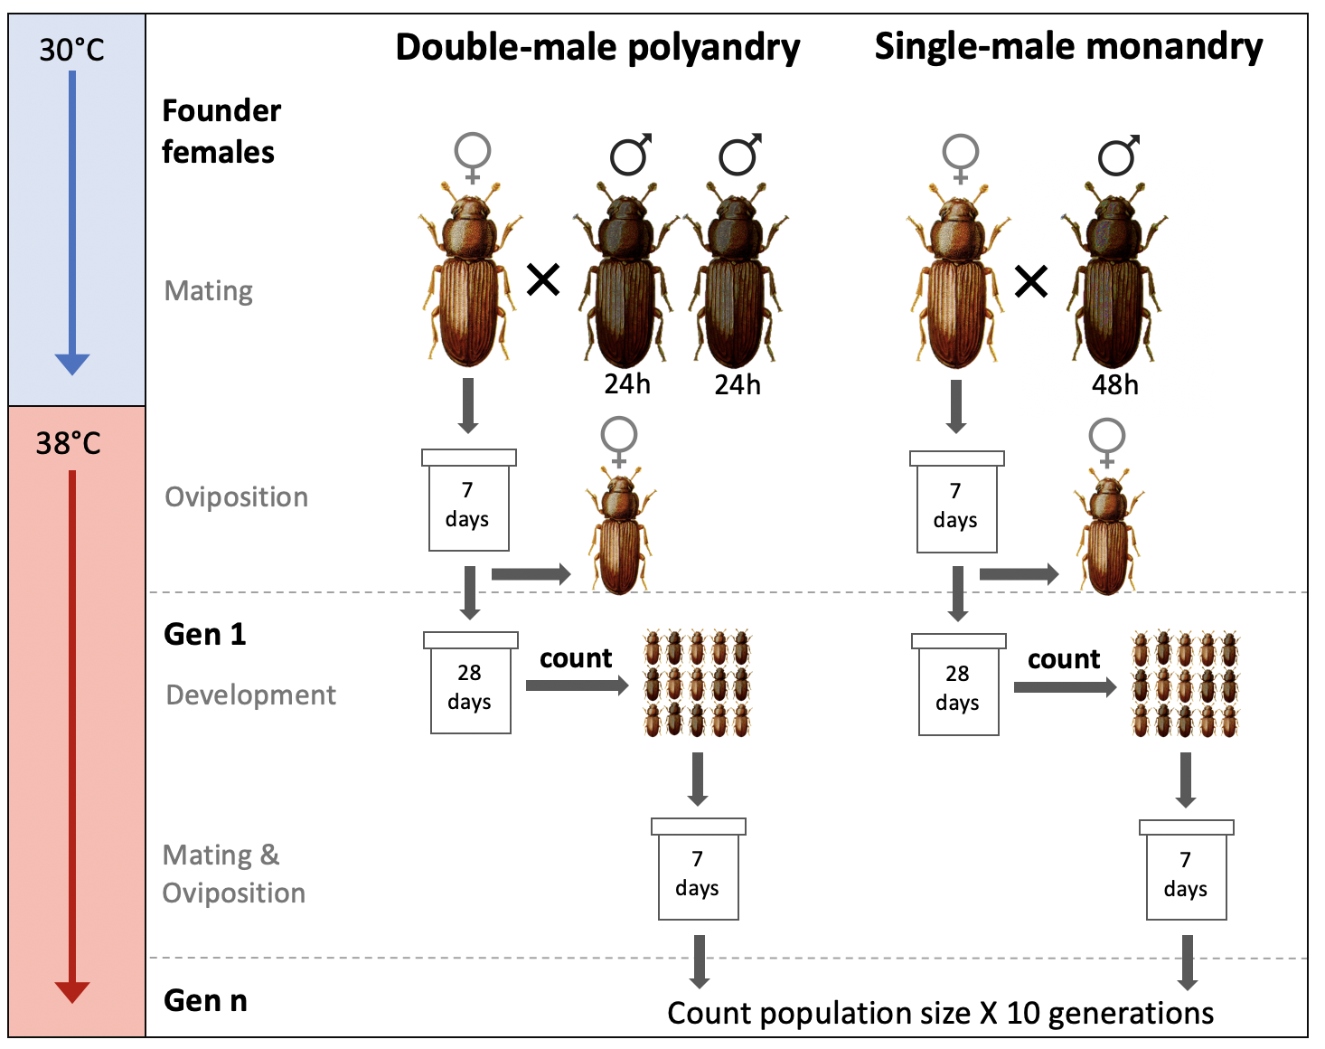

**Figure 1** Experimental design for *T. castaneum* colonisations.Individual females were mated with either one or two males, then introduced into a challengin thermal environment to lay eggs. Offspring were counted and used to found subsequent generations. We tracked a total of 108 populations for ten generations.

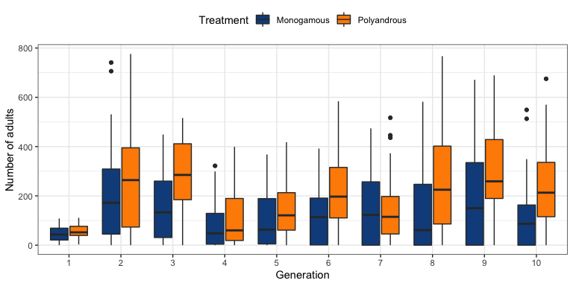

**Figure 2** Colonisation dynamics of experimental *T. castaneum* populations founded from monogamous or polyandrous females.

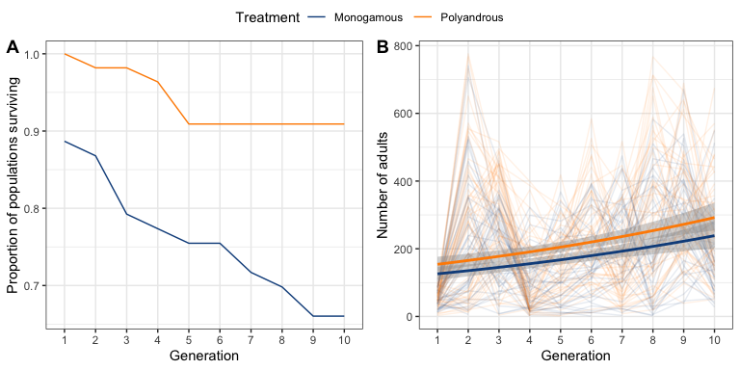

**Figure 3** Extinction and population dynamics of experimental *T. castaneum* populations founded from monogamous or polyandrous females. **A** Proportion of populations surviving over time; **B** number of adults in experimental populations. In **B**, thin lines represent individual populations, while the thick lines represent fitted values from a negative-binomial GLM.