On the fringe of Cornish moorland
Swept by winds from sea
Stands our dear old alma mater
Whose proud sons are we
Strong and kindly she has watched us
Work and play and dream
Guiding strengthening our young efforts
For the wider stream
Chorus
Raise the chorus let it ring
Through form room field and hall
Vivat schola Liskeardensis
Finest school of all

On her fields we battle stoutly
Take a blow and smile
Quicken up our weary muscles
Finish off the mile
Courage that her colours give
To strive and never yield
Heartens us until the last bell
Rings us from the field
Chorus
We whom alma mater draws
From town and moor and coast
Hope to win her proud remembrance
As in her we boast
May she nurture generations
Of good Cornish men
Watching o'er the happy schooldays
Of TRE POL and PEN
Chorus
LISKEARD GRAMMAR SCHOOL ASSOCIATION REUNION 2008

Saturday 3rd May at the Public Hall Liskeard

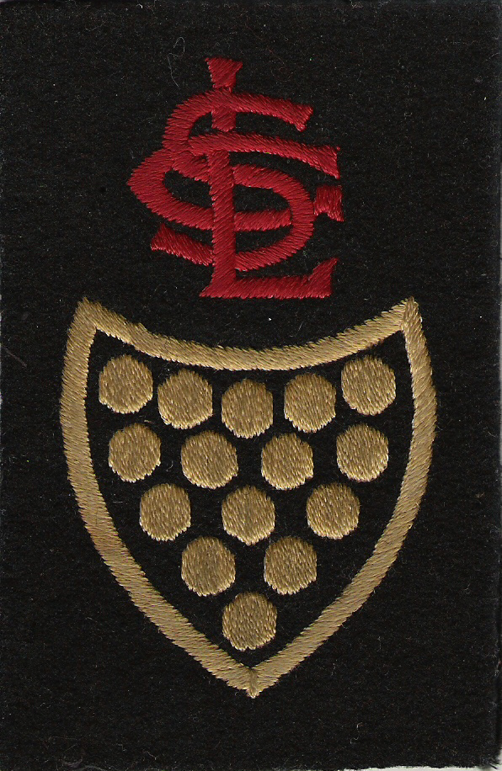

Master of Ceremonies - Tony Stephens

Label here

Arrival from 6.30 pm onwards

Reception in the LONG ROOM where you will be served with
Alcoholic & Non-Alcoholic Punch & Nibbles

Mary WILLIAMS will be waiting to take your ‘Year Group’ photographs in the QUIMPERLÉ ROOM and these will be available later in the evening

The Bar will be open to quench your thirst

7.45pm for 8.00pm

Take your seat for the Banquet in the Main Hall preceded by ‘The School Song’

The Raffle will be drawn after the meal

Your Association has invested in a small stock of Wine which will be available for a Donation to Association Funds

IN THE MAIN HALL
On the tables
Barnett Fare mini Pasties
Traditional Steak Honey and Mustard Sausage
St Endellion Brie and Cranberry Cheesestraws
Kettle Chips

From the Buffet
Whole Fresh Salmon Poached in White Wine
Garnished with Prawns
Carved Turkey and Local Carved Ham
Vegetarian Roulade
Hot New Potatoes
Drizzled with melted Butter and Chopped Parsley
Creamy Coleslaw Waldorf Tomato and Basil
A Big Mixed Green Salad
Fresh Rolls & Crusty Bread
Butter Dressings Condiments

Trio of Sweets served to the tables
Portion of each per plate
Rich Chocolate Fudge Torte
Individual Meringues filled with Cornish Clotted Cream
And Fresh Strawberries
Lemon Cream in Victoria Cups Served with Clotted Cream

For Special Diets ONLY Exotic Fresh Fruit Salad

From the Buffet
Tea Coffee Mints

