**Register a small business**: Do you have a passion for business? You have a bright idea, want to be your own boss and you’re ready to take the business world by storm? Register your business and get started here:

>> >

Yaa Asantewaa was not only a fierce warrior queen who led legions into battle through her wisdom and guidance, but was also trusted leader to her people. As Vukasantewaa, we believe that the best leaders to guide the youth of South Africa to a prosperous future exhibit such qualities as the great Yaa Asantewaa. Entrepreneurs are individuals who have the capacity to lead South Africa to a future that is poverty free by creating job opportunities for the youth and well creating sustainable wealth for themselves.

Here’s important information you need to know as a budding entrepreneur;

According to previous findings by World Wide Worx, there are an estimated 650,000 small businesses in South Africa, employing around 7.8 million people.

Estimates place the GDP contribution of small businesses at 52% and 61%.

**1. The majority of small business owners are self-funded**

63% of small business owners report using personal savings while 20% found investment or a loan from a family member, partner or friend. Only 6% turned to business angels or venture capitalists.

**2. Initial start-up funding is below R100,000**

The initial start-up funding required was below R100,000 for more than half (62%) of businesses surveyed, with only 4% raising more than R1,000,000, the report said.

**3. Small business owners are not big on ‘the cloud’**

When it comes to financial management, over half (51%) the small business owners surveyed use desktop accounting tools, and over a third still manage their finances manually. Only 8% have moved on to cloud accounting software.

**4. Cash flow is a big worry**

While 41% of business owners said they had no cash-flow worries, a big chunk of responding owners (38%) said that they were hit with unexpected cash flow issues – from late-paying clients, to unforeseen slumps in sales.

**5. Small businesses are super successful**

A massive 94% of businesses surveyed said that they were profitable, with more than a third (37%) saying they were profitable from the start. Three quarters of business owners believe they are making more money than they would have working for someone else.

**6. Running a business means sacrificing time off**

95% of business owners said they worked more than 8 hours a day, with 27% saying they never take time off – working every day of the year. Only 4% of business owners said they worked less than 8 hours a day.

**7. The biggest challenge is the competition**

Business owners cited competition from other business as the biggest challenge they face – though access to funding was another challenge worth noting. Keeping ahead of competitors was cited as the thing most likely to keep small business owners up at night.

**8. Small business embrace technology**

Two-thirds of small business owners said that technology was very important or essential for their business operations, with smart devices and apps making their lives and the running of their businesses easier. Only a small portion of businesses (29%) generate income online, though, with 49% of businesses opting for traditional brick and mortar.

**9. SMEs are surprisingly positive about the economy**

Small business owners were bullish about the South African economy, with more than half (58%) expecting the country’s economy to grow in the next year (versus 12% who expect it to shrink). Economic growth was the thing businesses were most looking forward to, and along with it, increased consumer demand and possible tax breaks from government.

Warren Buffet Tips:

On Earning: “Never depend on single income. Make investment to create a second source.”

On Spending: “If you buy things you do not need, soon you will have to sell things you need.”

On Saving: “Do not save what is left after spending, but spend what is left after saving.”

On Taking Risk: “Never test the depth of the river with both feet.”

Vukasantewaa helps you build your company profile to create an online presence that will showcase the expertise your company offers, and provides you with the opportunity to network with potential business partners and investors.

This is how we do it:

* + Create a wish-list of what the company intends i.e. company goals, service offering and target market.
  + Register their BBEE scores and through the application.
  + Network with similar minded individuals.

**Search for a job:** Are you passionate about you career? Ready to take on a new challenge, climb the corporate ladder and be the best in your field? The journey starts now, find the perfect job for yourself here:

>>>

Yaa Asantewaa fierce and conquering, was also a mother of a nation, whose maternal instincts drove her to protect her people and mostly to provide and secure a future for her nation. We as Vukasantewaa continue her legacy by providing guidance for the youth of South Africa seeking employment, by providing them with the best information to help guide them as they make their career choices.

Here’s important information you need to know about the employment market in South Africa:

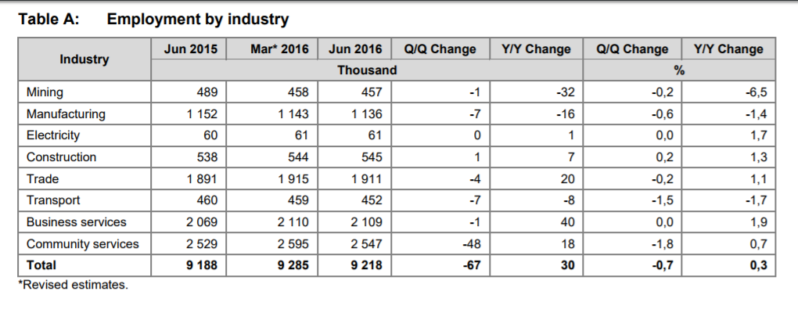

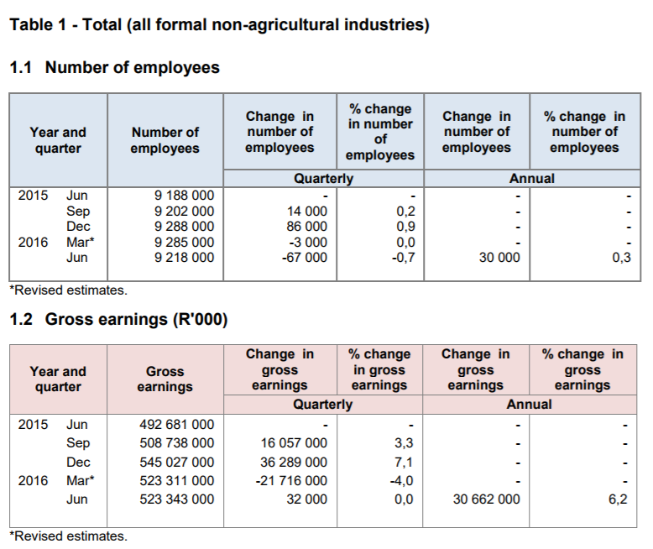

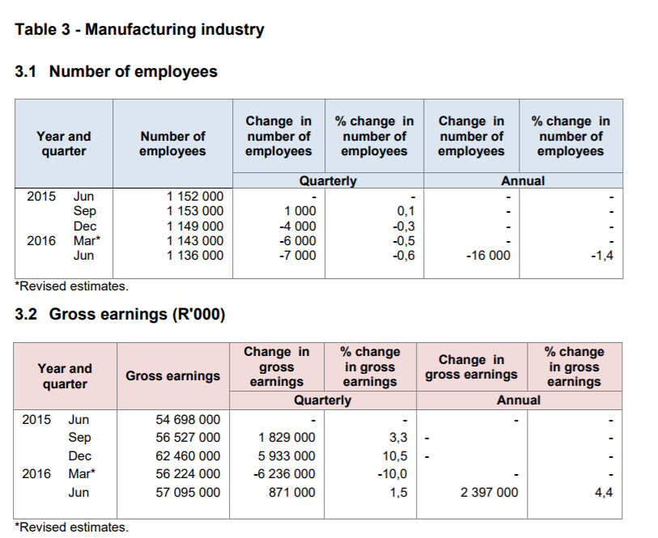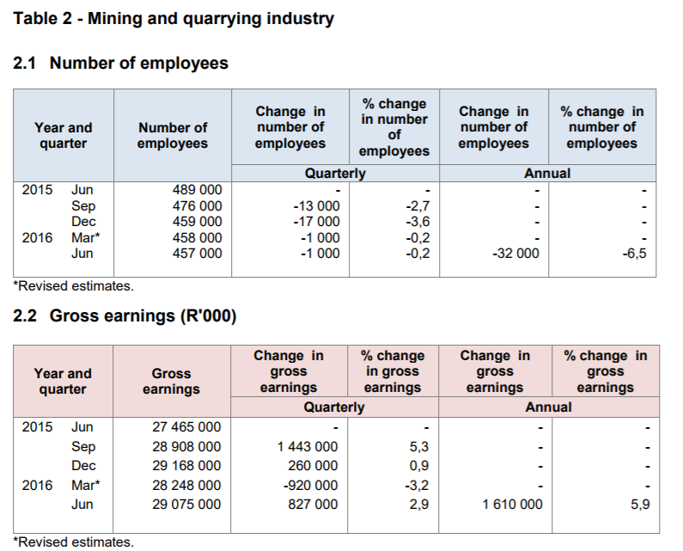

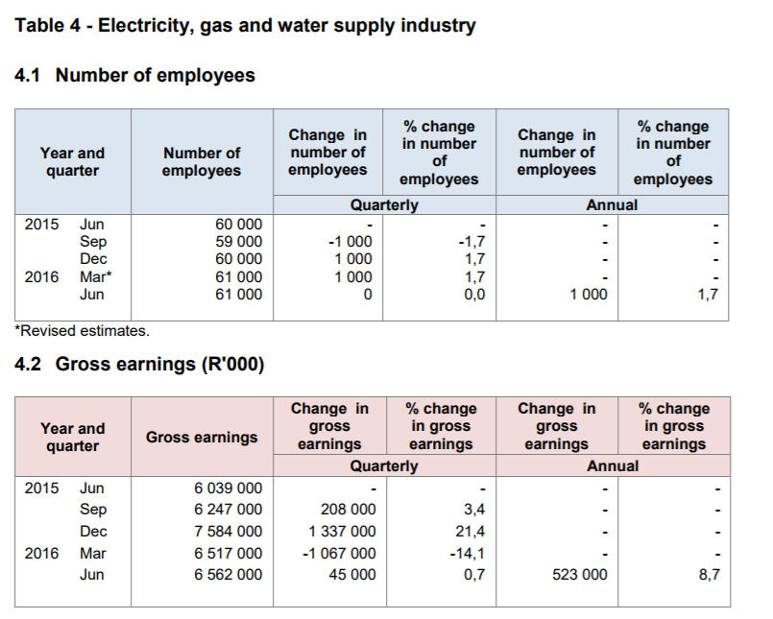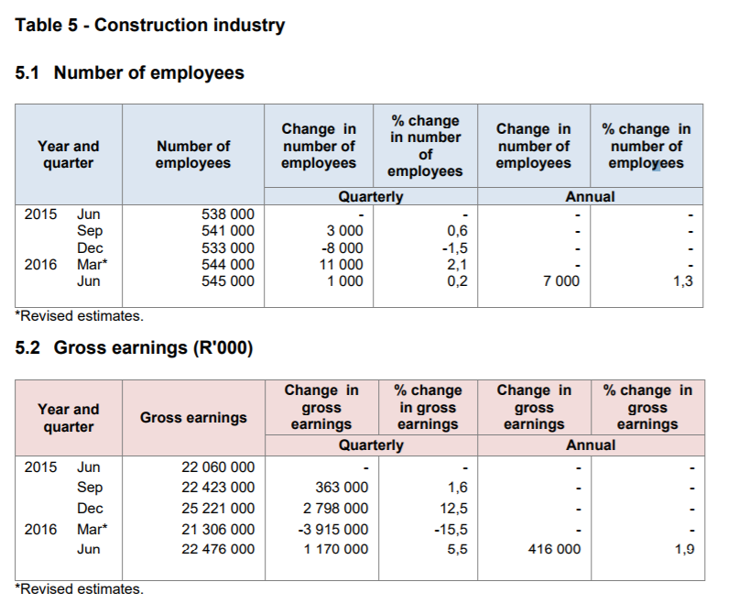

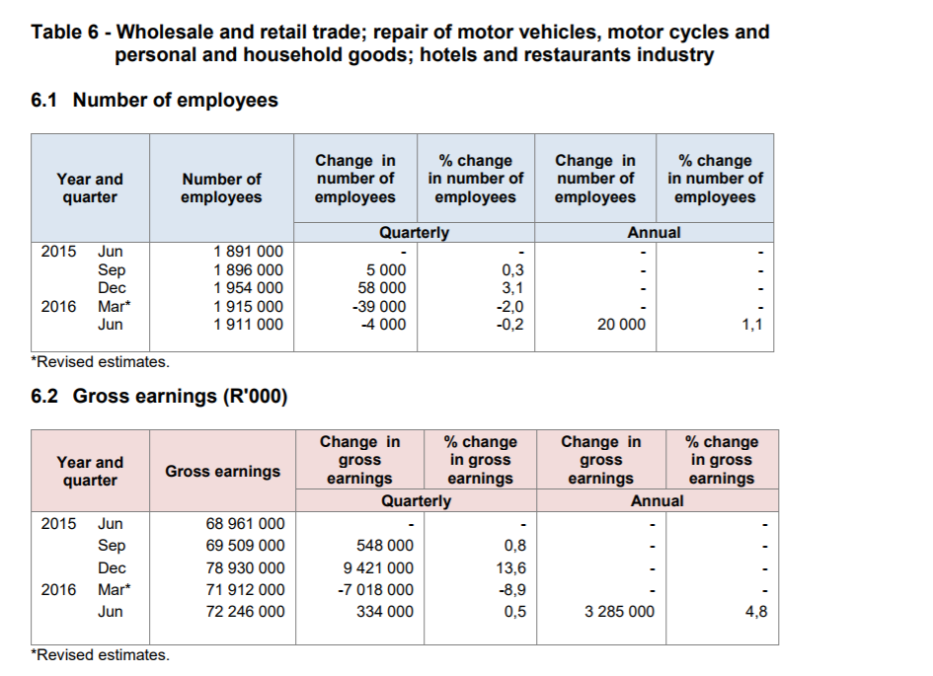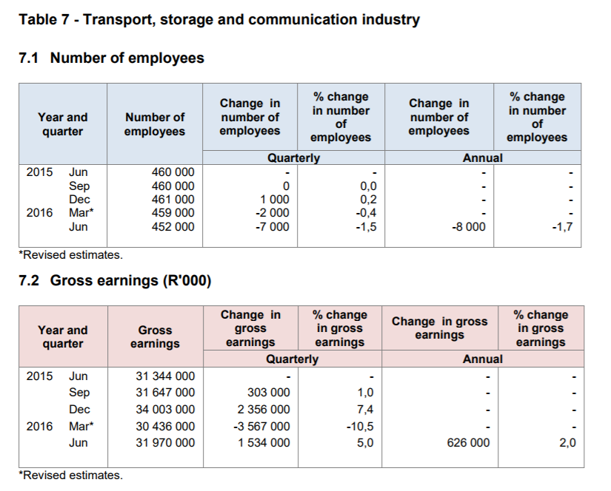

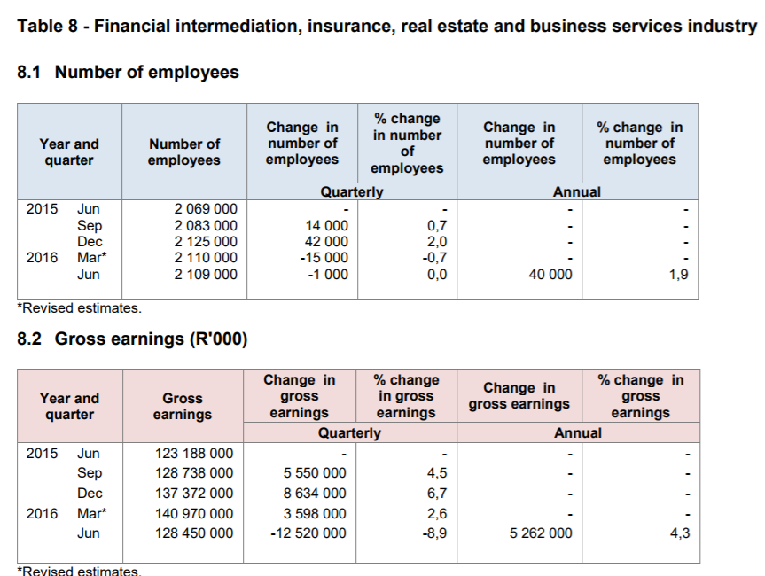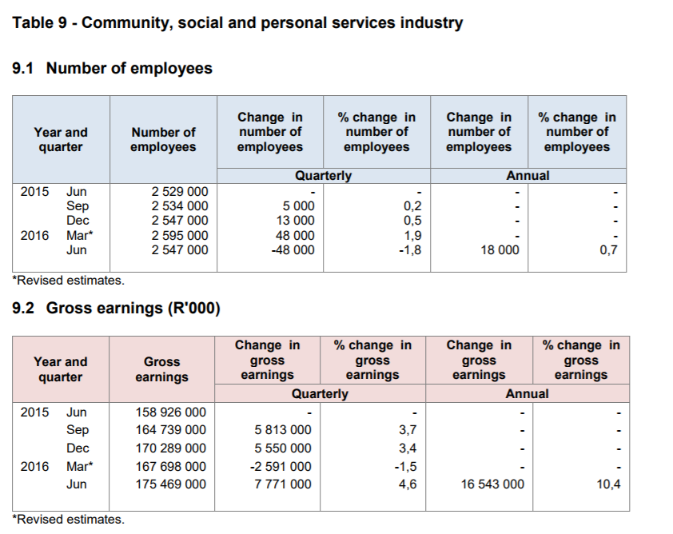

**Post a tender/business job:** Are you ahead of the business curve and you want to stay ahead? You want the right set of skills to set your business apart from the rest? Then you’re already on the right path, post your advert here:

>> Here is important information to know regarding the business market in South Africa:

Vukasantewaa is the perfect platform for you to access quality candidates for your advertisment The following features provide you with the best tools to achieve your goals:

* + Post tender/business adverts once off without registering at a fee.
  + Register and create a business profile.
  + Develop assessments for candidates to complete in order to screen the quality of your candidates.
  + One time tender issuers have the benefit of posting job adverts without registering.
* **Recruitment agency/business owner:** Will only the best do for you? you want the best of the best to further your business? Find the perfect candidate here:

>>

(this is according to the latest data provided by the 17th Commission for unemployment Equity Annual report)

TOP MANAGEMENT LEVEL • 68,5% of the positions are occupied by the White group; African, 14,4%; Indian 8,9%; Coloured 4,9% and Foreign National 3,4% • Males occupy 78,0% of the positions and females 22,0%

SENIOR MANAGEMENT LEVEL • 58,1% of the positions in Senior Management are occupied by the White group; African, 22,1%; Indian 10,6% Coloured 7,7% and Foreign National 1,4% • Males occupy 66,7% of the positions and females 33,3%

PROFESSIONALLY QUALIFIED LEVEL • 41,5% of the positions in Professionally Qualified level are occupied by Africans; 37,5% Whites; Coloured 9,7%; Indian 8,5% and Foreign National 2,8% • Males occupy 54,4% of the positions and females 45,6%

SKILLED TECHNICAL LEVEL • 60,2% of the positions in Skilled Technical level are occupied by Africans; 20,8% Whites; Coloured 11,5%; Indian 5,8% and Foreign National 1,8% • Males occupy 54,0% of the positions and females 46,0%

SEMI-SKILLED LEVEL • 76,1% of the positions at the Semi-Skilled level are occupied by Africans; Coloured 12,3%; White 6,2%, Indian 3,1% and Foreign National 2,3% • Males occupy 57,2% of the positions and females 42,8%

UNSKILLED LEVEL • 83,2% of the positions at Unskilled level are occupied by Africans; 11,4% Coloured, 3,4% Foreign Nationals, 1,2% Whites and 0,8% Indians • Males occupy 59,3% of the positions at this level and females 40,7%

Vukasantewaa helps you find the perfect job by exposing your profile to potential employers as well as recruitment agencies who will be able to view your profile online. With our user-friendly application, you will be able to:

* + Create a comprehensive profile
  + Search for jobs
  + Apply for jobs
  + Receive tips of potential employers and job opportunities based on your individual skill and experience matrix.

Vukasantewaa helps you get the best quality candidates by providing you with features that will help you manage the tasks of candidate recruitment efficiently. Here are the feature provided by Vukasantewaa:

* + Post jobs once off without registering, at a fee.
  + Compile job descriptions and post jobs.
  + Develop assessments for candidates to complete in order to screen the quality of the candidates.
  + Automated receipts of CVs from registered candidates.
  + A reporting functionality that will provide recruiters with a view of the employment market trends.