Conditional probability

Naive Bayes Classifiers:
- Multinomial
  - text classifier
    - histogram of number of times words occur in legitimate messages vs spam plus 1
    - P(w1|L)... and P(w1|S) (or likelihood ie values are discrete)
    - P(L|w1w2) > P(S | w1w2) ?
      - P(L|n*w1 and M*
      - w2) proportional to: P(L) * P(w1|L)^n P(w2|L)^m...
      - start with P(L) = L/(L+S)
    - bias vs variance tradeoff
      - doesn’t consider order or grouping of words (bias)
        - inability to capture true relationship (quality)
        - ie. fit a line to a curve
      - but works well (variance)
        - sum of squared differences between predictions and true values in test set (consistency)
        - issue with neural networks
        - less of an issue with large datasets
          - https://www.youtube.com/watch?v=a6YH6EbM9xA
    - overfit – fits training well but not test
      - https://www.youtube.com/watch?v=EehRcPo1M-Q
        - validation loss increases and training loss decreases
        - high variance
      - regularization
        - lower weights of the model
          - l1/l2
            - 0 <= add alpha <= 1 * sum of weights or sum of squared weights to loss calculation
          - drop out
            - https://www.youtube.com/watch?v=D8PJAL-MZv8
            - 0 activations with probability p for each gradient descent step
              - https://www.youtube.com/watch?v=D8PJAL-MZv8
            - different layers can have different drop out rates
              - https://www.youtube.com/watch?v=ARq74QuavAo
          - early stopping
          - data augmentation
            - add variations of data
              - ie. new colorizations or new orientations of images
      - linear regression
      - classification trees
        - build simple decision tree for each attribute
        - compute (Gini) impurity of leaves
          - 1 – P(Y)^2 – P(N)^2
        - total impurity = sum of Gini impurity of leaves/(samples in leaf / total samples)
        - when attribute is a number
          - sort attributes
          - compute average for adjacent attributes
          - calculate Gini impurity for each average age
          - pick average with lowest Gini impurity
        - put attribute with lowest impurity at top of tree
        - repeat
        - leaves with a single sample may indicate overfitting
          - pruning
            - https://www.youtube.com/watch?v=D0efHEJsfHo
          - limit samples per leaf
            - leaves maybe impure
            - but we do have a measure of accuracy
        - https://www.youtube.com/watch?v=_L39rN6gz7Y
        - regression trees
          - predict numeric values
          - divides samples into groups
            - prediction is average value per group
          - https://www.youtube.com/watch?v=g9c66TUylZ4
      - feature selection
        - https://www.youtube.com/watch?v=wpNl-JwwplA
      - cross validation
      - ensemble learning
        - combine results of multiple models
        - BAGging (Bootstrap AGgregation)
          - create multiple smaller training sets by randomly sample input data with replacement
          - average results of models generated
          - models can be built in parallel as opposed to boosting
          - ie. random forest
          - https://www.youtube.com/watch?v=RtrBtAKwcxQ
        - boosting
          - https://www.youtube.com/watch?v=3CC4N4z3GJc
          - classify samples
          - classify again with more weight given to samples originally misclassified
          - aggregate models according to their performance
          - unlike bagging reduces bias
            - with bagging bias in data directly impacts results because the weights of original sample are unchanged
          - https://www.youtube.com/watch?v=tjy0yL1rRRU
      - stacking
        - use output of inital models as input to meta model to reduce bias
          - https://www.youtube.com/watch?v=sN5ZcJLDMaE

    - https://www.youtube.com/watch?v=O2L2Uv9pdDA
    - https://www.youtube.com/watch?v=EuBBz3bI-aA&t=312s (bias and variability)

  - log
  - normal/Gaussian distribution
  - probability vs likelihood
    - prob = area under fixed distribution curve
    - likelihood
      - = point on y axis of distribution curve for any point on x axis for distributions which can be moved
      - likelihood of distribution given data
        - the goal of maximum likelihood is to find the optimum value of the parameters of a distribution given a set of measurements (ie mean and standard deviation for normal distribution or lamda for exponenital distribution)
        - maximum likelihood for normal distribution
          - if mean of distribution is well below average of data
          - the sum of the likelihoods for each of the data points is low
          - the maximum likelihood for the mean of the distribution is the same as the average of the data points
          - similarly find the standard deviation which maximizes the likelihoods
          - https://www.youtube.com/watch?v=XepXtl9YKwc
        - maximum likelihood for exponential distribution
          - exponential distribution
            - y = lambda e^(-lambda x)
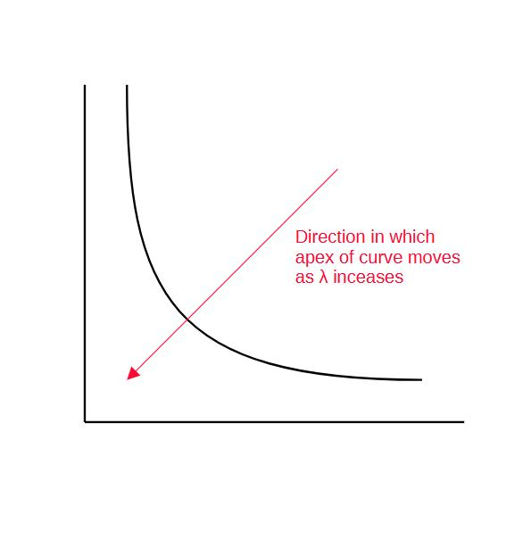

            - x axis is the amount of time between events
            - y axis scaled so that area under curve = 1
            - L(lamda | xn) = lamda e^(-lamda xn)
            - L(lamda | x1 and x2) = L(lamda | x1) L(lamda | x2)
            - solve for lamda when d L(lamda | x1,x2, ... xn) = 0
            - eqivalently solve for lamda when d log (L (lamda | x1,x2,...xn))
            - lamda = n / (x1 + x2 + ... + xn)
          - https://www.youtube.com/watch?v=p3T-_LMrvBc
    - https://www.youtube.com/watch?v=pYxNSUDSFH4
  - https://www.youtube.com/watch?v=H3EjCKtlVog

- Gaussian
  - find mean and standard deviation for normal distribution for each of the attributes when the result is true and when it is false
  - start with P(result is true) = T / (T+F) in sample data
  - multiply by likelihoods that result is true given each of the attributes
  - use log when dealing with small numbers to avoid underflow
    - log (ab) = log(a) + log(b)
  - compare with likelihood that result is false given a set of attributes
  - https://www.youtube.com/watch?v=H3EjCKtlVog

Bayes Generative
- instead of learning how to distinguish between classes (disciminative)
  - learn P(y|x)
- generative models: model a single class to understand its characteristics
  - learns P(x|y): class-conditional density (also P(y) prior)
- https://www.youtube.com/watch?v=z5UQyCESW64
- https://medium.com/data-science-in-your-pocket/naive-bayes-as-a-generative-model-7fcc28787188

How does Bayes Generative fit in Gans?

