**CSV to SHP Project**

A csv file is provided. This file needs to be stripped of special characters (%, $, etc) headers, and spaces facilitating the creation of a shapefile. The csv contains attributes on fire ignitions, i.e. date, acreage, location. There should be a separate shapefile created for each individual park unit (UNIT_ID) as well as a one shapefile for the entire csv file.

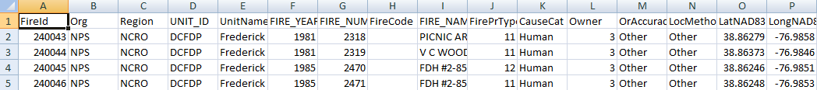

The resulting shapefiles need to be saved in a new folder, designated by the end user.

Within ArcMap a button needs to be created, with a GUI interface prompting the end user to select the csv for conversion and the output location of the new folder where the shapefiles will be saved too. The resulting shapefiles need to be named in the following convention; {UNIT_ID}_YYYYMMDD. The date reflects the date in which the shapefile was made. Newly created shapefiles do not need to be added to an ArcMap Document.

Sample data will be linked to the course website.

Project request from Justin Shedd.